|  |  |
| --- | --- |
|  | **MINISTRY OF EDUCATION AND TRAINING** |

|  |
| --- |
| **FPT UNIVERSITY** |
| Capstone Project Document |
| **BCDS – Building Cracks Detection System** |

|  |  |
| --- | --- |
| **BCDS Team** | |
| **Group Members** | Hoang Tuan Anh - SE130553  Le Nguyen Viet Hung - SE130486  Nguyen Quang Huy - SE130477  Tran Hoang Dung - SE130551 |
| **Supervisor** | Pham Cong Thanh  Doan Nguyen Thanh Hoa |
| **Ext Supervisor** | N/A |
| **Capstone Project code** | SP21SE04 |

- HCM, 01/2021 -

**Table of Contents**

Acknowledge 25

Definition and Acronyms 26

I. Project Introduction 26

1. Overview 26

1.1 Project Information 26

1.2 Project Team 27

a. Supervisors 27

b. Team Members 27

2. Product Background 27

3. Existing Systems 27

4. Business Opportunity 28

5. Software Product Vision 28

6. Project Scope & Limitations 28

6.1 Major Features 28

a. Admin 28

b. Manager 29

c. Staff 29

d. Unauthenticated User 29

e. Authenticated User 29

6.2 Limitations & Exclusions 29

II. Project Management Plan 30

1. Overview 30

1.1 WBS & Estimation 30

1.2 Project Objectives 32

1.3 Project Risks 33

2. Management Approach 33

2.1 Project Process 33

2.2 Quality Management 34

2.3 Training Plan 34

3. Master Schedule 34

4. Project Organization 35

4.1 Team & Structures 35

4.2 Roles & Responsibilities 35

5. Project Communication 36

5.1 Communication Plan 36

5.2 External Interface 36

a. FU Contacts 36

6. Configuration Management 37

6.1 Tools & Infrastructures 37

6.2 Document Management 37

6.3 Source Code Management 37

III. Software Requirement Specification 37

1. Overall Description 37

1.1 Product Overview 37

1.2 Business Rules 38

2. User Requirements 42

2.1 Overview 42

a. Use Case Diagram 42

b. System Actors 43

c. Use Cases List 43

2.2 UC01 - Login 46

2.3 UC02 - Create New Account 47

2.4 UC03 - Update Account 49

2.5 UC04 - Delete Account 50

2.6 UC05 - Reset Password 51

2.7 UC06 - Create New Area 52

2.8 UC07 - Update Area 54

2.9 UC08 - Delete Area 55

2.10 UC09 - Create New Repairer 56

2.11 UC10 - Update Repairer 58

2.12 UC11 - Delete Repairer 59

2.13 UC12 - View Profile 60

2.14 UC13 - Get List Of Notifications 61

2.15 UC14 - Get List Of Cracks 62

2.16 UC15 - View Crack Details 63

2.17 UC16 - Get List Of Repair Records 64

2.18 UC17 - View Repair Record Details 65

2.19 UC18 - Get List Of Repairers 66

2.20 UC19 - View Repairer Details 67

2.21 UC20 - Get List Of Detection Results 68

2.22 UC21 - View Detection Result Details 69

2.23 UC22 - Change Password 70

2.24 UC23 – Logout 72

2.25 UC24 - Get List Of Areas 73

2.26 UC25 - View Area Details 74

2.27 UC26 - Get List Of Users 75

2.28 UC27 - View User Details 76

2.29 UC28 - View Dashboard 77

2.30 UC29 - Delete Video 78

2.31 UC30 - Assign Staff To Area 79

2.32 UC31 - Remove Staff Out Of Area 80

2.33 UC32 - Verify Crack 81

2.34 UC33 - Reject Crack 82

2.35 UC34 - Update Crack 83

2.36 UC35 - Add Crack To Repair Record Queue 85

2.37 UC36 - Remove Crack From Repair Record Queue 86

2.38 UC37 - Repair Record 87

2.39 UC38 - Update Repair Record 88

2.40 UC39 - Evaluate Repair 90

2.41 UC40 – Import Video 91

2.42 UC41 - Detect Crack 92

2.43 UC42- Send Notification When Completely Detected 94

2.44 UC43- Send Notification When Created Repair Record 95

2.45 UC44- Send Notification When Update Repair Record 96

2.46 UC45- Send Notification When Evaluated Repair Record 97

2.47 UC46- Send Notification When Admin Update User 98

2.48 UC47- Send Notification When Manager Assign Area 99

3. Functional Requirements 99

3.1 System Functional Overview 99

a. Screen Flow 99

b. Screen Details 102

c. Screen Authorization 106

d. Non-Screen Functions 112

e. Entity Relationship Diagram 113

3.2 W1: Authentication/Authorization 114

a. Login web application 114

b. Forgot password 115

3.3 W2 - Admin: Manage Users 116

a. View list users 116

b. Create new user 117

c. Update user 118

d. Reset password for user 119

e. Delete user 119

3.4 W3 - Admin: Manage Areas 120

a. View list areas 120

b. Create new area 121

c. Update area 122

d. Delete area 123

3.5 W4 - Admin: Manage Repairers 123

a. View list repairers 123

b. Create new repairer 124

c. Update repairer 125

d. Delete repairer 126

3.6 W5 - Admin: View Dashboard 126

3.7 W6 - Admin: View List Cracks 127

a. View list cracks 127

b. View crack details 128

3.8 W7 – Admin: View List Repair Records 129

a. View list repair records 129

b. View repair record details 130

c. View list of cracks 132

d. View crack details 132

3.9 W8 – Admin: Manage Detection Results 133

a. View list detection results 133

b. Delete video 134

c. View detection result details 134

3.10 W9 – Admin: Manage Profile 135

a. View profile 135

b. Change password 136

3.11 W10 - Admin: View Notifications 136

3.12 W11 - Manager: View Dashboard 137

3.13 W12 - Manager: View List Cracks 138

a. View list cracks 138

b. View crack details 139

3.14 W13 – Manager: Manage Staffs 140

a. View list staffs 140

b. View staff details 141

3.15 W14 – Manager: View List Areas 142

a. View list areas 142

b. View area details 143

3.16 W15 – Manager: View List Repair Records 144

a. View list repair records 144

b. View repair record details 145

c. View list of cracks 147

d. View crack details 147

3.17 W16 – Manager: View List Repairers 148

a. View list repairers 148

b. View repairer details 149

3.17 W16 – Manager: Manage Detection Results 150

a. View list detection results 150

b. Delete video 150

3.18 W17 – Manager: Manage Profile 151

a. View profile 151

b. Change password 152

3.19 W18 - Manager: View Notifications 152

3.20 W19 - Staff: Manage Cracks 153

a. View list cracks 153

b. View crack details 154

c. Update crack 155

3.21 W20 – Staff: View List Repair Records 156

a. View list repair records 156

b. View repair record details 157

c. View list of cracks 159

d. View crack details 159

3.22 W21 – Staff: View List Repairers 160

a. View list repairers 160

b. View repairer details 161

3.23 W22 – Staff: Manage Detection Results 162

a. View list detection results 162

b. Detect cracks 163

c. View detection result details 164

3.24 W23 – Staff: Manage Profile 165

a. View profile 165

b. Change password 166

3.25 W24 - Staff: View Notifications 167

3.26 M1 – Staff: Authentication/Authorization 168

a. Login mobile app 168

b. Forgot password 169

3.27 M2 – Staff: Manage Cracks 171

a. View list not-verify cracks 171

b. Confirm crack 172

c. Reject crack 173

d. View list verify-crack 174

e. View crack detail – not add to queue yet 175

f. View crack detail – repair recorded 177

g. View crack detail – fixed 179

h. Add to queue 181

3.28 M3 – Staff: Manage Repair Records 183

a. Add to queue 183

b. Repair record 185

c. Remove from queue 186

d. Evaluate repair 188

e. View history 190

3.29 M4 – Staff: Manage Profile 191

a. View profile 191

b. Change password 192

3.30 M5 – Staff: View Notifications 193

a. View list notifications 193

b. View notification detail 194

4. Non-Functional Requirements 194

4.1 External Interfaces 194

a. User Interfaces 194

b. Software Interfaces 195

c. Hardware Interfaces 195

d. Communications Interfaces 195

4.2 Quality Attributes 195

a. Usability 195

b. Reliability 196

c. Performance 196

d. Dependability 196

d1. Security 196

d2. Safety 196

e. Supportability 196

f. Design Constraints 196

g. Support Documents 197

h. Purchased Components 197

5. Other Requirements 197

IV. Software Design Description 197

1. Overall Description 197

1.1 Assumptions 197

1.2 Design Constraints 198

2. System Architecture Design 198

2.1 Overall Architecture 198

2.3 Package Diagram 199

3. System Detailed Design 202

3.1 Class Diagram 202

3.2 Class Specification 203

a. Area 203

b. Crack 203

c. Repair Record 204

d. Users 204

e. Repairer 205

f. Push Notification 205

g. Role 206

h. Detection Result 206

3.3 Activity Diagrams 207

a. Login 207

b. Logout 208

c. Confirm Crack 209

d. Reject Crack 210

e. Update Crack 211

f. Add Crack To Queue 212

g. Repair Record 213

h. Evaluate Crack 214

3.4 Sequence Diagrams 215

a. Login 215

b. Create account 215

c. Update account 216

d. Delete account 216

e. Get list of accounts 217

f. Get list of staffs 217

g. Create area 218

h. Update area 218

i. Delete area 219

j. Get list of areas 219

k. Create repairer 220

l. Update repairer 220

m. Delete repairer 221

n. Get list of repairers 221

o. Assign staff to area 222

p. Delete video 222

q. Confirm crack 223

r. Reject crack 223

s. Update crack 224

4. Data & Database Design 225

4.1 Database Design 225

a. Area 225

b. Crack 226

c. Repair Record 227

d. Users 228

e. Repairer 228

f. Push Notification 229

g. Role 230

h. Detection Result 230

5. Algorithms & Research 231

5.1 Detect Crack 231

a. Problem definition 231

b. Requirement 231

c. Solution 231

Base Concept 231

Prepare data and train process 237

Evaluate Model 238

5.2 Check Duplicate Cracks 240

a. Problem definition 240

b. Solution 240

Purpose 240

Description 241

Complexity 243

V. Software Testing Documentation 244

1. Overall Description 244

1.1 Test Model 244

1.2 Testing Levels 244

1.3 Testing Types 244

2. Test Plan 245

2.1 Test Stages 245

2.2 Resources 245

a. Human Resources 245

2.3 Test Milestones 245

2.4 Deliverables 246

3. Test Cases 246

4. Test Reports 247

VI. Release Package & User Guides 248

1. Deliverable Package 248

1.1 Source codes & documents 248

1.2 Known Issues, Limitations & Restrictions 249

2. Installation Guides 249

2.1 System Requirements 249

a. Back End Server requirements: 249

2. Web Server requirements: 250

3. Detect Server requirements: 250

2.2 Environment setup requirements 251

2.3 Setup Files 251

2.4 Installation Instruction 251

a. Setup environment 251

1. Setup and start a Windows OS (Windows 10 or Windows Server 2016). 251

2. Install .NET Core Runtime 5. Hosting Bundles 251

3. Setup SQL Server 2019 254

4. Setup Api for application 259

5. NodeJS 259

6. Vue3 264

7. Fire Base 265

8. Run Web application. 274

9. Python 276

10. Run Detect Sever 280

11. Run Mobile Application 281

3. User Manual 285

3.1 Terms and definitions 285

3.2 System requirements 285

3.3 Application Usage 286

a. Overview 286

b. Login 287

c. Forgot Password 287

e. Create User 289

f. Update User 291

g. Reset Password 294

h. Delete Account 295

i. Create Area 297

j. Update Area 299

k. Delete Area 301

l. Create Repairer 303

m. Update Repairer 305

n. Delete Repairer 307

o. Detect crack(s) 309

VII. Appendix 310

1. Glossary 310

2. References 310

3. Appendix 311

**Table of Figures**

Figure 1. DevOps lifecycle 33

Figure 2. Team structures 35

Figure 3. Use Case diagram 42

Figure 4. <Use Case> Login 46

Figure 5. <Use Case> Create new account 47

Figure 6. <Use Case> Update account 49

Figure 7. <Use Case> Delete account 50

Figure 8. <Use Case> Reset password 51

Figure 9. <Use Case> Create new area 52

Figure 10. <Use Case> Update area 54

Figure 11. <Use Case> Delete area 55

Figure 12. <Use Case> Create new repairer 56

Figure 13. <Use Case> Update repairer 58

Figure 14. <Use Case> Delete repairer 59

Figure 15. <Use Case> View profile 60

Figure 16. <Use Case> Get list of notifications 61

Figure 17. <Use Case> Get list of cracks 62

Figure 18. <Use Case> View crack details 63

Figure 19. <Use Case> Get list of repair records 64

Figure 20. <Use Case> View repair record details 65

Figure 21. <Use Case> Get list of repairers 66

Figure 22. <Use Case> View repairer details 67

Figure 23. <Use Case> Get list of detection results 68

Figure 24. <Use Case> View detection result details 69

Figure 25. <Use Case> Change password 70

Figure 26. <Use Case> Logout 72

Figure 27. <Use Case> Get list of areas 73

Figure 28. <Use Case> View area details 74

Figure 29. <Use Case> Get list of users 75

Figure 30. <Use Case> View user details 76

Figure 31. <Use Case> View dashboard 77

Figure 32. <Use Case> Delete video 78

Figure 33. <Use Case> Assign staff to area 79

Figure 34. <Use Case> Remove staff out of area 80

Figure 35. <Use Case> Verify crack 81

Figure 36. <Use Case> Reject crack 82

Figure 37. <Use Case> Update crack 83

Figure 38. <Use Case> Add crack to repair record queue 85

Figure 39. <Use Case> Remove crack from repair record queue 86

Figure 40. <Use Case> Repair record 87

Figure 41. <Use Case> Update repair record 89

Figure 42. <Use Case> Evaluate repair 90

Figure 43. <Use Case> Import video 91

Figure 44. <Use Case> Detect crack 92

Figure 45. <Use Case> Send Notification When Completely Detected 94

Figure 46. <Use Case> Send Notification When Created Repair Record 95

Figure 47. <Use Case> Send Notification When Update Repair Record 96

Figure 48. <Use Case> Send Notification When Evaluates Repair Record 97

Figure 49. <Use Case> Send Notification When Admin Update User 98

Figure 50. <Use Case> Send Notification When Manager Assign Area 99

Figure 51. Admin screen flow 100

Figure 52. Manager screen flow 101

Figure 53. Staff Mobile App screen flow 102

Figure 54. Staff Web App screen flow 102

Figure 55 . Entity relationship diagram 113

Figure 56. Login screen 114

Figure 57. Forgot password screen 115

Figure 58. Input new password screen 115

Figure 59. List of users screen 116

Figure 60. User information popup 117

Figure 61. User details popup 118

Figure 62. Reset password confirm popup 119

Figure 63. Delete user confirm popup 119

Figure 64. List of areas screen 120

Figure 65. Area information popup 121

Figure 66. Area information popup 122

Figure 67. Delete area confirm popup 123

Figure 68. list of repairers screen 123

Figure 69. Create repairer popup 124

Figure 70. Repairer details popup 125

Figure 71. Delete repairer confirm popup 126

Figure 72. Dashboard screen 126

Figure 73. List of cracks screen 127

Figure 74. Crack details pop up 128

Figure 75. Crack details pop up 128

Figure 76. List of repair records screen 129

Figure 77. Repair record details popup 130

Figure 78. Repair record details popup 131

Figure 79. List of cracks screen 132

Figure 80. Crack details popup 133

Figure 81. Crack details popup 133

Figure 82. List of detection results screen 133

Figure 83. Delete video confirm popup 134

Figure 84. Detection result details screen 134

Figure 85. Profile screen 135

Figure 86. Change password screen 136

Figure 87. List of notifications screen 136

Figure 88. Dashboard screen 137

Figure 89. List of cracks screen 138

Figure 90. Crack details popup 139

Figure 91. Crack details popup 139

Figure 92. List of staffs screen 140

Figure 93. Staff details popup 141

Figure 94. List of areas screen 142

Figure 95. Area information popup 143

Figure 96. List of repair records screen 144

Figure 97. Repair record details popup 145

Figure 98. Repair record details popup 146

Figure 99. List of cracks screen 147

Figure 100. Crack details popup 148

Figure 101. Crack details popup 148

Figure 102. List of repairers screen 148

Figure 103. Repairer details popup 149

Figure 104. List of detection results 150

Figure 105. Delete video confirm popup 150

Figure 106. Profile screen 151

Figure 107. Change password screen 152

Figure 108. List of notifications screen 152

Figure 109. List of cracks screen 153

Figure 110. List of cracks screen 153

Figure 111. Crack details popup 154

Figure 112. Crack details popup 155

Figure 113. Update crack popup 155

Figure 114. List of repair record screen 156

Figure 115. Repair record details popup 157

Figure 116. Repair record details popup 158

Figure 117. List of cracks screen 159

Figure 118. Crack details popup 159

Figure 119. Crack details popup 160

Figure 120. List of repairers screen 160

Figure 121. Repairer details popup 161

Figure 122. List of detection results screen 162

Figure 123. File upload screen 163

Figure 124. Detection result details screen 164

Figure 125. Profile screen 165

Figure 126. Change password screen 166

Figure 127. List of notifications screen 167

Figure 128. Login screen 168

Figure 129. Forgot password screen 169

Figure 130. Reset password screen 170

Figure 131. Not verified cracks screen 171

Figure 132. Confirm crack popup 172

Figure 133. Reject crack popup 173

Figure 134. Verified cracks screen 174

Figure 135. Crack details screen 175

Figure 136. Crack details screen 176

Figure 137. Crack details screen 177

Figure 138. Crack details screen 178

Figure 139. Crack details screen 179

Figure 140. Crack details screen 180

Figure 141. Verified cracks screen 181

Figure 142. Verified cracks screen 182

Figure 143. Unrecorded cracks screen 183

Figure 144. Unrecorded cracks screen 184

Figure 145. Queue screen 185

Figure 146. Queue screen 186

Figure 147. Remove cracks bottom slide 187

Figure 148. Evaluation details screen 188

Figure 149. Repair evaluation screen 189

Figure 150. History screen 190

Figure 151. Profile screen 191

Figure 152. Change password screen 192

Figure 153. List of notifications screen 193

Figure 154. Notification details screen 194

Figure 155. Overall architecture 198

Figure 156. <Package Diagram> Back-end 199

Figure 157. <Package Diagram> Web App 200

Figure 158. <Package Diagram> Mobile App 201

Figure 159. Class diagram 202

Figure 160. <Activity Diagram> Login 207

Figure 161. <Activity Diagram> Logout 208

Figure 162. <Activity Diagram> Confirm crack 209

Figure 163. <Activity Diagram> Reject crack 210

Figure 164. <Activity Diagram> Update crack 212

Figure 165. <Activity Diagram> Add crack to queue 212

Figure 166. <Activity Diagram> Repair record 213

Figure 167. <Activity Diagram> Evaluate crack 214

Figure 168. <Sequence Diagram> Login 215

Figure 169. <Sequence Diagram> Create account 215

Figure 170. <Sequence Diagram> Update account 216

Figure 171. <Sequence Diagram> Delete account 216

Figure 172. <Sequence Diagram> Get list of accounts 217

Figure 173. <Sequence Diagram> Get list of staffs 217

Figure 174. <Sequence Diagram> Create area 218

Figure 175. <Sequence Diagram> Update area 218

Figure 176. <Sequence Diagram> Delete area 219

Figure 177. <Sequence Diagram> Get list of areas 219

Figure 178. <Sequence Diagram> Create repairer 220

Figure 179. <Sequence Diagram> Update repairer 220

Figure 180. <Sequence Diagram> Delete repairer 221

Figure 181. <Sequence Diagram> Get list of repairers 221

Figure 182. <Sequence Diagram> Assign staff to area 222

Figure 183. <Sequence Diagram> Delete video 222

Figure 184. <Sequence Diagram> Confirm crack 223

Figure 185. <Sequence Diagram> Reject crack 223

Figure 186. <Sequence Diagram> Update crack 224

Figure 187. Database design 225

Figure 188 . Base Network 231

Figure 189. Extra layer 232

Figure 190. Convolution 233

Figure 191. Convolution example in process 233

Figure 192. Pooling 234

Figure 193. Pool example in process 234

Figure 194. ReLU layer 235

Figure 195. YOLO grid 3x3 235

Figure 196. Feature map 236

Figure 197. YOLO prediction on each grid 236

Figure 198. YOLO final result 237

Figure 199. Cluster image 237

Figure 200. Cluster image 238

Figure 201. Simulate the camera of drone 238

Figure 202. Simulate the camera of drone 239

Figure 203. Simulate the camera of drone 240

Figure 204. Two frames 240

Figure 205. Calculate the opposite edge of 55 degrees 241

Figure 206. Map frame 1 to oxygen coordinate axis 242

Figure 207. Ratio to calculate frame transition distance 242

Figure 208. IOU ratio 243

Figure 209. Agile model 244

Figure 210. Test case report 247

Figure 211. Unit test case report 248

Figure 212 251

Figure 213 252

Figure 214 252

Figure 215 253

Figure 216 253

Figure 217 254

Figure 218 254

Figure 219 255

Figure 220 255

Figure 221 256

Figure 222 256

Figure 223 256

Figure 224 257

Figure 225 257

Figure 226 258

Figure 227 258

Figure 228 259

Figure 229 259

Figure 230 260

Figure 231 260

Figure 232 260

Figure 233 261

Figure 234 261

Figure 235 262

Figure 236 262

Figure 237 263

Figure 238 263

Figure 239 264

Figure 240 264

Figure 241 265

Figure 242 265

Figure 243 265

Figure 244 266

Figure 245 266

Figure 246 267

Figure 247 267

Figure 248 268

Figure 249 268

Figure 250 269

Figure 251 269

Figure 252 270

Figure 253 270

Figure 254 271

Figure 255 271

Figure 256 272

Figure 257 272

Figure 258 272

Figure 259 273

Figure 260 273

Figure 261 274

Figure 262 274

Figure 263 275

Figure 264 275

Figure 265 275

Figure 266 276

Figure 267 276

Figure 268 276

Figure 269 277

Figure 270 277

Figure 271 277

Figure 272 278

Figure 273 278

Figure 274 279

Figure 275 279

Figure 276 280

Figure 277 280

Figure 278 280

Figure 279 280

Figure 280 281

Figure 281 281

Figure 282 282

Figure 283 283

Figure 284 284

Figure 285 285

Figure 286. Login page 286

Figure 287. Dashboard 286

Figure 288. Login screen 287

Figure 289. Login button 287

Figure 290. Forgot password screen 288

Figure 291. Confirm button 288

Figure 292. Reset password mail 289

Figure 293. Forgot password screen 289

Figure 294. Change password button 289

Figure 295 290

Figure 296 290

Figure 297 290

Figure 298 291

Figure 299 291

Figure 300 292

Figure 301 292

Figure 302 293

Figure 303 294

Figure 304 294

Figure 305 294

Figure 306 295

Figure 307 295

Figure 308 296

Figure 309 296

Figure 310 297

Figure 311 297

Figure 312 298

Figure 313 298

Figure 314 298

Figure 315 299

Figure 316 299

Figure 317 300

Figure 318 300

Figure 319 301

Figure 320 301

Figure 321 302

Figure 322 302

Figure 323 303

Figure 324 303

Figure 325 303

Figure 326 304

Figure 327 304

Figure 328 304

Figure 329 305

Figure 330 305

Figure 331 306

Figure 332 306

Figure 333 307

Figure 334 308

Figure 335 308

Figure 336 308

Figure 337 308

Figure 338 309

Figure 339 309

Figure 340 309

Figure 341 310

**List of Tables**

Table 1. Definitions and Acronyms 24

Table 2. Supervisors 25

Table 3. Team members 26

Table 4. WBS & Estimation 29

Table 5. Project risks 31

Table 6. Training plan 33

Table 7. Master schedule 33

Table 8. Role & Responsibilities 34

Table 9. Communication plan 35

Table 10. FU contacts 35

Table 11. Tools & Infrastructures 35

Table 12. Business rules 36

Table 13. System actors 42

Table 14. Web App use case list 42

Table 15. UC01 - Login 45

Table 16. UC02 – Create new account 46

Table 17. UC03 – Update account 48

Table 18. UC04 – Delete account 49

Table 19. UC05 – Reset password 50

Table 20. UC06 – Create new area 51

Table 21. UC07 – Update area 53

Table 22. UC08 – Delete area 54

Table 23. UC – Create new repairer 55

Table 24. UC10 – Update repairer 57

Table 25. UC11 – Delete repairer 58

Table 26. UC12 – View profile 59

Table 27. UC13 - Get list of notifications 60

Table 28. UC14 - Get list of cracks 61

Table 29. UC15 - View crack details 62

Table 30. UC16 – Get list of repair records 63

Table 31. UC17 – View repair record details 64

Table 32. UC18 – Get list of repairers 65

Table 33. UC19 – View repairer details 66

Table 34. UC20 – Get list of detection results 67

Table 35. UC21 – View detection result details 68

Table 36. UC22 – Change password 69

Table 37. UC23 - Logout 71

Table 38. UC24 – Get list of areas 72

Table 39. UC25 – View area details 73

Table 40. UC26 – Get list of users 74

Table 41. UC27 – View user details 75

Table 42. UC28 – View dashboard 76

Table 43. UC29 – Delete video 77

Table 44. UC30 – Assign staff to area 78

Table 45. UC31 – Remove staff out of area 79

Table 46. UC32 – Verify crack 80

Table 47. UC33 – Reject crack 81

Table 48. UC34 – Update crack 82

Table 49. UC35 – Add crack to repair record queue 84

Table 50. UC36. Remove crack from repair record queue 85

Table 51. UC37 – Repair record 86

Table 52. UC38 – Update repair record 88

Table 53. UC39 – Evaluate repair 89

Table 54. UC40 – Import video 90

Table 55. UC41 – Detect crack 91

Table 56. UC42 - Send Notification When Completely Detected 93

Table 57. UC43 - Send Notification When Created Repair Record 94

Table 58. UC44 - Send Notification When Update Repair Record 95

Table 59. UC45 - Send Notification When Evaluates Repair Record 96

Table 60. UC46 - Send Notification When Admin Update User 97

Table 61. UC47 - Send Notification When Manager Assign Area 98

Table 62. Admin screen detail 101

Table 63. Manager screen detail 102

Table 64. Staff Web App screen detail 103

Table 65. Staff Mobile App screen detail 104

Table 66. Admin screen authorization 105

Table 67. Manager screen authorization 107

Table 68. Staff Web App screen authorization 108

Table 69. Staff Mobile App screen authorization 109

Table 70. Non-Screen functions 111

Table 71. Entity description 112

Table 72. <Class Specification> Area 202

Table 73. <Class Specification> Crack 202

Table 74. <Class Specification> Repair record 203

Table 75. <Class Specification> User 203

Table 76. <Class Specification> Repairer 204

Table 77. <Class Specification> Push notification 204

Table 78. <Class Specification> Role 205

Table 79. <Class Specification> Detection result 205

Table 80. <Database Design> Area 224

Table 81. <Database Design> Crack 225

Table 82. <Database Design> Repair record 226

Table 83. <Database Design> Users 227

Table 84. <Database Design> Repairer 227

Table 85. <Database Design> Push notification 228

Table 86. <Database Design> Role 229

Table 87. <Database Design> Detection result 229

Table 88 . Annotation 240

Table 89. Test stages 244

Table 90. Human resources 244

Table 91. Test milestones 244

Table 92. Deliverables 245

Table 93. Source codes & documents 247

Table 94. Back End Server - Recommended hardware configuration 248

Table 95. Web Server - Recommended hardware configuration 249

Table 96. Detect Server - Recommended hardware configuration 249

Table 97. Appendix 310

# Acknowledge

First of all, we would like to express our sincere and deepest gratitude to our supervisors, Mr. Pham Cong Thanh and Mr. Doan Nguyen Thanh Hoa, for giving us the precious opportunity to participate in this project. During the process of making the project, the enthusiasm, understanding and valuable knowledge you bring to us are what makes us very grateful. No matter day or night, as long as we have problems, you are always ready to support without complaining, once again we would like to sincerely thank you Mr. Thanh and Mr. Hoa.

We owe deep thanks to Mr. Nguyen The Hoang, Mr. Nguyen Trong Tai, Mr. Lam Huu Khanh Phuong and Mr. Nguyen Xuan Phu for taking valuable time to help us review this project. Furthermore, all of you also gave very sincere and accurate suggestions to help us realize where the problem is and what we should do to make this project more complete.

We would like to thanks to each individual in our group for our enthusiasm, hard-working, and non-stop effort. Sometimes our group fell into a state of deadlock, stress, and fatigue, but luckily, we all tried to overcome them to reach today. Special thanks to Hoang Tuan Anh for being a great leader, always be the one who gives the best effort and direction for group members. Thank you Le Nguyen Viet Hung for always tolerating the mistakes of us and the diligent no matter day or night. Much appreciations to Nguyen Quang Huy for his silent contributions and always actively taking care of other members. Thank you Tran Hoang Dung for not giving up and always trying to care about the smallest things.

Last but not least, we would like to extend our gratitude to our families and friends who have provided emotional and practical support for this project. Thanks for everything all of you give us, we will forever be engraved in our heart.

# Definition and Acronyms

Table . Definitions and Acronyms

|  |  |
| --- | --- |
| **Acronym** | **Definition** |
| BCDS | Building Cracks Detection System |
| BCD | Building Cracks Detection |
| BR | Business Rule |
| ERD | Entity Relationship Diagram |
| GUI | Graphical User Interface |
| UAT | User Acceptance Test |
| UC | Use Case |
| W | Web App |
| M | Mobile App |
| IOU | Intersection Over Union |
| FPS | Frame(s) Per Second |
| MSG | Message |
| API | Application Program Interface |

# I. Project Introduction

## 1. Overview

### 1.1 Project Information

* Project name: Detect cracks on the surfaces of the building
* Project code: BCDS
* Group name: BCDS Team
* Software type: Web App, Mobile App

### 1.2 Project Team

#### a. Supervisors

Table . Supervisors

|  |  |  |  |
| --- | --- | --- | --- |
| **Full Name** | **Email** | **Phone Number** | **Title** |
| Pham Cong Thanh | thanhpc@fe.edu.vn | 0908316748 | Lecturer |
| Doan Nguyen Thanh Hoa | hoadnt@fe.edu.vn |  | Lecturer |

#### b. Team Members

Table . Team members

|  |  |  |  |
| --- | --- | --- | --- |
| **Full Name** | **Email** | **Mobile** | **Role** |
| Hoang Tuan Anh | anhhtse130553@fpt.edu.vn | 0824338079 | Leader |
| Le Nguyen Viet Hung | hunglnvse130486@fpt.edu.vn | 0915333452 | Member |
| Nguyen Quang Huy | huynqse130477@fpt.edu.vn | 0399283881 | Member |
| Tran Hoang Dung | dungthse130551@fpt.edu.vn | 0916769665 | Member |

## 2. Product Background

When building managers want to conduct quality control of their building, it is necessary to allocate a number of employees corresponding to the total area of ​​that space (at least two people). In case not enough people do it, they need to hire more outside employees, make contracts and pay a cost appropriate to the amount of work. This takes a lot of time, cost and it is not certain that all of the building has been checked, and the obtained data is prone to errors and loss. In particular, for equipment in high and dangerous positions, the inspection will take place in a difficult and potentially dangerous way for employees. Moreover, when hiring outside employees, managers need to appoint more supervisors to ensure quality.

## 3. Existing Systems

Currently almost testing is based on human strength, there is no support system.

## 4. Business Opportunity

Many users have suggested a system that allows them to check the cracks of building simply and quickly, without the need for large employees but still ensure quality, workload as well as data storage calculation for comparison when the problem occurs many times.

That system will make inspection easier, the number of employees and cost is also reduced significantly. In the past, we needed a team with at least two employees to perform the job. For the BCD system, we only need one employee, one drone and one computer, smartphone. The use of drones will contribute to increased accuracy and objectivity as well as be more convenient when the device is located in locations that are difficult for people to directly observe.

## 5. Software Product Vision

For managers who want to check and monitor problems with their building, BCD system is an application based on AI technology, use drone to record video and managed by computer, smartphone will record cracks and give information about their area, time and severity. Unlike the current manual checks, users using the BCD system do not need to directly go checking the problem, instead just send the request and wait for the result, which will help them to save labor, money and time, especially for high and dangerous positions that are difficult for them to directly observe.

## 6. Project Scope & Limitations

### 6.1 Major Features

#### Admin

**FE-01:** Create, view, update, delete, reset password for user.

**FE-02**: Create, view, update, delete area.

**FE-03**: Create, view, update, delete repairer.

#### Manager

**FE-04:** View list of staffs in area.

**FE-05:** View list of areas.

**FE-06:** Assign staff to area.

**FE-07:** Update area for user.

#### Staff

**FE-08:** Record, verify, update crack.

**FE-09:** Record repair time, process and results.

**FE-10**: Evaluate repair result.

**FE-11:** Receive notification when BCDS completes cracks detection.

#### Unauthenticated User

**FE-12:** Login, reset password.

#### Authenticated User

**FE-13:** View profile, view notifications, change password.

**FE-14:** View list of cracks, repairers, repair records in area.

**FE-15:** View statistics number of cracks,  number of repair records,…

### 6.2 Limitations & Exclusions

**LI-01:** The BCD system only assists humans in detecting building's cracks, does not completely replace humans, and still need human participation to record and re-check accuracy because of AI errors.

**LI-02:** This system is only for the purpose of recording the condition, repair history, not to schedule repairs or work arrangements for repairer.

**LI-03:** The system is currently only used for buildings, and has not been applied for many other types of spaces.

**LI-04:** The detection result depends on the accuracy of the drone control.

**LI-05:** Only detect the painted walls, no moss.

**LI-06:** Removing duplicates process only applies on one direction recording video.

# II. Project Management Plan

## 1. Overview

### 1.1 WBS & Estimation

Table . WBS & Estimation

|  |  |  |  |
| --- | --- | --- | --- |
| **#** | **WBS Item** | **Complexity** | **Est. Effort** |
| ***1*** | ***Admin Application*** |  |  |
| 1.1 | Login | Simple | 1 |
| 1.2 | Logout | Simple | 1 |
| 1.3 | View Profile | Simple | 1 |
| 1.4 | Change Password | Simple | 1 |
| 1.5 | Forgot Password | Medium | 3 |
| 1.6 | View Dashboard | Complex | 7 |
| 1.7 | Manage Users | Complex | 7 |
| 1.8 | Manage Areas | Complex | 7 |
| 1.9 | Manage Repairers | Complex | 7 |
| 1.10 | View List Of Users | Medium | 3 |
| 1.11 | View List Of Areas | Medium | 3 |
| 1.12 | View List Of Notifications | Medium | 3 |
| 1.13 | View List Of Repair Records | Medium | 3 |
| 1.14 | View List Of Cracks | Medium | 3 |
| 1.15 | View List Of Detection Results | Medium | 3 |
| 1.16 | View List Of Repairers | Medium | 3 |
| ***2*** | ***Manager Application*** |  |  |
| 2.1 | Login | Simple | 1 |
| 2.2 | Logout | Simple | 1 |
| 2.3 | View Profile | Simple | 1 |
| 2.4 | Change Password | Simple | 1 |
| 2.5 | Forgot Password | Medium | 3 |
| 2.6 | View Dashboard | Complex | 7 |
| 2.7 | View List Of Staffs | Medium | 3 |
| 2.8 | View List Of Areas | Medium | 3 |
| 2.9 | View List Of Notifications | Medium | 3 |
| 2.10 | View List Of Repair Records | Medium | 3 |
| 2.11 | View List Of Cracks | Medium | 3 |
| 2.12 | View List Of Detection Results | Medium | 3 |
| 2.13 | View List Of Repairers | Medium | 3 |
| ***3*** | ***Staff Application (Web)*** |  |  |
| 3.1 | Login | Simple | 1 |
| 3.2 | Logout | Simple | 1 |
| 3.3 | View Profile | Simple | 1 |
| 3.4 | Change Password | Simple | 1 |
| 3.5 | Forgot Password | Medium | 3 |
| 3.6 | Manage Cracks | Complex | 7 |
| 3.7 | View List Of Notifications | Medium | 3 |
| 3.8 | View List Of Repair Records | Medium | 3 |
| 3.9 | View List Of Cracks | Medium | 3 |
| 3.10 | View List Of Detection Results | Medium | 3 |
| 3.11 | View List Of Repairers | Medium | 3 |
| ***4*** | ***Staff Application (Mobile)*** |  |  |
| 4.1 | Login | Simple | 1 |
| 4.2 | Logout | Simple | 1 |
| 4.3 | View Profile | Simple | 1 |
| 4.4 | Change Password | Simple | 1 |
| 4.5 | Forgot Password | Medium | 3 |
| 4.6 | Manage Cracks | Complex | 7 |
| 4.7 | Manage Repair Records | Complex | 7 |
| 4.8 | View List Of Notifications | Medium | 3 |
| 4.9 | View List Of Repair Records | Medium | 3 |
| 4.10 | View List Of Cracks | Medium | 3 |
| 4.11 | View List Of Repairers | Medium | 3 |
| ***Total Estimated Effort (man-days)*** | | | 153 |

### 1.2 Project Objectives

* Timeliness: 70%
* Allocated Effort: 4 (members) * 4 (months) * 21 (days/month) = 336 man-days
* Estimated total cost: 7 million VNĐ

### 1.3 Project Risks

Table . Project risks

|  |  |  |  |  |
| --- | --- | --- | --- | --- |
| **#** | **Risk Description** | **Impact** | **Possibility** | **Response Plans** |
| 1 | Drone is crashed | High | Medium | * Charge the battery fully before each turn and let the drone land before running out of battery. * Check the weather and objects around the flying point to minimize the occurrence of a collision. |
| 2 | Member drops out | High | Low | * Reduce scope |

## 2. Management Approach

### 2.1 Project Process



Figure . DevOps lifecycle

***Source:***[*https://www.guru99.com/devops-tutorial.html*](https://www.guru99.com/devops-tutorial.html)

The BCD system developed using the DevOps model is a simple framework for the most effective coordination among development team members when implementing complex products.

Some reasons why we choose DevOps:

* Easy to learn and use.
* Suitable for small and medium projects.
* Optimize team performance and efficiency.

Continuous DevOps Life-cycle:

* Development
* Testing
* Integration
* Deployment
* Monitoring

### 2.2 Quality Management

* Make rules about clean coding convention to easily manage and support each other.
* Carefully cross-review code.
* Do user testing.

### 2.3 Training Plan

Table . Training plan

|  |  |  |  |
| --- | --- | --- | --- |
| **Training Area** | **Participants** | **When, Duration** | **Waiver Criteria** |
| Machine Learning basic | All member | Week 1, 7 days | Mandatory |
| Git, Github | All member | Week 2, 3 days | Mandatory |
| Flutter | All member | Week 3, 5 days | Mandatory |
| VueJS | All member | Week 3-4, 7 days | Mandatory |

## 3. Master Schedule

***Note:*** *Effort unit is day*

Table . Master schedule

|  |  |  |  |  |
| --- | --- | --- | --- | --- |
| **#** | **Deliverable** | **Effort** | **Due Date** | **Deliverable Scope** |
| 1 | Project Plan document | 5 | 09/01/2021 | Overall project plan |
| 2 | SRS documents | 15 | 24/01/2021 | Software requirements |
| 3 | Design documents | 20 | 13/02/2021 | Architecture design, Detailed design, Database, UI design |
| 4 | Crack detection | 25 | 25/03/2021 | Code, System test cases |
| 5 | Web application | 18 | 05/04/2021 | Code, System test cases |
| 6 | Mobile application | 20 | 10/04/2021 | Code, System test cases |
| 7 | Final code package | 5 | 15/04/2021 | Code, System test cases |
| 8 | Test reports | 5 | 18/04/2021 | Code, System test reports |
| 9 | Guides documents | 5 | 20/04/2021 | Installation guides, User manual guilds |
| 10 | Final project package | 5 | 24/04/2021 | Final codes & documents, User manual |

## 4. Project Organization

### 4.1 Team & Structures

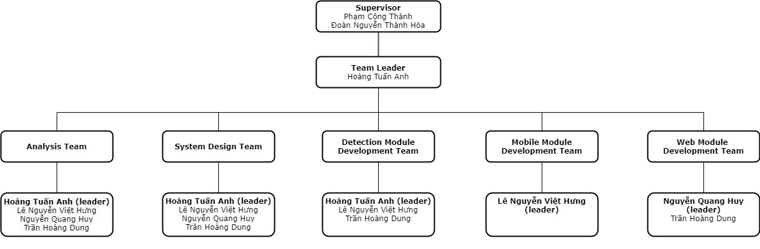

Figure . Team structures

### 4.2 Roles & Responsibilities

Table . Role & Responsibilities

|  |  |
| --- | --- |
| **Role** | **Responsibility** |
| Project Manager | * Specify user requirements. * Specify system’s features. * Support team in technical and business analysis. |
| Team Leader | * Plan projects and assign tasks to team members. * Support members to complete tasks on time. |
| Analysis Team | * Analyse user requirements and business rules. * Research other directions to promptly change and correct. |
| System Design Team | * Determine the appropriate architecture for the property of the project. * Outline the goals of the project. * Propose solutions to meet the given objectives. |
| Mobile Module Development Team | * Implement user interface. * Implement code for staff’s modules. |
| Web Module Development Team | * Implement user interface. * Implement code for management. |
| Detection Module Development Team | * Implement code for cracks detection. |

## 5. Project Communication

### 5.1 Communication Plan

Table . Communication plan

|  |  |  |  |  |
| --- | --- | --- | --- | --- |
| **Communication Item** | **Who/ Target** | **Purpose** | **When, Frequency** | **Type, Tool, Method(s)** |
| Working in group | Team members | * Improve group solidarity. * Members with good skills can train other members. * Discuss and work together to help each other | 4 days per week | Face to face, Online |
| Mentoring | Team members and Mentors | * Review team’s work progress. * Give advice and direction. * Technical support. | 3, 4 times per week | Face to face, Online |

### 5.2 External Interface

#### a. FU Contacts

Table . FU contacts

|  |  |  |  |
| --- | --- | --- | --- |
| **Function** | **Contact Person**  **(name, position)** | **Contact address**  **(email, telephone)** | **Responsibility** |
| Supervisor | Phạm Công Thành  Đoàn Nguyễn Thành Hòa |  | * Provide document template. * Give instruction to project team. * Review deliverables. * Supervise project status |

## 6. Configuration Management

### 6.1 Tools & Infrastructures

Table . Tools & Infrastructures

|  |  |
| --- | --- |
| **Programming languages** | **C#, Javascript, Dart, Python** |
| Framework | Entity Framework Core, VueJS, Flutter, Flask |
| API | Rest API |
| DBMS | MS SQL |
| IDEs/Editors | Visual Studio Code, Visual Studio |
| UML tools | Draw.io, StarUML |
| Version Control | Git |
| Deployment server | Azure Web Service |
| Project management tool | Trello |

### 6.2 Document Management

Use Google Shared Drives and Trello to manage easily.

### 6.3 Source Code Management

Use Git.

# III. Software Requirement Specification

## 1. Overall Description

### 1.1 Product Overview

For employers who want to speed up the detection of cracks in tall buildings, reduce the number of employees to hire and ensure worker safety, BCD is a system that connects with drone to find cracks on the surface of the building and record result information. The system also helps users easily statistics the number of cracks in an area, from which users can control as well as provide reasonable maintenance and upgrades.

### 1.2 Business Rules

Table . Business rules

|  |  |
| --- | --- |
| **ID** | **Rule Definition** |
| BR-01 | Password is encrypted before being sent to the server |
| BR-02 | Admin can only delete available users |
| BR-03 | Admin can only delete available areas |
| BR-04 | Admin can only delete available repairers |
| BR-05 | Admin can view all users in system |
| BR-06 | Admin can view all areas in system |
| BR-07 | Admin can view all cracks in system |
| BR-08 | Admin can view all repair records in system |
| BR-09 | Admin can view all repairers in system |
| BR-10 | Admin can view all detection results in system |
| BR-11 | Admin can view dashboard of all areas in system |
| BR-12 | Only admin can update the area(s) for manager |
| BR-13 | Admin can not delete area when it is being managed by staff or manager |
| BR-14 | Admin can not delete a user when this user has unfinished repair records |
| BR-15 | Admin can not assign area for staff |
| BR-16 | Manager can manage many staffs |
| BR-17 | Manager can only manage at most three areas and at least one area |
| BR-18 | Manager can only assign staff who does not have an area |
| BR-19 | Manager can only view areas that he/she manages |
| BR-20 | Manager can only view staff that he/she manages |
| BR-21 | Manager can only view the dashboard of his/her area |
| BR-22 | Manager can only view cracks of the areas that he/she manages |
| BR-23 | Manager can only view repair record of the areas that he/she manages |
| BR-24 | Manager can only view detection results of the areas that he/she manages |
| BR-25 | Manager can view all repairers in system |
| BR-26 | Manager can not log in to the system if has not been assigned area |
| BR-27 | Each staff can only manage one area |
| BR-28 | Each staff is managed by one manager |
| BR-29 | Staff can only view cracks of the area that he/she manages |
| BR-30 | Staff can only view repair record of the area that he/she manages |
| BR-31 | Staff can only view detection results of the area that he/she manages |
| BR-32 | Staff can view all repairers in system |
| BR-33 | Staff can not log in to the system if he/she has not been assigned area |
| BR-34 | Staff can only verify cracks belong to the area that he/she manages |
| BR-35 | Staff can only record repairs belong to the area that he/she manages |
| BR-36 | Staff can only evaluate repairs belong to the area that he/she manages |
| BR-37 | User can only view his/her own notifications |
| BR-38 | Each area is managed by one manager |
| BR-39 | Each area is managed by one staff |
| BR-40 | Area name has to be different |
| BR-41 | Password input must not be shown in plain text |
| BR-42 | The system must log out user from web application if current token information is not valid anymore |
| BR-43 | The system must log out user from mobile application if current token information is not valid anymore |
| BR-44 | Detection file's format must be .mp4 |
| BR-45 | Admin can not update role for manager and staff |
| BR-46 | Admin can not update area for staff |
| BR-47 | Repairer name has to be different |
| BR-48 | User can only view his/her own profile |
| BR-49 | User can only change his/her own password |
| BR-50 | Admin can delete all detect video after this repair has completed |
| BR-51 | Manager can delete detect video belong to the areas that he/she manages after this repair has completed |
| BR-52 | Default severity of unconfirmed crack is Medium |
| BR-53 | Severity High is auto pushed into queue |
| BR-54 | Staff can only update crack that has not recorded repair |
| BR-55 | Staff can only update crack that has been verified |
| BR-56 | Staff can only add crack that is not in queue to repair record queue |
| BR-57 | Staff can only add crack that has been verified to repair record queue |
| BR-58 | Staff can only update record repairs belong to the area that he/she manages |
| BR-59 | Staff can only reject cracks belong to the area that he/she manages |
| BR-60 | Staff can only import video belong to the area that he/she manages |
| BR-61 | Staff can not import duplicate video |
| BR-62 | The repair record which has been evaluated can not be updated |
| BR-63 | Crack which has severity is low can not be added to the queue |
| BR-64 | Staff can only remove cracks in his/her area out of queue |
| BR-65 | Crack which has severity is low can not be removed from queue |
| BR-66 | Repair time can only be before the current at most one month |
| BR-67 | Assessment result range is 0 - 100 |

## 2. User Requirements

### 2.1 Overview

#### a. Use Case Diagram

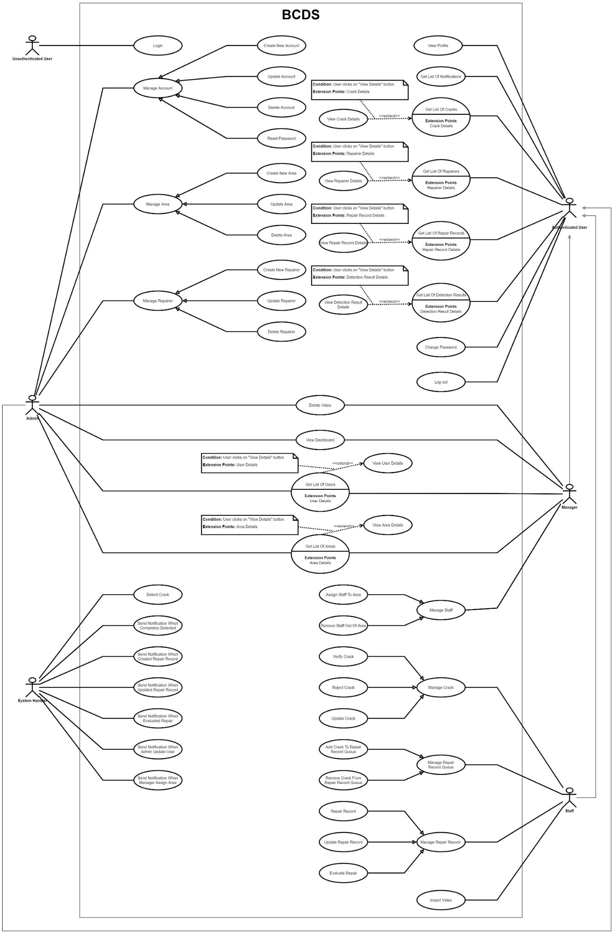

[Figure 3. Use Case diagram](https://drive.google.com/file/d/1DzUO8ADEfnz1m-1Vsuetqo2vzUktjJQP/view?usp=sharing)

#### b. System Actors

Table . System actors

|  |  |  |
| --- | --- | --- |
| **#** | **Actor** | **Description** |
| 1 | Unauthenticated User | A user who has not logged in to BCD |
| 2 | Admin | A user who has logged in to BCD system with role admin |
| 3 | Manager | A user who has logged in to BCD system with role manager |
| 4 | Staff | A user who has logged in to BCD system with role staff |
| 5 | System Handler | BCD system |
| 6 | Authenticated User | A user who has logged in to BCD system |

#### c. Use Cases List

Table . Web App use case list

|  |  |  |  |
| --- | --- | --- | --- |
| **ID** | **Use Case** | **Primary Actors** | **Secondary Actors** |
| UC01 | Login | Unauthenticated User |  |
| UC02 | Create New Account | Admin |  |
| UC03 | Update Account | Admin |  |
| UC04 | Delete Account | Admin |  |
| UC05 | Reset Password | Admin |  |
| UC06 | Create New Area | Admin |  |
| UC07 | Update Area | Admin |  |
| UC08 | Delete Area | Admin |  |
| UC09 | Create New Repairer | Admin |  |
| UC10 | Update Repairer | Admin |  |
| UC11 | Delete Repairer | Admin |  |
| UC12 | View Profile | Authenticated User |  |
| UC13 | Get List Of Notifications | Authenticated User |  |
| UC14 | Get List Of Cracks | Authenticated User |  |
| UC15 | View Crack Details | Authenticated User |  |
| UC16 | Get List Of Repair Records | Authenticated User |  |
| UC17 | View Repair Record Details | Authenticated User |  |
| UC18 | Get List Of Repairers | Authenticated User |  |
| UC19 | View Repairer Details | Authenticated User |  |
| UC20 | Get List Of Detection Results | Authenticated User |  |
| UC21 | View Detection Result Details | Authenticated User |  |
| UC22 | Change Password | Authenticated User |  |
| UC23 | Logout | Authenticated User |  |
| UC24 | Get List Of Areas | Admin, Manager |  |
| UC25 | View Area Details | Admin, Manager |  |
| UC26 | Get List Of Users | Admin, Manager |  |
| UC27 | View User Details | Admin, Manager |  |
| UC28 | View Dashboard | Admin, Manager |  |
| UC29 | Delete Video | Admin, Manager |  |
| UC30 | Assign Staff To Area | Manager |  |
| UC31 | Remove Staff Out Of Area | Manager |  |
| UC32 | Verify Crack | Staff |  |
| UC33 | Reject Crack | Staff |  |
| UC34 | Update Crack | Staff |  |
| UC35 | Add Crack To Repair Record Queue | Staff |  |
| UC36 | Remove Crack From Repair Record Queue | Staff |  |
| UC37 | Repair Record | Staff |  |
| UC38 | Update Repair Record | Staff |  |
| UC39 | Evaluate Repair | Staff |  |
| UC40 | Import Video | Staff |  |
| UC41 | Detect Crack | System Handler |  |
| UC42 | Send Notification When Completely Detected | System Handler |  |
| UC43 | Send Notification When Created Repair Record | System Handler |  |
| UC44 | Send Notification When Updated Repair Record | System Handler |  |
| UC45 | Send Notification When Evaluated Repair | System Handler |  |
| UC46 | Send Notification When Admin Update User | System Handler |  |
| UC47 | Send Notification When Manager Assign Area | System Handler |  |

### 2.2 UC01 - Login

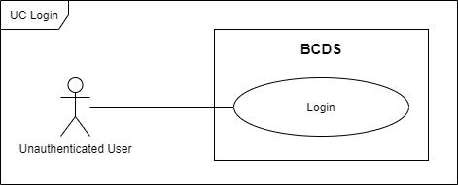

Figure . <Use Case> Login

Table . UC01 - Login

|  |  |  |  |
| --- | --- | --- | --- |
| ID and Name: | **UC-01 Login** | | |
| Created By: | HuyNQ | Date Created: | 19/02/2021 |
| Primary Actor: | Unauthenticated User | Secondary Actors: |  |
| Description: | An unauthenticated user logs in to BCDS. | | |
| Trigger: | An unauthenticated user sends a login command by clicking on “Login” button. | | |
| Preconditions: | PRE-1.User has an account.  PRE-2. User has not logged in to BCDS.  PRE-3. Current screen is “Login”. | | |
| Post-conditions: | POST-1:   * Success: User logins to BCDS with his/her role successfully and gets direct to “Dashboard” screen. * Fail: BCDS shows error message.   POST-2:   * Success: If this is a new user, BCDS will show “Change Password” popup for user update password and go to “Dashboard” screen. * Fail: BCDS shows error message. | | |
| Normal Flow: | **1.0 Login** (Exception 1.1.E1)   1. User goes to login view. It includes:  * Username: text input * Password: password input  1. User inputs Username and Password. 2. User clicks on “Login” button. 3. BCDS checks Username and Password. (Exception 1.0.E1) (Exception 1.0.E2) (Exception 1.0.E3) (Alternative 1.0) 4. BCDS generates token information and returns to client-side. 5. Client-side saves token information to local storage. 6. BCDS allows user to access with this account with his/her specific role. | | |
| Alternative Flows: | **1.0 User logins to BCDS the first time**   1. BCDS shows “Change Password” popup. It includes:  * New Password: password input * Confirm Password: password input  1. User inputs two fields above. 2. User clicks on “Confirm” button. (Exception 1.0.E2) (Exception 1.0.E3) 3. BCDS closes “Change Password” popup. | | |
| Exceptions: | **1.0.E1 User enters wrong identity information**   1. User inputs invalid Username and Password. 2. BCDS shows message MSG01.   **1.0.E2 Missing of required fields**   1. BCDS shows message MSG52.   **1.0.E3 Input’s length is larger than specified**   1. BCDS shows message MSG54.   **1.1.E1 Internet connection lost**   1. BCDS forwards to Lost Internet page. | | |
| Priority: | High | | |
| Frequency of Use: | Medium | | |
| Business Rules: | BR-01, BR-26, BR-33, BR- 41 | | |
| Other Information: | N/A | | |
| Assumptions: | N/A | | |

### 2.3 UC02 - Create New Account

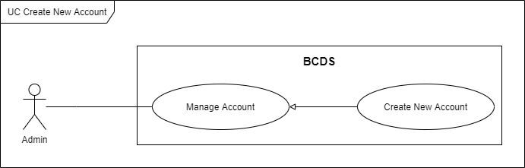

Figure . <Use Case> Create new account

Table . UC02 – Create new account

|  |  |  |  |
| --- | --- | --- | --- |
| ID and Name: | **UC-02 Create New Account** | | |
| Created By: | HuyNQ | Date Created: | 19/02/2021 |
| Primary Actor: | Admin | Secondary Actors: |  |
| Description: | An admin creates new account with role manager or staff. | | |
| Trigger: | An admin sends a create new account command by clicking on “New” button on “Users” screen. | | |
| Preconditions: | PRE-1. Admin has already logged in to BCDS.  PRE-2. Current screen is “Users”. | | |
| Post-conditions: | POST-1:   * Success: BCDS creates new account with role manager or staff and shows success messages. * Fail: BCDS shows error messages. | | |
| Normal Flow: | **2.0 Create new account** (Exception 2.1.E1)   1. Admin goes to manage users view and clicks on “New” button. 2. BCDS shows a popup with six fields. (Alternative 2.0) (Alternative 2.1) 3. Admin inputs information:  * Full Name: text input * Email: email input * Phone Number: number input * Role: dropdown list * Area: dropdown list * Address: text input  1. Admin clicks on “Create” button. 2. BCDS creates new account and shows message MSG03. (Exception 2.0.E1) (Exception 2.0.E2) (Exception 2.0.E3) (Exception 2.0.E4) | | |
| Alternative Flows: | **2.0 Admin cancels create new account**   1. Admin clicks on “Cancel” button. 2. BCDS closes popup.   **2.1 Admin choose “X” button**   1. User clicks on “X” button. 2. BCDS closes popup. | | |
| Exceptions: | **2.0.E1 Missing of required fields**   1. BCDS shows message MSG52.   **2.0.E2 Invalid inputs**   1. BCDS shows message MSG53.   **2.0.E3 Input’s length is larger than specified**   1. BCDS shows message MSG54.   **2.0.E4 Phone Number is not validate**   1. BCDS shows message MSG55.   **2.1.E1 Internet connection lost**   1. BCDS forwards to Lost Internet page. | | |
| Priority: | Medium | | |
| Frequency of Use: | Low | | |
| Business Rules: | BR-15, BR-17 | | |
| Other Information: | N/A | | |
| Assumptions: | N/A | | |

### 2.4 UC03 - Update Account

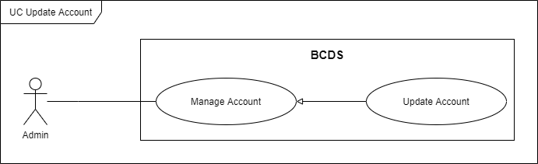

Figure . <Use Case> Update account

Table . UC03 – Update account

|  |  |  |  |
| --- | --- | --- | --- |
| ID and Name: | **UC-03 Update Account** | | |
| Created By: | HuyNQ | Date Created: | 19/02/2021 |
| Primary Actor: | Admin | Secondary Actors: |  |
| Description: | An admin requests to update an account’s information. | | |
| Trigger: | An admin sends an update account command by clicking on “Edit” button on “Users” screen. | | |
| Preconditions: | PRE-1. Admin has already logged in to BCDS.  PRE-2. Current screen is “Users”. | | |
| Post-conditions: | POST-1:   * Success: BCDS updates account’s information and shows success messages. * Fail: BCDS shows error messages. | | |
| Normal Flow: | **3.0. Update account** (Exception 3.1.E1)   1. Admin goes to manage user view and clicks on “Edit” button at corresponding user. 2. BCDS shows a popup with detailed information of this user. (Alternative 3.0) (Alternative 3.1) 3. Admin can edit information:  * User Name: text view * Full Name: text input * Email: email input * Phone Number: number input * Address: text input * Role: text view * Area: dropdown list  1. Admin clicks on “Update” button. 2. BCDS updates account’s information and shows message MSG05. (Exception 3.0.E1) (Exception 3.0.E2) | | |
| Alternative Flows: | **3.0 Admin cancels update account.**   1. Admin clicks on “Cancel” button. 2. BCDS closes popup.   **3.1 Admin choose “X” button**   1. Admin clicks on “X” button. 2. BCDS closes popup. | | |
| Exceptions: | **3.0.E1 Missing of required fields**   1. BCDS shows message MSG52.   **3.0.E2 Invalid inputs**   1. BCDS shows message MSG53.   **3.0.E3 Input’s length is larger than specified**   1. BCDS shows message MSG54.   **3.0.E4 Phone Number is not validate**   1. BCDS shows message MSG55.   **3.1.E1 Internet connection lost**   1. BCDS forwards to Lost Internet page. | | |
| Priority: | Medium | | |
| Frequency of Use: | Low | | |
| Business Rules: | BR-45, BR-46 | | |
| Other Information: | N/A | | |
| Assumptions: | N/A | | |

### 2.5 UC04 - Delete Account

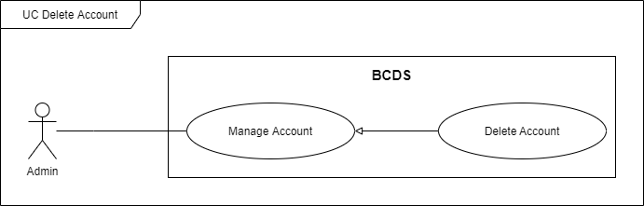

Figure . <Use Case> Delete account

Table . UC04 – Delete account

|  |  |  |  |
| --- | --- | --- | --- |
| ID and Name: | **UC-04 Delete Account** | | |
| Created By: | HuyNQ | Date Created: | 19/02/2021 |
| Primary Actor: | Admin | Secondary Actors: |  |
| Description: | An admin requests to delete an account. | | |
| Trigger: | An admin sends a delete account command by clicking on “Delete Account” button on “Users” screen. | | |
| Preconditions: | PRE-1. Admin has already logged in to BCDS.  PRE-2. Current screen is “Users”. | | |
| Post-conditions: | POST-1:   * Success: BCDS deletes account and shows success message. * Fail: BCDS shows error message. | | |
| Normal Flow: | **4.0 Delete** **account** (Exception 4.0.E1)   1. Admin goes to manage user view and clicks on “Delete Account” button at corresponding user. 2. BCDS shows confirm dialog. (Alternative 4.0) (Alternative 4.1) 3. Admin clicks on “Yes” button. 4. BCDS changes this account’s status isDel from False to True and shows message MSG09. | | |
| Alternative Flows: | **4.0 Admin choose “No” button**   1. Admin clicks on “No” button on confirm dialog. 2. BCDS closes dialog.   **4.1. Admin choose “X” button**   1. Admin clicks on “X” button on confirm dialog. 2. BCDS closes dialog. | | |
| Exceptions: | **4.0.E1 Internet connection lost**   1. BCDS forwards to Lost Internet page. | | |
| Priority: | Medium | | |
| Frequency of Use: | Low | | |
| Business Rules: | BR-02, BR-14 | | |
| Other Information: | N/A | | |
| Assumptions: | N/A | | |

### 2.6 UC05 - Reset Password

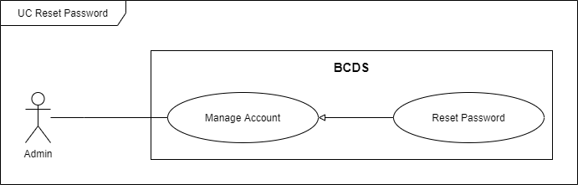

Figure . <Use Case> Reset password

Table . UC05 – Reset password

|  |  |  |  |
| --- | --- | --- | --- |
| ID and Name: | **UC-05 Reset Password** | | |
| Created By: | AnhHT | Date Created: | 19/02/2021 |
| Primary Actor: | Admin | Secondary Actors: |  |
| Description: | An admin requests to reset password of staffs/managers. | | |
| Trigger: | An admin sends reset password command by clicking on “Reset Password” button on “Users” screen. | | |
| Preconditions: | PRE-1. Admin has already logged in to BCDS.  PRE-2. Current screen is “Users”. | | |
| Post-conditions: | POST-1:   * Success: BCDS resets password and shows success messages. * Fail: BCDS shows error messages. | | |
| Normal Flow: | **5.0 Reset password** (Exception 5.0.E1)   1. Admin goes to manage user view and clicks on “Reset Password” button at corresponding user. 2. BCDS shows confirm dialog. (Alternative 5.0) (Alternative 5.1) 3. Admin clicks on “Yes” button. 4. BCDS reset this user’s password and shows message MSG07. | | |
| Alternative Flows: | **5.0 Admin choose “No” button**   1. Admin clicks on “No” button on confirm dialog. 2. BCDS closes dialog.   **5.1 Admin choose “X” button**   1. Admin clicks on “X” button on confirm dialog. 2. BCDS closes dialog. | | |
| Exceptions: | **5.0.E1 Internet connection lost**   1. BCDS forwards to Lost Internet page. | | |
| Priority: | Medium | | |
| Frequency of Use: | Low | | |
| Business Rules: | N/A | | |
| Other Information: | N/A | | |
| Assumptions: | N/A | | |

### 2.7 UC06 - Create New Area

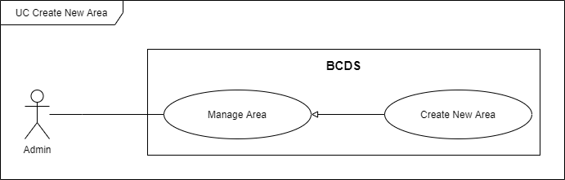

Figure . <Use Case> Create new area

Table . UC06 – Create new area

|  |  |  |  |
| --- | --- | --- | --- |
| ID and Name: | **UC-06 Create New Area** | | |
| Created By: | HuyNQ | Date Created: | 19/02/2021 |
| Primary Actor: | Admin | Secondary Actors: |  |
| Description: | An admin requests to create new area. | | |
| Trigger: | An admin sends a create new area command by clicking on “New” button on “Areas” screen. | | |
| Preconditions: | PRE-1. Admin has already logged in to BCDS.  PRE-2. Current screen is “Areas”. | | |
| Post-conditions: | POST-1:   * Success: BCDS creates new area and shows success messages. * Fail: BCDS shows error messages. | | |
| Normal Flow: | **6.0 Create new area** (Exception 6.1.E1)   1. Admin goes to manage areas view and clicks on “New” button. 2. BCDS shows a popup with two fields. (Alternative 6.0) (Alternative 6.1) 3. Admin inputs information:  * Area Name: text input * Description: text input  1. Admin clicks on “Create” button. 2. BCDS creates new area and shows message MSG11. (Exception 6.0.E1) (Exception 6.0.E2) | | |
| Alternative Flows: | **6.0 Admin cancel create new area**   1. Admin clicks on “Cancel” button. 2. BCDS closes popup.   **6.1 Admin choose “X” button**   1. Admin clicks on “X” button. 2. BCDS closes popup. | | |
| Exceptions: | **6.0.E1 Missing of required fields**   1. BCDS shows message MSG52.   **6.0.E2 Input’s length is larger than specified**   1. BCDS shows message MSG54.   **6.1.E1 Internet connection lost**   1. BCDS forwards to Lost Internet page. | | |
| Priority: | Medium | | |
| Frequency of Use: | Low | | |
| Business Rules: | BR-38, BR-39, BR-40 | | |
| Other Information: | N/A | | |
| Assumptions: | N/A | | |

### 2.8 UC07 - Update Area

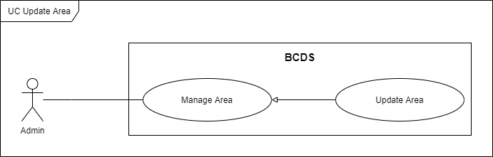

Figure . <Use Case> Update area

Table . UC07 – Update area

|  |  |  |  |
| --- | --- | --- | --- |
| ID and Name: | **UC-07 Update Area** | | |
| Created By: | HuyNQ | Date Created: | 19/02/2021 |
| Primary Actor: | Admin | Secondary Actors: |  |
| Description: | An admin requests to update area information. | | |
| Trigger: | An admin sends an update area command by clicking on “Edit” button on “Areas” screen. | | |
| Preconditions: | PRE-1. Admin has already logged in to BCDS.  PRE-2. Current screen is “Areas”. | | |
| Post-conditions: | POST-1:   * Success: BCDS updates area’s information and shows success messages. * Fail: BCDS shows error messages. | | |
| Normal Flow: | **7.0 Update area** (Exception 7.1.E1)   1. Admin goes to manage areas view and clicks on “Edit” button at corresponding area. 2. BCDS shows a popup with detailed information of this area. (Alternative 7.0) (Alternative 7.1) 3. Admin can edit information:  * Area Name: text input * Description: text input * Created Date: datetime view * Last Modified: datetime view  1. Admin clicks on “Save” button. 2. BCDS updates area’s information and shows message MSG13. (Exception 7.0.E1) (Exception 7.0.E2) | | |
| Alternative Flows: | **7.0 Admin cancel update area**   1. Admin clicks on “Cancel” button. 2. BCDS closes popup.   **7.1. Admin choose “X” button**   1. Admin clicks on “X” button. 2. BCDS closes popup. | | |
| Exceptions: | **7.0.E1 Missing of required fields**   1. BCDS shows message MSG52.   **7.0.E2 Input’s length is larger than specified**   1. BCDS shows message MSG54.   **7.1.E1 Internet connection lost**   1. BCDS forwards to Lost Internet page. | | |
| Priority: | Medium | | |
| Frequency of Use: | Low | | |
| Business Rules: | BR-40 | | |
| Other Information: | N/A | | |
| Assumptions: | N/A | | |

### 2.9 UC08 - Delete Area

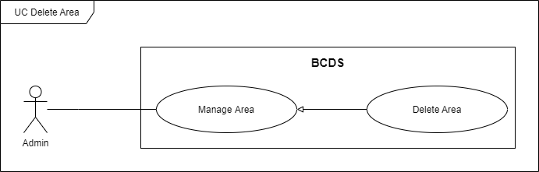

Figure . <Use Case> Delete area

Table . UC08 – Delete area

|  |  |  |  |
| --- | --- | --- | --- |
| ID and Name: | **UC-8 Delete Area** | | |
| Created By: | HuyNQ | Date Created: | 19/02/2021 |
| Primary Actor: | Admin | Secondary Actors: |  |
| Description: | An admin requests to delete an area. | | |
| Trigger: | An admin sends a delete an area command by clicking on “Delete Area” button on “Areas” screen. | | |
| Preconditions: | PRE-1. Admin has already logged in to BCDS.  PRE-2. Current screen is “Areas”. | | |
| Post-conditions: | POST-1:   * Success: BCDS deletes area and shows success message. * Fail: BCDS shows error message. | | |
| Normal Flow: | **8.0 Delete** **area** (Exception 8.0.E1)   1. Admin goes to manage areas view and clicks on “Delete Area” button at corresponding area. 2. BCDS shows confirm dialog. (Alternative 8.0) (Alternative 8.1) 3. User clicks on “Yes” button. 4. BCDS changes this area’s status isDel from False to True and shows message MSG15. | | |
|  | **8.0. Admin choose “No” button**   1. Admin clicks on “No” button on confirm dialog. 2. BCDS closes dialog.   **8.1. Admin choose “X” button**   1. Admin clicks on “X” button on confirm dialog. 2. BCDS closes dialog. | | |
| Exceptions: | **8.0.E1 Internet connection lost**   1. BCDS forwards to Lost Internet page. | | |
| Priority: | Medium | | |
| Frequency of Use: | Low | | |
| Business Rules: | BR-03, BR-13 | | |
| Other Information: | N/A | | |
| Assumptions: | N/A | | |

### 2.10 UC09 - Create New Repairer

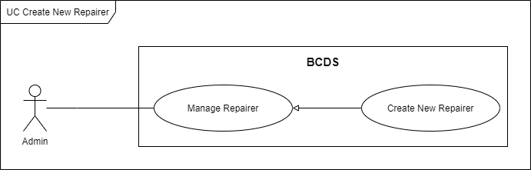

Figure . <Use Case> Create new repairer

Table . UC – Create new repairer

|  |  |  |  |
| --- | --- | --- | --- |
| ID and Name: | **UC-9 Create New Repairer** | | |
| Created By: | HuyNQ | Date Created: | 19/02/2021 |
| Primary Actor: | Admin | Secondary Actors: |  |
| Description: | An admin requests to create new repairer. | | |
| Trigger: | An admin sends a create new repairer command by clicking on “New” button on “Repairers” screen. | | |
| Preconditions: | PRE-1. Admin has already logged in to BCDS.  PRE-2. Current screen is “Repairers”. | | |
| Post-conditions: | POST-1:   * Success: BCDS creates new repairer and shows success messages. * Fail: BCDS shows error messages. | | |
| Normal Flow: | **9.0 Create new repairer** (Exception 9.1.E1)   1. Admin goes to manage repairer view and clicks on “New” button. 2. BCDS shows a popup with four fields. (Alternative 9.0) (Alternative 9.1) 3. Admin inputs information.  * Name: text input * Phone Number: number input * Address: text input * Email: email input  1. Admin clicks on “Create” button. 2. BCDS creates new repairer and shows message MSG17. (Exception 9.0.E1) (Exception 9.0.E2) (Exception 9.0.E3) (Exception 9.0.E4) | | |
| Alternative Flows: | **9.0 Admin cancels create new repairer**   1. Admin clicks on “Cancel” button. 2. BCDS closes popup.   **9.1 Admin choose “X” button**   1. Admin clicks on “X” button. 2. BCDS closes popup. | | |
| Exceptions: | **9.0.E1 Missing of required fields**   1. BCDS shows message MSG52.   **9.0.E2 Invalid inputs**   1. BCDS shows message MSG53.   **9.0.E3 Input’s length is larger than specified**   1. BCDS shows message MSG54.   **9.0.E4 Phone Number is not validate**   1. BCDS shows message MSG55.   **9.1.E1 Internet connection lost**   1. BCDS forwards to Lost Internet page. | | |
| Priority: | Medium | | |
| Frequency of Use: | Low | | |
| Business Rules: | BR-47 | | |
| Other Information: | N/A | | |
| Assumptions: | N/A | | |

### 2.11 UC10 - Update Repairer

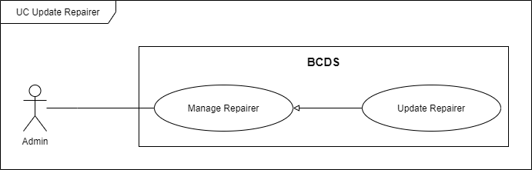

Figure . <Use Case> Update repairer

Table . UC10 – Update repairer

|  |  |  |  |
| --- | --- | --- | --- |
| ID and Name: | **UC-10 Update Repairer** | | |
| Created By: | HuyNQ | Date Created: | 19/02/2021 |
| Primary Actor: | Admin | Secondary Actors: |  |
| Description: | An admin requests to update repairer’s information. | | |
| Trigger: | An admin sends an update repairer command by clicking on “Edit” button on “Repairers” screen. | | |
| Preconditions: | PRE-1. Admin has already logged in to BCDS.  PRE-2. Current screen is “Repairers”. | | |
| Post-conditions: | POST-1:   * Success: BCDS updates repairer’s information and shows success messages. * Fail: BCDS shows error messages. | | |
| Normal Flow: | **10.0 Update repairer** (Exception 10.1.E1)   1. Admin goes to manage repairer view and clicks on “Edit” button at corresponding repairer. 2. BCDS shows a popup with detailed information of this repairer. (Alternative 10.0) (Alternative 10.1) 3. Admin can edit information:  * Name: text input * Phone Number: number input * Address: text input * Email: email input * Created Date: datetime view * Last Modified: datetime view  1. Admin clicks on “Save” button. 2. BCDS updates repairer’s information and shows message MSG19. (Exception 10.0.E1) (Exception 10.0.E2) (Exception 10.0.E3) (Exception 10.0.E4) | | |
| Alternative Flows: | **10.0 Admin cancel update repairer**   1. Admin clicks on “Cancel” button. 2. BCDS closes popup.   **10.1 Admin choose “X” button**   1. Admin clicks on “X” button. 2. BCDS closes popup. | | |
| Exceptions: | **10.0.E1 Missing of required fields**   1. BCDS shows message MSG52.   **10.0.E2 Invalid inputs**   1. BCDS shows message MSG53.   **10.0.E3 Input’s length is larger than specified**   1. BCDS shows message MSG54.   **10.0.E4 Phone Number is not validate**   1. BCDS shows message MSG55.   **10.1.E1 Internet connection lost**   1. BCDS forwards to Lost Internet page. | | |
| Priority: | Medium | | |
| Frequency of Use: | Low | | |
| Business Rules: |  | | |
| Other Information: | N/A | | |
| Assumptions: | N/A | | |

### 2.12 UC11 - Delete Repairer

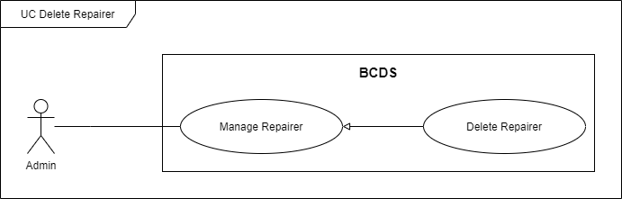

Figure . <Use Case> Delete repairer

Table . UC11 – Delete repairer

|  |  |  |  |
| --- | --- | --- | --- |
| ID and Name: | **UC-11 Delete** **Repairer** | | |
| Created By: | HuyNQ | Date Created: | 19/02/2021 |
| Primary Actor: | Admin | Secondary Actors: |  |
| Description: | An admin requests to delete a repairer. | | |
| Trigger: | An admin sends a delete a repairer command by clicking on “Delete” button on “Repairers” screen. | | |
| Preconditions: | PRE-1. Admin has already logged in to BCDS.  PRE-2. Current screen is “Repairers”. | | |
| Post-conditions: | POST-1:   * Success: BCDS deletes repairer and shows success messages. * Fail: BCDS shows error messages. | | |
| Normal Flow: | **11.0 Delete** **repairer** (Exception 11.0.E1)   1. Admin goes to manage repairer view and clicks on “Delete” button at corresponding repairer. 2. BCDS shows confirm dialog. (Alternative 11.0) (Alternative 11.1) 3. Admin clicks on “Yes” button. 4. BCDS changes this repairer’s status isDel from False to True and shows message MSG21. | | |
| Alternative Flows: | **11.0 Admin chooses “No” button**   1. Admin clicks on “No” button on confirm dialog. 2. BCDS closes dialog.   **11.1 Admin chooses “X” button**   1. Admin clicks on “X” button on confirm dialog. 2. BCDS closes dialog. | | |
| Exceptions: | **11.0.E1 Internet connection lost**   1. BCDS forwards to Lost Internet page. | | |
| Priority: | Medium | | |
| Frequency of Use: | Low | | |
| Business Rules: | BR-04 | | |
| Other Information: | N/A | | |
| Assumptions: | N/A | | |

### 2.13 UC12 - View Profile

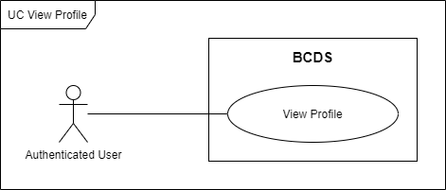

Figure . <Use Case> View profile

Table . UC12 – View profile

|  |  |  |  |
| --- | --- | --- | --- |
| ID and Name: | **UC-12 View Profile** | | |
| Created By: | HuyNQ | Date Created: | 19/02/2021 |
| Primary Actor: | Authenticated User | Secondary Actors: |  |
| Description: | An authenticated user requests to view own profile. | | |
| Trigger: | An authenticated user sends a view profile command by clicking on “Profile” button on top navigator’s dropdown. | | |
| Preconditions: | PRE-1. An authenticated user has already logged in to BCDS. | | |
| Post-conditions: | POST-1:   * Success: BCDS shows this user’s profile. * Fail: BCDS shows error messages. | | |
| Normal Flow: | **12.0 View profile** (Exception 12.0.E1)   1. An authenticated user clicks on “Profile” button on top navigator’s dropdown. 2. BCDS shows this user’s profile. | | |
| Alternative Flows: | N/A | | |
| Exceptions: | **12.0.E1 Internet connection lost**   1. BCDS forwards to Lost Internet page. | | |
| Priority: | Low | | |
| Frequency of Use: | Low | | |
| Business Rules: | BR-48 | | |
| Other Information: | N/A | | |
| Assumptions: | N/A | | |

### 2.14 UC13 - Get List Of Notifications

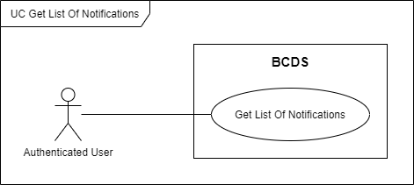

Figure . <Use Case> Get list of notifications

Table . UC13 - Get list of notifications

|  |  |  |  |
| --- | --- | --- | --- |
| ID and Name: | **UC-13 Get List Of Notifications** | | |
| Created By: | HuyNQ | Date Created: | 19/02/2021 |
| Primary Actor: | Authenticated User | Secondary Actors: |  |
| Description: | An authenticated user requests to get a list of notifications. | | |
| Trigger: | An authenticated user sends a get list of notifications command by clicking on “Notifications” button on top navigator’s dropdown. | | |
| Preconditions: | PRE-1. An authenticated user has already logged in to BCDS. | | |
| Post-conditions: | POST-1:   * Success: BCDS shows list of notifications. * Fail: BCDS shows error messages. | | |
| Normal Flow: | **13.0 Get** **list of notifications** (Exception 13.0.E1) (Alternative 13.0)   1. An authenticated user clicks on “Notifications” button on top navigator’s dropdown. 2. BCDS shows list of notifications. | | |
| Alternative Flows: | **13.0 User chooses “See all” button**   1. An authenticated user chooses “See all” button on top navigator’s notification dropdown. 2. BCDS shows list of notifications. | | |
| Exceptions: | **13.0.E1 Internet connection lost**   1. BCDS forwards to Lost Internet page. | | |
| Priority: | Medium | | |
| Frequency of Use: | Medium | | |
| Business Rules: | BR-37 | | |
| Other Information: | N/A | | |
| Assumptions: | N/A | | |

### 2.15 UC14 - Get List Of Cracks

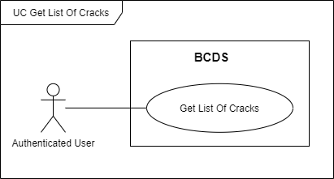

Figure . <Use Case> Get list of cracks

Table . UC14 - Get list of cracks

|  |  |  |  |
| --- | --- | --- | --- |
| ID and Name: | **UC-14 Get List Of Cracks** | | |
| Created By: | AnhHT | Date Created: | 19/02/2021 |
| Primary Actor: | Authenticated User | Secondary Actors: |  |
| Description: | An authenticated user requests to get a list of cracks. | | |
| Trigger: | An authenticated user sends a get list of cracks command by clicking on “Cracks” button on the left sidebar. | | |
| Preconditions: | PRE-1. An authenticated user has already logged in to BCDS. | | |
| Post-conditions: | POST-1:   * Success: BCDS shows list of cracks. * Fail: BCDS shows error messages. | | |
| Normal Flow: | **14.0 Get** **list of cracks** (Exception 14.0.E1) (Alternative 14.0)   1. An authenticated user clicks on “Cracks” button on the left sidebar. 2. BCDS shows list of cracks. | | |
| Alternative Flows: | **14.0 User views list of cracks on “Repair Records” page** (Exception 14.0.E1)   1. An authenticated user goes to “Repair Records” page. 2. Choose one record then click on dropdown button. 3. BCDS shows list cracks. | | |
| Exceptions: | **14.0.E1 Internet connection lost**   1. BCDS forwards to Lost Internet page. | | |
| Priority: | High | | |
| Frequency of Use: | High | | |
| Business Rules: | BR-07, BR-22, BR-29 | | |
| Other Information: | N/A | | |
| Assumptions: | N/A | | |

### 2.16 UC15 - View Crack Details

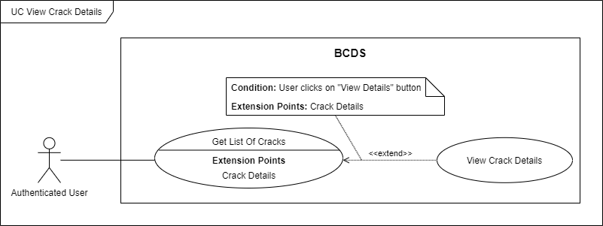

Figure . <Use Case> View crack details

Table . UC15 - View crack details

|  |  |  |  |
| --- | --- | --- | --- |
| ID and Name: | **UC-15 View Crack Details** | | |
| Created By: | AnhHT | Date Created: | 19/02/2021 |
| Primary Actor: | Authenticated User | Secondary Actors: |  |
| Description: | An authenticated user requests to view crack details. | | |
| Trigger: | An authenticated user sends a view crack details command by clicking on “View Crack Details” button on “Cracks” screen. | | |
| Preconditions: | PRE-1. An authenticated user has already logged in to BCDS.  PRE-2. Current screen is “Cracks”. | | |
| Post-conditions: | POST-1:   * Success: BCDS shows crack details. * Fail: BCDS shows error messages. | | |
| Normal Flow: | **15.0 View crack details** (Exception 15.0.E1) (Alternative 15.0)   1. Admin goes to manage cracks view and clicks on “View Crack Details” button at corresponding crack. 2. BCDS shows crack’s detail information. | | |
| Alternative Flows: | **15.0 User view crack details on  “Repair Records” page** (Exception 15.0.E1)   1. An authenticated user goes to “Repair Records” page. 2. Choose one record then click on dropdown button. 3. BCDS shows list of cracks. 4. User clicks on “View Crack Details” button at corresponding crack. 5. BCDS shows crack’s detail information. | | |
| Exceptions: | **15.0.E1 Internet connection lost**   1. BCDS forwards to Lost Internet page. | | |
| Priority: | Medium | | |
| Frequency of Use: | Medium | | |
| Business Rules: | BR-07, BR-22, BR-29 | | |
| Other Information: | N/A | | |
| Assumptions: | N/A | | |

### 2.17 UC16 - Get List Of Repair Records

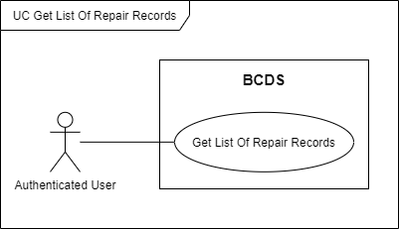

Figure . <Use Case> Get list of repair records

Table . UC16 – Get list of repair records

|  |  |  |  |
| --- | --- | --- | --- |
| ID and Name: | **UC-16 Get List Of Repair Records** | | |
| Created By: | AnhHT | Date Created: | 19/02/2021 |
| Primary Actor: | Authenticated User | Secondary Actors: |  |
| Description: | An authenticated user requests to get list of repair records. | | |
| Trigger: | An authenticated user sends a get list of repair records command by clicking on “Repair Records” button on the left sidebar. | | |
| Preconditions: | PRE-1. An authenticated user has already logged in to BCDS. | | |
| Post-conditions: | POST-1:   * Success: BCDS shows list of repair records. * Fail: BCDS shows error messages. | | |
| Normal Flow: | **16.0 Get list of repair records** (Exception 16.0.E1)   1. An authenticated user clicks on “Repair Records” button on the left sidebar. 2. BCDS shows list of repair records. | | |
| Alternative Flows: | N/A | | |
| Exceptions: | **16.0.E1 Internet connection lost**   1. BCDS forwards to Lost Internet page. | | |
| Priority: | High | | |
| Frequency of Use: | High | | |
| Business Rules: | BR-08, BR-23, BR-35 | | |
| Other Information: | N/A | | |
| Assumptions: | N/A | | |

### 2.18 UC17 - View Repair Record Details

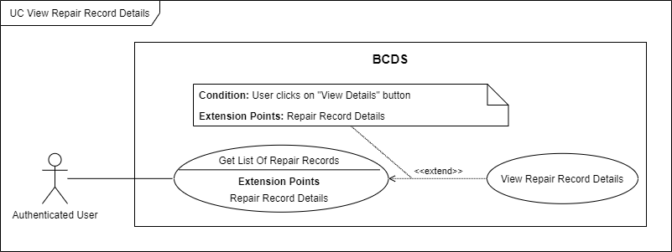

Figure . <Use Case> View repair record details

Table . UC17 – View repair record details

|  |  |  |  |
| --- | --- | --- | --- |
| ID and Name: | **UC-17 View Repair Record Details** | | |
| Created By: | AnhHT | Date Created: | 19/02/2021 |
| Primary Actor: | Authenticated User | Secondary Actors: |  |
| Description: | An authenticated user requests to view repair record details. | | |
| Trigger: | An authenticated user sends a view repair record details command by clicking on “View Record Details” button on “Repair Records” screen. | | |
| Preconditions: | PRE-1. An authenticated user has already logged in to BCDS.  PRE-2. Current screen is “Repair Records”. | | |
| Post-conditions: | POST-1:   * Success: BCDS shows repair record details. * Fail: BCDS shows error messages. | | |
| Normal Flow: | **17.0 View repair record** **details** (Exception 17.0.E1)   1. Admin goes to manage repair record view and clicks on “View Record Details” button at corresponding repair record. 2. BCDS shows repair record’s details information. | | |
| Alternative Flows: | N/A | | |
| Exceptions: | **17.0.E1 Internet connection lost**   1. BCDS forwards to Lost Internet page. | | |
| Priority: | Medium | | |
| Frequency of Use: | Medium | | |
| Business Rules: | BR-08, BR-23, BR-35 | | |
| Other Information: | N/A | | |
| Assumptions: | N/A | | |

### 2.19 UC18 - Get List Of Repairers

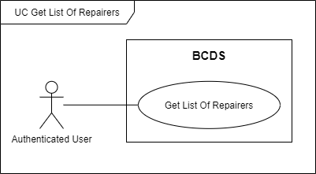

Figure . <Use Case> Get list of repairers

Table . UC18 – Get list of repairers

|  |  |  |  |
| --- | --- | --- | --- |
| ID and Name: | **UC-18 Get List Of Repairers** | | |
| Created By: | DungTH | Date Created: | 20/02/2021 |
| Primary Actor: | Authenticated User | Secondary Actors: |  |
| Description: | An authenticated user requests to get list of repairers. | | |
| Trigger: | An authenticated user sends a get list of repairers command by clicking on “Repairers” button on the left sidebar. | | |
| Preconditions: | PRE-1. An authenticated user has already logged in to BCDS. | | |
| Post-conditions: | POST-1:   * Success: BCDS shows list of repairers. * Fail: BCDS shows error messages. | | |
| Normal Flow: | **18.0 Get list of repairers** (Exception 18.0.E1)   1. An authenticated user clicks on “Repairers” button on the left sidebar. 2. BCDS shows list of repairers. | | |
| Alternative Flows: | N/A | | |
| Exceptions: | **18.0.E1 Internet connection lost**   1. BCDS forwards to Lost Internet page. | | |
| Priority: | Medium | | |
| Frequency of Use: | Medium | | |
| Business Rules: | BR-09, BR-25, BR-32 | | |
| Other Information: | N/A | | |
| Assumptions: | N/A | | |

### 2.20 UC19 - View Repairer Details

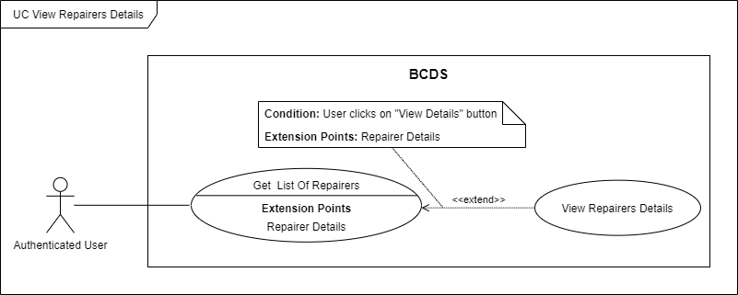

Figure . <Use Case> View repairer details

Table . UC19 – View repairer details

|  |  |  |  |
| --- | --- | --- | --- |
| ID and Name: | **UC-19 View Repairer Details** | | |
| Created By: | DungTH | Date Created: | 20/02/2021 |
| Primary Actor: | Authenticated User | Secondary Actors: |  |
| Description: | An authenticated user requests to view repairer details. | | |
| Trigger: | An authenticated user sends a view repairer details command by clicking on “View Details” button on “Repair Records” screen. | | |
| Preconditions: | PRE-1. An authenticated user has already logged in to BCDS.  PRE-2. Current screen is “Repairers”. | | |
| Post-conditions: | POST-1:   * Success: BCDS shows repairer details. * Fail: BCDS shows error messages. | | |
| Normal Flow: | **19.0 View repairer** **details** (Exception 19.0.E1)   1. An authenticated user goes to repairers view and clicks on “View Details” button at corresponding repairer. 2. BCDS shows repairer’s detail information. | | |
| Alternative Flows: | N/A | | |
| Exceptions: | **19.0.E1 Internet connection lost**   1. BCDS forwards to Lost Internet page. | | |
| Priority: | Medium | | |
| Frequency of Use: | Low | | |
| Business Rules: | BR-09, BR-25, BR-32 | | |
| Other Information: | N/A | | |
| Assumptions: | N/A | | |

### 2.21 UC20 - Get List Of Detection Results

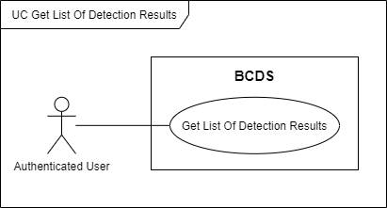

Figure . <Use Case> Get list of detection results

Table . UC20 – Get list of detection results

|  |  |  |  |
| --- | --- | --- | --- |
| ID and Name: | **UC-20 Get List Of Detection Results** | | |
| Created By: | DungTH | Date Created: | 20/02/2021 |
| Primary Actor: | Authenticated User | Secondary Actors: |  |
| Description: | An authenticated user requests to get list of detection results. | | |
| Trigger: | An authenticated user sends a get list of detection results command by clicking on “Detection Results” button on the left sidebar. | | |
| Preconditions: | PRE-1. An authenticated user has already logged in to BCDS. | | |
| Post-conditions: | POST-1:   * Success: BCDS shows list of detection results. * Fail: BCDS shows error messages. | | |
| Normal Flow: | **20.0. Get list of detection results** (Exception 20.0.E1)   1. An authenticated user clicks on “Detection Results” button on the left sidebar. 2. BCDS shows list of detection results. | | |
| Alternative Flows: | N/A | | |
| Exceptions: | **20.0.E1 Internet connection lost**   1. BCDS forwards to Lost Internet page. | | |
| Priority: | High | | |
| Frequency of Use: | High | | |
| Business Rules: | BR-10, BR-24, BR-31 | | |
| Other Information: | N/A | | |
| Assumptions: | N/A | | |

### 2.22 UC21 - View Detection Result Details

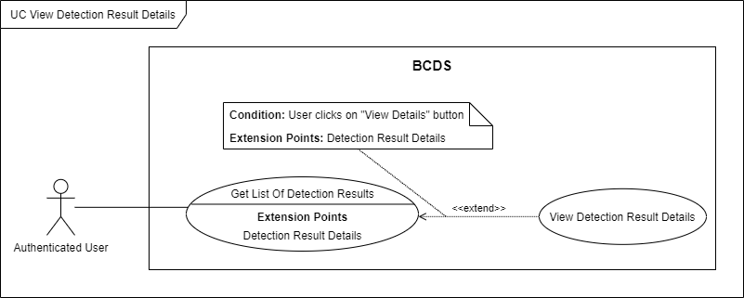

Figure . <Use Case> View detection result details

Table . UC21 – View detection result details

|  |  |  |  |
| --- | --- | --- | --- |
| ID and Name: | **UC-21 View Detection Result Details** | | |
| Created By: | DungTH | Date Created: | 20/02/2021 |
| Primary Actor: | Authenticated User | Secondary Actors: |  |
| Description: | An authenticated user requests to view detection result details. | | |
| Trigger: | An authenticated user sends a view detection result details command by clicking on “View Details” button on “Detection Results” screen. | | |
| Preconditions: | PRE-1. An authenticated user has already logged in to BCDS.  PRE-2. Current screen is “Detection Results”. | | |
| Post-conditions: | POST-1:   * Success: BCDS shows detection result details. * Fail: BCDS shows error messages. | | |
| Normal Flow: | **21.0. View detection result** **details** (Exception 21.0.E1)   1. An authenticated user goes to manage detection results view and clicks on “View Details” button at corresponding detection result. 2. BCDS shows detection result’s detail information. | | |
| Alternative Flows: | N/A | | |
| Exceptions: | **21.0.E1 Internet connection lost**   1. BCDS forwards to Lost Internet page. | | |
| Priority: | High | | |
| Frequency of Use: | High | | |
| Business Rules: | BR-10, BR-24, BR-31 | | |
| Other Information: | N/A | | |
| Assumptions: | N/A | | |

### 2.23 UC22 - Change Password

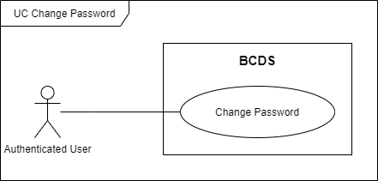

Figure . <Use Case> Change password

Table . UC22 – Change password

|  |  |  |  |
| --- | --- | --- | --- |
| ID and Name: | **UC-22 Change Password** | | |
| Created By: | HungLNV | Date Created: | 19/02/2021 |
| Primary Actor: | Authenticated User | Secondary Actors: |  |
| Description: | An authenticated user requests to change his/her account’s password | | |
| Trigger: | An authenticated user sends a change password command by going to “Profile” screen, input old password and new password then choose “Change” button. | | |
| Preconditions: | PRE-1. An authenticated user has already logged in to BCDS.  PRE-2. Current screen is “Profile”. | | |
| Post-conditions: | POST-1:   * Success: BCDS changes user’s password and shows success message. * Fail: BCDS shows error messages. | | |
| Normal Flow: | **22.0. Change password** (Exception 22.1.E1)   1. An authenticated user goes to profile view. 2. User inputs three fields include:  * Old Password: password input * New Password: password input * Confirm New Password: password input  1. User clicks on “Change” button. (Exception 22.0.E1) (Exception 22.0.E2) (Exception 22.0.E3) 2. BCDS changes user’s password and shows MSG45. | | |
| Alternative Flows: | N/A | | |
| Exceptions: | **22.0.E1 Missing of required fields**   1. BCDS shows message MSG52.   **22.0.E2 Input’s length is larger than specified**   1. BCDS shows message MSG54.   **22.0.E3 Password is invalid**   1. BCDS show message MSG56.   **22.1.E1 Internet connection lost**   1. BCDS forwards to Lost Internet page. | | |
| Priority: | Medium | | |
| Frequency of Use: | Low | | |
| Business Rules: | BR-01, BR- 41, BR-49 | | |
| Other Information: | N/A | | |
| Assumptions: | N/A | | |

### 2.24 UC23 – Logout

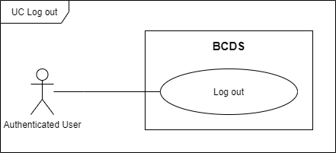

Figure . <Use Case> Logout

Table . UC23 - Logout

|  |  |  |  |
| --- | --- | --- | --- |
| ID and Name: | **UC-23 Logout** | | |
| Created By: | HungLNV | Date Created: | 19/02/2021 |
| Primary Actor: | Authenticated User | Secondary Actors: |  |
| Description: | An authenticated user requests to log out of the BCDS. | | |
| Trigger: | An authenticated user sends a logout command by clicking on “Logout” button. | | |
| Preconditions: | PRE-1.An authenticated user has already logged in to BCDS. | | |
| Post-conditions: | POST-1: User’s token information is removed from local storage.  POST-2: Screen “Login” will be shown. | | |
| Normal Flow: | **23.0 Logout** (Exception 23.0.E1)   1. User clicks on “Logout” button. 2. BCDS removes user’s token information and navigates user to “Login” screen. | | |
| Alternative Flows: | N/A | | |
| Exceptions: | **23.0.E1 Internet connection lost**   1. BCDS forwards to Lost Internet page. | | |
| Priority: | Medium | | |
| Frequency of Use: | Medium | | |
| Business Rules: | BR-42 | | |
| Other Information: | N/A | | |
| Assumptions: | N/A | | |

### 2.25 UC24 - Get List Of Areas

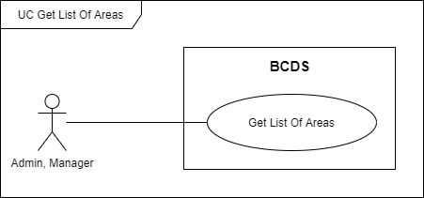

Figure . <Use Case> Get list of areas

Table . UC24 – Get list of areas

|  |  |  |  |
| --- | --- | --- | --- |
| ID and Name: | **UC-24 Get List Of Areas** | | |
| Created By: | DungTH | Date Created: | 19/02/2021 |
| Primary Actor: | Admin, Manager | Secondary Actors: |  |
| Description: | Admin/Manager requests to get list of areas. | | |
| Trigger: | Admin/Manager sends a get list of areas command by clicking on “Areas” button on the left sidebar. | | |
| Preconditions: | PRE-1. Admin/Manager has already logged in to BCDS. | | |
| Post-conditions: | POST-1:   * Success: BCDS shows list of areas. * Fail: BCDS shows error messages. | | |
| Normal Flow: | **24.0 Get list of area** (Exception 24.0.E1)   1. Admin/Manager clicks on “Areas” button on the left sidebar. 2. BCDS shows list of areas. | | |
| Alternative Flows: | N/A | | |
| Exceptions: | **24.0.E1 Internet connection lost**   1. BCDS forwards to Lost Internet page. | | |
| Priority: | Medium | | |
| Frequency of Use: | High | | |
| Business Rules: | BR-06, BR-19 | | |
| Other Information: | N/A | | |
| Assumptions: | N/A | | |

### 2.26 UC25 - View Area Details

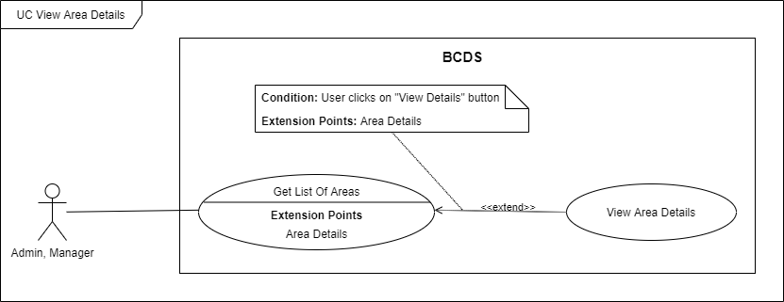

Figure . <Use Case> View area details

Table . UC25 – View area details

|  |  |  |  |
| --- | --- | --- | --- |
| ID and Name: | **UC-25 View Area Details** | | |
| Created By: | DungTH | Date Created: | 20/02/2021 |
| Primary Actor: | Admin, Manager | Secondary Actors: |  |
| Description: | Admin/Manager requests to view area details. | | |
| Trigger: | Admin/Manager sends a view area details command by clicking on “View Area Details” button on “Areas” screen. | | |
| Preconditions: | PRE-1. Admin/Manager has already logged in to BCDS.  PRE-2. Current screen is “Areas”. | | |
| Post-conditions: | POST-1:   * Success: BCDS shows repair record details. * Fail: BCDS shows error messages. | | |
| Normal Flow: | **25.0 View area** **details** (Exception 25.0.E1)   1. Admin/Manager goes to manage area view and clicks on “View Area Details” button at corresponding area. 2. BCDS shows area’s detail information. | | |
| Alternative Flows: | N/A | | |
| Exceptions: | **25.0.E1 Internet connection lost**   1. BCDS forwards to Lost Internet page. | | |
| Priority: | Medium | | |
| Frequency of Use: | Medium | | |
| Business Rules: | BR-06, BR-19 | | |
| Other Information: | N/A | | |
| Assumptions: | N/A | | |

### 2.27 UC26 - Get List Of Users

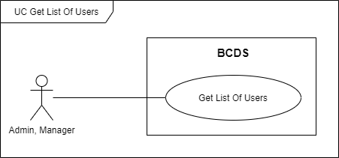

Figure . <Use Case> Get list of users

Table . UC26 – Get list of users

|  |  |  |  |
| --- | --- | --- | --- |
| ID and Name: | **UC-26 Get List Of Users** | | |
| Created By: | DungTH | Date Created: | 19/02/2021 |
| Primary Actor: | Admin, Manager | Secondary Actors: |  |
| Description: | Admin/Manager requests to get list of users. | | |
| Trigger: | Admin/Manager sends a get list of users command by clicking on “Users” button on the left sidebar. | | |
| Preconditions: | PRE-1. Admin/Manager has already logged in to BCDS. | | |
| Post-conditions: | POST-1:   * Success: BCDS shows list of users. * Fail: BCDS shows error messages. | | |
| Normal Flow: | **26.0 Get list of users** (Exception 26.0.E1)   1. Admin/Manager clicks on “Users” button on the left sidebar. 2. BCDS shows list of users. | | |
| Alternative Flows: | N/A | | |
| Exceptions: | **26.0.E1 Internet connection lost**   1. BCDS forwards to Lost Internet page. | | |
| Priority: | Medium | | |
| Frequency of Use: | Medium | | |
| Business Rules: | BR-05, BR-20 | | |
| Other Information: | N/A | | |
| Assumptions: | N/A | | |

### 2.28 UC27 - View User Details

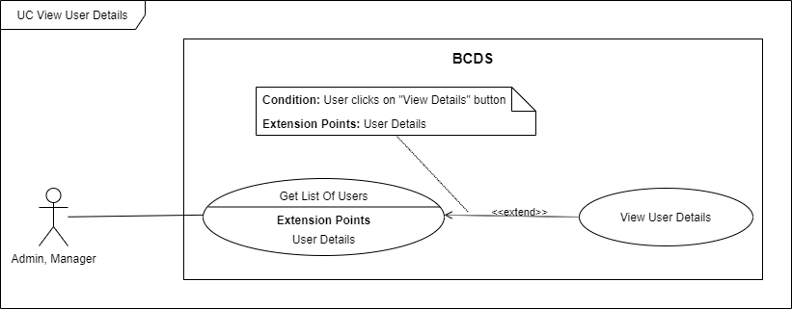

Figure . <Use Case> View user details

Table . UC27 – View user details

|  |  |  |  |
| --- | --- | --- | --- |
| ID and Name: | **UC-27 View User Details** | | |
| Created By: | DungTH | Date Created: | 20/02/2021 |
| Primary Actor: | Admin, Manager | Secondary Actors: |  |
| Description: | Admin/Manager requests to view user details. | | |
| Trigger: | Admin/Manager sends a view user details command by clicking on “View User Details” button on “Users” screen. | | |
| Preconditions: | PRE-1. Admin/Manager has already logged in to BCDS.  PRE-2. Current screen is “Users”. | | |
| Post-conditions: | POST-1:   * Success: BCDS shows user details. * Fail: BCDS shows error messages. | | |
| Normal Flow: | **27.0 View user** **details** (Exception 27.0.E1)   1. Admin/Manager goes to manage user view and clicks on “View User Details” button at corresponding user. 2. BCDS shows user’s detail information. | | |
| Alternative Flows: | N/A | | |
| Exceptions: | **27.0.E1 Internet connection lost**   1. BCDS forwards to Lost Internet page. | | |
| Priority: | Medium | | |
| Frequency of Use: | Medium | | |
| Business Rules: | BR-05, BR-20 | | |
| Other Information: | N/A | | |
| Assumptions: | N/A | | |

### 2.29 UC28 - View Dashboard

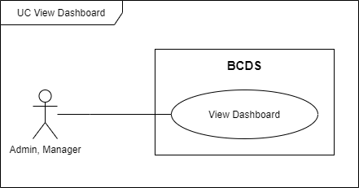

Figure . <Use Case> View dashboard

Table . UC28 – View dashboard

|  |  |  |  |
| --- | --- | --- | --- |
| ID and Name: | **UC-28 View Dashboard** | | |
| Created By: | DungTH | Date Created: | 21/02/2021 |
| Primary Actor: | Admin, Manager | Secondary Actors: |  |
| Description: | Admin/Manager requests to view dashboard. | | |
| Trigger: | Admin/Manager sends a view dashboard command by clicking on “Dashboard” button on the left sidebar. | | |
| Preconditions: | PRE-1. Admin/Manager has already logged in to BCDS. | | |
| Post-conditions: | POST-1:   * Success: BCDS shows dashboard. * Fail: BCDS shows error messages. | | |
| Normal Flow: | **28.0 View dashboard** (Exception 28.0.E1)   1. Admin/Manager clicks on “Dashboard” button on the left sidebar. 2. BCDS shows dashboard. | | |
| Alternative Flows: | N/A | | |
| Exceptions: | **28.0.E1 Internet connection lost**   1. BCDS forwards to Lost Internet page. | | |
| Priority: | Medium | | |
| Frequency of Use: | Medium | | |
| Business Rules: | BR-11, BR-21 | | |
| Other Information: | N/A | | |
| Assumptions: | N/A | | |

### 2.30 UC29 - Delete Video

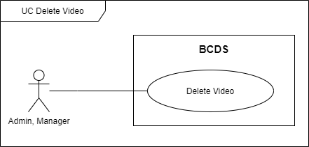

Figure . <Use Case> Delete video

Table . UC29 – Delete video

|  |  |  |  |
| --- | --- | --- | --- |
| ID and Name: | **UC-29 Delete Video** | | |
| Created By: | DungTH | Date Created: | 19/02/2021 |
| Primary Actor: | Admin, Manager | Secondary Actors: |  |
| Description: | Admin, Manager requests to delete video. | | |
| Trigger: | Admin/Manager sends a delete video command by clicking on “Delete Video” button on “Detection Results” screen. | | |
| Preconditions: | PRE-1. Admin/Manager has already logged in to BCDS.  PRE-2. Current screen is “Detection Results”. | | |
| Post-conditions: | POST-1:   * Success: BCDS deletes video and shows success messages. * Fail: BCDS shows error messages. | | |
| Normal Flow: | **29.0 Delete video** (Exception 29.0.E1)   1. Admin/Manager goes to manage detection results view and clicks on “Delete Video” button at corresponding detection results. 2. BCDS shows confirm dialog. (Alternative 29.0) (Alternative 29.1) 3. Admin/Manager clicks on “Yes” button. BCDS deletes this video and show message MSG41. | | |
| Alternative Flows: | **29.0 Admin chooses “No” button**   1. Admin clicks on “No” button on confirm dialog. 2. BCDS closes dialog.   **29.1 Admin clicks outside**   1. Admin clicks outside of confirm dialog. 2. BCDS closes dialog. | | |
| Exceptions: | **29.0.E1 Internet connection lost**   1. BCDS forwards to Lost Internet page. | | |
| Priority: | High | | |
| Frequency of Use: | Medium | | |
| Business Rules: | BR-50, BR-51 | | |
| Other Information: | N/A | | |
| Assumptions: | N/A | | |

### 2.31 UC30 - Assign Staff To Area

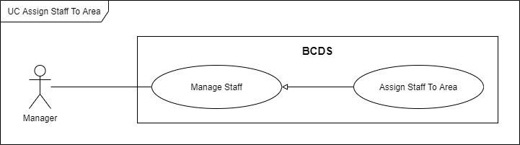

Figure . <Use Case> Assign staff to area

Table . UC30 – Assign staff to area

|  |  |  |  |
| --- | --- | --- | --- |
| ID and Name: | **UC-30 Assign Staff To Area** | | |
| Created By: | HungLNV | Date Created: | 20/02/2021 |
| Primary Actor: | Manager | Secondary Actors: |  |
| Description: | A manager requests to assign staff to area. | | |
| Trigger: | A manager sends an assign staff to area command by choosing an area then clicking on “Update Area” button on “Staffs” screen. | | |
| Preconditions: | PRE-1. Manager has already logged in to BCDS.  PRE-2. Current screen is “Staffs”. | | |
| Post-conditions: | POST-1:   * Success: BCDS update staff’s area and shows success messages. * Fail: BCDS shows error messages. | | |
| Normal Flow: | **30.0. Assign staff to area** (Exception 30.0.E1)   1. Manager goes to staffs view and chooses one staff. 2. BCDS shows staff’s information popup. (Alternative 33.0) (Alternative 30.1) 3. Manager chooses one area for staff. 4. Click on “Update Area” button. 5. BCDS update staff’s area and shows message MSG62. | | |
| Alternative Flows: | **30.0 Manager chooses “Cancel” button**   1. Manager clicks on “Cancel” button. 2. BCDS closes popup.   **30.1 Manager chooses “X” button**   1. Manager clicks on “Cancel” button. 2. BCDS closes popup. | | |
| Exceptions: | **30.0.E1 Internet connection lost**   1. BCDS forwards to Lost Internet page. | | |
| Priority: | Medium | | |
| Frequency of Use: | Medium | | |
| Business Rules: | BR-18, BR-27 | | |
| Other Information: | N/A | | |
| Assumptions: | N/A | | |

### 2.32 UC31 - Remove Staff Out Of Area

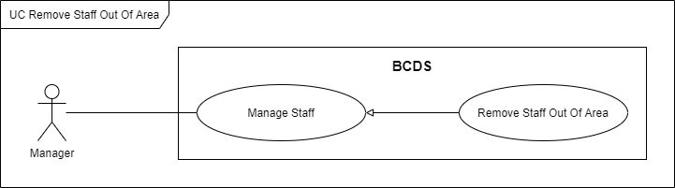

Figure . <Use Case> Remove staff out of area

Table . UC31 – Remove staff out of area

|  |  |  |  |
| --- | --- | --- | --- |
| ID and Name: | **UC-31 Remove Staff Out Of Area** | | |
| Created By: | HungLNV | Date Created: | 19/02/2021 |
| Primary Actor: | Manager | Secondary Actors: |  |
| Description: | A manager requests to remove staff out of area. | | |
| Trigger: | A manager sends a remove staff out of area command by choosing an area then clicking on “Update Area” button on “Staffs” screen. | | |
| Preconditions: | PRE-1. Manager has already logged in to BCDS.  PRE-2. Current screen is “Staffs”. | | |
| Post-conditions: | POST-1:   * Success: BCDS remove staff’s area and shows success messages. * Fail: BCDS shows error messages. | | |
| Normal Flow: | **31.0 Remove staff out of area** (Exception 31.0.E1)   1. Manager goes to staffs view and chooses one staff. 2. BCDS shows staff’s information popup. (Alternative 31.0) (Alternative 31.1) 3. Manager chooses <<No Area>>. 4. Click on “Update Area” button 5. BCDS update staff’s area and shows message MSG62. | | |
| Alternative Flows: | **31.0 Manager chooses “Cancel” button**   1. Manager clicks on “Cancel” button. 2. BCDS closes popup.   **31.1 Manager chooses “X” button**   1. Manager clicks on “X” button. 2. BCDS closes popup. | | |
| Exceptions: | **31.0.E1 Internet connection lost**   1. BCDS forwards to Lost Internet page. | | |
| Priority: | Medium | | |
| Frequency of Use: | Low | | |
| Business Rules: |  | | |
| Other Information: | N/A | | |
| Assumptions: | N/A | | |

### 2.33 UC32 - Verify Crack

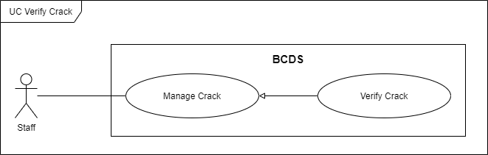

Figure . <Use Case> Verify crack

Table . UC32 – Verify crack

|  |  |  |  |
| --- | --- | --- | --- |
| ID and Name: | **UC-32 Verify Crack** | | |
| Created By: | DungTH | Date Created: | 20/02/2021 |
| Primary Actor: | Staff | Secondary Actors: |  |
| Description: | A staff requests to verify crack | | |
| Trigger: | A staff sends a verify crack command by clicking on “Confirm” and input information in popup. | | |
| Preconditions: | PRE-1. Staff has already logged in to BCDS.  PRE-2. Current screen is “Detection Result Details”. | | |
| Post-conditions: | POST-1:   * Success: BCDS changes this crack’s status from “Unconfirmed” to “Unrecorded” and shows success messages. * Fail: BCDS shows error messages. | | |
| Normal Flow: | **32.0. Verify crack** (Exception 32.1.E1)   1. Staff goes to detection result details view and clicks on “Confirm” button at corresponding crack. 2. BCDS shows a popup include: (Alternative 32.0) (Alternative 32.1)  * Position: text input * Description: text input * Severity: radio button  1. Staff inputs information then chooses “Confirm” button. (Exception 32.0.E1) (Exception 32.0.E2) 2. BCDS changes this crack’s status from “Unconfirmed” to “Unrecorded” and show MSG23. | | |
| Alternative Flows: | **32.0 Staff chooses “Cancel” button**   1. Staff clicks on “Cancel” button. 2. BCDS closes popup.   **32.1 Staff clicks outside of popup**   1. Staff clicks outside of popup. 2. BCDS closes popup. | | |
| Exceptions: | **32.0.E1 Missing of required fields**   1. BCDS shows message MSG52.   **32.0.E2 Input’s length is larger than specified**   1. BCDS shows message MSG54.   **32.1.E1 Internet connection lost**   1. BCDS forwards to Lost Internet page. | | |
| Priority: | High | | |
| Frequency of Use: | High | | |
| Business Rules: | BR-34, BR-52 | | |
| Other Information: | N/A | | |
| Assumptions: | N/A | | |

### 2.34 UC33 - Reject Crack

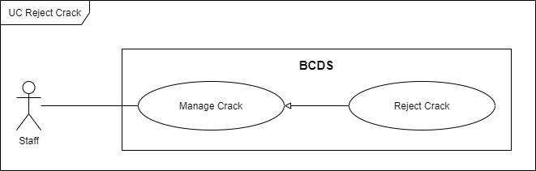

Figure . <Use Case> Reject crack

Table . UC33 – Reject crack

|  |  |  |  |
| --- | --- | --- | --- |
| ID and Name: | **UC-33 Reject Crack** | | |
| Created By: | HungLNV | Date Created: | 19/02/2021 |
| Primary Actor: | Staff | Secondary Actors: |  |
| Description: | A staff requests to reject crack | | |
| Trigger: | A staff sends a reject crack command by clicking on “Reject”. | | |
| Preconditions: | PRE-1. Staff has already logged in to BCDS.  PRE-2. Current screen is “Detection Result Details”. | | |
| Post-conditions: | POST-1:   * Success: BCDS changes this crack’s status from “Unconfirmed” to “DetectFailed” and shows success messages. * Fail: BCDS shows error messages. | | |
| Normal Flow: | **33.0. Reject crack** (Exception 33.0.E1)   1. Staff goes to detection result details view and clicks on “Reject” button at corresponding crack. 2. BCDS shows a confirm dialog. 3. Staff choose “Yes” button. 4. BCDS changes this crack’s status from “Unconfirmed” to “DetectFailed” and show MSG27. | | |
| Alternative Flows: | **33.0 Staff chooses “Cancel” button**   1. Staff clicks on “Cancel” button. 2. BCDS closes dialog.   **33.1 Staff clicks outside of dialog**   1. Staff clicks outside of dialog. 2. BCDS closes dialog. | | |
| Exceptions: | **33.0.E1 Internet connection lost**   1. BCDS forwards to Lost Internet page. | | |
| Priority: | High | | |
| Frequency of Use: | Medium | | |
| Business Rules: | BR-59 | | |
| Other Information: | N/A | | |
| Assumptions: | N/A | | |

### 2.35 UC34 - Update Crack

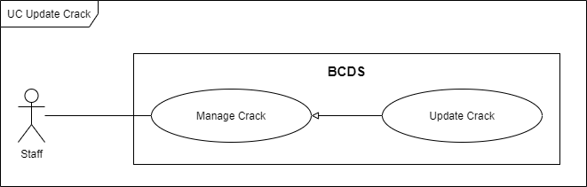

Figure . <Use Case> Update crack

Table . UC34 – Update crack

|  |  |  |  |
| --- | --- | --- | --- |
| ID and Name: | **UC-34 Update Crack** | | |
| Created By: | DungTH | Date Created: | 19/02/2021 |
| Primary Actor: | Staff | Secondary Actors: |  |
| Description: | A staff requests to update crack’s information. | | |
| Trigger: | A staff sends an update crack command by clicking on “Update Crack” button on “Cracks” screen. | | |
| Preconditions: | PRE-1. Staff has already logged in to BCDS.  PRE-2. Current screen is “Cracks”. | | |
| Post-conditions: | POST-1:   * Success: BCDS updates crack’s information and shows success messages. * Fail: BCDS shows error messages. | | |
| Normal Flow: | **34.0 Update crack** (Exception 34.1.E1) (Alternative 34.0)   1. Staff goes to cracks view then clicks on “Update Crack” button. 2. BCDS shows a popup with cracks’ information: (Alternative 34.1) (Alternative 34.2)  * Position: text input * Description: text input * Severity: radio button  1. Staff changes crack’s information then chooses “Update” button. (Exception 34.0.E1) (Exception 34.0.E2) 2. BCDS updates crack information and show message MSG25. | | |
| Alternative Flows: | **34.0 Staff updates crack on “Detection Result Details” screen** (Exception 34.1.E1)   1. Staff goes to detection result details view then chooses tab “Verified Cracks”. 2. BCDS shows list of verified cracks. 3. Staff clicks on “Update Crack” button on the corresponding crack. 4. BCDS shows a popup with cracks’ information: (Alternative 34.1) (Alternative 34.2)  * Position: text input * Description: text input * Severity: radio button  1. Staff changes crack’s information then chooses “Update” button. (Exception 34.0.E1) (Exception 34.0.E2) 2. BCDS updates crack information and show message MSG25.   **34.1 Staff cancels update crack**   1. Staff clicks on “Cancel” button. 2. BCDS closes popup.   **34.2 Staff clicks outside of popup**   1. User clicks outside of popup. 2. BCDS closes popup. | | |
| Exceptions: | **34.0.E1 Missing of required fields**   1. BCDS shows message MSG52.   **33.0.E2 Input’s length is larger than specified**   1. BCDS shows message MSG54.   **34.1.E1 Internet connection lost**   1. BCDS forwards to Lost Internet page. | | |
| Priority: | Medium | | |
| Frequency of Use: | Medium | | |
| Business Rules: | BR-54 | | |
| Other Information: | N/A | | |
| Assumptions: | N/A | | |

### 2.36 UC35 - Add Crack To Repair Record Queue

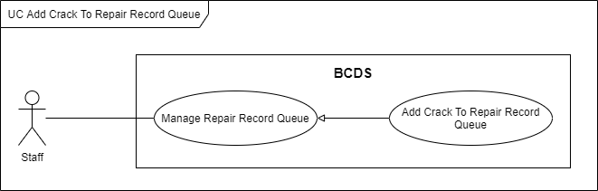

Figure . <Use Case> Add crack to repair record queue

Table . UC35 – Add crack to repair record queue

|  |  |  |  |
| --- | --- | --- | --- |
| ID and Name: | **UC-35 Add Crack To Repair Record Queue** | | |
| Created By: | HungLNV | Date Created: | 19/02/2021 |
| Primary Actor: | Staff | Secondary Actors: |  |
| Description: | A staff requests to add crack to repair record queue. | | |
| Trigger: | Trigger 1: A staff sends an add crack to repair record queue command by choosing “Add to queue” button on corresponding crack.  Trigger 2: Crack’s severity is High. | | |
| Preconditions: | PRE-1: Staff has already logged in to BCDS.  PRE-2: Current screen is “Crack”.  PRE-3: Current tab is “Verify”. | | |
| Post-conditions: | POST-1:   * Success: BCDS adds chosen cracks to repair record queue and shows success message. * Fail: BCDS shows error messages. | | |
| Normal Flow: | **35.0 Add crack to repair record queue** (Exception 35.0.E1) (Alternative 35.0)   1. Staff goes to tab “Verify” on “Crack” screen. 2. Staff chooses “Add to queue” button on corresponding crack. 3. BCDS adds chosen cracks to repair record queue and shows message MSG29. | | |
| Alternative Flows: | **35.0 Add crack from “Repair Record” screen**   1. Staff goes to tab “Unrecorded” on “Repair” screen. 2. Staff clicks on “Add” button on corresponding crack. 3. BCDS adds chosen cracks to repair record queue and shows message MSG29. | | |
| Exceptions: | **35.0.E1 Internet connection lost**   1. BCDS forwards to Lost Internet page. | | |
| Priority: | High | | |
| Frequency of Use: | High | | |
| Business Rules: | BR-35, BR-56, BR-57, BR-63 | | |
| Other Information: | N/A | | |
| Assumptions: | N/A | | |

### 2.37 UC36 - Remove Crack From Repair Record Queue

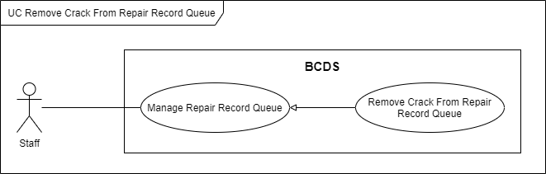

Figure . <Use Case> Remove crack from repair record queue

Table . UC36. Remove crack from repair record queue

|  |  |  |  |
| --- | --- | --- | --- |
| ID and Name: | **UC-36 Remove Crack From Record Repair Queue** | | |
| Created By: | HungLNV | Date Created: | 19/02/2021 |
| Primary Actor: | Staff | Secondary Actors: |  |
| Description: | A staff requests to remove crack from record repair queue. | | |
| Trigger: | Trigger 1: A staff sends a remove crack from record repair queue command by choosing cracks and clicking on “Remove” button.  Trigger 2: Crack’s severity is Low. | | |
| Preconditions: | PRE-1: Staff has already logged in to BCDS.  PRE-2: Current screen is “Repair”.  PRE-3: Current tab is “Queue”. | | |
| Post-conditions: | POST-1:   * Success: BCDS removes chosen cracks out of record repair queue and shows success message. * Fail: BCDS shows error messages. | | |
| Normal Flow: | **36.0 Remove crack from record repair queue** (Exception 36.0.E1)   1. Staff goes to tab “Queue” on “Repair” screen then clicks on “Remove” button. 2. BCDS shows a bottom sheet with a list of cracks in queue. 3. Staff checks to cracks that want to remove then clicks on “Remove” button. 4. BCDS removes chosen cracks from record repair and shows message MSG31. | | |
| Alternative Flows: | N/A | | |
| Exceptions: | **36.0.E1 Internet connection lost**   1. BCDS forwards to Lost Internet page. | | |
| Priority: | Medium | | |
| Frequency of Use: | Low | | |
| Business Rules: | BR-64, BR-65 | | |
| Other Information: | N/A | | |
| Assumptions: | N/A | | |

### 2.38 UC37 - Repair Record

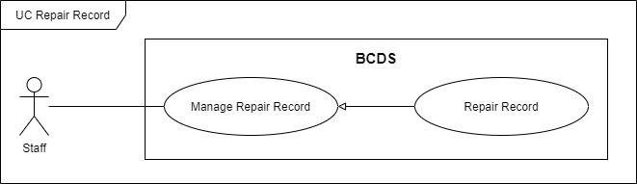

Figure . <Use Case> Repair record

Table . UC37 – Repair record

|  |  |  |  |
| --- | --- | --- | --- |
| ID and Name: | **UC-37 Repair Record** | | |
| Created By: | HungLNV | Date Created: | 19/02/2021 |
| Primary Actor: | Staff | Secondary Actors: |  |
| Description: | A staff requests to record repair. | | |
| Trigger: | A staff sends a record repair command by going to tab “Queue” on screen “Repair”, input information then choose “Record Repair” button. | | |
| Preconditions: | PRE-1: Staff has already logged in to BCDS.  PRE-2: Current screen is “Repair”.  PRE-3: Current tab is “Queue”. | | |
| Post-conditions: | POST-1:   * Success: BCDS creates repair record and shows success message. * Fail: BCDS shows error messages. | | |
| Normal Flow: | **37.0 Repair record** (Exception 37.1.E1)   1. Staff goes to tab “Queue” on “Repair” screen. 2. Staff inputs information, includes:  * Expense: number input * Date: date input * Time: time input * Repairer: dropdown list  1. Staff chooses “Record Repair” button. (Exception 37.0.E1) (Exception 37.0.E2) 2. BCDS creates repair record and shows message MSG33. | | |
| Alternative Flows: | N/A | | |
| Exceptions: | **37.0.E1 Missing of required fields**   1. BCDS shows message MSG52.   **37.0.E2 Input’s length is larger than specified**   1. Staff can not continue input.   **37.1.E1 Internet connection lost**   1. BCDS forwards to Lost Internet page. | | |
| Priority: | High | | |
| Frequency of Use: | High | | |
| Business Rules: | BR-35, BR-66 | | |
| Other Information: | N/A | | |
| Assumptions: | N/A | | |

### 2.39 UC38 - Update Repair Record

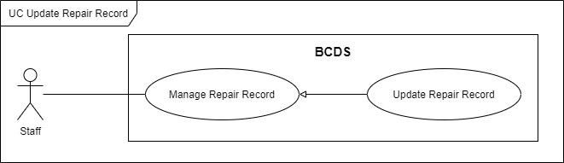

Figure . <Use Case> Update repair record

Table . UC38 – Update repair record

|  |  |  |  |
| --- | --- | --- | --- |
| ID and Name: | **UC-38 Update Repair Record** | | |
| Created By: | HungLNV | Date Created: | 19/02/2021 |
| Primary Actor: | Staff | Secondary Actors: |  |
| Description: | A staff requests to update repair record. | | |
| Trigger: | A staff sends an update repair record command by choosing a repair record, change information then click on “Update” button. | | |
| Preconditions: | PRE-1: Staff has already logged in to BCDS.  PRE-2: Current screen is “Repair”.  PRE-3: Current tab is “Repair”. | | |
| Post-conditions: | POST-1:   * Success: BCDS update repair record’s information and shows success message. * Fail: BCDS shows error messages. | | |
| Normal Flow: | **38.0 Update repair record** (Exception 38.1.E1)   1. Staff goes to tab “Repair” on “Repair” screen. 2. Chooses one repair record. 3. BCDS navigates to “Repair Record Detail” screen. It includes:  * Expense: number input * Date: date input * Time: time input * Repairer: dropdown list  1. Staff changes information then chooses “Update” button. (Exception 38.0.E1) (Exception 38.0.E2) 2. BCDS updates information and shows message MSG35. | | |
| Alternative Flows: |  | | |
| Exceptions: | **38.0.E1 Missing of required fields**   1. BCDS shows message MSG52.   **38.0.E2 Input’s length is larger than specified**   1. Staff can not continue input.   **38.0.E1 Internet connection lost**   1. BCDS forwards to Lost Internet page. | | |
| Priority: | High | | |
| Frequency of Use: | Medium | | |
| Business Rules: | BR-58, BR-62, BR-66 | | |
| Other Information: | N/A | | |
| Assumptions: | N/A | | |

### 2.40 UC39 - Evaluate Repair

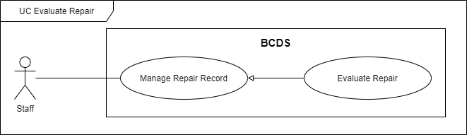

Figure . <Use Case> Evaluate repair

Table . UC39 – Evaluate repair

|  |  |  |  |
| --- | --- | --- | --- |
| ID and Name: | **UC-39 Evaluate Repair** | | |
| Created By: | HungLNV | Date Created: | 19/02/2021 |
| Primary Actor: | Staff | Secondary Actors: |  |
| Description: | A staff requests to evaluate repair. | | |
| Trigger: | A staff sends an evaluate repair command by evaluating all cracks in a repair record, evaluate this repair then choose “Evaluate” button. | | |
| Preconditions: | PRE-1: Staff has already logged in to BCDS.  PRE-2: Current screen is “Repair Record Detail”. | | |
| Post-conditions: | POST-1:   * Success: BCDS saves evaluation information and shows success message. * Fail: BCDS shows error messages. | | |
| Normal Flow: | **39.0 Evaluate repair** (Exception 39.1.E1)   1. Staff goes to “Repair Record Detail” screen. It includes the evaluation list of cracks in the repair record, each evaluation of crack includes:  * Rating: rating bar  1. Staff inputs evaluation information and clicks on “Not yet” button to change status from “Not yet” to “Done” for each crack, then chooses “Next” button. (Exception 39.0.E1) 2. BCDS goes to “Repair Evaluation” screen. It includes:  * RepairRecordId: textview * Repairer: textview * Repairing Date: datetime view * Rating Average: number view * Description: text input  1. Staff inputs information then clicks on “Confirm” button. 2. BCDS records this evaluation, navigates to “History” screen and shows message MSG39. | | |
| Alternative Flows: | N/A | | |
| Exceptions: | **39.0.E1 Not evaluate all cracks**   1. Staff does not evaluate all cracks then clicks on “Next” button. 2. BCDS shows message MSG38.   **39.1.E1 Internet connection lost**   1. BCDS forwards to Lost Internet page. | | |
| Priority: | High | | |
| Frequency of Use: | Medium | | |
| Business Rules: | BR-36, BR-67 | | |
| Other Information: | N/A | | |
| Assumptions: | N/A | | |

### 2.41 UC40 – Import Video

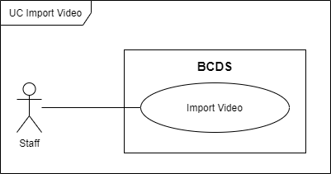

Figure . <Use Case> Import video

Table . UC40 – Import video

|  |  |  |  |
| --- | --- | --- | --- |
| ID and Name: | **UC-40 Import Video** | | |
| Created By: | HungLNV | Date Created: | 19/02/2021 |
| Primary Actor: | Staff | Secondary Actors: |  |
| Description: | A staff requests to import video. | | |
| Trigger: | A staff sends an import video command by choosing a video. | | |
| Preconditions: | PRE-1: Staff has already logged in to BCDS.  PRE-2: Current screen is “Detection Results”. | | |
| Post-conditions: | POST-1:   * Success: BCDS imports this chosen video. * Fail: BCDS shows error messages. | | |
| Normal Flow: | **40.0 Import video**   1. Staff goes to “Detection Results” screen. 2. Staff clicks on “Choose File” button. 3. A choose file popup is shown. (Alternative 40.0) (Alternative 40.1) 4. Choosing a video in area that he/she manages then clicks “Open” button. (Exception 40.0.E1) (Exception 40.0.E2) 5. BCDS imports this video and shows video’s information. | | |
| Alternative Flows: | **40.0 Staff chooses “Cancel” button**   1. Staff chooses “Cancel” button. 2. Choose file popup is closed.   **40.1 Staff chooses “X” button**   1. Staff chooses “X” button. 2. Choose file popup is closed. | | |
| Exceptions: | **40.0.E1 Input wrong file format**   1. BCDS shows message MSG60   **40.0.E2 Input video is existed**   1. BCDS shows message MSG51 | | |
| Priority: | High | | |
| Frequency of Use: | High | | |
| Business Rules: | BR-44, BR-60, BR-61 | | |
| Other Information: | N/A | | |
| Assumptions: | N/A | | |

### 2.42 UC41 - Detect Crack

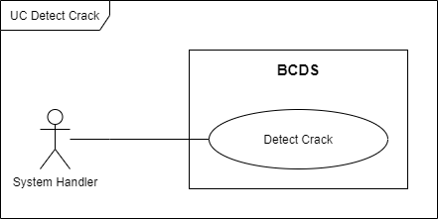

Figure . <Use Case> Detect crack

Table . UC41 – Detect crack

|  |  |  |  |
| --- | --- | --- | --- |
| ID and Name: | **UC-41 Detect Cracks** | | |
| Created By: | AnhHT | Date Created: | 19/02/2021 |
| Primary Actor: | System Handler | Secondary Actors: |  |
| Description: | A staff inputs a video shot by drone and sends a detection request, then Detection module will detect this video and shows list of detected cracks. | | |
| Trigger: | Staff sends a detect cracks command by importing video and clicking on “Detect” button. | | |
| Preconditions: | PRE-1: Staff has already logged in to BCDS.  PRE-2: Current screen is “Detection Results”. | | |
| Post-conditions: | POST-1:   * Success: BCDS shows list of detected cracks and success message. * Failed: BCDS show error message. | | |
| Normal Flow: | **41.0  Detect cracks** (Exception 41.1.E1)   1. Staff goes to “Detection Results” screen. 2. Click on “Choose File” button to choose video (.mp4) which is shot by drone then input Description field. (Exception 41.0.E2) (Exception 41.0.E3) (Exception 41.0.E4) 3. Staff clicks on “Detect” button. (Exception 41.0.E1) 4. BCDS call Detection module to detect this video. 5. On detecting process, BCDS returns list of cracks to staff’s devices (web app and mobile app). 6. When detection process is done, BCDS will show detected video with bounding box on each crack and send notification to staff. | | |
| Alternative Flows: | N/A | | |
| Exceptions: | **41.0.E1 Missing of required fields**   1. BCDS shows message MSG52.   **41.0.E2 Input’s length is larger than specified**   1. BCDS shows message MSG54.   **40.0.E3 Input wrong file format**   1. BCDS shows message MSG60   **40.0.E4 Input video is existed**   1. BCDS shows message MSG51   **40.1.E1 Internet connection lost**   1. BCDS forwards to Lost Internet page. | | |
| Priority: | High | | |
| Frequency of Use: | High | | |
| Business Rules: | BR-44, BR-60, BR-61 | | |
| Other Information: | N/A | | |
| Assumptions: | N/A | | |

### 2.43 UC42- Send Notification When Completely Detected

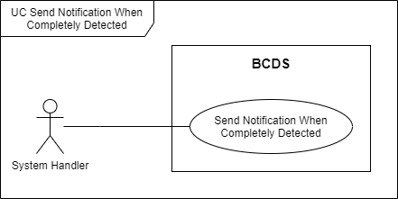

Figure . <Use Case> Send Notification When Completely Detected

Table . UC42 - Send Notification When Completely Detected

|  |  |  |  |
| --- | --- | --- | --- |
| ID and Name: | **UC-42 Send Notification When Completely Detected** | | |
| Created By: | AnhHT | Date Created: | 19/02/2021 |
| Primary Actor: | System Handler | Secondary Actors: |  |
| Description: | BCDS sends notification to corresponding staff when completely detected. | | |
| Trigger: | After BCDS completely detects cracks. | | |
| Preconditions: | N/A | | |
| Post-conditions: | POST-1:   * Success: BCDS sends notification to user. * Fail: BCDS does not send notification to user. | | |
| Normal Flow: | **42.0 BCDS completely detects cracks** (Exception 42.0.E1)   1. After a staff sends detect crack request, BCDS will detect this video. 2. When completely detection, BCDS sends a notification to this staff. | | |
| Alternative Flows: | N/A | | |
| Exceptions: | **42.0.E1 Internet connection lost**   1. BCDS does not send notification to user. | | |
| Priority: | Medium | | |
| Frequency of Use: | High | | |
| Business Rules: |  | | |
| Other Information: | N/A | | |
| Assumptions: | N/A | | |

### 2.44 UC43- Send Notification When Created Repair Record

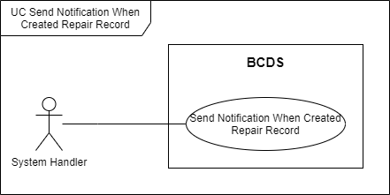

Figure . <Use Case> Send Notification When Created Repair Record

Table . UC43 - Send Notification When Created Repair Record

|  |  |  |  |
| --- | --- | --- | --- |
| ID and Name: | **UC-43 Send Notification When Created Repair Record** | | |
| Created By: | AnhHT | Date Created: | 19/02/2021 |
| Primary Actor: | System Handler | Secondary Actors: |  |
| Description: | BCDS sends notification to corresponding user. | | |
| Trigger: | A staff creates a repair record. | | |
| Preconditions: | N/A | | |
| Post-conditions: | POST-1:   * Success: BCDS sends notification to user. * Fail: BCDS does not send notification to user. | | |
| Normal Flow: | **43.0 Staff creates a repair record** (Exception 43.0.E1)   1. A staff goes to “Repair” screen and creates a repair record. 2. BCDS creates repair record for staff and sends a notification. | | |
| Alternative Flows: | N/A | | |
| Exceptions: | **43.0.E1 Internet connection lost**   1. BCDS does not send notification to user. | | |
| Priority: | Medium | | |
| Frequency of Use: | High | | |
| Business Rules: |  | | |
| Other Information: | N/A | | |
| Assumptions: | N/A | | |

### 2.45 UC44- Send Notification When Update Repair Record

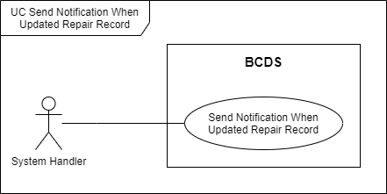

Figure . <Use Case> Send Notification When Update Repair Record

Table . UC44 - Send Notification When Update Repair Record

|  |  |  |  |
| --- | --- | --- | --- |
| ID and Name: | **UC-44 Send Notification When Update Repair Record** | | |
| Created By: | AnhHT | Date Created: | 19/02/2021 |
| Primary Actor: | System Handler | Secondary Actors: |  |
| Description: | BCDS sends notification to corresponding user. | | |
| Trigger: | A staff updates a repair record. | | |
| Preconditions: | N/A | | |
| Post-conditions: | POST-1:   * Success: BCDS sends notification to user. * Fail: BCDS does not send notification to user. | | |
| Normal Flow: | **44.0 Staff creates a repair record** (Exception 44.0.E1)   1. A staff goes to “Repair” screen and updates a repair record’s information. 2. BCDS updates repair record’s information for staff and sends a notification. | | |
| Alternative Flows: | N/A | | |
| Exceptions: | **44.0.E1 Internet connection lost**   1. BCDS does not send notification to user. | | |
| Priority: | Medium | | |
| Frequency of Use: | Medium | | |
| Business Rules: |  | | |
| Other Information: | N/A | | |
| Assumptions: | N/A | | |

### 2.46 UC45- Send Notification When Evaluated Repair Record

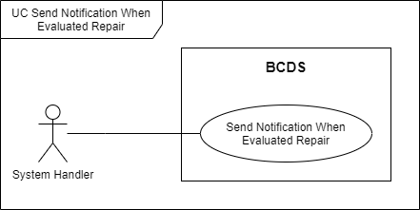

Figure . <Use Case> Send Notification When Evaluates Repair Record

Table . UC45 - Send Notification When Evaluates Repair Record

|  |  |  |  |
| --- | --- | --- | --- |
| ID and Name: | **UC-45 Send Notification When Evaluated Repair Record** | | |
| Created By: | AnhHT | Date Created: | 19/02/2021 |
| Primary Actor: | System Handler | Secondary Actors: |  |
| Description: | BCDS sends notification to corresponding user. | | |
| Trigger: | A staff evaluates a repair record. | | |
| Preconditions: | N/A | | |
| Post-conditions: | POST-1:   * Success: BCDS sends notification to user. * Fail: BCDS does not send notification to user. | | |
| Normal Flow: | **45.0 Staff evaluated a repair record** (Exception 45.0.E1)   1. A staff goes to “Repair” screen and evaluate a repair. 2. BCDS evaluates repair and sends a notification to staff. | | |
| Alternative Flows: | N/A | | |
| Exceptions: | **45.0.E1 Internet connection lost**   1. BCDS does not send notification to user. | | |
| Priority: | Medium | | |
| Frequency of Use: | Medium | | |
| Business Rules: |  | | |
| Other Information: | N/A | | |
| Assumptions: | N/A | | |

### 2.47 UC46- Send Notification When Admin Update User

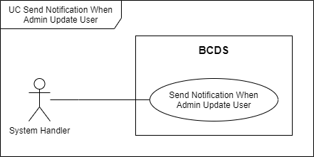

Figure . <Use Case> Send Notification When Admin Update User

Table . UC46 - Send Notification When Admin Update User

|  |  |  |  |
| --- | --- | --- | --- |
| ID and Name: | **UC-46 Send Notification When Admin Update User** | | |
| Created By: | AnhHT | Date Created: | 19/02/2021 |
| Primary Actor: | System Handler | Secondary Actors: |  |
| Description: | BCDS sends notification to corresponding user. | | |
| Trigger: | An admin updates user’s information. | | |
| Preconditions: | N/A | | |
| Post-conditions: | POST-1:   * Success: BCDS sends notification to user. * Fail: BCDS does not send notification to user. | | |
| Normal Flow: | **46.0 Send notification when admin update user** (Exception 46.0.E1)   1. An admin goes to “Users” screen and updates user’s information. 2. BCDS updates this user’s information and sends a notification to corresponding user. | | |
| Alternative Flows: | N/A | | |
| Exceptions: | **46.0.E1 Internet connection lost**   1. BCDS does not send notification to user. | | |
| Priority: | Medium | | |
| Frequency of Use: | Low | | |
| Business Rules: |  | | |
| Other Information: | N/A | | |
| Assumptions: | N/A | | |

### 2.48 UC47- Send Notification When Manager Assign Area

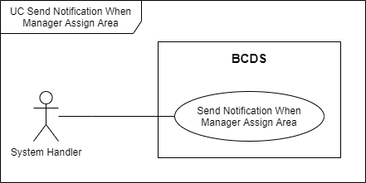

Figure . <Use Case> Send Notification When Manager Assign Area

Table . UC47 - Send Notification When Manager Assign Area

|  |  |  |  |
| --- | --- | --- | --- |
| ID and Name: | **UC-47 Send Notification When Manager Assign Area** | | |
| Created By: | AnhHT | Date Created: | 19/02/2021 |
| Primary Actor: | System Handler | Secondary Actors: |  |
| Description: | BCDS sends notification to corresponding user. | | |
| Trigger: | A manager assigns area for staff. | | |
| Preconditions: | N/A | | |
| Post-conditions: | POST-1:   * Success: BCDS sends notification to user. * Fail: BCDS does not send notification to user. | | |
| Normal Flow: | **47.0 Manager assign area for staff** (Exception 47.0.E1)   1. A manager goes to “Staffs” screen and assigns area for staff. 2. BCDS update staff’s area and sends a notification to staff. | | |
| Alternative Flows: | N/A | | |
| Exceptions: | **47.0.E1 Internet connection lost**   1. BCDS does not send notification to user. | | |
| Priority: | Medium | | |
| Frequency of Use: | Low | | |
| Business Rules: |  | | |
| Other Information: | N/A | | |
| Assumptions: | N/A | | |

## 3. Functional Requirements

### 3.1 System Functional Overview

#### a. Screen Flow

* **Admin**

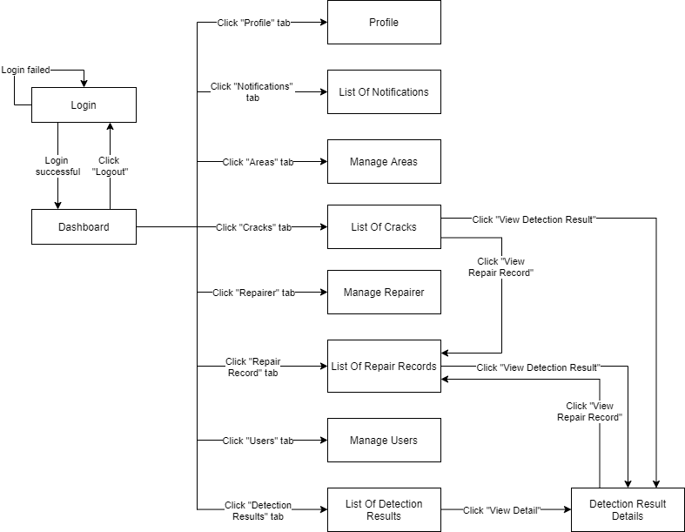

[Figure 51. Admin screen flow](https://drive.google.com/file/d/1Pp40k1hwfOAKxDC9OvHmvABUGNv2zdjq/view?usp=sharing)

* **Manager**

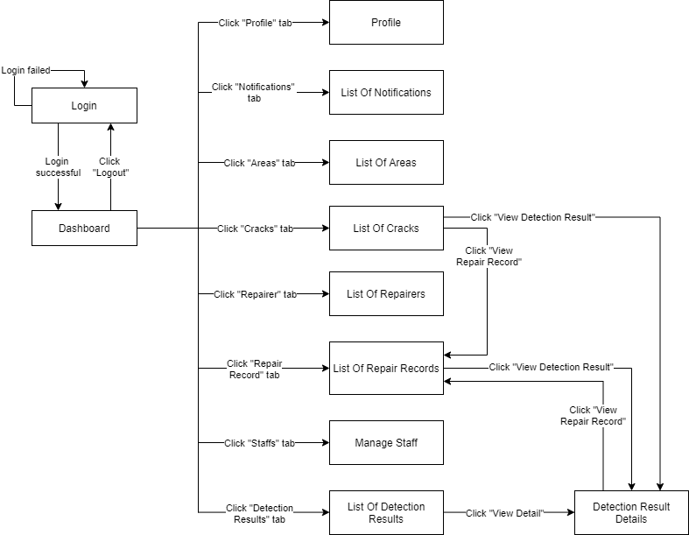

[Figure 52. Manager screen flow](https://drive.google.com/file/d/1M24zY5LE2hCn-KElyB74p2Zp9ysevZLX/view?usp=sharing)

* 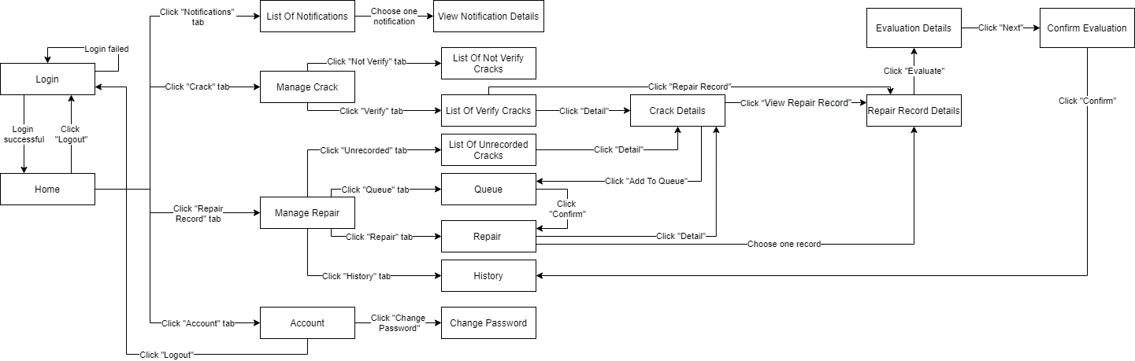**Staff**

[Figure 53. Staff Mobile App screen flow](https://drive.google.com/file/d/1lhJlD_IVppbJX3ACV0seNcU3DDNysGU6/view?usp=sharing)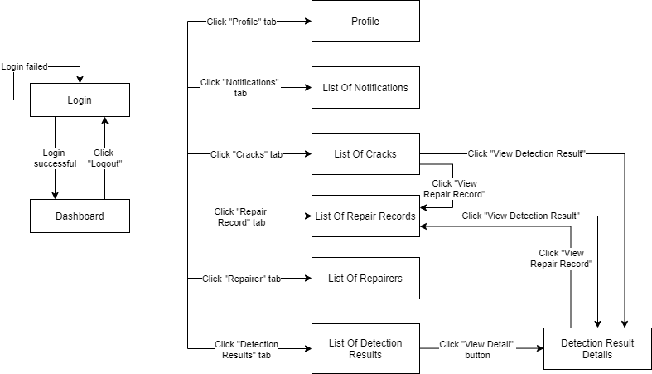

[Figure 54. Staff Web App screen flow](https://drive.google.com/file/d/10FeFL3Ze1_lIJ35Fzvi_3gNj2-o69nu9/view?usp=sharing)

#### b. Screen Details

* **Admin**

Table . Admin screen detail

|  |  |  |  |
| --- | --- | --- | --- |
| **Id** | **Feature** | **Screen** | **Description** |
| 01 | Authenticate user | Login | Allow user to login with username and password |
| 02 | Display general information | Dashboard | Allow admin to view general information and choose screen to navigate |
| 03 | Allow admin to view his/her account information | Profile | Allow admin to view his/her own information such as Full Name, Phone, Email, Area,… |
| 04 | List of notifications | List Of Notifications | Show list of notifications |
| 05 | Allow admin to create, update, delete areas | Manage Areas | Show list of areas with detail information and allow admin to create, update, delete areas |
| 06 | List of cracks | List Of Cracks | Show list of cracks |
| 07 | Allow admin to create, update, delete repairers | Manage Repairers | Show list of repairers with detail information and allow admin to create, update, delete repairers |
| 08 | List of repair records | List Of Repair Records | Show list of repair records |
| 09 | Allow admin to create, update, delete users | Manage Users | Show list of users with detail information and allow admin to create, update, delete users |
| 10 | List of detection results | List Of Detection Results | Show list of detection results |
| 11 | Allow admin to view detection result details | Detection Result Details | Show detection result details |

* **Manager**

Table . Manager screen detail

|  |  |  |  |
| --- | --- | --- | --- |
| **Id** | **Feature** | **Screen** | **Description** |
| 01 | Authenticate user | Login | Allow user to login with username and password |
| 02 | Display general information | Dashboard | Allow manager to view general information and choose screen to navigate |
| 03 | Allow manager to view his/her account information | Profile | Allow manager to view his/her account information |
| 04 | List of notifications | List Of Notifications | Show list of notifications |
| 05 | List of areas | List Of Areas | Show list of areas |
| 06 | List of cracks | List Of Cracks | Show list of cracks |
| 07 | List of repairers | List Of Repairers | Show list of repairers |
| 08 | List of repair records | List Of Repair Records | Show list of repair records |
| 09 | Allow manager to assign staff to area, delete staff’s area | Manage Staff | Allow manager to assign staff to area, delete staff’s area |
| 10 | List of detection results | List Of Detection Results | Show list of detection results |
| 11 | Allow manager to view detection result details | Detection Result Details | Show detection result details |

* **Staff – web**

Table . Staff Web App screen detail

|  |  |  |  |
| --- | --- | --- | --- |
| **Id** | **Feature** | **Screen** | **Description** |
| 01 | Authenticate user | Login | Allow user to login with username and password |
| 02 | Display general information | Dashboard | Allow manager to view general information and choose screen to navigate |
| 03 | Allow staff to view his/her account information | Profile | Allow staff to view his/her account information |
| 04 | List of notifications | List Of Notifications | Show list of notifications |
| 05 | List of cracks | List Of Cracks | Show list of cracks |
| 06 | List of repairers | List Of Repairers | Show list of repairers |
| 07 | List of repair records | List Of Repair Records | Show list of repair records |
| 08 | List of detection results | List Of Detection Results | Show list of detection results |
| 09 | Allow staff to view detection result details | Detection Result Details | Show detection result details |

* **Staff – mobile**

Table . Staff Mobile App screen detail

|  |  |  |  |
| --- | --- | --- | --- |
| **Id** | **Feature** | **Screen** | **Description** |
| 01 | Authenticate user | Login | Allow user to login with username and password |
| 02 | Display general information | Home | Allow staff to view general information and choose screen to navigate |
| 03 | List of notifications | List Of Notifications | Show list of notifications |
| 04 | Allow staff to view notification details | View Notification Details | Show notification details |
| 05 | Allow staff to view list of cracks | Manage Crack | Show list of cracks divided in two tabs: verify and not verify |
| 06 | List of not verify cracks | List Of Not Verify Cracks | Show list of not verify cracks |
| 07 | List of verify cracks | List Of Verify Cracks | Show list of verify cracks |
| 08 | Allow staff to view crack detail | Crack Details | Show crack’s detail information for staff to update |
| 09 | Show repair record details | Repair Record Details | Show repair record details |
| 10 | Show evaluation details | Evaluation Details | Allow staff to evaluate on each crack |
| 11 | Allow staff to confirm evaluation | Confirm Evaluation | Allow staff to evaluate record repair |
| 12 | Allow staff to view list of record repair | Manage Repair | Show list of record repair divided in four tabs: unrecorded, queue, repair, history |
| 13 | List of unrecorded cracks | List Of Unrecorded Cracks | Show list of unrecorded cracks |
| 14 | List of repair  queues | Queue | Show list of repair queues |
| 15 | List of repair record | Repair | Show list of repair record |
| 16 | List of repair histories | History | Show list of repair histories |
| 17 | Allow staff to view his/her account information | Account | Allow staff to view his/her account information |
| 18 | Allow staff to change his/her password | Change Password | Allow staff to change his/her password |

#### c. Screen Authorization

Table . Admin screen authorization

|  |  |  |
| --- | --- | --- |
| **Screen** | **Unauthenticated User** | **Administrator** |
| Login | X |  |
| *Authenticate User* | X |  |
| Dashboard |  | X |
| *View general information* |  | X |
| *Navigate to other screens* |  | X |
| Profile |  | X |
| *View information* |  | X |
| *Change password* |  | X |
| List Of Notifications |  | X |
| *Show list of notifications* |  | X |
| Manage Areas |  | X |
| *Show list of areas* |  | X |
| *Allow admin to create new area* |  | X |
| *Allow admin to update area* |  | X |
| *Allow admin to delete area* |  | X |
| List Of Cracks |  | X |
| *Show list of cracks* |  | X |
| Manage Repairers |  | X |
| *Show list of repairers* |  | X |
| *Allow admin to create new repairer* |  | X |
| *Allow admin to update repairer* |  | X |
| *Allow admin to delete repairer* |  | X |
| List Of Repair Records |  | X |
| *Show list of repair records* |  | X |
| Manage Users |  | X |
| *Show list of users* |  | X |
| *Allow admin to create new user* |  | X |
| *Allow admin to update user* |  | X |
| *Allow admin to delete user* |  | X |
| *Allow admin to reset user’s password* |  | X |
| List Of Detection Results |  | X |
| *Show list of detection results* |  | X |
| Detection Result Details |  | X |
| *Show detection result details* |  | X |

***Annotation:***

* Unauthenticated User: a user who has not logged in to BCDS.
* Administrator: a user who has logged in to BCDS with role admin.

Table . Manager screen authorization

|  |  |  |
| --- | --- | --- |
| **Screen** | **Unauthenticated User** | **Manager** |
| Login | X |  |
| *Authenticate User* | X |  |
| Dashboard |  | X |
| *View general information* |  | X |
| *Navigate to other screens* |  | X |
| Profile |  | X |
| *View information* |  | X |
| *Change password* |  | X |
| List Of Notifications |  | X |
| *Show list of notifications* |  | X |
| List Of Areas |  | X |
| *Show list of areas* |  | X |
| List Of Cracks |  | X |
| *Show list of cracks* |  | X |
| List Of Repairers |  | X |
| *Show list of repairers* |  | X |
| List Of Repair Records |  | X |
| *Show list of repair records* |  | X |
| Manage Staff |  | X |
| *Show list of staffs* |  | X |
| *Assign staff to area* |  | X |
| *Delete staff’s area* |  | X |
| List Of Detection Results |  | X |
| *Show list of detection results* |  | X |
| Detection Result Details |  | X |
| *Show detection result details* |  | X |

***Annotation:***

* Unauthenticated User: a user who has not logged in to BCDS.
* Manager: A user who has logged in to BCDS with role manager.

Table . Staff Web App screen authorization

|  |  |  |
| --- | --- | --- |
| **Screen** | **Unauthenticated User** | **Staff** |
| Login | X |  |
| *Authenticate User* | X |  |
| Profile |  | X |
| *View information* |  | X |
| *Change password* |  | X |
| List Of Notifications |  | X |
| *Show list of notifications* |  | X |
| List Of Cracks |  | X |
| *Show list of cracks* |  | X |
| List Of Repairers |  | X |
| *Show list of repairers* |  | X |
| List Of Repair Records |  | X |
| *Show list of repair records* |  | X |
| List Of Detection Results |  | X |
| *Show list of detection results* |  | X |
| Detection Result Details |  | X |
| *Show detection result details* |  | X |

***Annotation:***

* Unauthenticated User: a user who has not logged in to BCDS.
* Staff: A user who has logged in to BCDS web app with role staff.

Table . Staff Mobile App screen authorization

|  |  |  |
| --- | --- | --- |
| **Screen** | **Unauthenticated User** | **Staff** |
| Login | X |  |
| *Authenticate* *User* | X |  |
| List Of Notifications |  | X |
| *Show list of notifications* |  | X |
| View Notification Details |  | X |
| *Show notification details* |  | X |
| Manage Crack |  | X |
| *Show list of cracks* |  | X |
| List Of Not Verify Cracks |  | X |
| *Show list of not verify cracks* |  | X |
| List Of Verify Cracks |  | X |
| *Show list of verify cracks* |  | X |
| Crack Details |  | X |
| *Show crack details* |  | X |
| *Allow staff to update crack information* |  | X |
| Repair Record Detail |  | X |
| *Show repair record detail* |  | X |
| *Allow staff to update repair record information* |  | X |
| Evaluation Details |  | X |
| *Allow staff to evaluate each crack in repair record* |  | X |
| ConfirmEvaluation |  | X |
| *Allow staff to evaluate repair record* |  | X |
| Manage Repair |  | X |
| *Show list of repair record* |  | X |
| List Of Unrecorded Cracks |  | X |
| *Show list of unrecorded cracks* |  | X |
| Queue |  | X |
| *Show list of cracks added to queue* |  | X |
| Repair |  | X |
| *Show repair record* |  | X |
| History |  | X |
| *Show repair record history* |  | X |
| Account |  | X |
| *Show staff’s information* |  | X |
| Change Password |  | X |
| *Allow staff to change password* |  | X |

***Annotation:***

* Unauthenticated User: a user who has not logged in to BCDS.
* Staff: a user who has logged in to BCDS mobile app with role staff.

#### d. Non-Screen Functions

Table . Non-Screen functions

|  |  |  |
| --- | --- | --- |
| **#** | **System Function** | **Description** |
| 1 | Send notification | System handler will send notifications to users |
| 2 | Detect crack | System handler will detect cracks and send list of detected cracks to users |

#### e. Entity Relationship Diagram

***Note:*** *using Crow's foot notation*

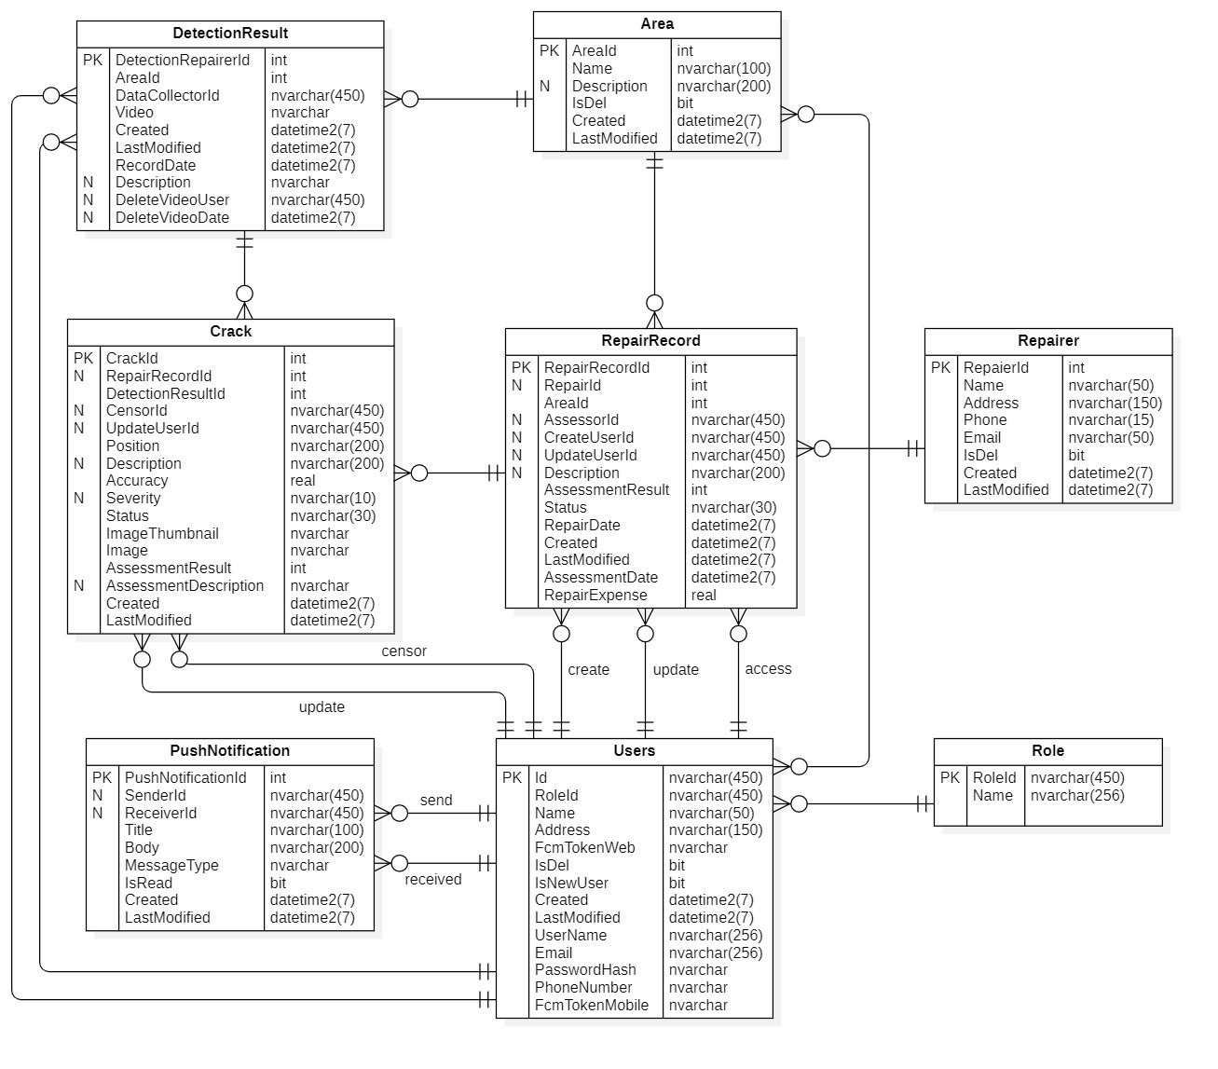

Figure 55 . Entity relationship diagram

Table . Entity description

|  |  |  |
| --- | --- | --- |
| **#** | **Entity** | **Description** |
| 1 | Users | Store information of user (admin, manager, staff) for authentication and authorization |
| 2 | Role | Store information of role for authorization |
| 3 | Area | Store information of areas such as: name, description,… |
| 4 | Crack | Store information about cracks such as: position, image, status,… |
| 5 | Repair Record | Store information of repair records such as: status, assessment result,… |
| 6 | Repairer | Store information of repairers such as: name, phone,… |
| 7 | Detection Result | Store information of detection results such as: record date, video,... |
| 8 | PushNotification | Store information of notification such as: title, body,… |

### 3.2 W1: Authentication/Authorization

#### a. Login web application

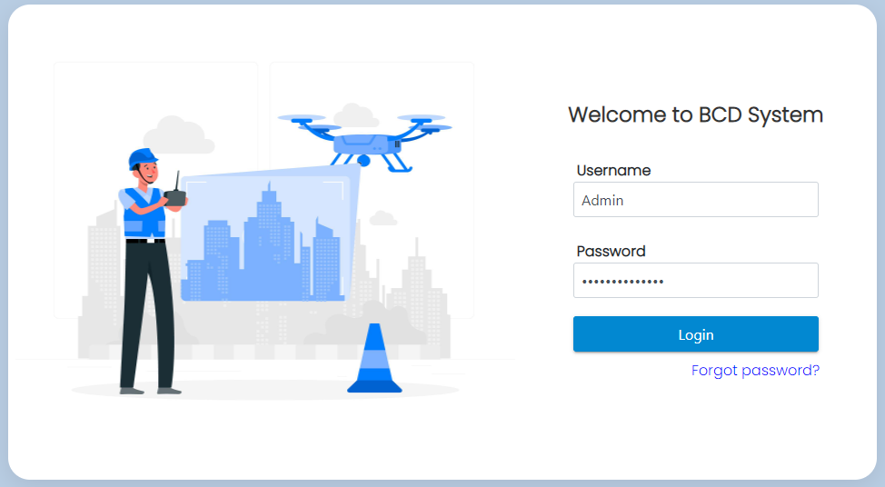

Figure . Login screen

This function is for all users to use their account logging into BCDS, include requirements:

* Users have to input required fields: Username, Password.
* “Login” button.
* “Forgot Password?” link.

#### b. Forgot password

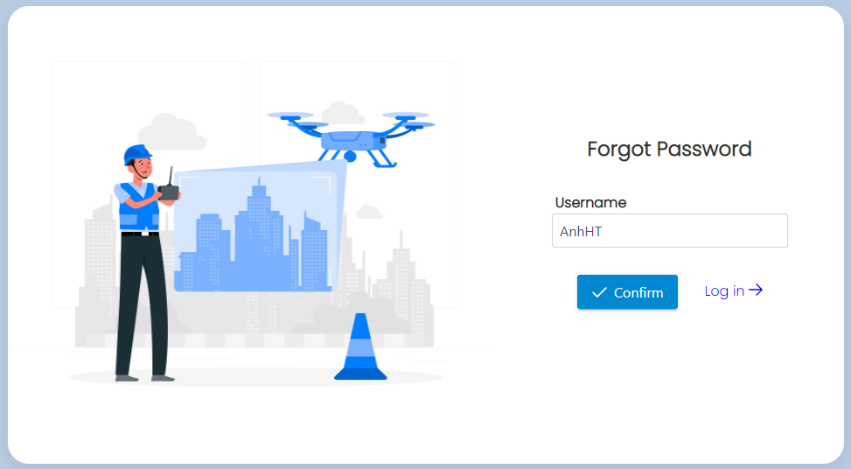

Figure . Forgot password screen

This function is for all users if they forgot password, include requirements:

* Users have to input required field: Username.
* “Confirm” button.
* “Sign in link.

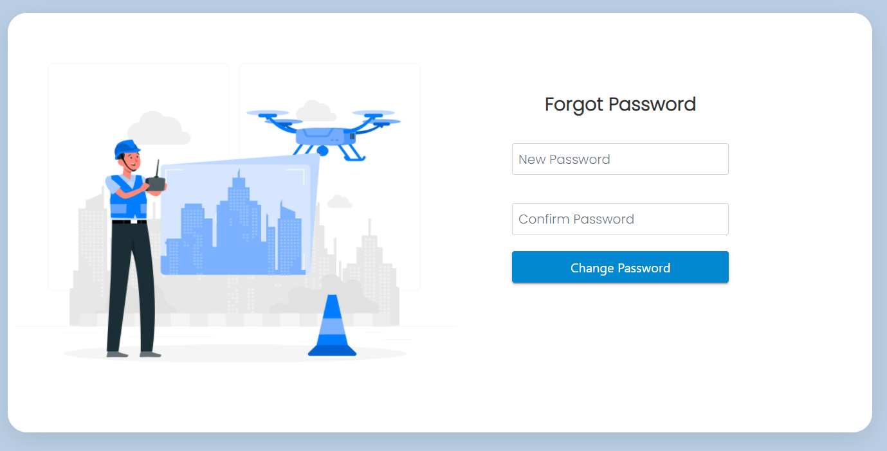

Figure . Input new password screen

After receiving reset password email, users will be directed to change password, include requirements:

* Users have to input required fields: New Password, Confirm Password.
* “Change Password” button.

### 3.3 W2 - Admin: Manage Users

#### a. View list users

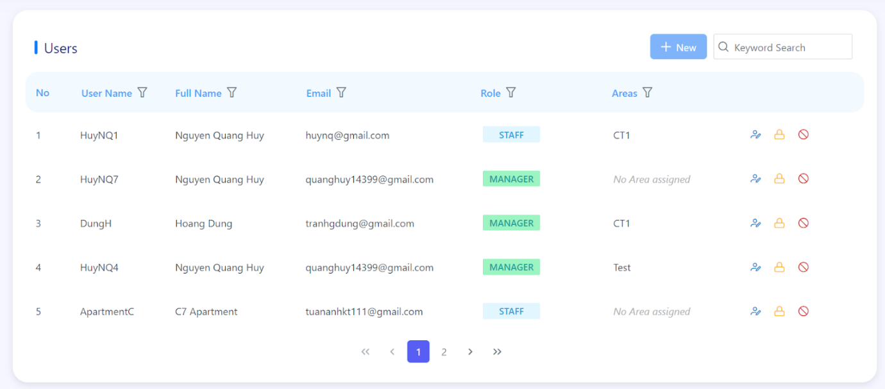

Figure . List of users screen

This function is for admin to view list users, include the following elements:

* Search box.
* "New" button.
* List of users.
* "Edit" button.
* "Reset Password" button.
* "Delete Account" button.

#### b. Create new user

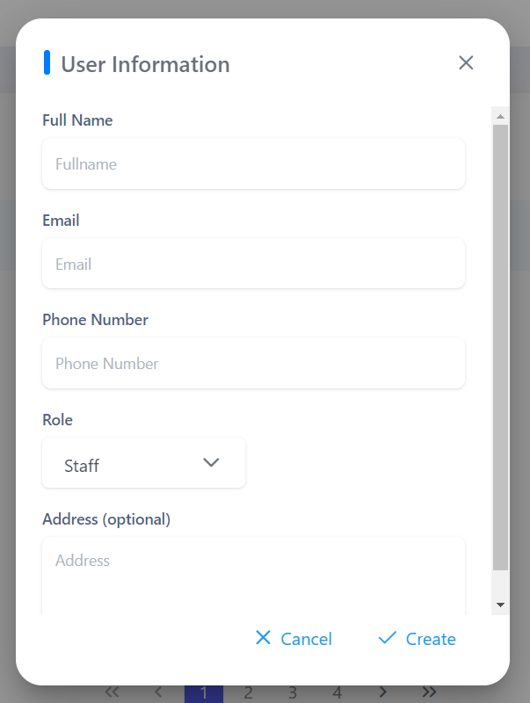

Figure . User information popup

This function is for admin to create new user, include requirements:

* Admin has to input/select required fields: Full Name, Email, Phone Number, Role.
* Optional fields: Area (if role is manager), Address.

#### c. Update user

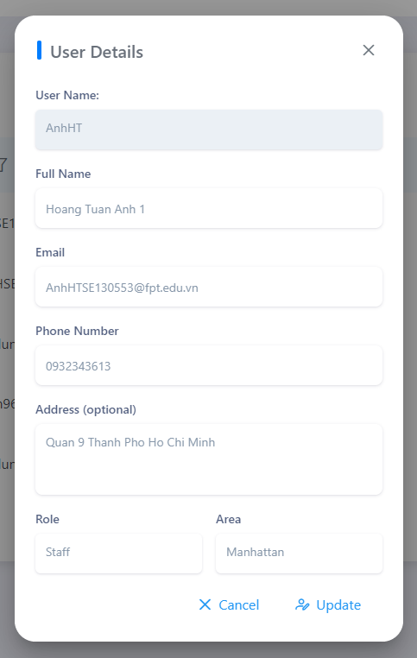

Figure . User details popup

This function is for admin to update user, include requirements:

* System auto-fill fields: User Name.
* Admin has to input/select required fields: Full Name, Email, Phone Number, Role.
* Optional fields: Area (if role is manager), Address.

#### d. Reset password for user

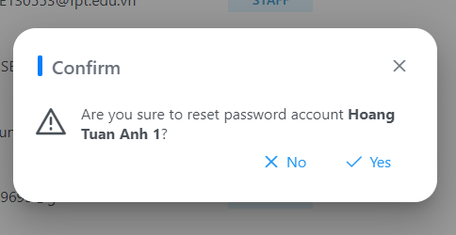

Figure . Reset password confirm popup

This function is for admin to reset password for user, include 2 options:

* Yes: if admin wants to reset this user’s password.
* No: if admin does not want to reset password.

#### e. Delete user

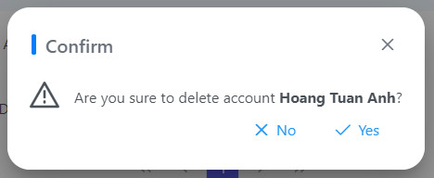

Figure . Delete user confirm popup

This function is for admin to delete account of user, include 2 options:

* Yes: if admin wants to delete this user’s account.
* No: if admin does not want to delete account.

### 3.4 W3 - Admin: Manage Areas

#### a. View list areas

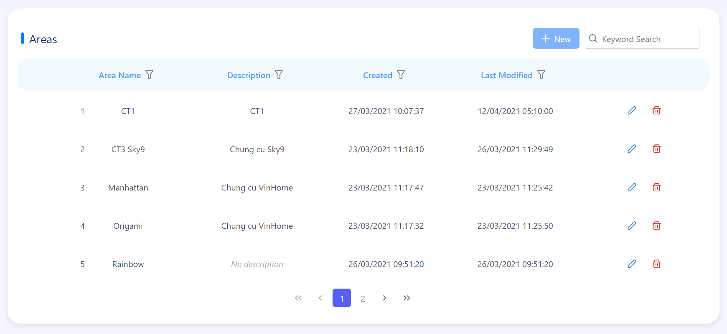

Figure . List of areas screen

This function is for admin to view list areas, include the following information:

* Search box.
* "New" button.
* List of areas.
* "Edit" button.
* "Delete Area" button.

#### b. Create new area

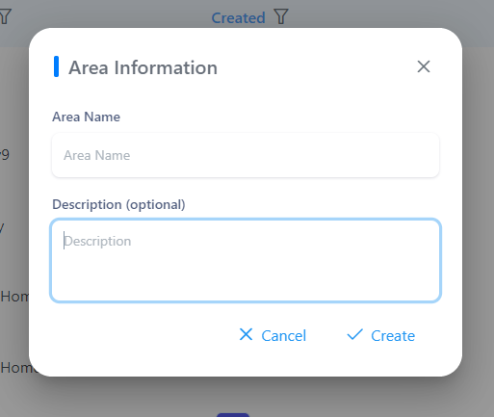

Figure . Area information popup

This function is for admin to create new area, include requirements:

* Admin has to input/select required field: Area Name.
* Optional field: Description.

#### c. Update area

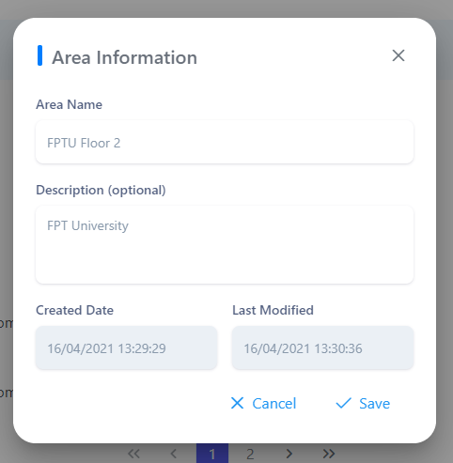

Figure . Area information popup

This function is for admin to create new area, include requirements:

* System auto-fill fields: Created Date, Last Modified.
* Admin has to input/select required field: Area Name.
* Optional field: Description.

#### d. Delete area

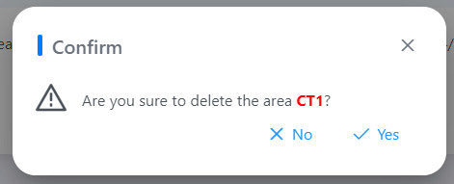

Figure . Delete area confirm popup

This function is for admin to delete area, include 2 options:

* Yes: if admin wants to delete this area.
* No: if admin does not want to delete area.

### 3.5 W4 - Admin: Manage Repairers

#### a. View list repairers

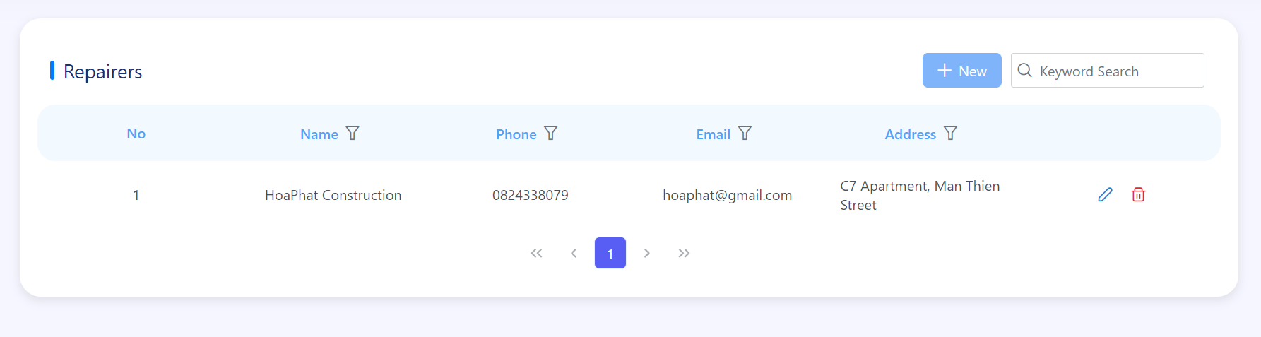

Figure . list of repairers screen

This function is for admin to view list repairers, include the following information:

* Search box.
* "New" button.
* List of Repairers.
* "Edit" button.
* "Delete" button.

#### b. Create new repairer

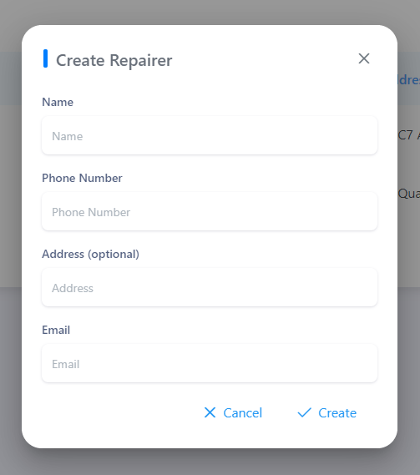

Figure . Create repairer popup

This function is for admin to create new repairer, include requirements:

* Admin has to input/select required fields: Name, Phone Number, Email.
* Optional field: Address.

#### c. Update repairer

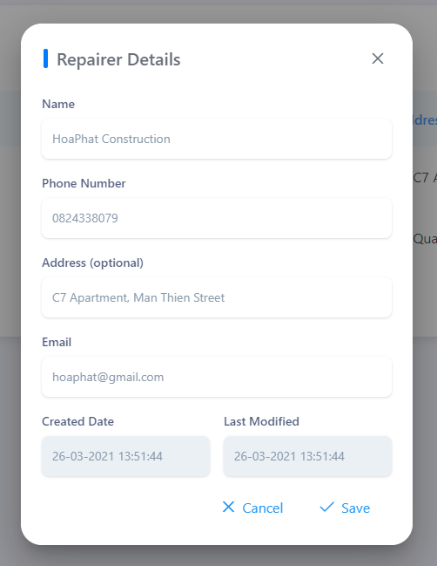

Figure . Repairer details popup

This function is for admin to update area, include requirements:

* System auto-fill fields: Created Date, Last Modified.
* Admin has to input/select required fields: Name, Phone Number, Email.
* Optional field: Address.

#### d. Delete repairer

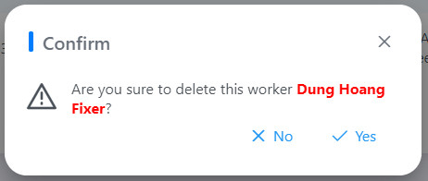

Figure . Delete repairer confirm popup

This function is for admin to delete repairer, include 2 options:

* Yes: if admin wants to delete this repairer.
* No: if admin does not want to delete repairer.

### 3.6 W5 - Admin: View Dashboard

Figure . Dashboard screen

This function is for admin to view statistics of BCD system, include the following elements:

* Filter include Year and Area.
* Four boxes: Cracks Total, Repair Records Total, Repair Expense Total, Average Assessment.
* Two charts: Repair Expense, Cracks By Severity.

### 3.7 W6 - Admin: View List Cracks

#### a. View list cracks

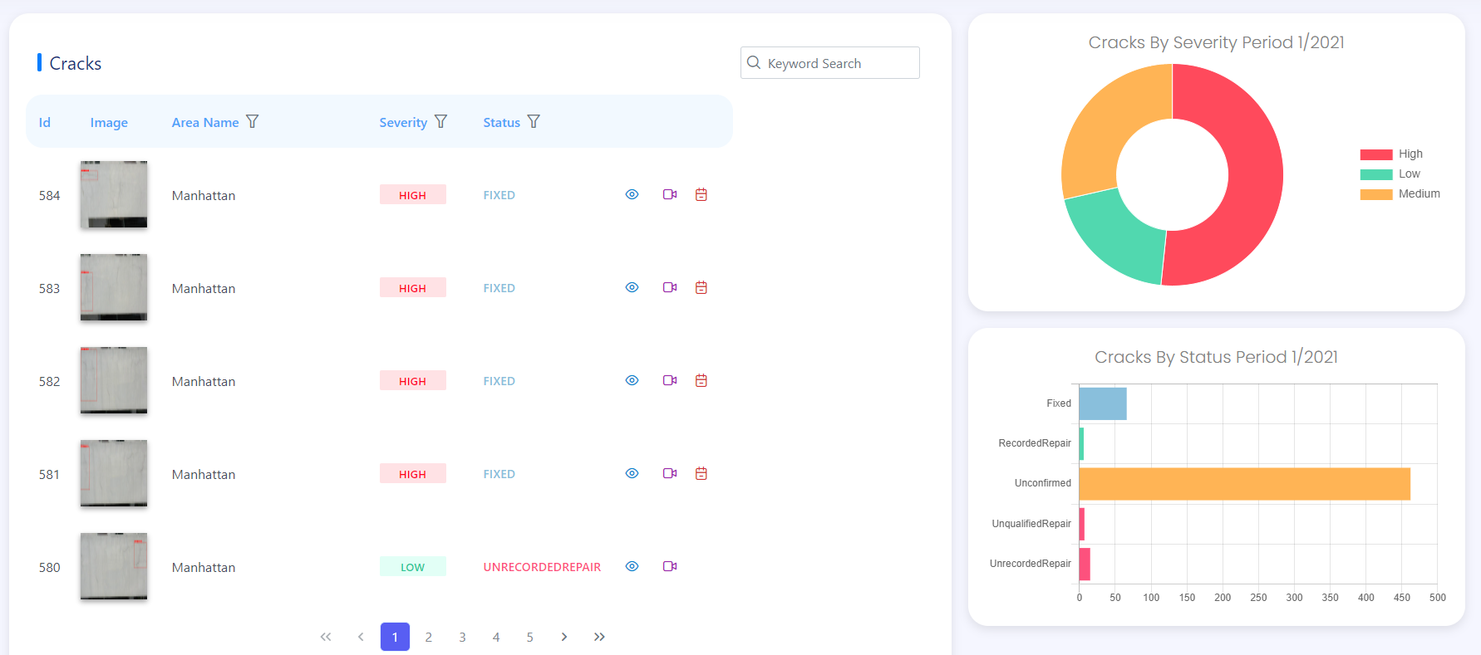

Figure . List of cracks screen

This function is for admin to view list of cracks, include the following elements:

* Search box.
* List of cracks.
* "View Crack Details" button.
* "View Detection Result" button.
* "View Repair Record" button.
* Two charts: Cracks By Severity, Cracks By Status.

#### b. View crack details

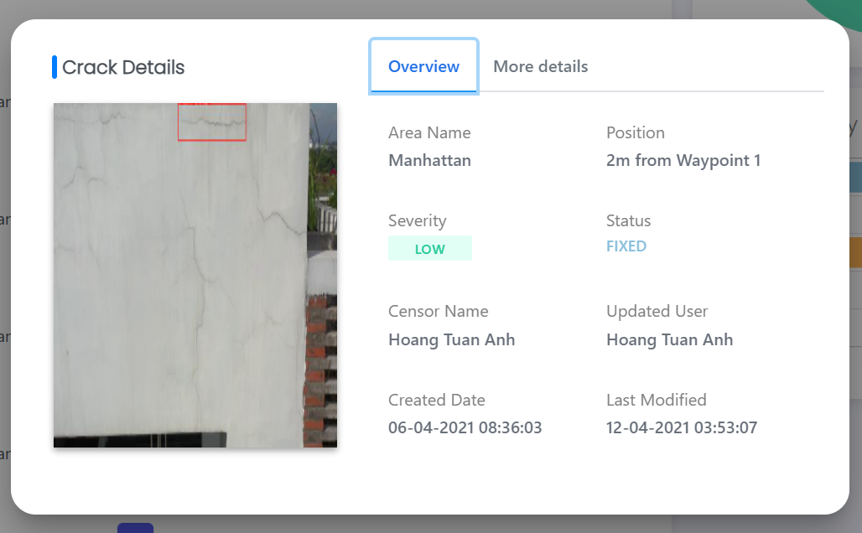

Figure . Crack details pop up

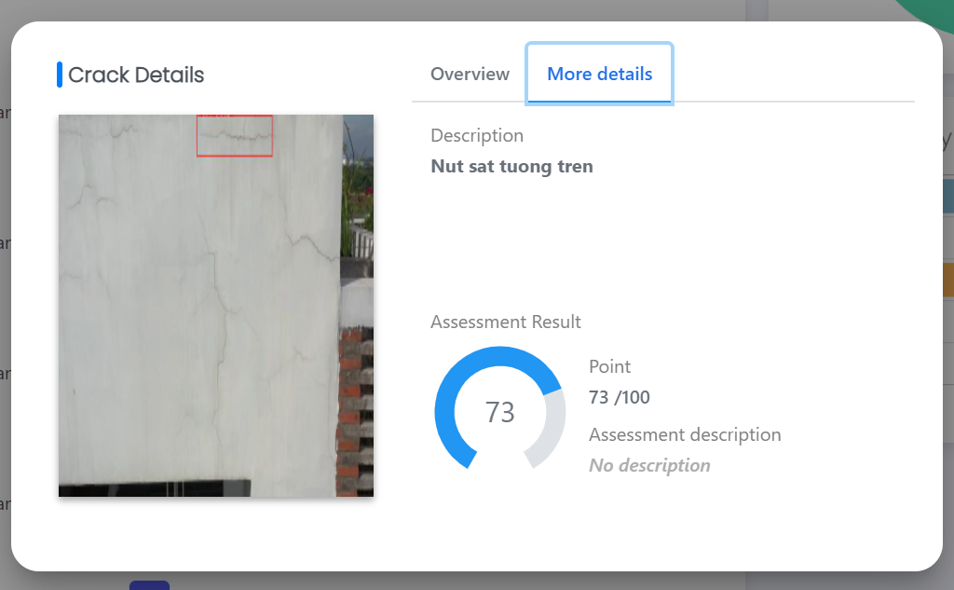

Figure . Crack details pop up

This function is for admin to view crack details, include the following elements:

* Crack's image.
* "Overview" tab: Area Name, Position, Severity, Status, Censor Name, Updated User, Created Date, Last Modified.
* "More Details" tab: Description, Assessment Result.

### 3.8 W7 – Admin: View List Repair Records

#### a. View list repair records

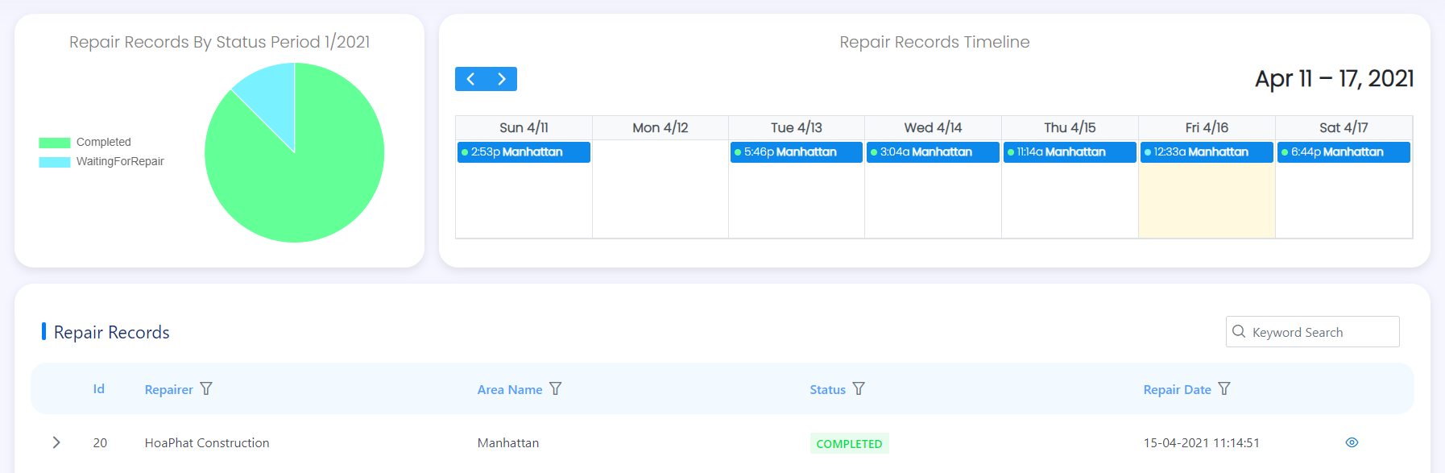

Figure . List of repair records screen

This function is for admin to view list repair records, include the following elements:

* Repair Records By Status chart.
* Repair Records Timeline.
* Search box.
* List of Repair Records.
* "View Record Details" button.

#### b. View repair record details

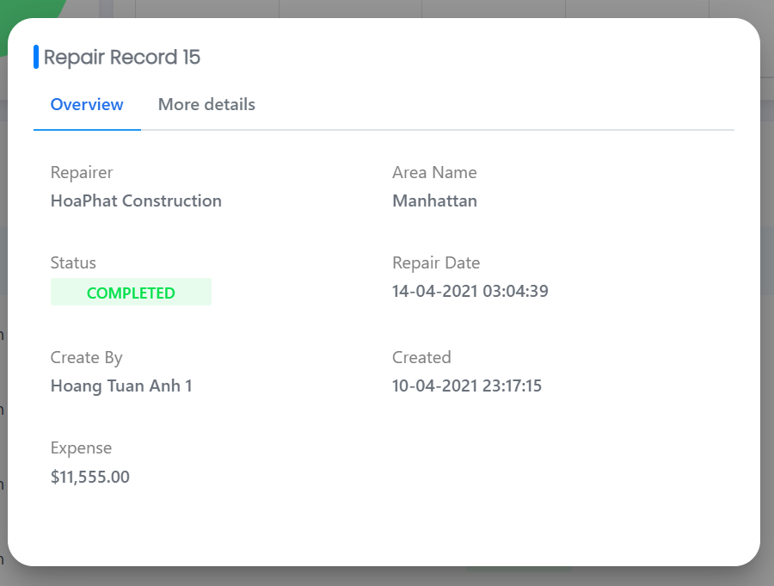

Figure . Repair record details popup

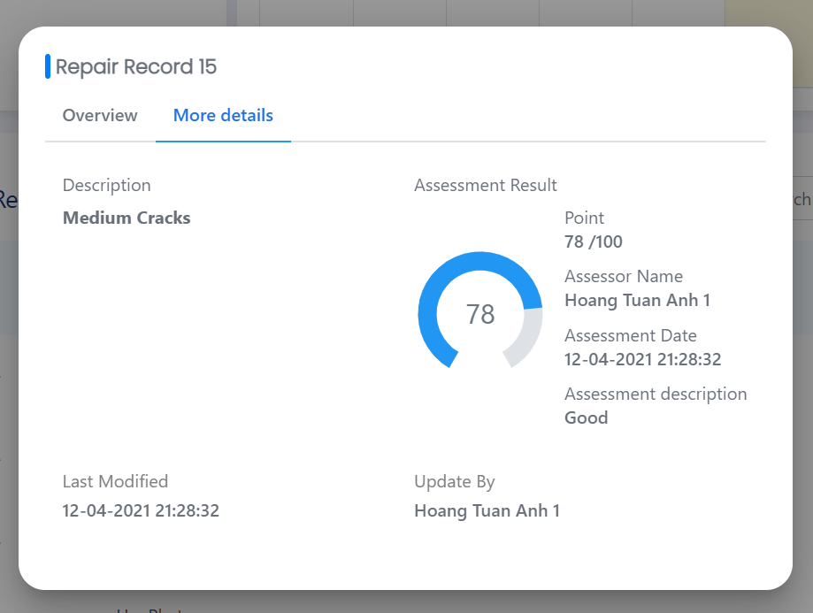

Figure . Repair record details popup

This function is for admin to view repair record details, include the following elements:

* "Overview" tab: Repairer, Area Name, Status, Repair Date, Create User, Created, Expense.
* "More Details" tab: Description, Assessment Result, Last Modified, Update User.

#### c. View list of cracks

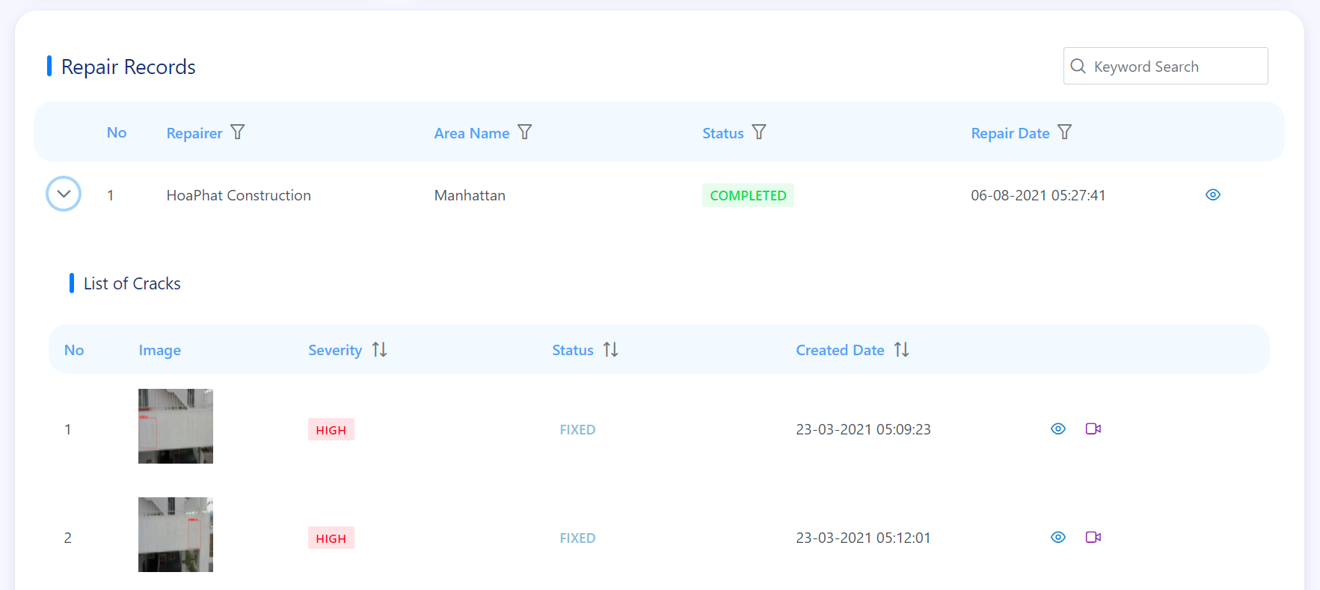

Figure . List of cracks screen

This function is for admin to view list cracks, include the following elements:

* List of Cracks.
* "View Crack Details" button.
* "View Detection Result" button.

#### d. View crack details

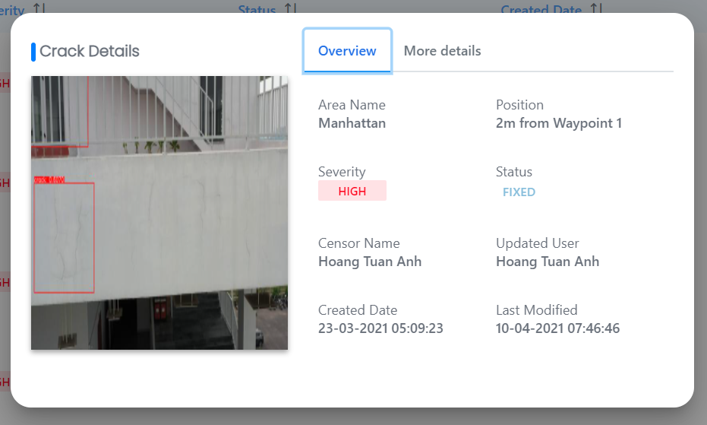

Figure . Crack details popup

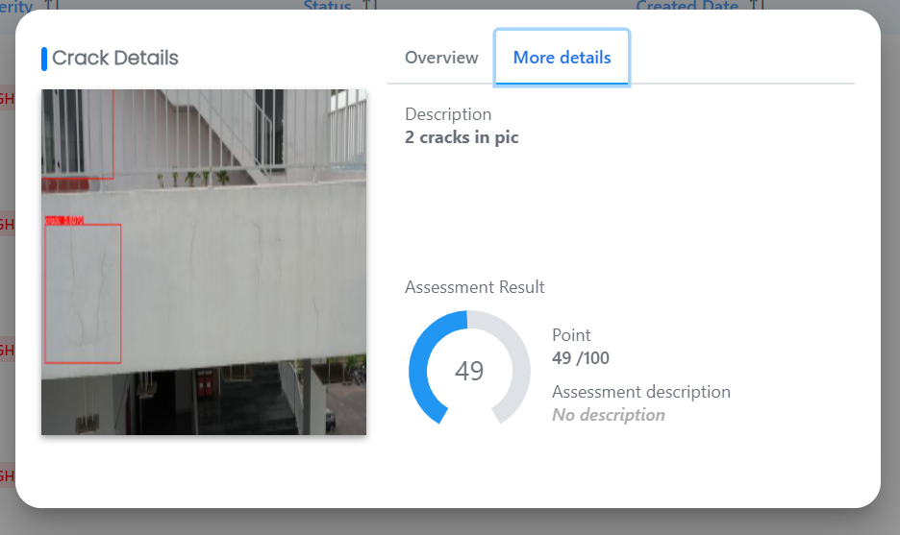

Figure . Crack details popup

This function is for admin to view crack details, include the following elements:

* Crack's image.
* "Overview" tab: Area Name, Position, Severity, Status, Censor Name, Updated User, Created Date, Last Modified.
* "More Details" tab: Description, Assessment Results.

### 3.9 W8 – Admin: Manage Detection Results

#### a. View list detection results

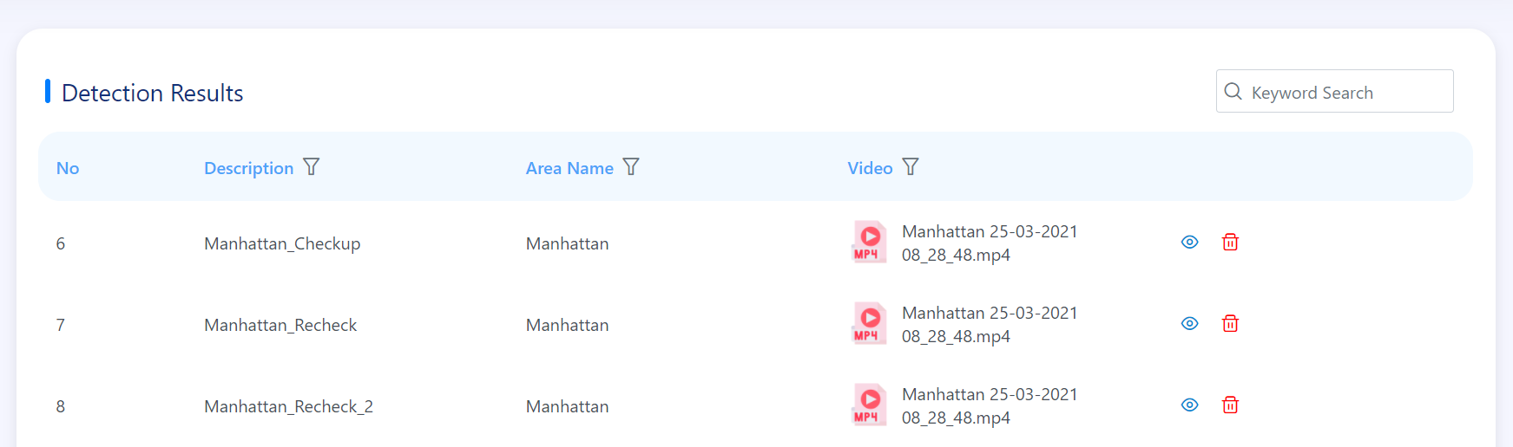

Figure . List of detection results screen

This function is for admin to view list detection results, include the following elements:

* Search box.
* List of Detection Results.
* "View Details" button.
* "Delete Video" button.

#### b. Delete video

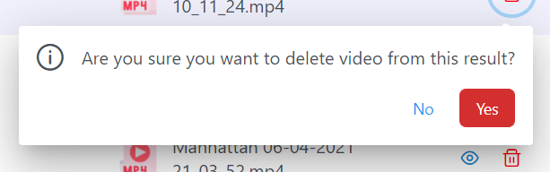

Figure . Delete video confirm popup

This function is for admin to delete detection video, include 2 options:

* Yes: if admin wants to delete this video.
* No: if admin does not want delete this video.

#### c. View detection result details

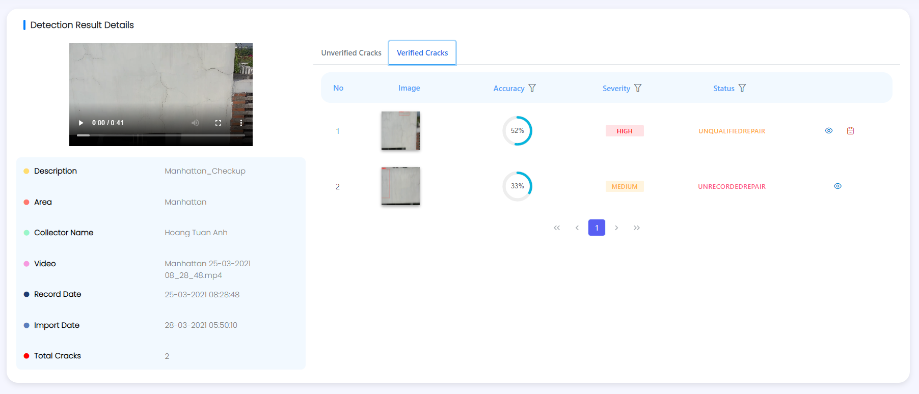

Figure . Detection result details screen

This function is for admin to view detection result details, include the following elements:

* Detection result information: video, description, area, collector name, video name, record date, import date, total cracks.
* Unverified Cracks tab.
* Verified Cracks tab.

### 3.10 W9 – Admin: Manage Profile

#### a. View profile

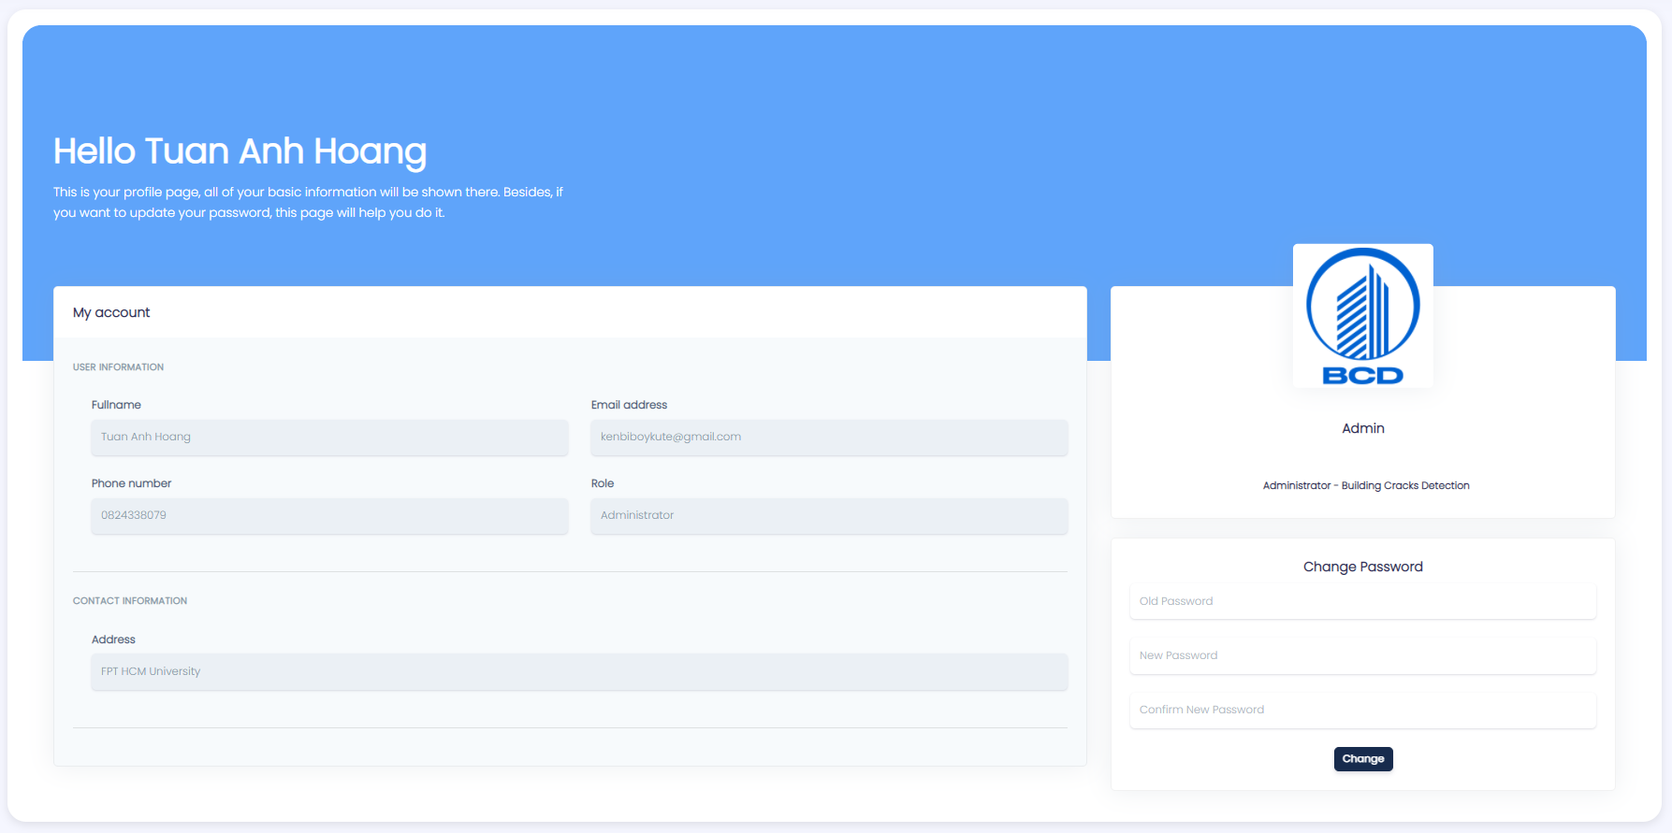

Figure . Profile screen

This function is for admin to view own profile, include the following elements:

* User Information
* Contact Information
* Change Password field

#### b. Change password

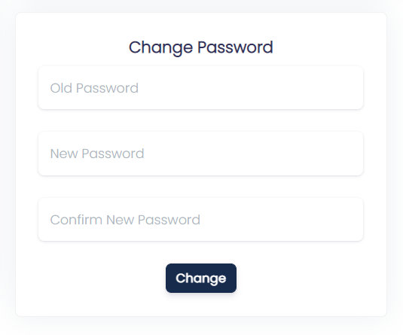

Figure . Change password screen

This function is for admin to change own password, include requirements:

* Admin has to input required fields: Old Password, New Password, Confirm Password.

### 3.11 W10 - Admin: View Notifications

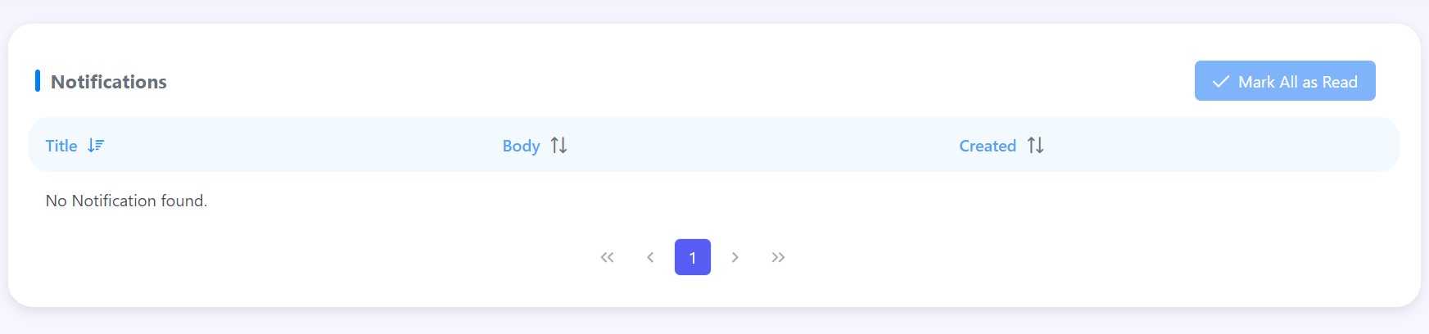

Figure . List of notifications screen

This function is for admin to view notifications, include the following elements:

* List of notifications.
* “Mark All as Read” button.

### 3.12 W11 - Manager: View Dashboard

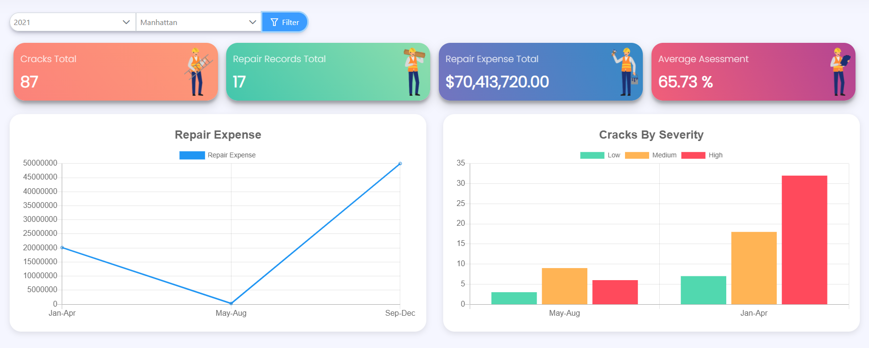

Figure . Dashboard screen

This function is for manager to view statistics of his/her areas, include the following elements:

* Filter include Year and Area.
* Four boxes: Cracks Total, Repair Records Total, Repair Expense Total, Average Assessment.
* Two charts: Repair Expense, Cracks By Severity.

### 3.13 W12 - Manager: View List Cracks

#### a. View list cracks



Figure . List of cracks screen

This function is for manager to view list of cracks, include the following elements:

* Search box.
* List of cracks.
* "View Crack Details" button.
* "View Detection Result" button.
* "View Repair Record" button.
* Two charts: Cracks By Severity, Cracks By Status.

#### b. View crack details



Figure . Crack details popup



Figure . Crack details popup

This function is for manager to view crack details, include the following elements:

* Crack's image.
* "Overview" tab: Area Name, Position, Severity, Status, Censor Name, Updated User, Created Date, Last Modified.
* "More Details" tab: Description, Assessment Result.

### 3.14 W13 – Manager: Manage Staffs

#### a. View list staffs

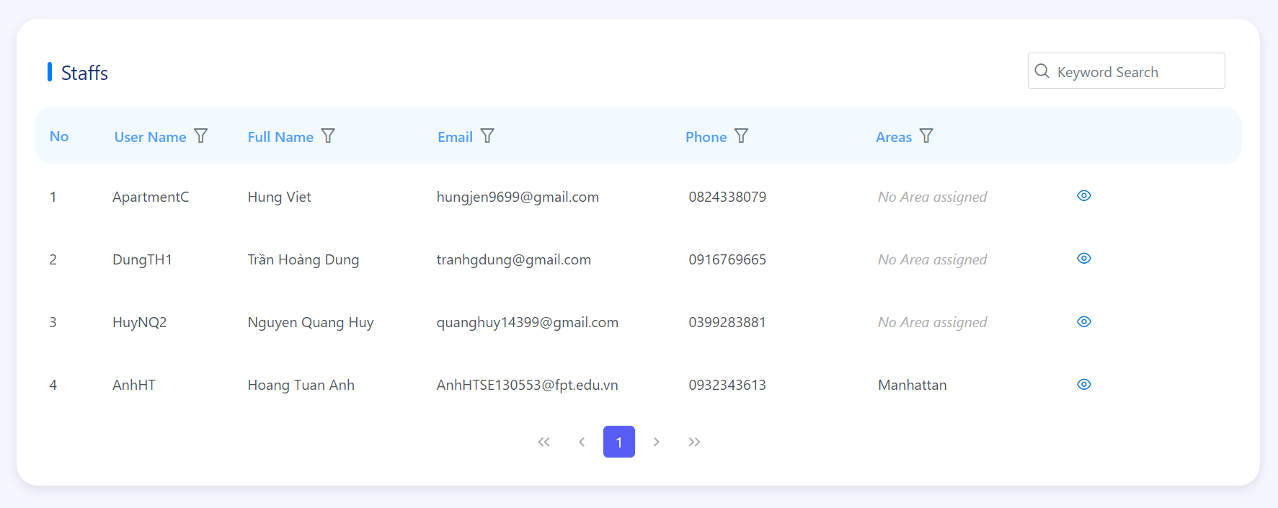

Figure . List of staffs screen

This function is for manager to view list staffs that he/she manages, include the following elements:

* Search box.
* List of staffs.
* "View Staff Details" button.

#### b. View staff details

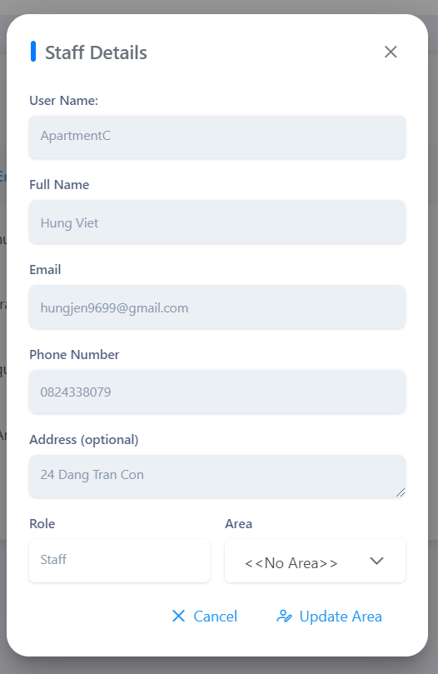

Figure . Staff details popup

This function is for manager to view staff details, include requirements:

* System auto-fill fields: User Name, Full Name, Email, Phone Number, Address, Role.
* Optional field: Area.

### 3.15 W14 – Manager: View List Areas

#### a. View list areas

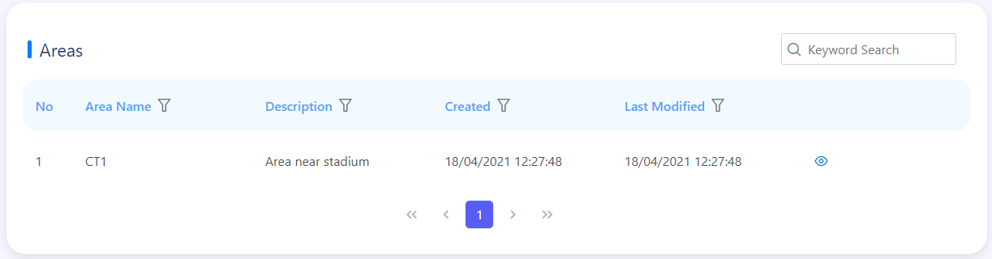

Figure . List of areas screen

This function is for manager to view list areas that he/she manages, include the following elements:

* Search box.
* List of areas.
* "View Area Details" button.

#### b. View area details

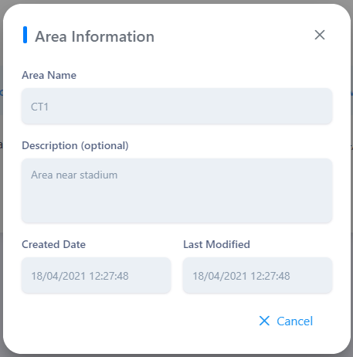

Figure . Area information popup

This function is for manager to view area details, include the following elements:

* Area Name.
* Description.
* Created Date.
* Last Modified.

### 3.16 W15 – Manager: View List Repair Records

#### a. View list repair records



Figure . List of repair records screen

This function is for manager to view list repair records, include the following elements:

* Repair Records By Status chart.
* Repair Records Timeline.
* Search box.
* List of Repair Records.
* "View Record Details" button.

#### b. View repair record details



Figure . Repair record details popup



Figure . Repair record details popup

This function is for manager to view repair record details, include the following elements:

* "Overview" tab: Repairer, Area Name, Status, Repair Date, Create User, Created, Expense.
* "More Details" tab: Description, Assessment Result, Last Modified, Update User.

#### c. View list of cracks



Figure . List of cracks screen

This function is for manager to view list cracks, include the following elements:

* List of Cracks.
* "View Crack Details" button.
* "View Detection Result" button.

#### d. View crack details



Figure . Crack details popup



Figure . Crack details popup

This function is for manager to view crack details, include the following elements:

* Crack's image.
* "Overview" tab: Area Name, Position, Severity, Status, Censor Name, Updated User, Created Date, Last Modified.
* "More Details" tab: Description, Assessment Results.

### 3.17 W16 – Manager: View List Repairers

#### a. View list repairers

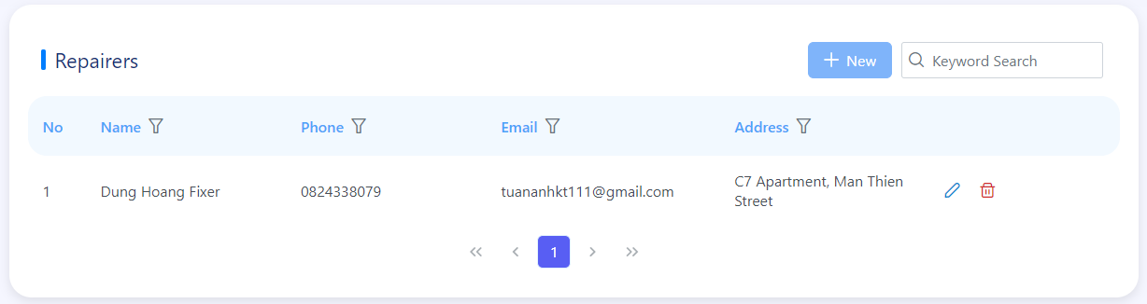

Figure . List of repairers screen

This function is for manager to view list repairers, include the following elements:

* List of repairers.
* "View Repairer Details” button.

#### b. View repairer details

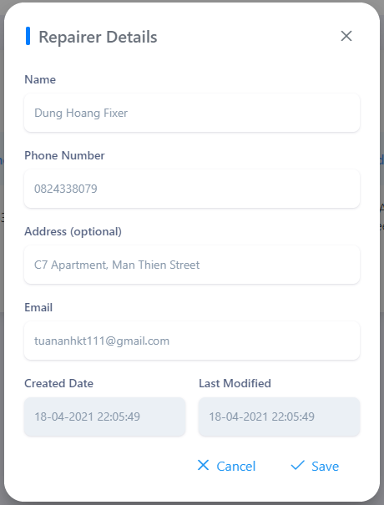

Figure . Repairer details popup

This function is for manager to view repairer details, include the following elements:

* Name.
* Phone Number.
* Address.
* Email.
* Created Date.
* Last Modified.
* “Cancel” button.

### 3.17 W16 – Manager: Manage Detection Results

#### a. View list detection results

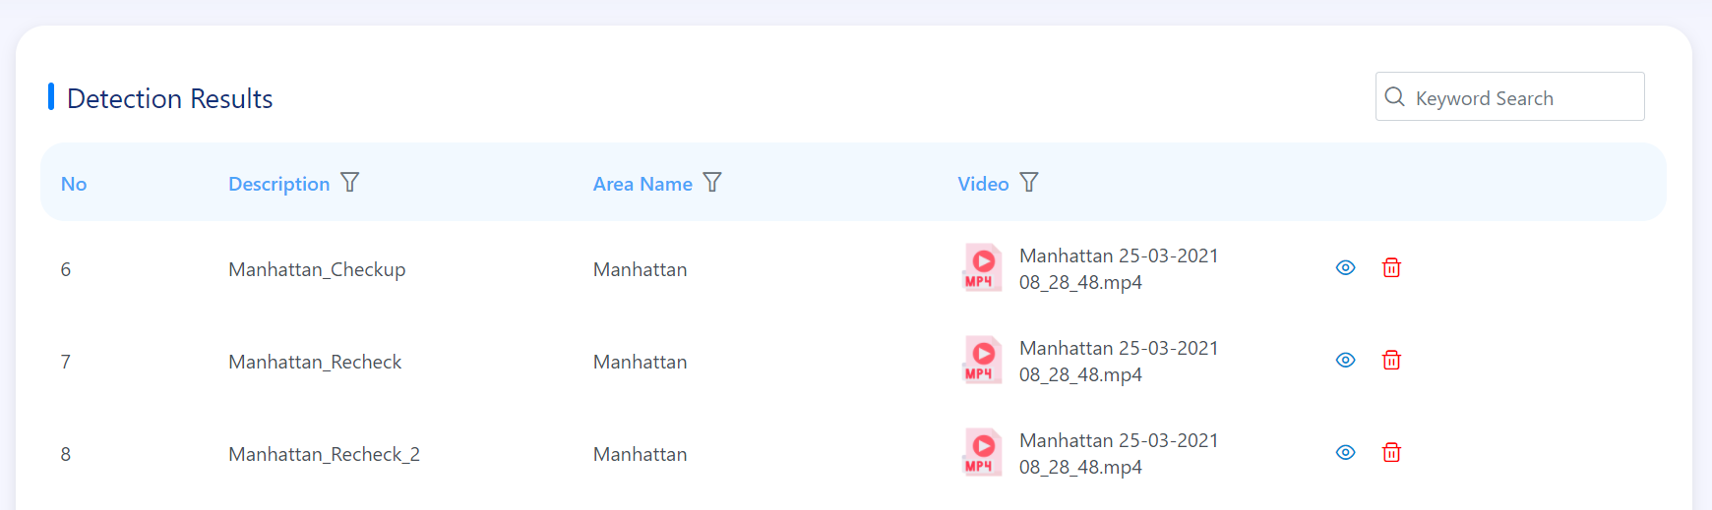

Figure . List of detection results

This function is for manager to view list detection results, include the following elements:

* Search box.
* List of Detection Results.
* "View Details" button.

#### b. Delete video



Figure . Delete video confirm popup

This function is for manager to delete detection video, include 2 options:

* Yes: if manager wants to delete this video.
* No: if manager does not want delete this video.

### 3.18 W17 – Manager: Manage Profile

#### a. View profile

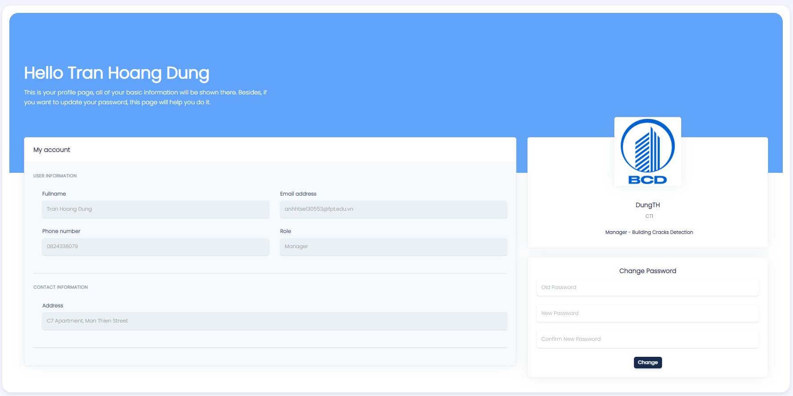

Figure . Profile screen

This function is for manager to view own profile, include the following elements:

* User Information
* Contact Information
* Change Password field

#### b. Change password



Figure . Change password screen

This function is for manager to change own password, include requirements:

* Manager has to input required fields: Old Password, New Password, Confirm Password.

### 3.19 W18 - Manager: View Notifications



Figure . List of notifications screen

This function is for admin to view notifications, include the following elements:

* List of notifications.
* “Mark All as Read” button.

### 3.20 W19 - Staff: Manage Cracks

#### a. View list cracks

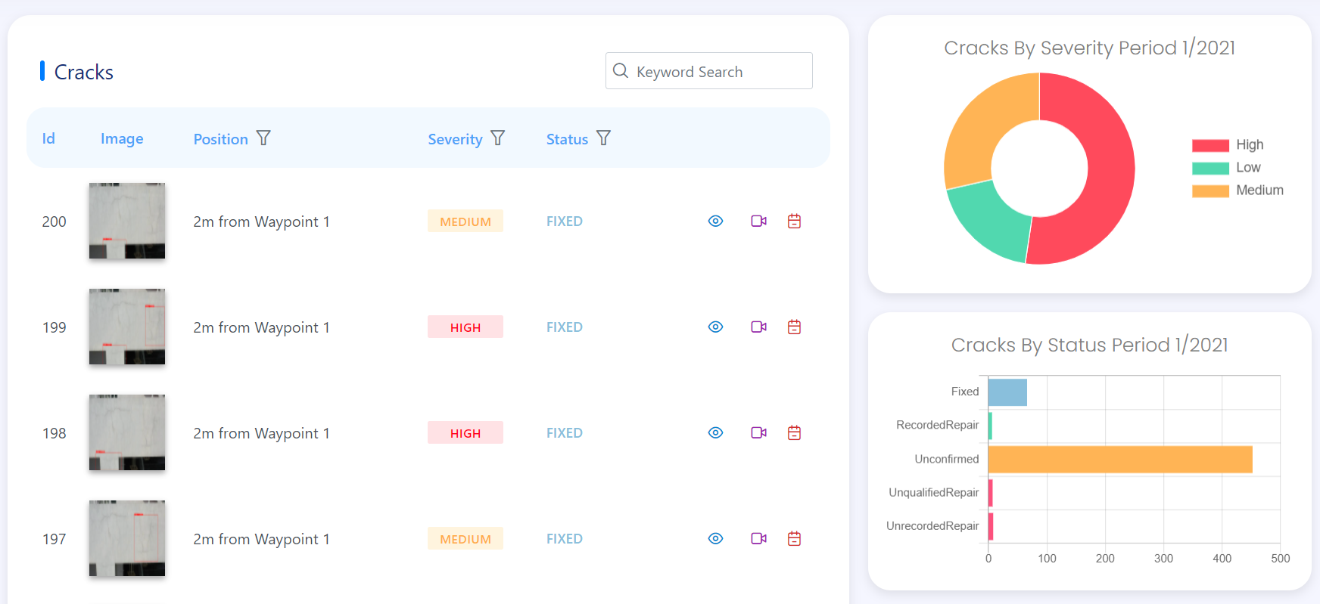

Figure . List of cracks screen

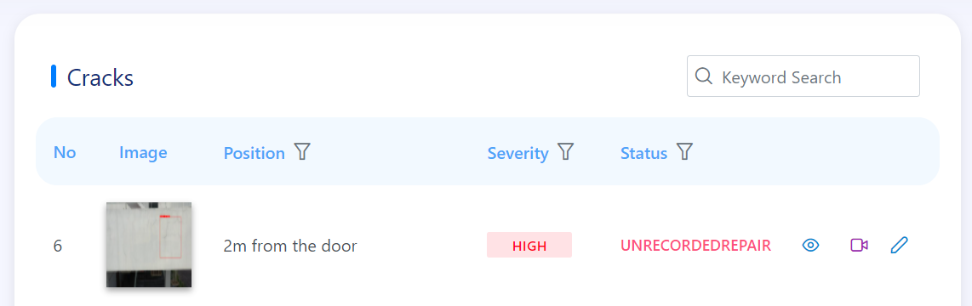

Figure . List of cracks screen

This function is for staff to view list of cracks, include the following elements:

* Search box.
* List of cracks.
* "View Crack Details" button.
* "View Detection Result" button.
* "View Repair Record" button.
* “Update Crack” button.
* Two charts: Cracks By Severity, Cracks By Status.

#### b. View crack details



Figure . Crack details popup



Figure . Crack details popup

This function is for staff to view crack details, include the following elements:

* Crack's image.
* "Overview" tab: Area Name, Position, Severity, Status, Censor Name, Updated User, Created Date, Last Modified.
* "More Details" tab: Description, Assessment Result.

#### c. Update crack

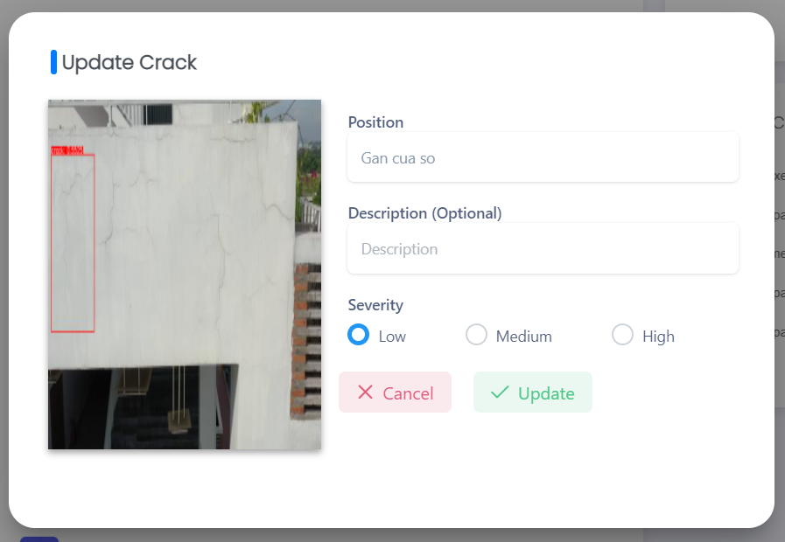

Figure . Update crack popup

This function is for staff to update crack details, include requirements:

* System auto-fill fields: Severity.
* Staff has to input/select required fields: Position.
* Optional fields: Description.

### 3.21 W20 – Staff: View List Repair Records

#### a. View list repair records



Figure . List of repair record screen

This function is for staff to view list repair records, include the following elements:

* Repair Records By Status chart.
* Repair Records Timeline.
* Search box.
* List of Repair Records.
* "View Record Details" button.

#### b. View repair record details

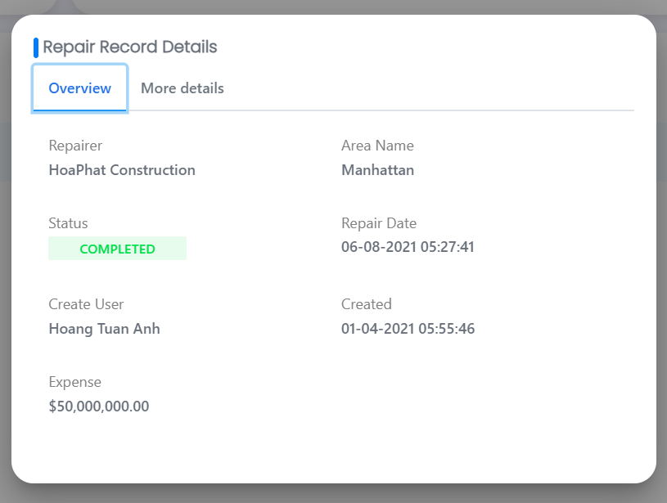

Figure . Repair record details popup

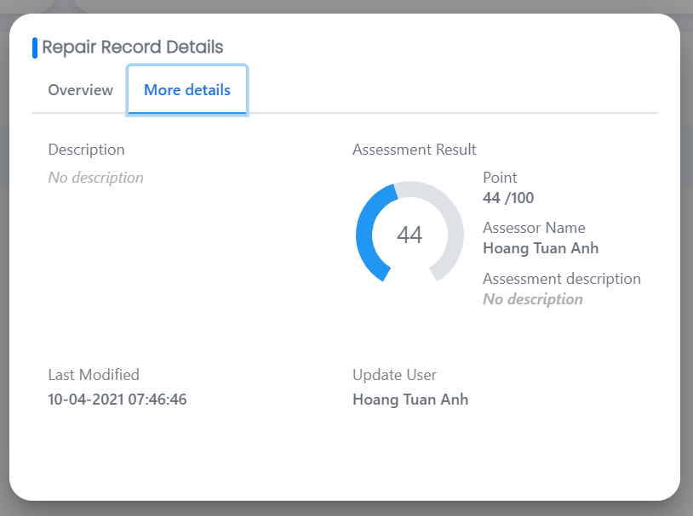

Figure . Repair record details popup

This function is for staff to view repair record details, include the following elements:

* "Overview" tab: Repairer, Area Name, Status, Repair Date, Create User, Created, Expense.
* "More Details" tab: Description, Assessment Result, Last Modified, Update User.

#### c. View list of cracks

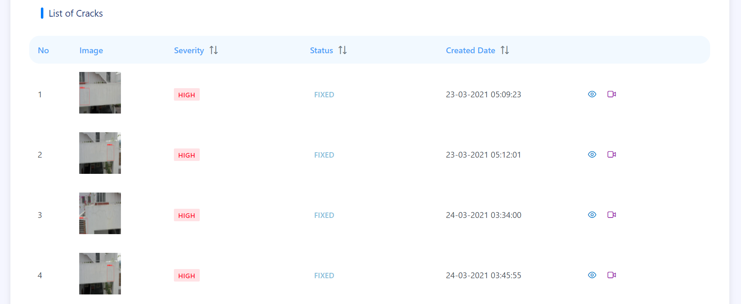

Figure . List of cracks screen

This function is for staff to view list cracks, include the following elements:

* List of Cracks.
* "View Crack Details" button.
* "View Detection Result" button.

#### d. View crack details



Figure . Crack details popup



Figure . Crack details popup

This function is for staff to view crack details, include the following elements:

* Crack's image.
* "Overview" tab: Area Name, Position, Severity, Status, Censor Name, Updated User, Created Date, Last Modified.
* "More Details" tab: Description, Assessment Results.

### 3.22 W21 – Staff: View List Repairers

#### a. View list repairers

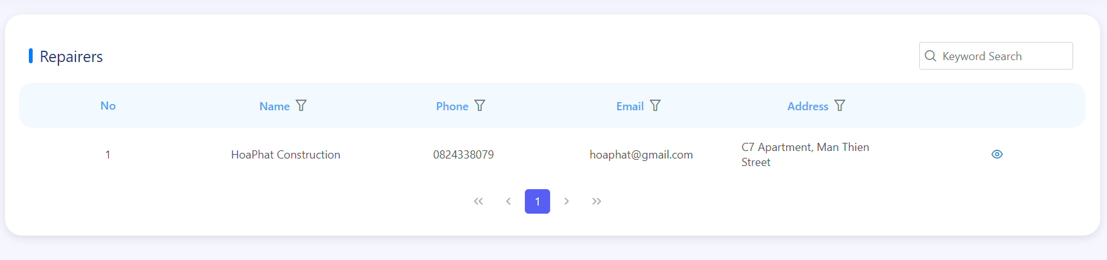

Figure . List of repairers screen

This function is for staff to view list repairers, include the following elements:

* List of repairers.
* "View Repairer Details” button.

#### b. View repairer details

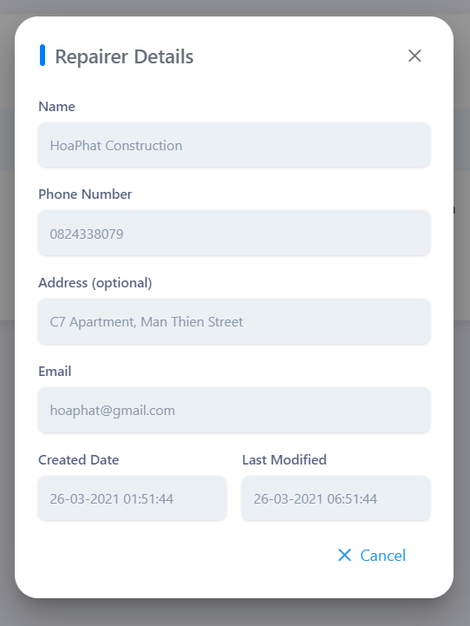

Figure . Repairer details popup

This function is for staff to view repairer details, include the following elements:

* Name.
* Phone Number.
* Address.
* Email.
* Created Date.
* Last Modified.
* “Cancel” button.

### 3.23 W22 – Staff: Manage Detection Results

#### a. View list detection results

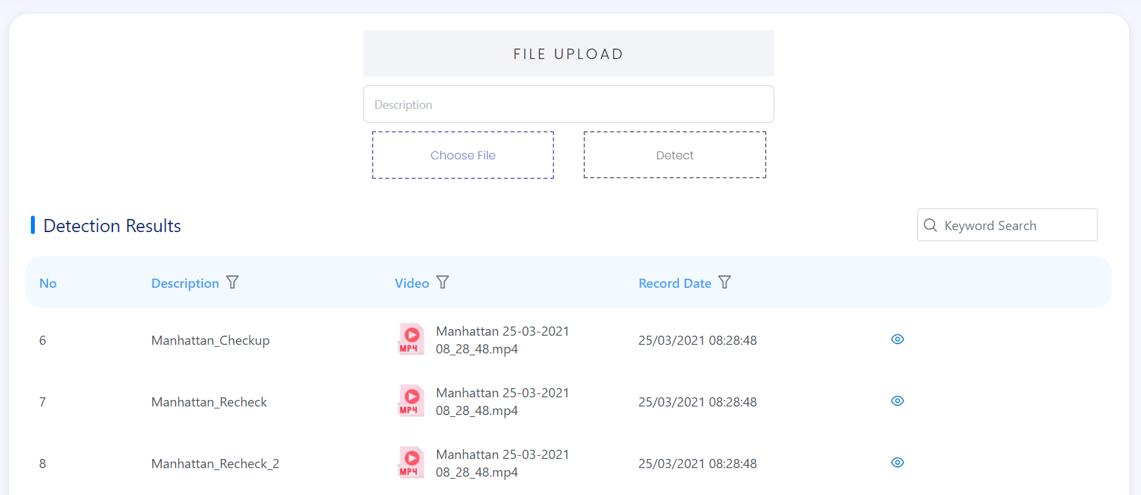

Figure . List of detection results screen

This function is for staff to view list detection results, include the following elements:

* Description.
* “Choose File” button.
* “Detect” button.
* Search box.
* List of Detection Results.
* "View Details" button.

#### b. Detect cracks

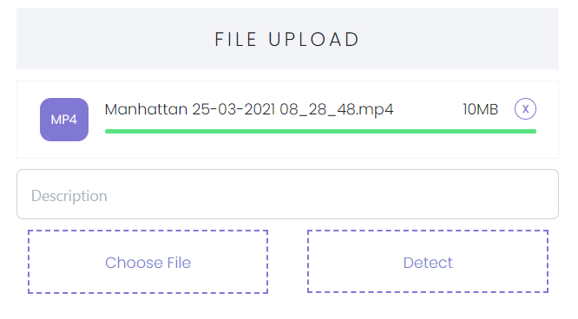

Figure . File upload screen

This function is for staff to detect cracks, include the following elements:

* Staff has to input/select required field: Description.
* “Choose File” button.
* “Detect” button.

#### c. View detection result details

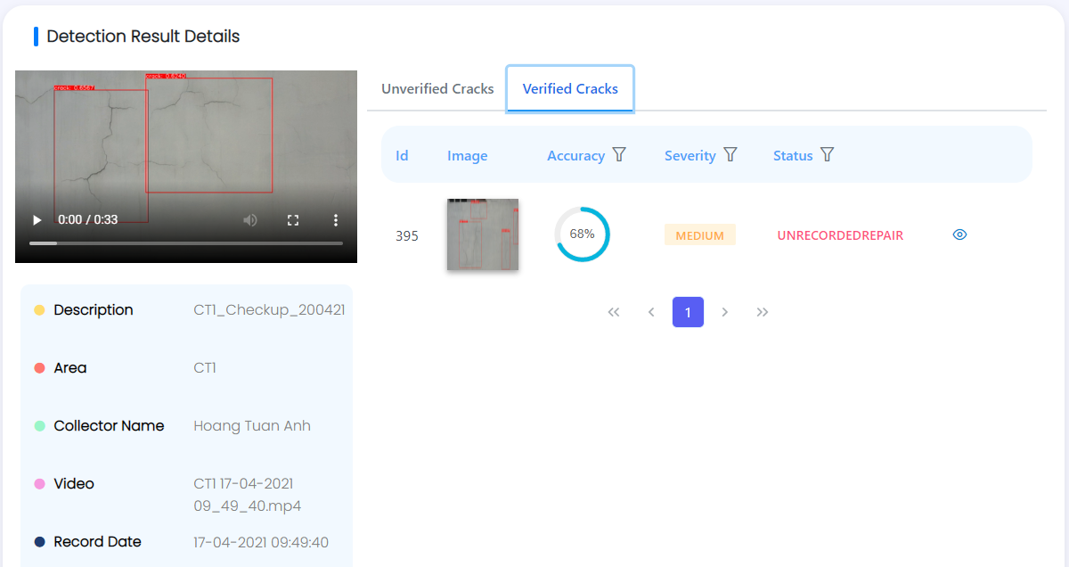

Figure . Detection result details screen

This function is for staff to view detection result details, include the following elements:

* Detection result information: video, description, area, collector name, video name, record date, import date, total cracks.
* Unverified Cracks tab.
* Verified Cracks tab.

### 3.24 W23 – Staff: Manage Profile

#### a. View profile

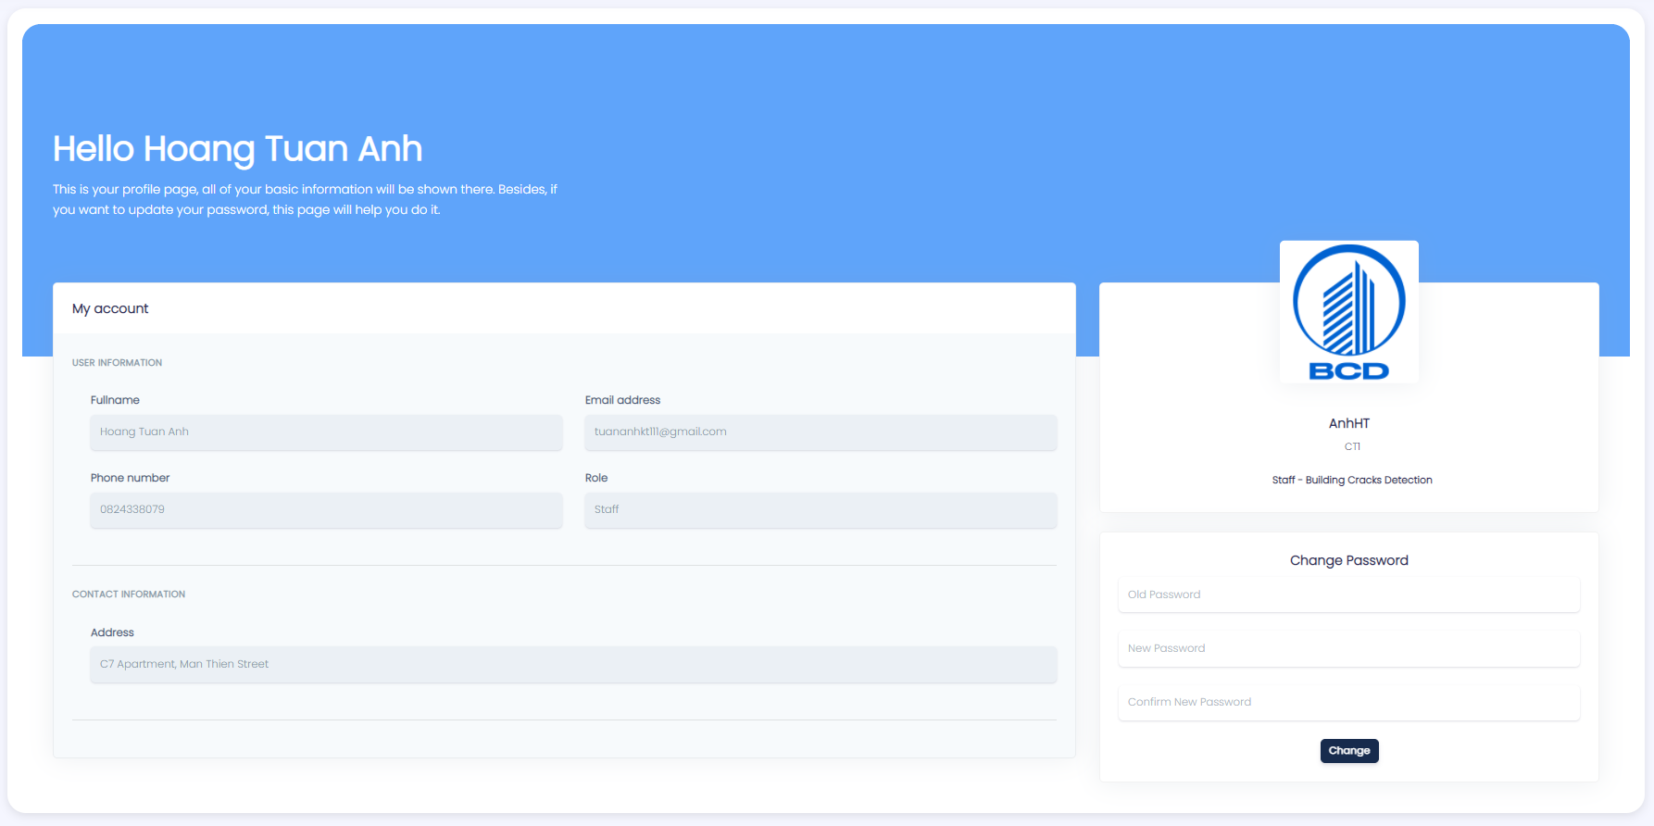

Figure . Profile screen

This function is for staff to view own profile, include the following elements:

* User Information
* Contact Information
* Change Password field

#### b. Change password



Figure . Change password screen

This function is for staff to change own password, include requirements:

* Staff has to input required fields: Old Password, New Password, Confirm Password.

### 3.25 W24 - Staff: View Notifications

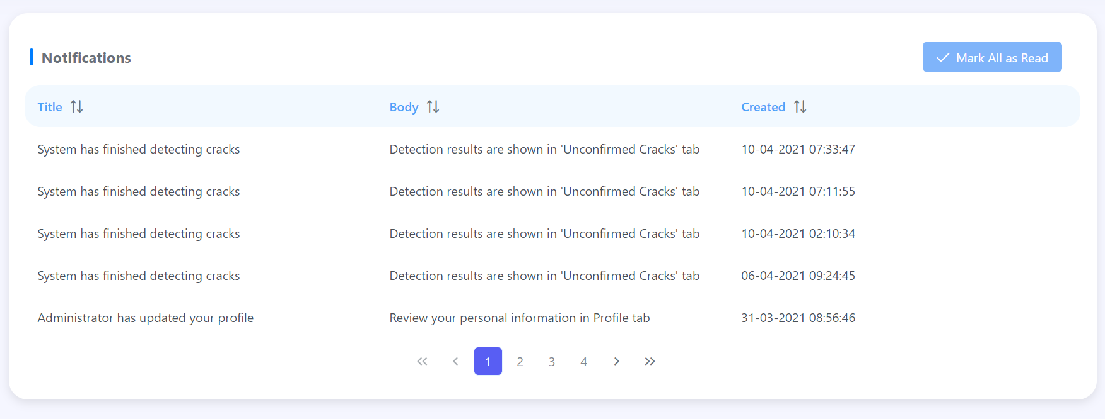

Figure . List of notifications screen

This function is for staff to view notifications, include the following elements:

* List of notifications.
* “Mark All as Read” button.

### 3.26 M1 – Staff: Authentication/Authorization

#### a. Login mobile app

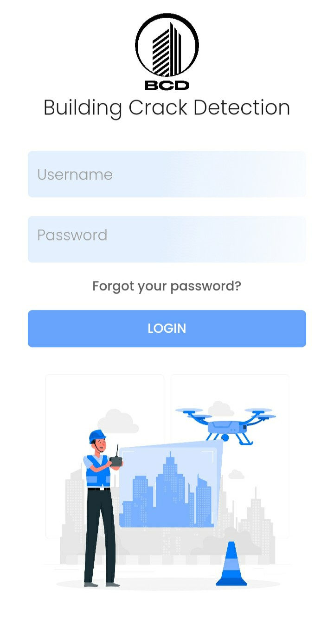

Figure . Login screen

This function is for staffs to use their account logging into system, include requirements:

* Staff has to input required fields: Username, Password.
* “Login” button.
* “Forgot your password?” link.

#### b. Forgot password

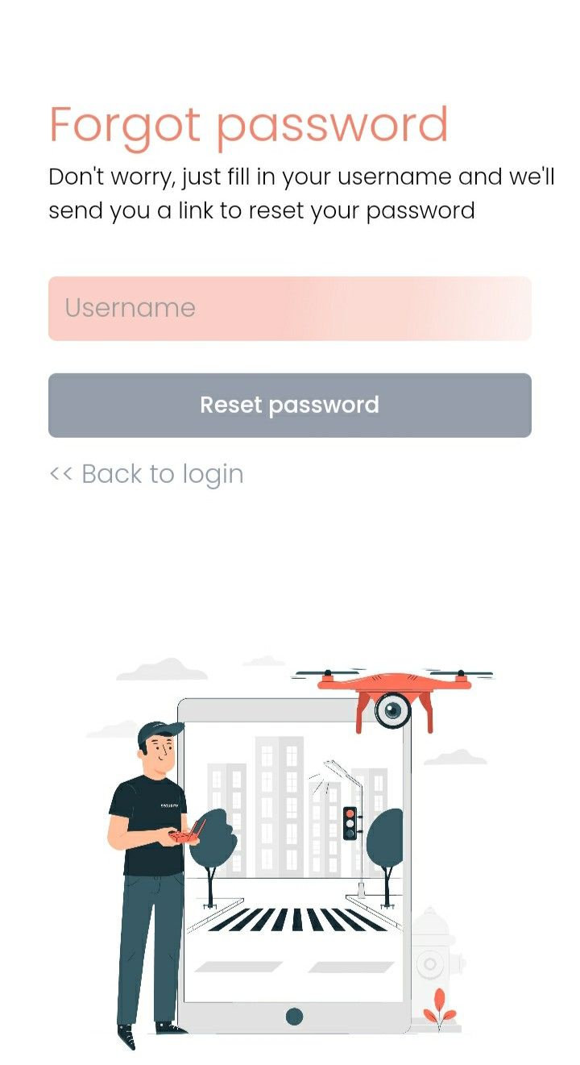

Figure . Forgot password screen

This function is for staffs to reset password, include requirements:

* Staff has to input required field: Username.
* “Reset password” button.
* “Back to login” link.

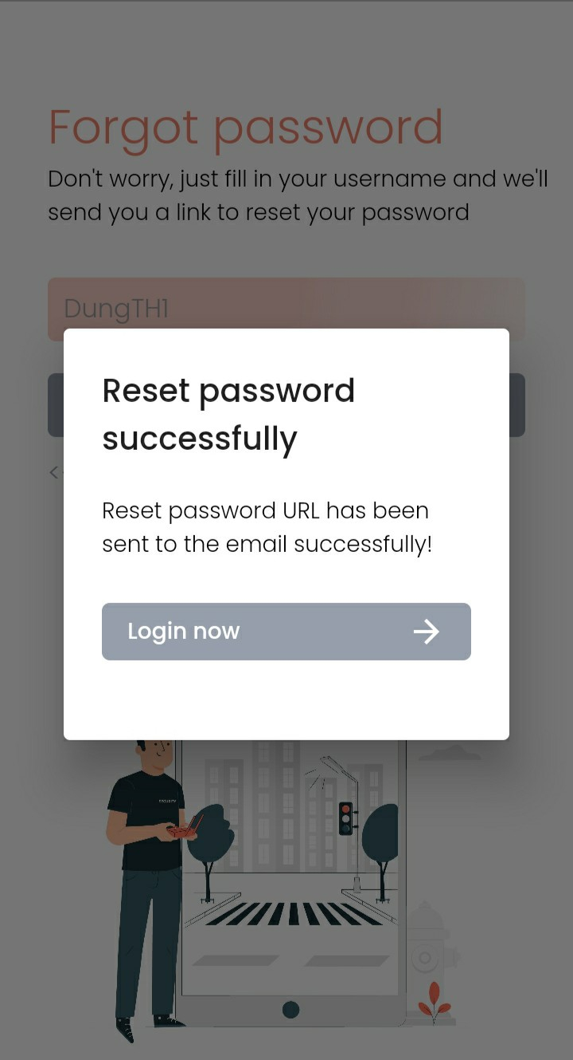

Figure . Reset password screen

After input Username, BCD system will send a reset password URL to staff’s email.

### 3.27 M2 – Staff: Manage Cracks

#### a. View list not-verify cracks

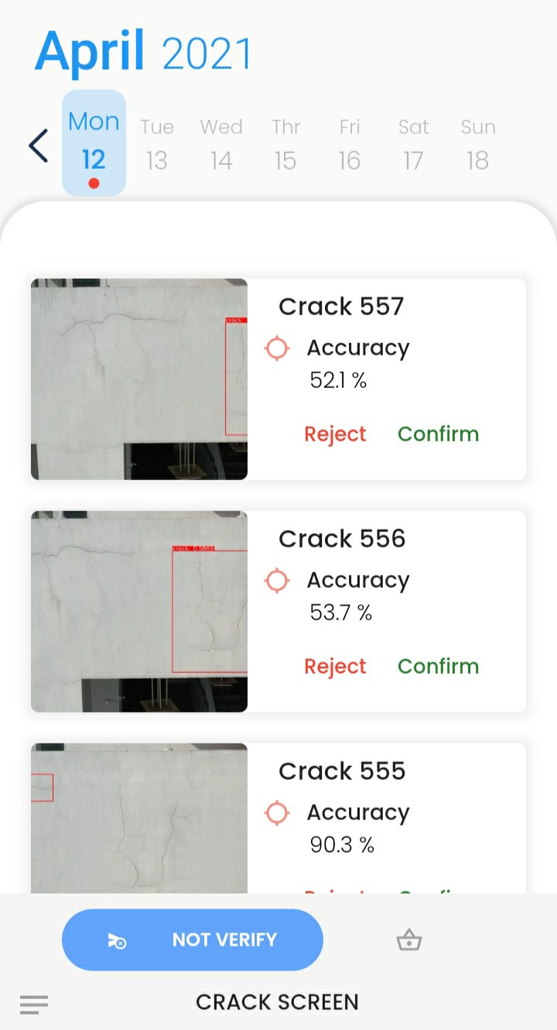

Figure . Not verified cracks screen

This function is for staffs to view list not-verify-cracks, include the following information:

* Calendar.
* List of not-verify-cracks.

#### b. Confirm crack

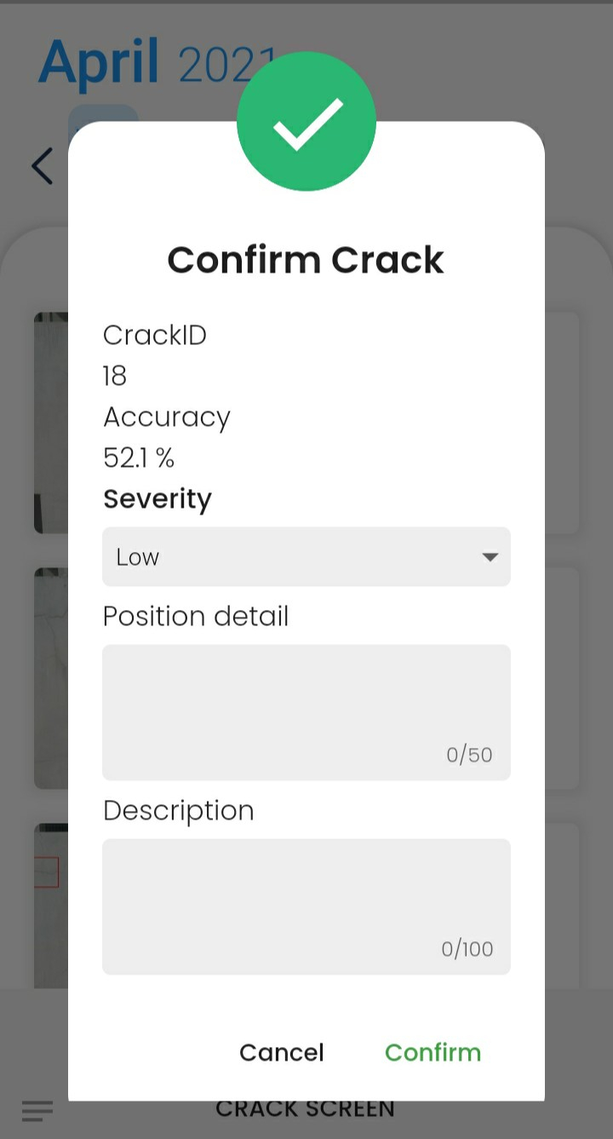

Figure . Confirm crack popup

This function is for staffs to confirm crack, include requirements:

* System auto-fill fields: CrackID, Accuracy.
* Staff has to input/select required fields: Severity, Position detail.
* Optional field: Description.

#### c. Reject crack

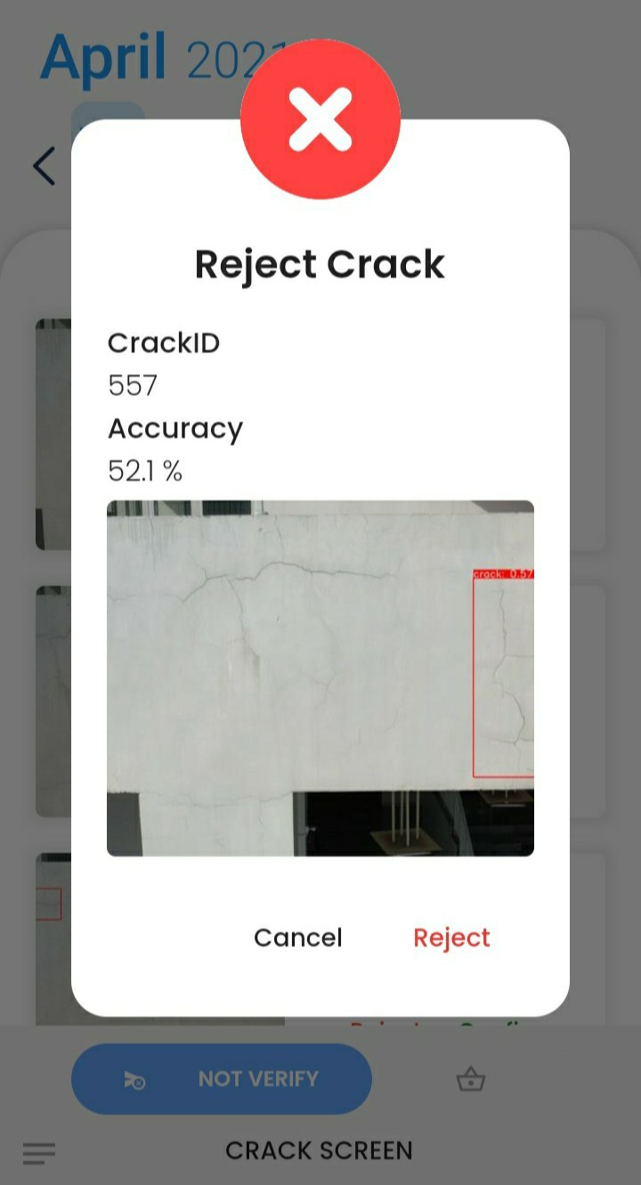

Figure . Reject crack popup

This function is for staffs to confirm crack, include requirements:

* System auto-fill fields: CrackID, Accuracy.
* Staff has to confirm Reject or Cancel.

#### d. View list verify-crack

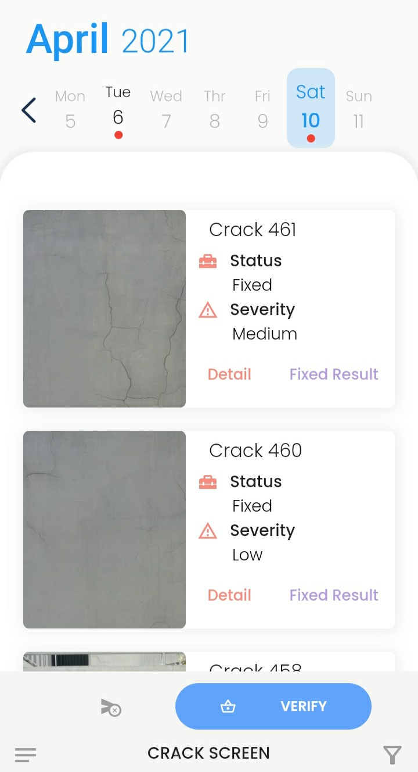

Figure . Verified cracks screen

This function is for staffs to view list verify-cracks, include the following information:

* Calendar.
* List of verify-cracks.

#### e. View crack detail – not add to queue yet

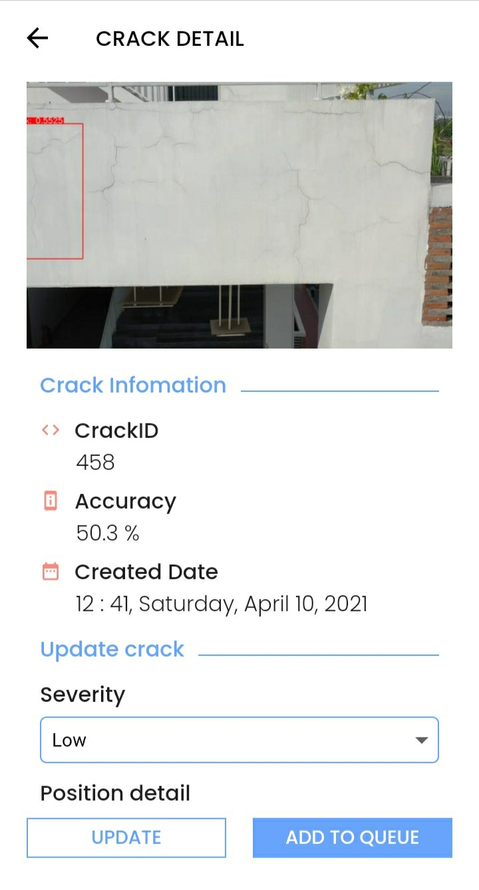

Figure . Crack details screen

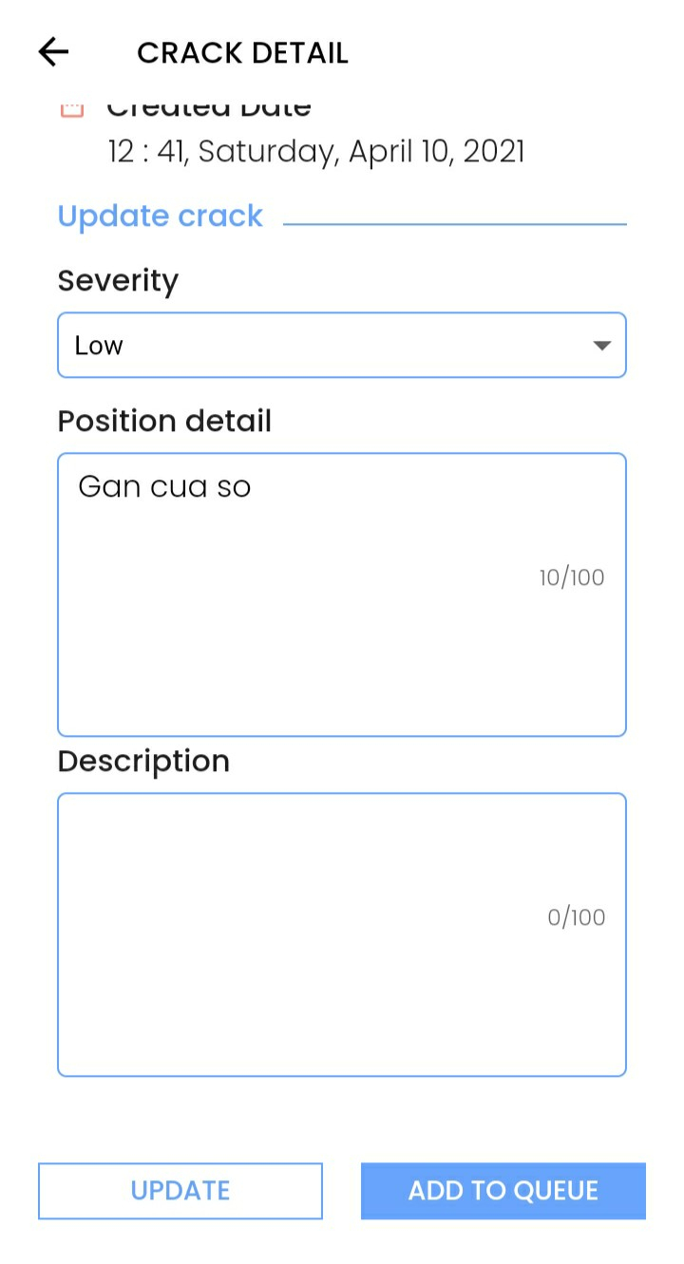

Figure . Crack details screen

This function is for staffs to view detail information of crack that not add to queue yet, include the following information:

* Crack image.
* System auto-fill fields:
  + Crack information: CrackID, Accuracy, Created Date, Position detail.
* Update crack fields: Severity, Position detail, Description.
* “Update” button.
* “Add to queue” button.

#### f. View crack detail – repair recorded

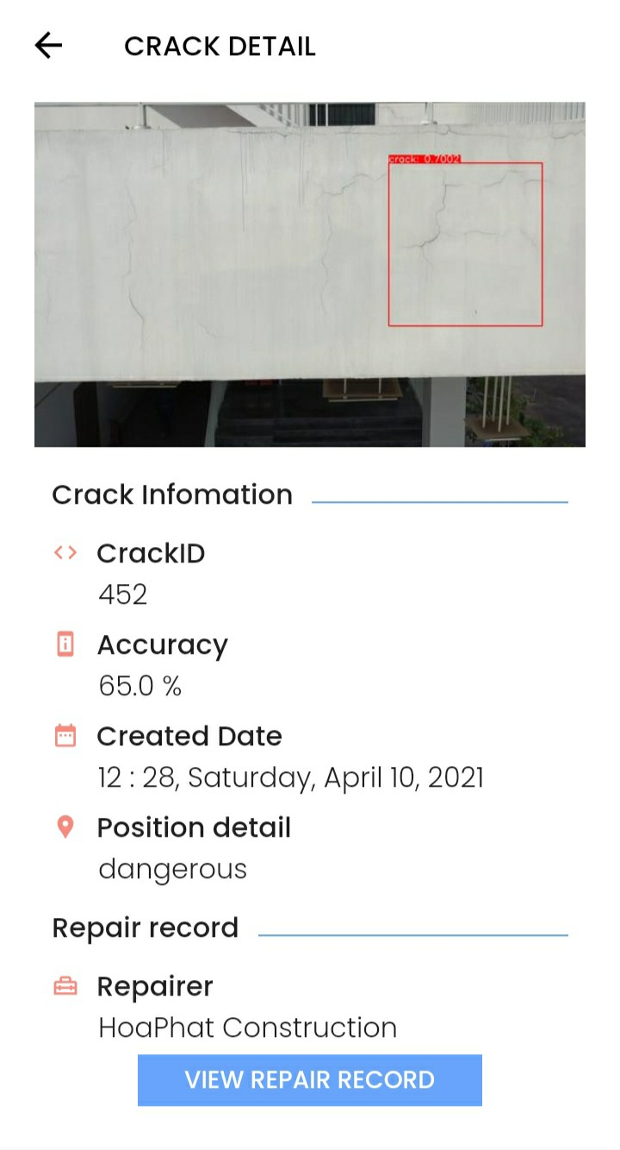

Figure . Crack details screen

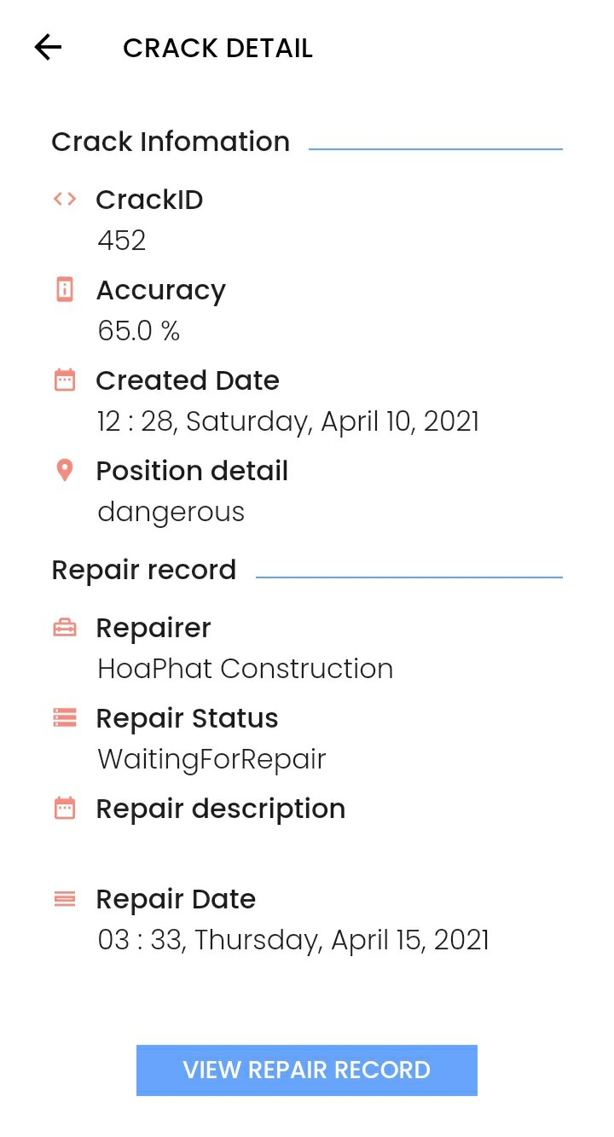

Figure . Crack details screen

This function is for staffs to view detail information of crack that has been recorded repair, include the following information:

* Crack image.
* System auto-fill fields:
  + Crack information: CrackID, Accuracy, Created Date, Position detail.
  + Repair record: Repairer, Repair Status, Repair Description, Repair Date.
* “View repair record” button.

#### g. View crack detail – fixed

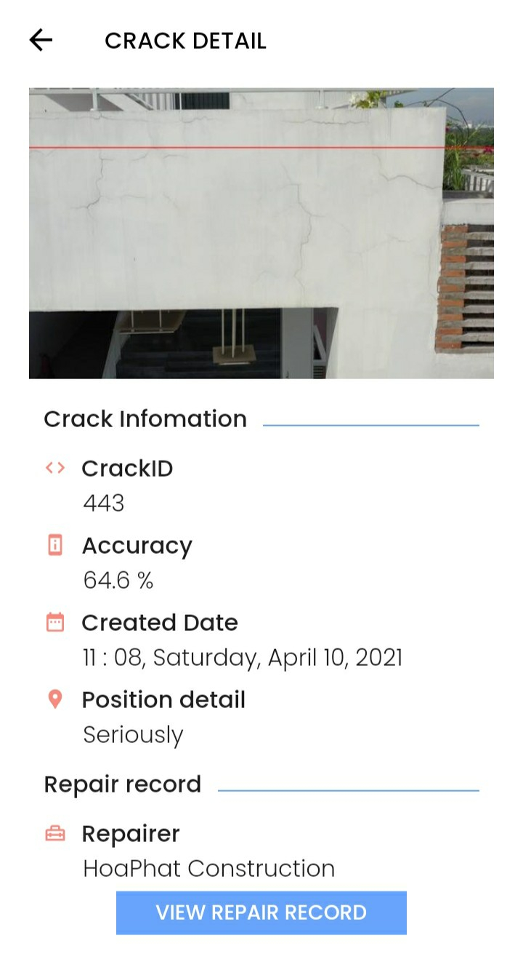

Figure . Crack details screen

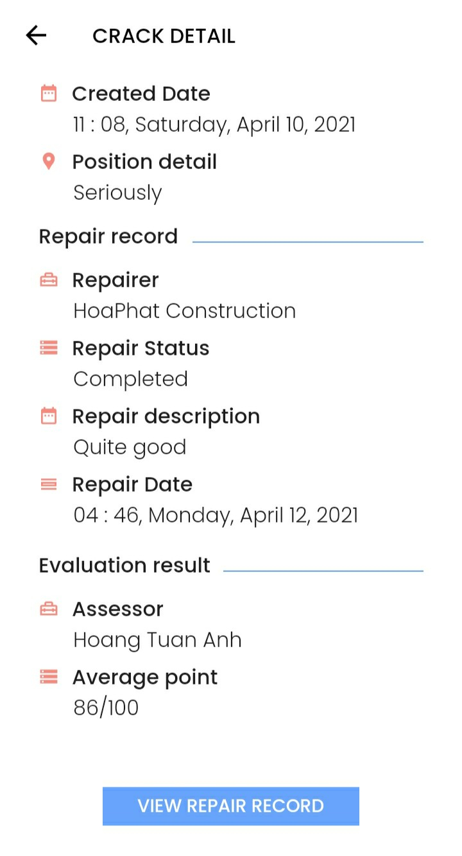

Figure . Crack details screen

This function is for staffs to view detail information of crack that has been fixed, include the following information:

* Crack image.
* System auto-fill fields:
  + Crack information: CrackID, Accuracy, Created Date, Position detail.
  + Repair record: Repairer, Repair Status, Repair Description, Repair Date.
  + Evaluation result: Assessor, Average point.
* “View repair record” button.

#### h. Add to queue

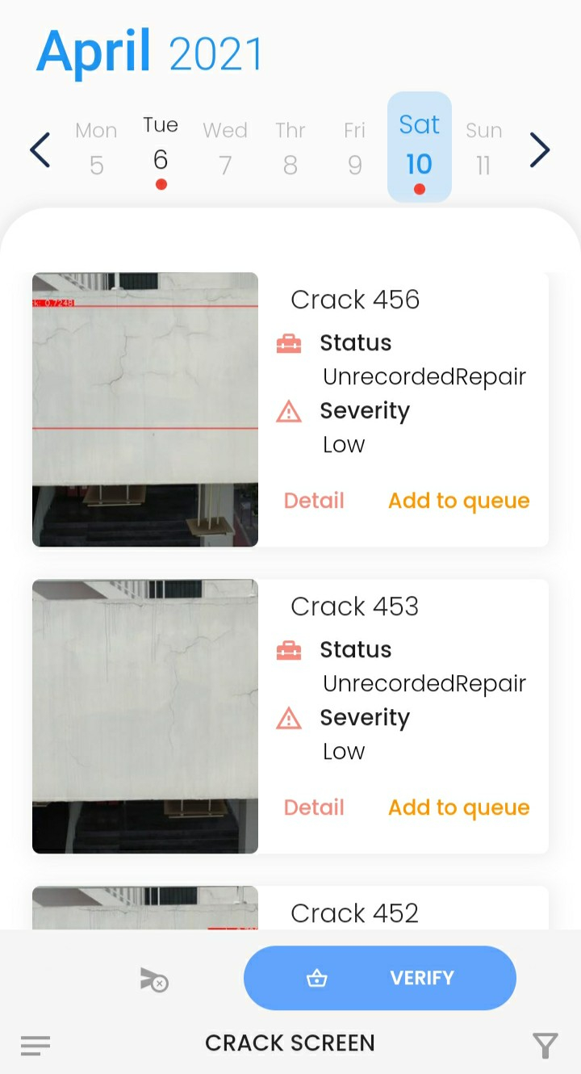

Figure . Verified cracks screen

This function is for staffs to add crack to queue to wait for repairing by clicks “Add to queue” button on each crack that want to add.

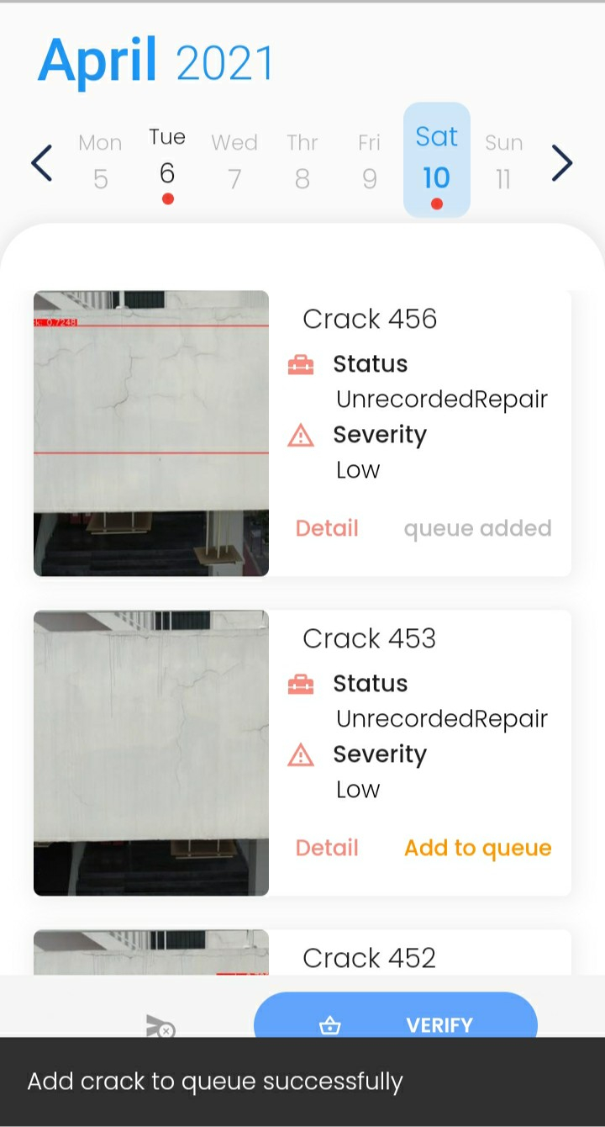

Figure . Verified cracks screen

After added, “Add to queue” button will be replaced by status “queue added” and BCDS show a success message.

### 3.28 M3 – Staff: Manage Repair Records

#### a. Add to queue

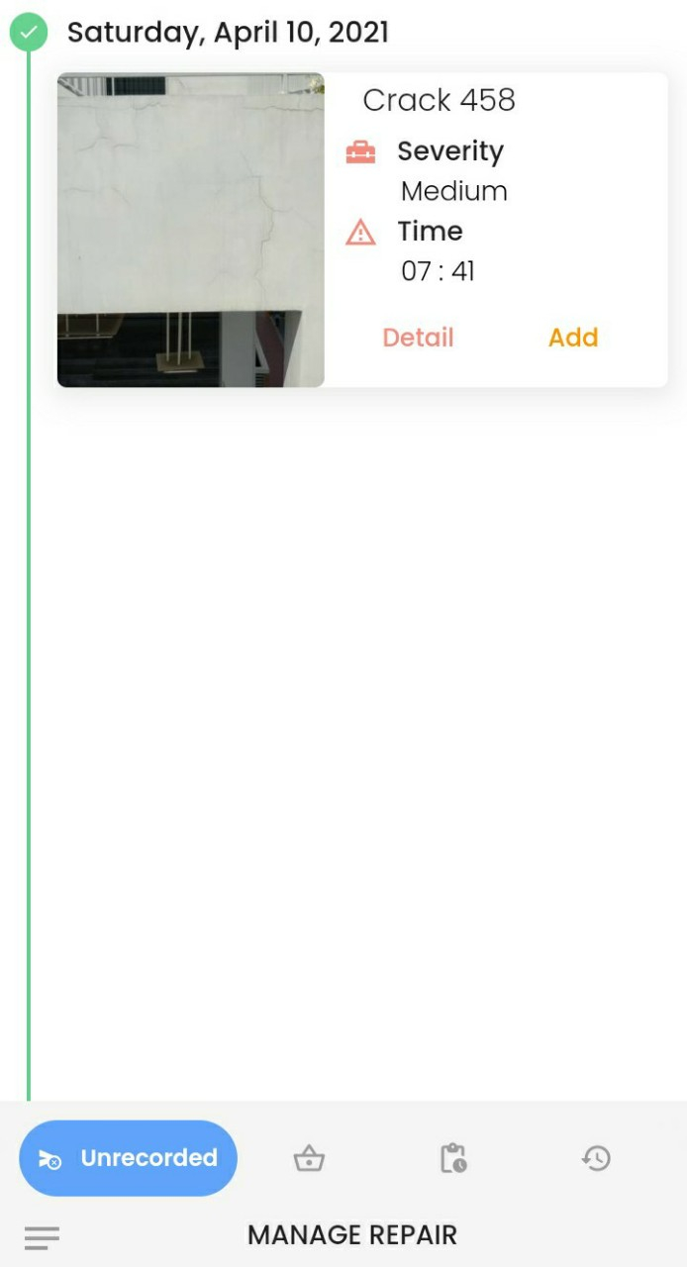

Figure . Unrecorded cracks screen

This function is for staffs to add crack to queue to wait for repairing by clicks “Add to queue” button on each crack that want to add.

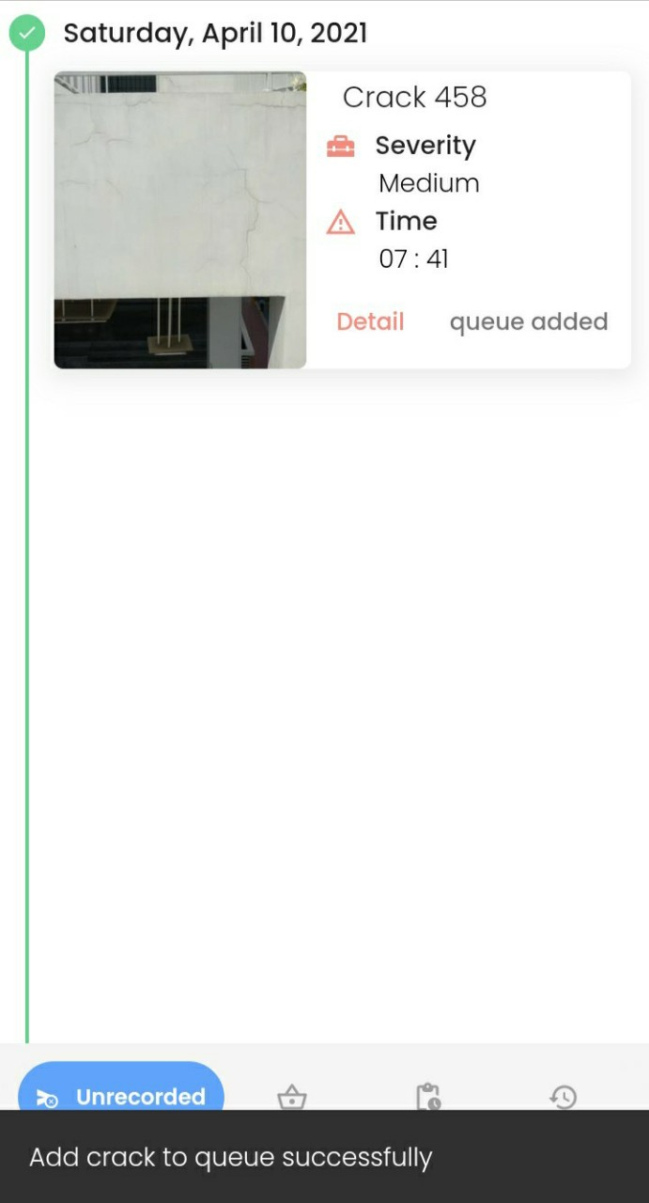

Figure . Unrecorded cracks screen

After added, “Add to queue” button will be replaced by status “queue added” and BCDS show a success message.

#### b. Repair record

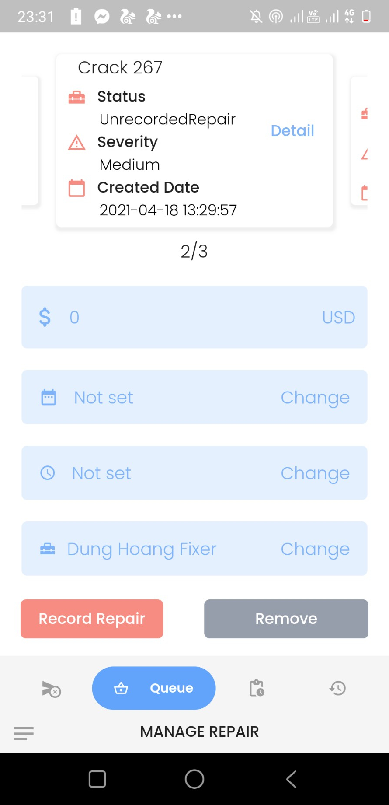

Figure . Queue screen

This function is for staffs to record a repair, include requirements:

* Staff has to input/select required fields: Expense, Date, Time, Repairer.

#### c. Remove from queue



Figure . Queue screen

This function is for staffs to remove crack from queue by clicks “Remove” button then BCDS shows a bottom sheet with a list of cracks in queue (severity is medium).

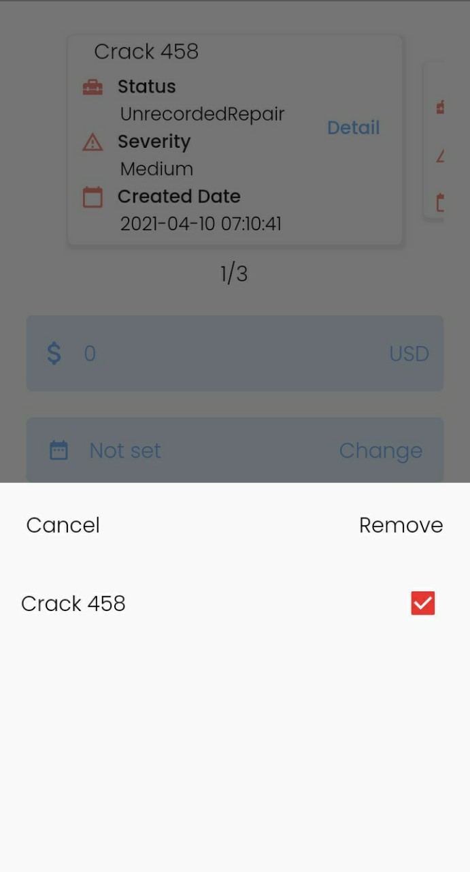

Figure . Remove cracks bottom slide

Staff checks on crack that want to remove then clicks “Remove” button.

#### d. Evaluate repair

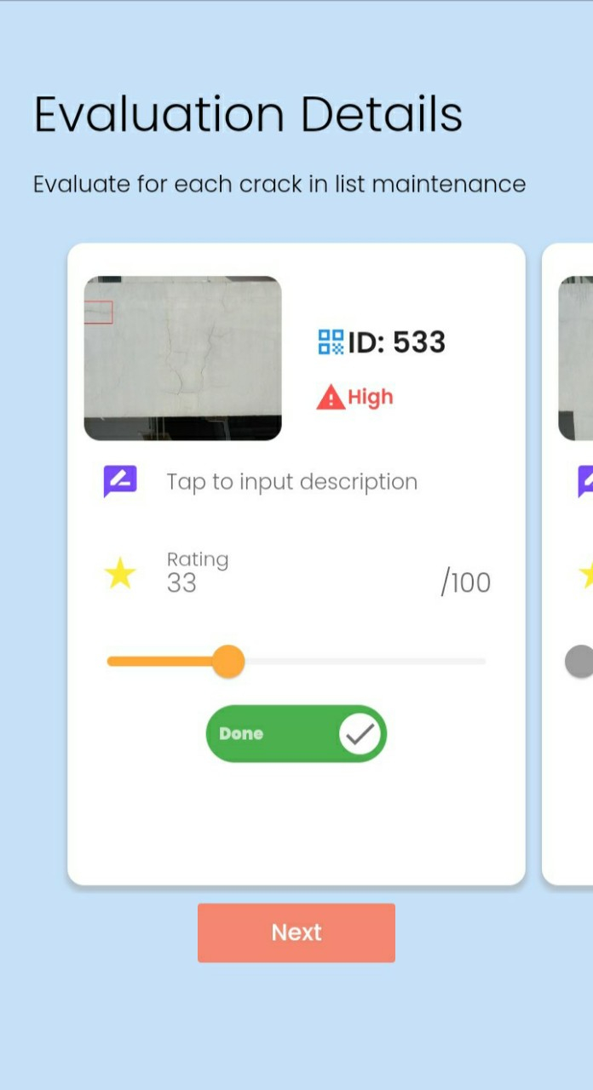

Figure . Evaluation details screen

This function is for staffs to evaluate a repair. Firstly, staff goes to “Evaluation Details” screen, evaluate each crack then click “Next” button.

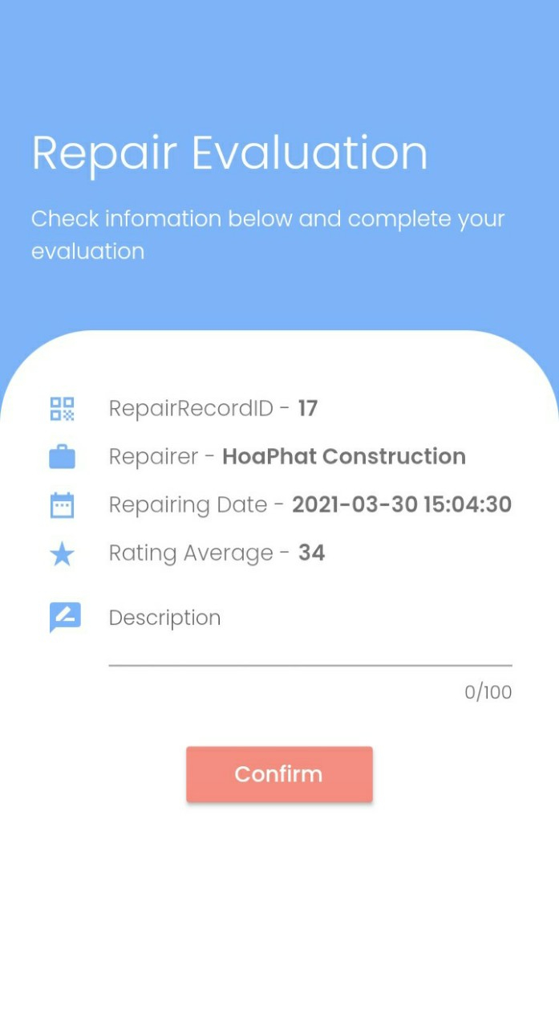

Figure . Repair evaluation screen

BCDS directs to “Repair Evaluation” screen, staff input Description field and choose “Confirm” button.

#### e. View history

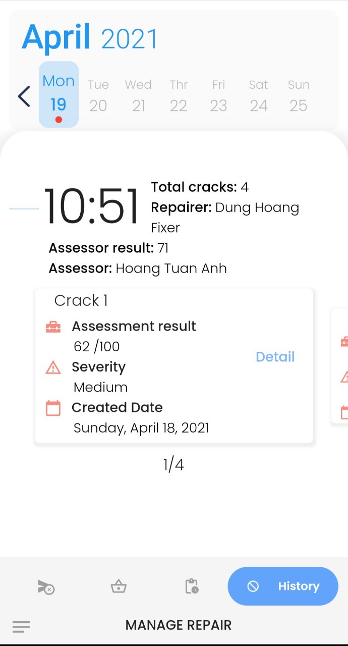

Figure . History screen

This function is for staffs to view history of repair record that is evaluated by going to “History” tab.

### 3.29 M4 – Staff: Manage Profile

#### a. View profile

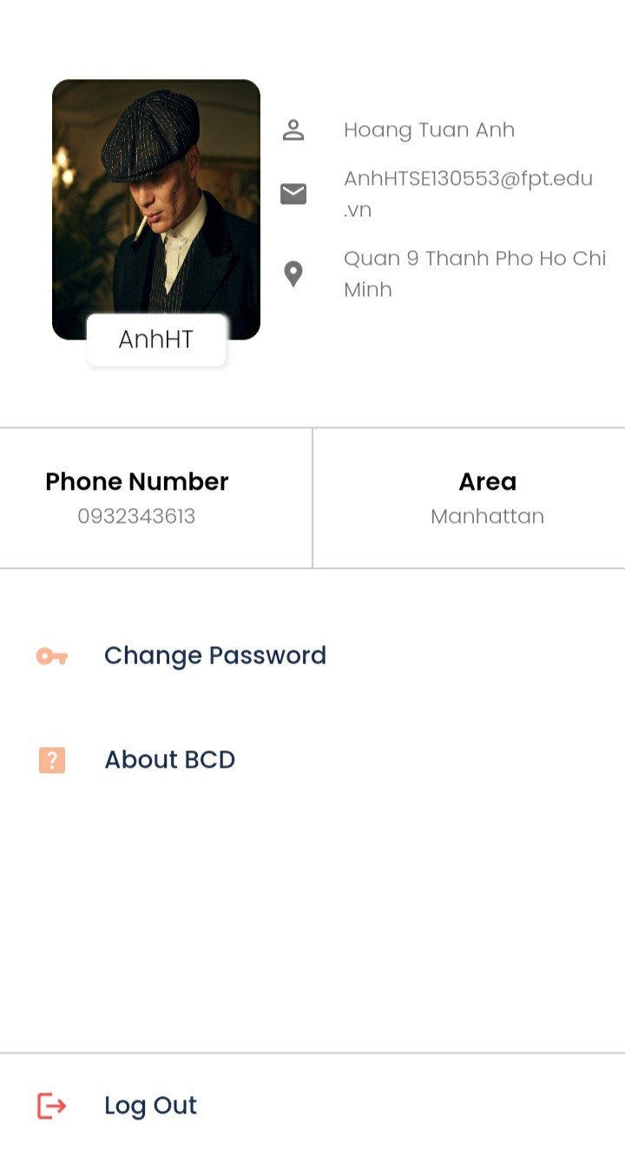

Figure . Profile screen

This function is for staffs to view own profile, include the following information:

* Image.
* User Name.
* Full Name.
* Email.
* Address.
* Phone Number.
* Area.
* “Change Password” button.
* “Log Out” button.

#### b. Change password

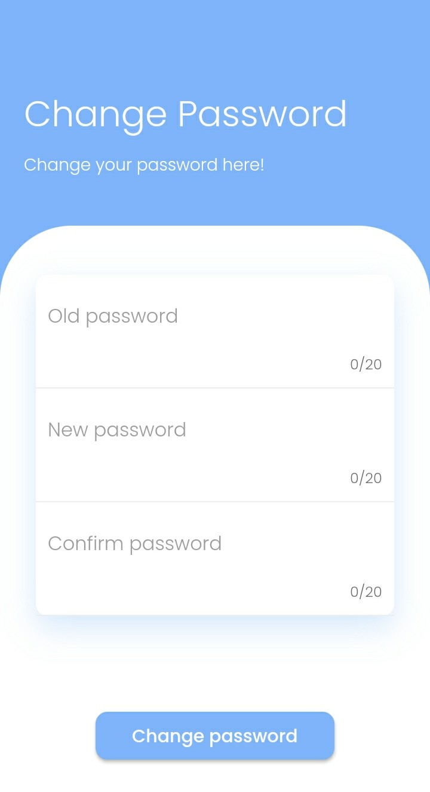

Figure . Change password screen

This function is for staffs to change own password, include requirements:

* Staff has to input/select required fields: Old password, New password, Confirm password.

### 3.30 M5 – Staff: View Notifications

#### a. View list notifications

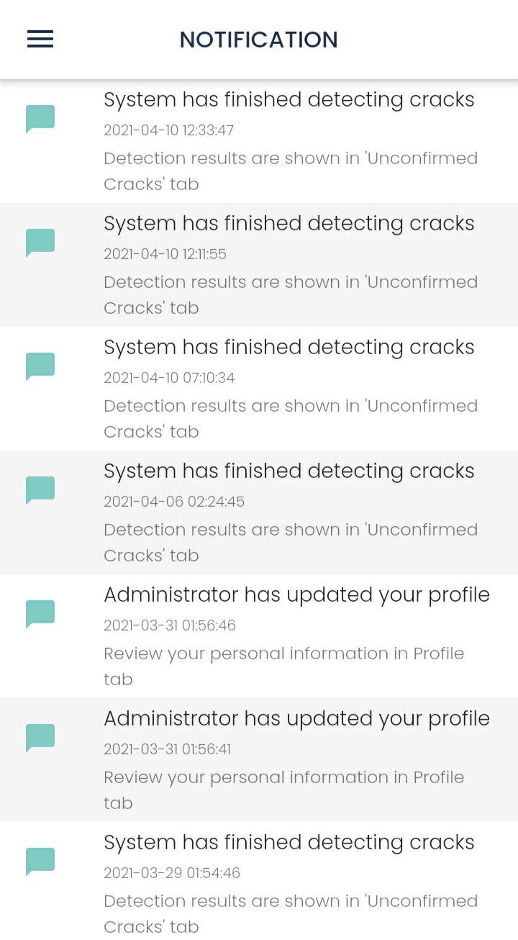

Figure . List of notifications screen

This function is for staffs to view list of notifications by choosing “Notification” tab.

#### b. View notification detail

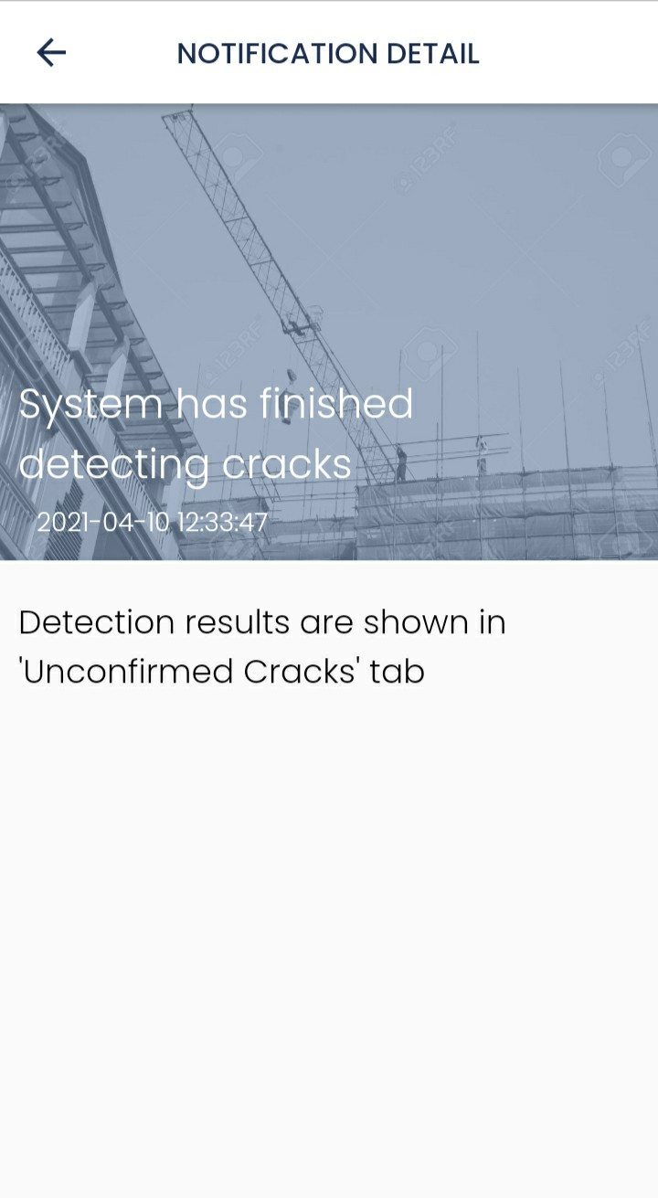

Figure . Notification details screen

This function is for staffs to view notification detail by choosing one notification.

## 4. Non-Functional Requirements

### 4.1 External Interfaces

#### a. User Interfaces

UI-1: UI must be in English.

UI-2: GUI must be friendly, clear and easy to use.

UI-3: Information content pages should be concise, clear and users can focus easily.

UI-4: Content will fit the screen of almost android phone, allows users to view the main content without zooming or scrolling horizontally.

UI-5: Elements are designed for touching gesture to help users interact with app easily and more comfortable.

UI-6: Background and font colors have great contrast to help users easy to read text.

#### b. Software Interfaces

SI-1:Web application: browser Google Chrome (version 70 or higher) and Firefox (version 60 or higher), Internet Explorer (version 10 or higher) or with any web browser that support HTML5 & CSS3.

SI-2:Mobile application: phone operating system requires Android version 6.0 or higher.

#### c. Hardware Interfaces

HI-1: Desktop or laptop.

HI-2: Drone.

#### d. Communications Interfaces

CI-1: System handler will send notifications or emails to admin, manager, staff based on specific functions.

### 4.2 Quality Attributes

#### a. Usability

* Users will probably take at least 2 days to learn how to use the system.
* The UI of website fits for each browser on each device.
* The system should be intuitive and easy so that even non-IT staff can use.

#### b. Reliability

* The accuracy of crack detection must be over 70%.
* The likelihood of application failure must be less than 5%.

#### c. Performance

* The system must be able to handle continuous video streams from the drone.
* Normal response time is less than 500ms.

#### d. Dependability

##### d1. Security

* Each role in system can only access its own functions.
* Only Admin has full access to system.
* Before saving data to database, all input is validated.

##### d2. Safety

* Integration of BCD system is low-impact on the workflow of workers.

#### e. Supportability

* Should apply RESTFUL Web API Standard.
* Should follow the coding convention.
* All development tools should be listed with attached documents.

#### f. Design Constraints

* Using OpenCV and open source frameworks.
* Coding language:
  + Python: image processing and detection.
  + C#: back-end server.
  + Dart: UI of mobile programming.
  + Javascript: UI of web programming.

#### g. Support Documents

* Manual documents should be step-by-step, simple and clear.
* Installation instructions should be easy and straightforward.
* Include full of configuration parameters.

#### h. Purchased Components

* Microsoft Azure

## 5. Other Requirements

N/A

# IV. Software Design Description

## 1. Overall Description

### 1.1 Assumptions

This system is designed basing on these following assumptions:

* Software/OS:
  + Windows 10
  + Google Chrome browser
  + SQL Server 2019
  + .NET 5.0
  + NodeJS 14.16.1
  + Flutter 1.22.4
* Hardware:
  + Computer that have internet connection
  + Drone

### 1.2 Design Constraints

* End-user environment: OS with have Chrome, android phone, drone.
* Network communication: this system works based on the network connection.

## 2. System Architecture Design

### 2.1 Overall Architecture

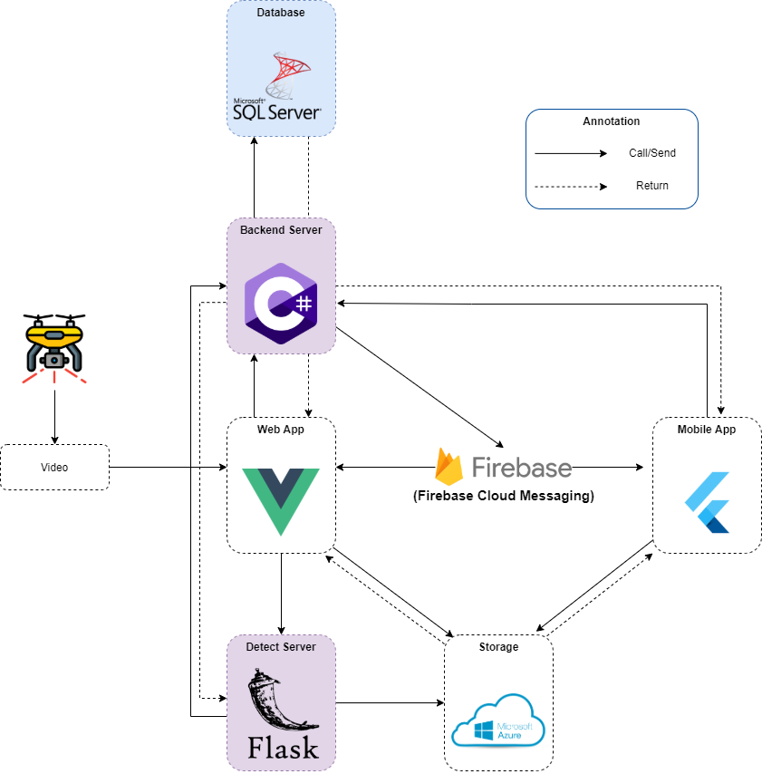

Figure . Overall architecture

### 2.3 Package Diagram

Figure . <Package Diagram> Back-end

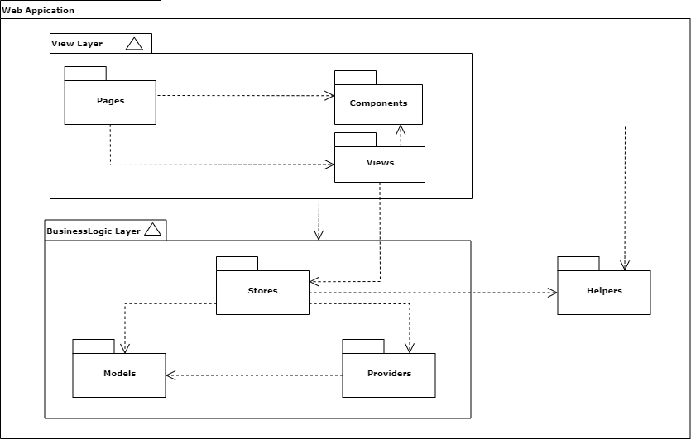

Figure . <Package Diagram> Web App

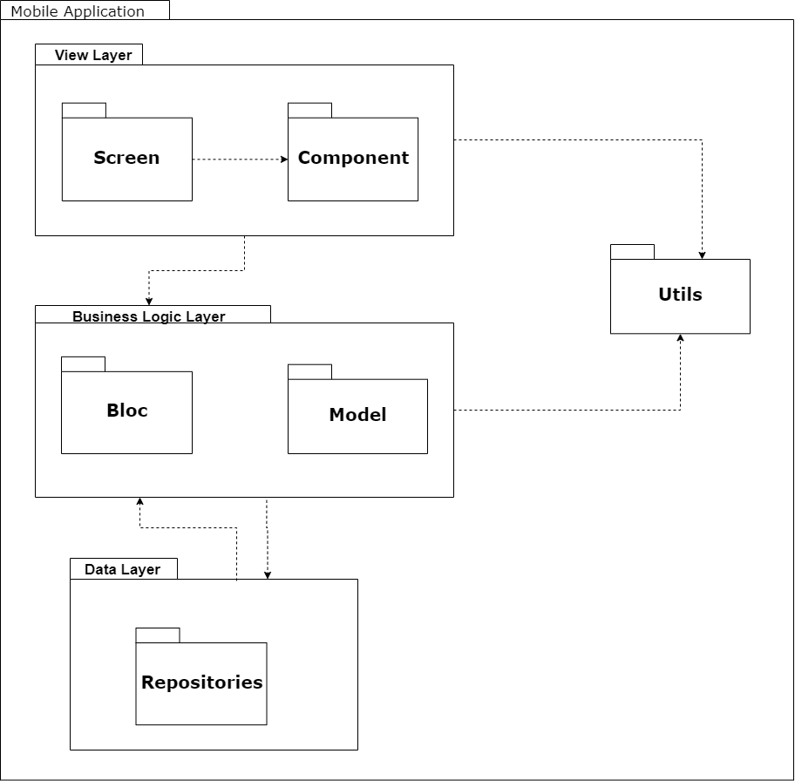

Figure . <Package Diagram> Mobile App

## 3. System Detailed Design

### 3.1 Class Diagram

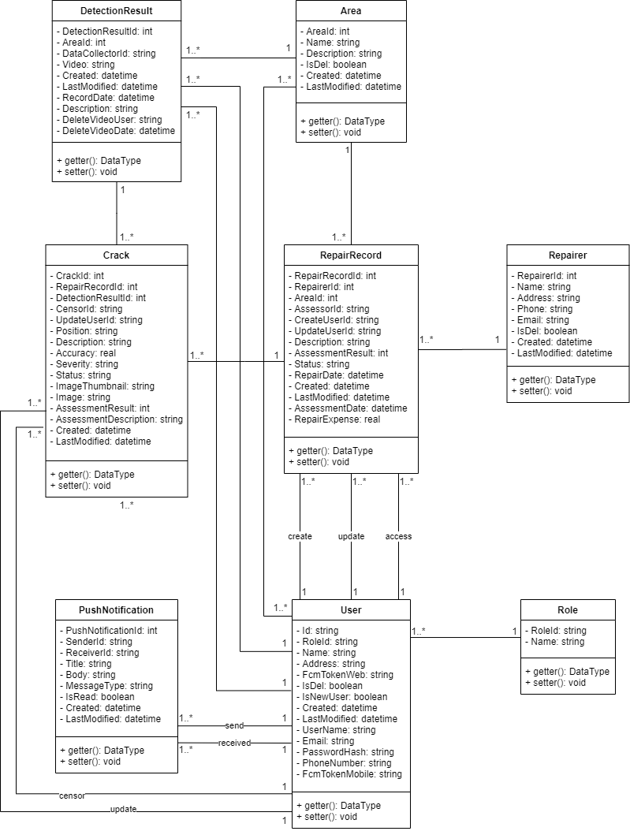

Figure . Class diagram

### 3.2 Class Specification

#### a. Area

Table . <Class Specification> Area

|  |  |  |
| --- | --- | --- |
| **Property** | **Type** | **Description** |
| AreaId | int | Unique identifier of area |
| Name | string | Name of location |
| Description | string | Description of area |
| IsDel | boolean | Delete status of area |
| Created | datetime | Created date of area |
| LastModified | datetime | Last modified date of area |
| getter() | data type | Get attribute of class |
| setter() | void | Set value of class’s attribute |

#### b. Crack

Table . <Class Specification> Crack

|  |  |  |
| --- | --- | --- |
| **Property** | **Type** | **Description** |
| CrackId | int | Unique identifier of crack |
| RepairRecordId | int | Unique identifier of repair record |
| DetectionResultId | int | Unique identifier of detection result |
| CensorId | string | Unique identifier of censor |
| UpdateUserId | string | Unique identifier of updater |
| Position | string | Position of crack |
| Description | string | Description of crack |
| Accuracy | real | Accuracy of crack |
| Severity | string | Severity of crack |
| Status | string | Status of crack |
| ImageThumbnail | string | Image Thumbnail of crack |
| Image | string | Image of crack |
| AssessmentResult | int | Assessment result of crack |
| AssessmentDescription | string | Assessment description of crack |
| Created | datetime | Created date of crack |
| LastModified | datetime | Last modified date of crack |
| getter() | data type | Get attribute of class |
| setter() | void | Set value of class’s attribute |

#### c. Repair Record

Table . <Class Specification> Repair record

|  |  |  |
| --- | --- | --- |
| **Property** | **Type** | **Description** |
| RepairRecordId | int | Unique identifier of repair record |
| RepairerId | int | Unique identifier of repairer |
| AreaId | int | Unique identifier of area |
| AssessorId | string | Unique identifier of assessor |
| CreateUserId | string | Unique identifier of creator |
| UpdateUserId | string | Unique identifier of updater |
| Description | string | Description of repair record |
| AssessmentResult | int | Assessment result of repair record |
| Status | string | Status of repair record |
| RepairDate | datetime | Repair date of repair record |
| Created | datetime | Created date of repair record |
| LastModified | datetime | Last modified date of repair record |
| AssessmentDate | datetime | Assessment date of repair record |
| RepairExpense | real | Expense of repair record |
| getter() | data type | Get attribute of class |
| setter() | void | Set value of class’s attribute |

#### d. Users

Table . <Class Specification> User

|  |  |  |
| --- | --- | --- |
| **Property** | **Type** | **Description** |
| Id | string | Unique identifier of user |
| RoleId | string | Role of user |
| Name | string | Name of user |
| Address | string | Address of user |
| FcmTokenWeb | string | Firebase Token for web app of user |
| IsDel | boolean | Delete status of user |
| IsNewUser | boolean | New user status of user |
| Created | datetime | Created date of user |
| LastModified | datetime | Last modified date of user |
| UserName | string | Username of user |
| Email | string | Email of user |
| PasswordHash | string | Password of user |
| PhoneNumber | string | Phone of user |
| FcmTokenMobile | string | FcmTokenMobile of user |
| getter() | data type | Get attribute of class |
| setter() | void | Set value of class’s attribute |

#### e. Repairer

Table . <Class Specification> Repairer

|  |  |  |
| --- | --- | --- |
| **Property** | **Type** | **Description** |
| RepairerId | int | Unique identifier of repairer |
| Name | string | Name of repairer |
| Address | string | Address of repairer |
| Phone | string | Phone of repairer |
| Email | string | Email of repairer |
| IsDel | boolean | Delete status of repairer |
| Created | datetime | Created date of repairer |
| LastModified | datetime | Last modified date of repairer |
| getter() | data type | Get attribute of class |
| setter() | void | Set value of class’s attribute |

#### f. Push Notification

Table . <Class Specification> Push notification

|  |  |  |
| --- | --- | --- |
| **Property** | **Type** | **Description** |
| PushNotificationId | int | Unique identifier of notification |
| SenderId | string | Unique identifier of sender |
| ReceiverId | string | Unique identifier of receiver |
| Title | string | Title of notification |
| Body | string | Body of notification |
| MessageType | string | Type of notification |
| IsRead | boolean | Read status of notification |
| Created | datetime | Created date of notification |
| LastModified | datetime | Last modified date of notification |
| getter() | data type | Get attribute of class |
| setter() | void | Set value of class’s attribute |

#### g. Role

Table . <Class Specification> Role

|  |  |  |
| --- | --- | --- |
| **Property** | **Type** | **Description** |
| RoleId | string | Unique identifier of role |
| Name | string | Name of role |
| getter() | data type | Get attribute of class |
| setter() | void | Set value of class’s attribute |

#### h. Detection Result

Table . <Class Specification> Detection result

|  |  |  |
| --- | --- | --- |
| **Property** | **Type** | **Description** |
| DetectionResultId | int | Unique identifier of detection result |
| AreaId | int | Unique identifier of area |
| DataCollectorId | string | Unique identifier of data collector |
| Video | string | Video of detection result |
| Created | datetime | Created date of detection result |
| LastModified | datetime | Last modified date of detection result |
| RecordDate | datetime | Record date of video |
| Description | string | Description of detection result |
| DeleteVideoUser | string | User who delete detection video |
| DeleteVideoDate | datetime | Date and time user delete detection video |
| getter() | data type | Get attribute of class |
| setter() | void | Set value of class’s attribute |

### 3.3 Activity Diagrams

#### a. Login

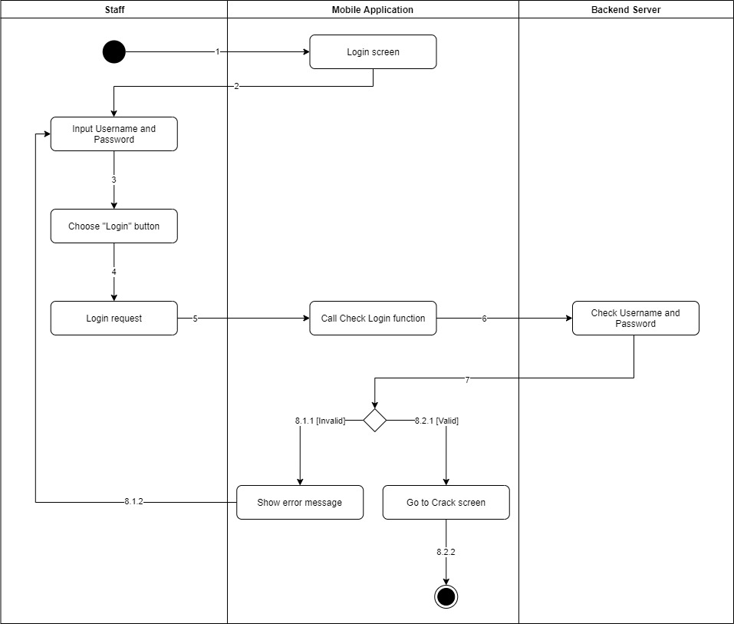

Figure 160. <Activity Diagram> Login

#### b. Logout

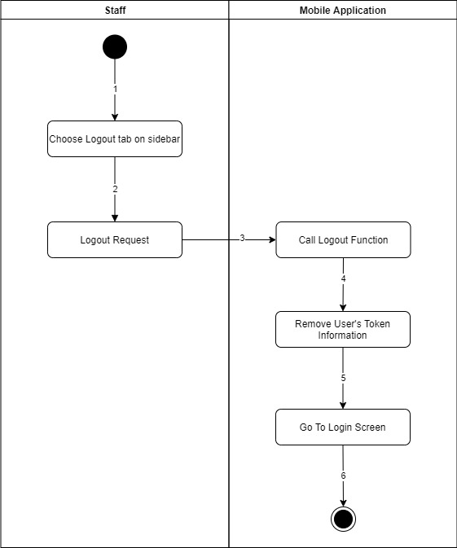

Figure 161. <Activity Diagram> Logout

#### c. Confirm Crack

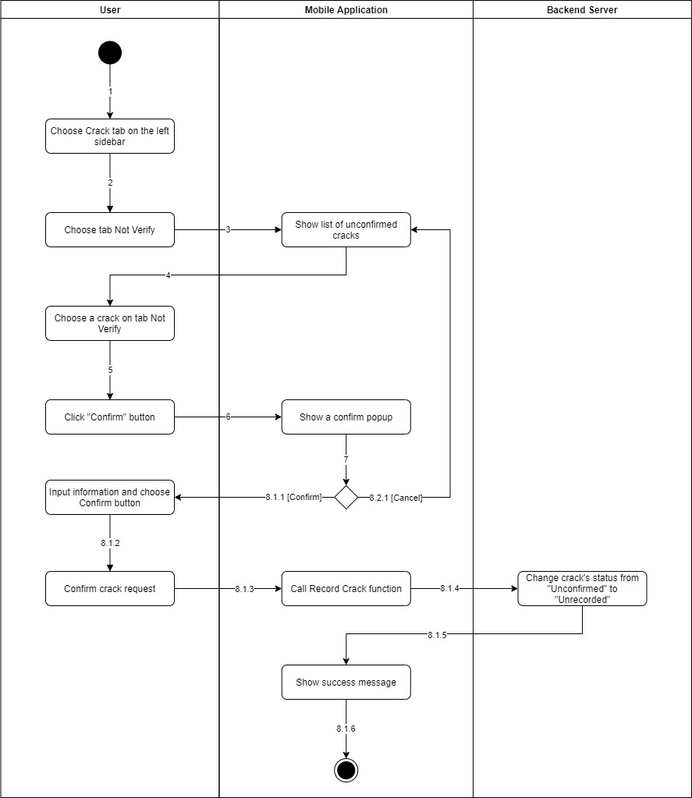

Figure 162. <Activity Diagram> Confirm crack

#### d. Reject Crack

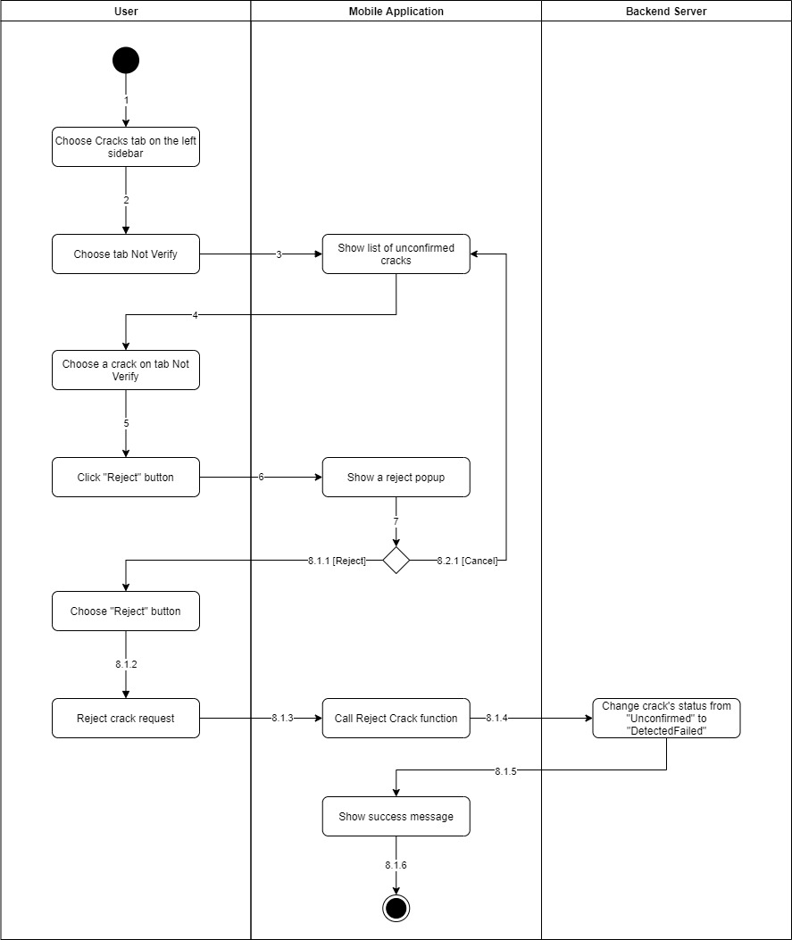

Figure 163. <Activity Diagram> Reject crack

#### e. Update Crack

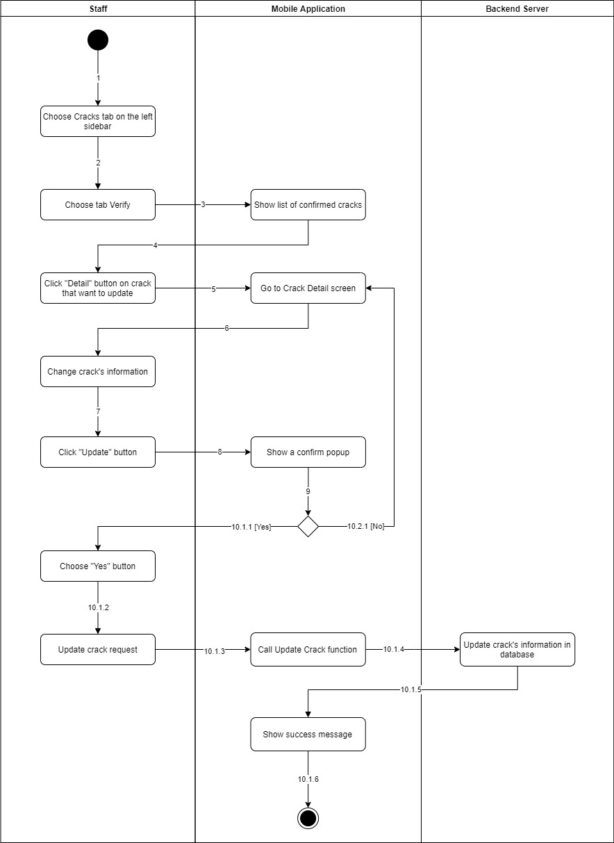

Figure 164. <Activity Diagram> Update crack

#### f. Add Crack To Queue

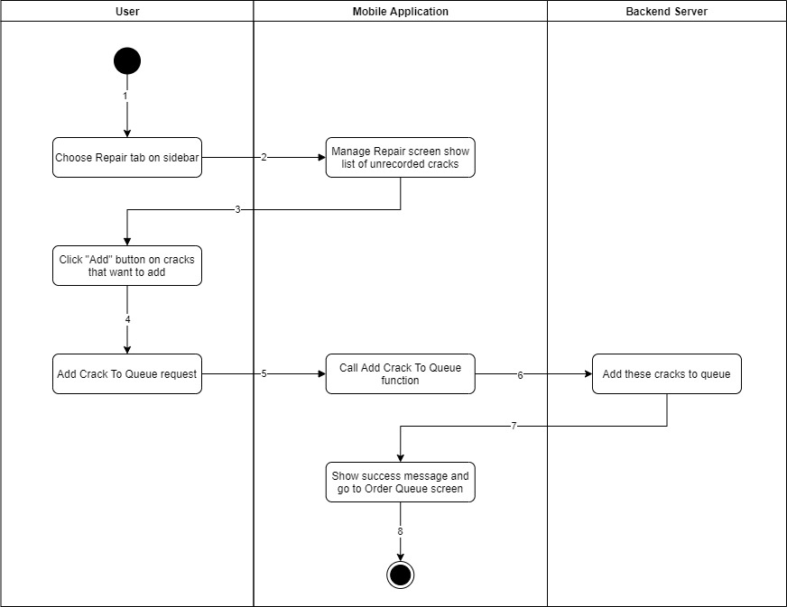

Figure 165. <Activity Diagram> Add crack to queue

#### g. Repair Record

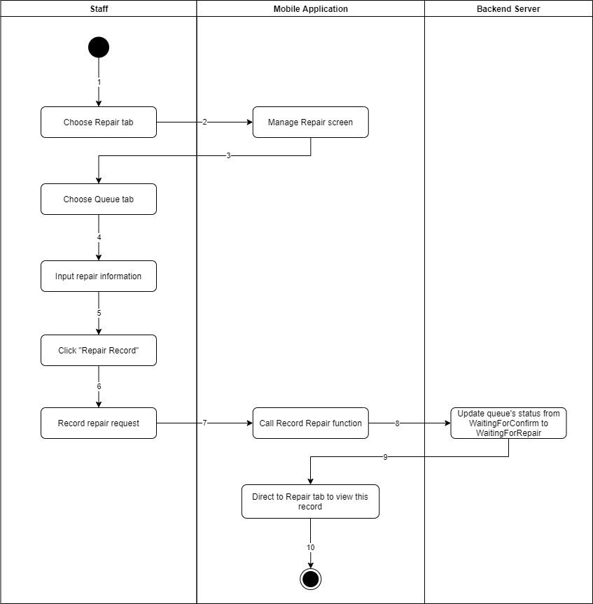

Figure 166. <Activity Diagram> Repair record

#### h. Evaluate Crack

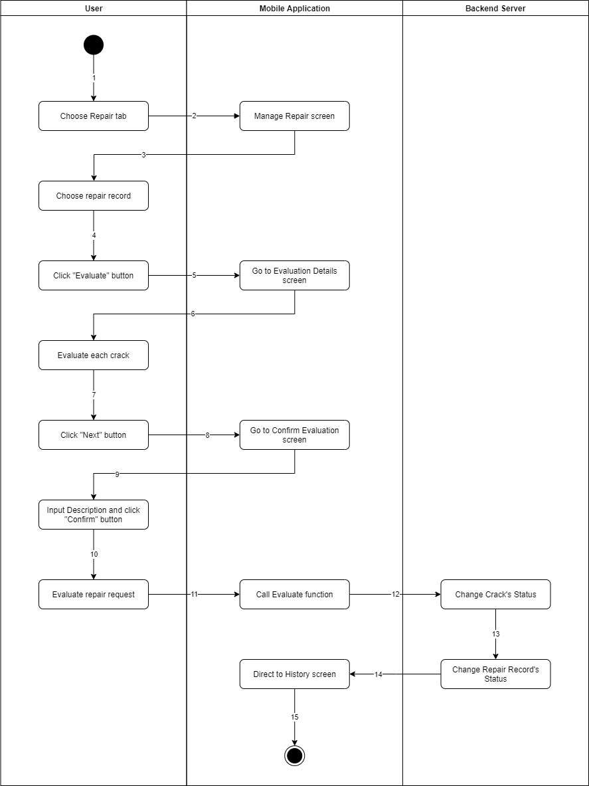

Figure 167. <Activity Diagram> Evaluate crack

### 3.4 Sequence Diagrams

#### a. Login

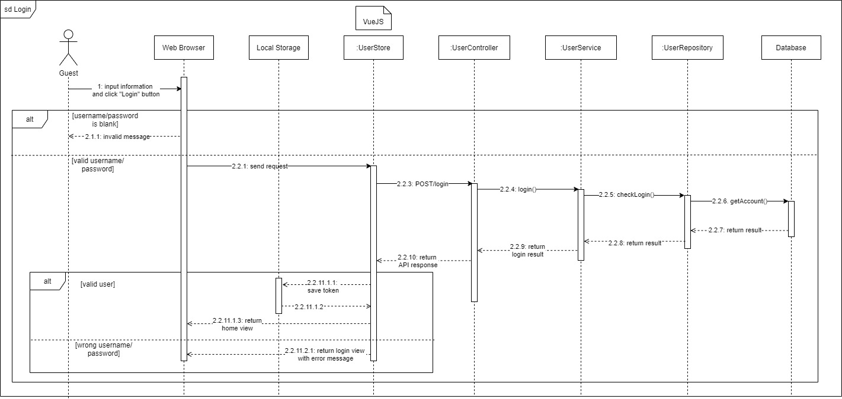

[Figure 168. <Sequence Diagram> Login](https://drive.google.com/file/d/1MKzaiWp8J6yOHegh5QzOFxClFxr8tbus/view?usp=sharing)

#### b. Create account

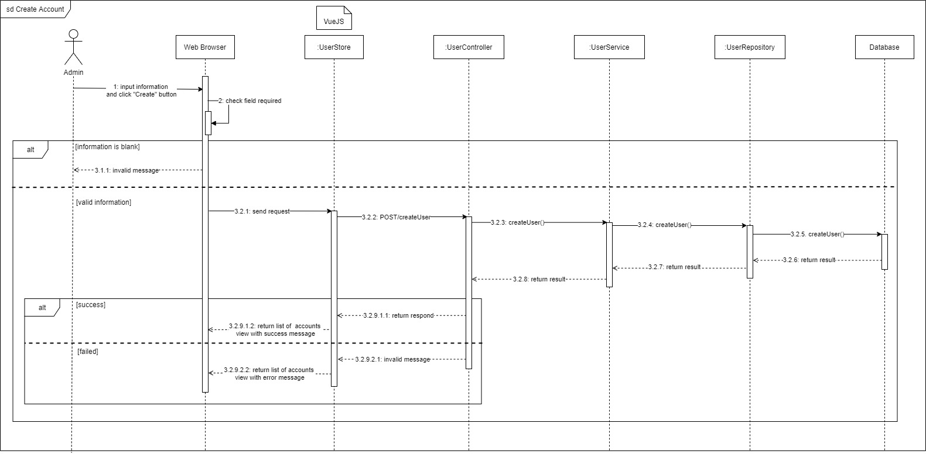

[Figure 169. <Sequence Diagram> Create account](https://drive.google.com/file/d/1HpU2gett4ms-GckrvRRE_4xhnvoXU-Sx/view?usp=sharing)

#### c. Update account

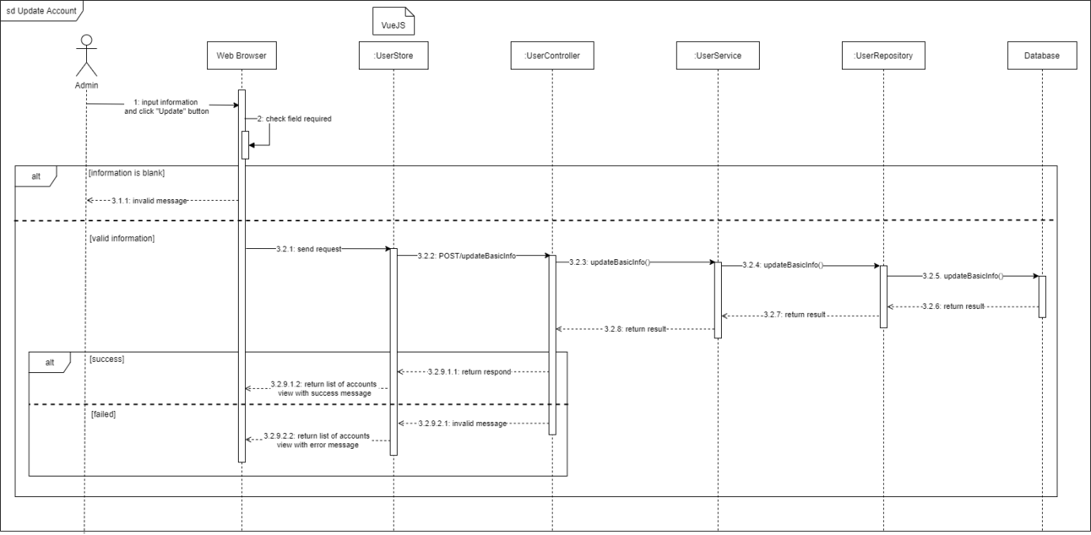

[Figure 170. <Sequence Diagram> Update account](https://drive.google.com/file/d/1cI6lJHGWWdNu3mTOE5_oL60KJtT6QJ2y/view?usp=sharing)

#### d. Delete account

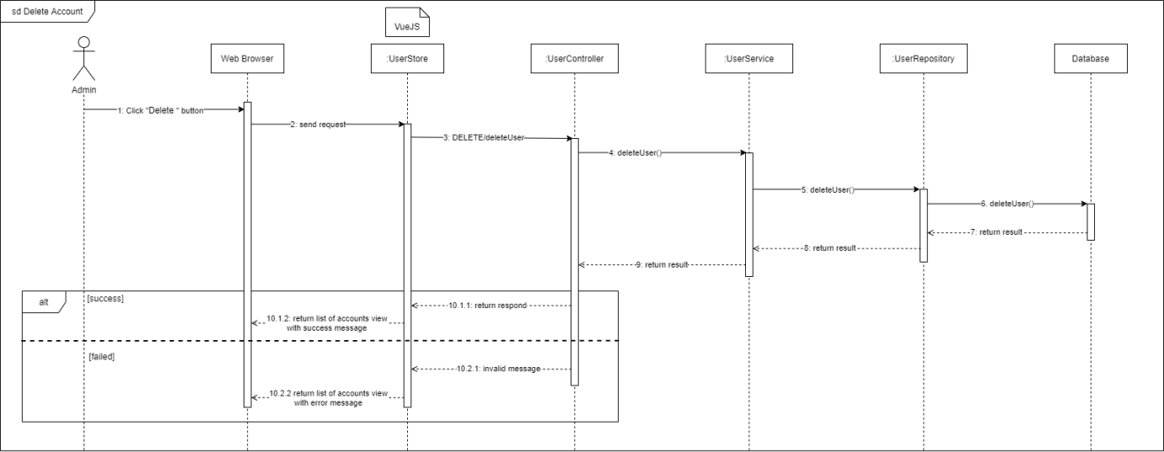

[Figure 171. <Sequence Diagram> Delete account](https://drive.google.com/file/d/1y65mJIdD5xDk1CmZ6G4XAOn_uJTMkJIA/view?usp=sharing)

#### e. Get list of accounts

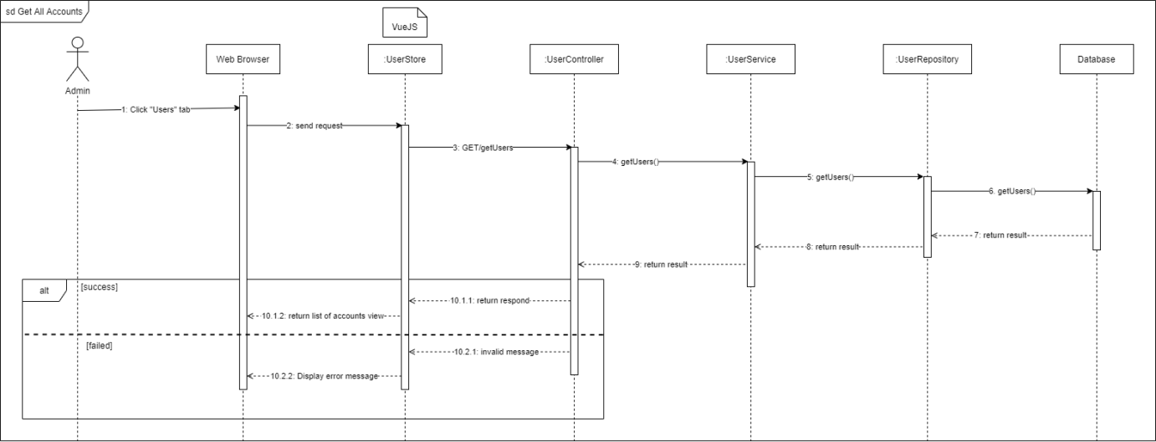

[Figure 172. <Sequence Diagram> Get list of accounts](https://drive.google.com/file/d/1srdrxR6GhzzJDSR4yHnHJ3CkbirUQNKq/view?usp=sharing)

#### f. Get list of staffs

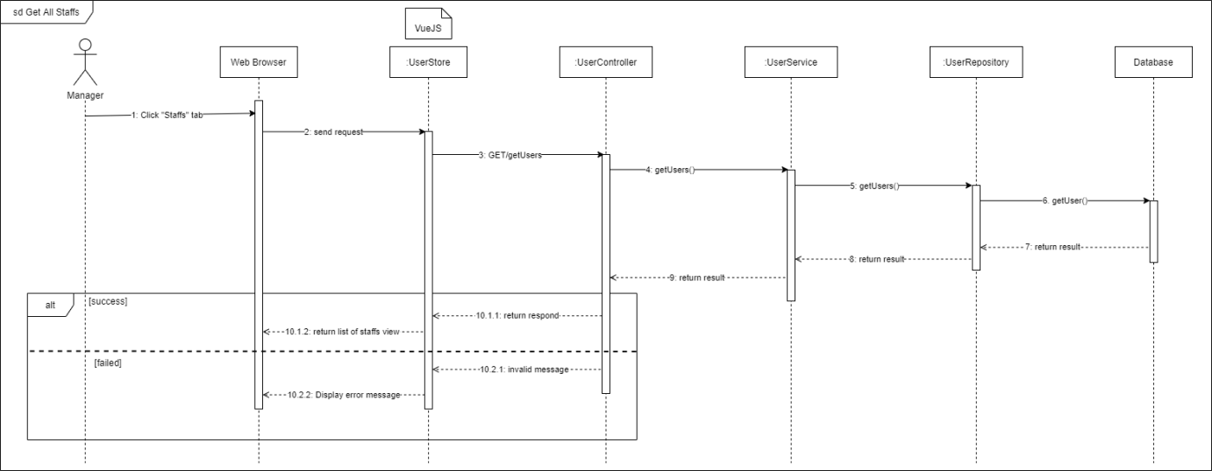

[Figure 173. <Sequence Diagram> Get list of staffs](https://drive.google.com/file/d/1f5VPz235kCiRKAkHTRORqcwWuJImbrBj/view?usp=sharing)

#### g. Create area

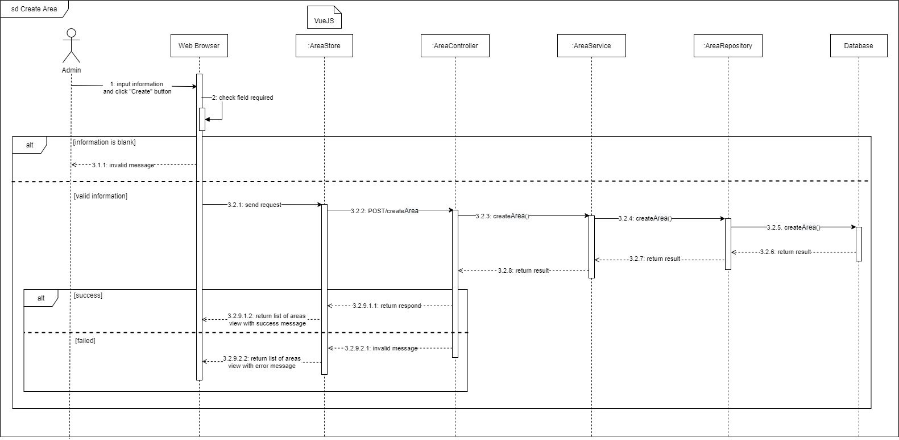

[Figure 174. <Sequence Diagram> Create area](https://drive.google.com/file/d/1J4PRSByiKIB7NQtD-nmga62E8fYwV0Ei/view?usp=sharing)

#### h. Update area

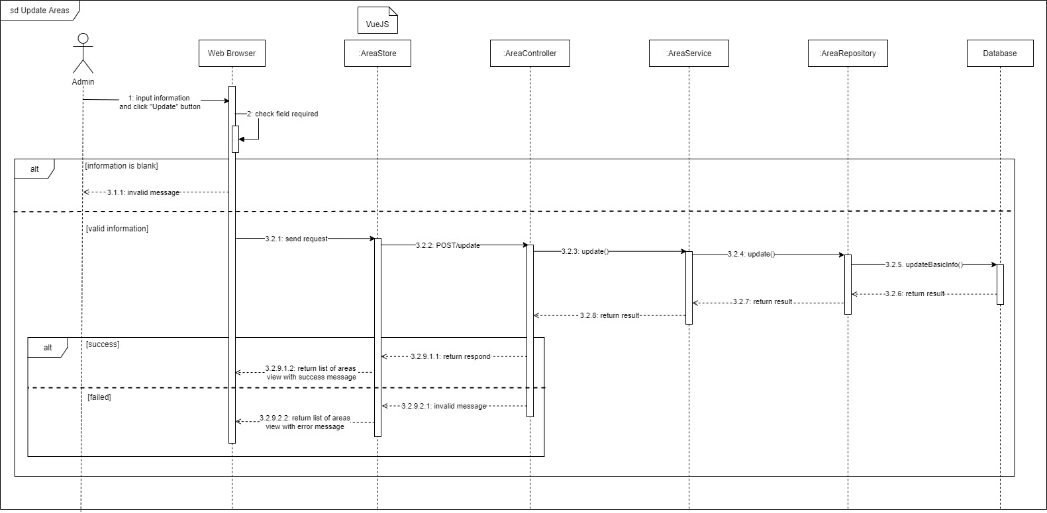

[Figure 175. <Sequence Diagram> Update area](https://drive.google.com/file/d/1Bn8j52PDP4PHEn2ZdehrjF0z7XMfq6Kt/view?usp=sharing)

#### i. Delete area

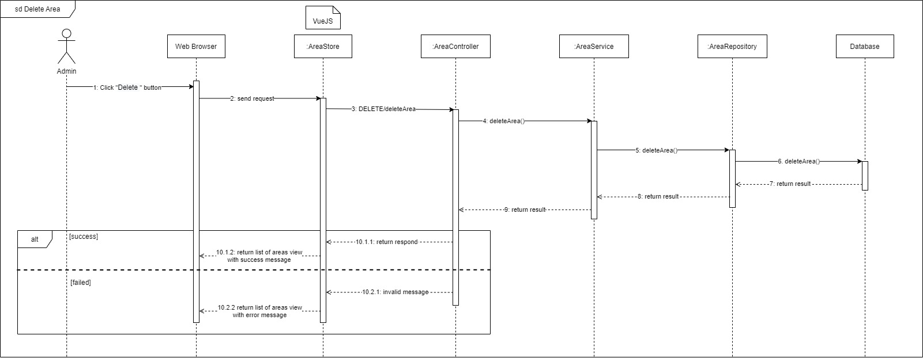

[Figure 176. <Sequence Diagram> Delete area](https://drive.google.com/file/d/1Bn8j52PDP4PHEn2ZdehrjF0z7XMfq6Kt/view?usp=sharing)

#### j. Get list of areas

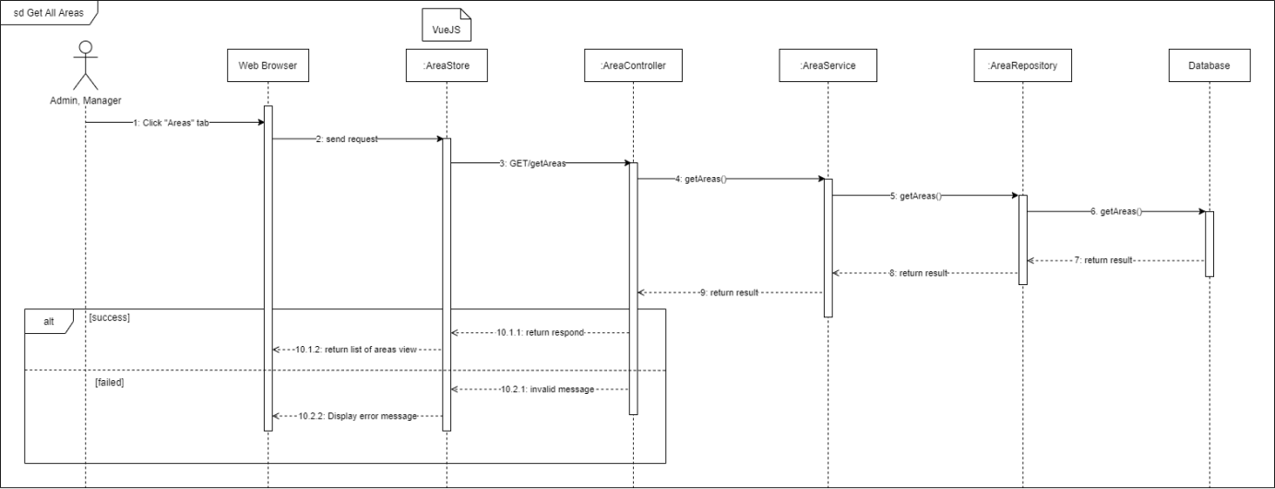

[Figure 177. <Sequence Diagram> Get list of areas](https://drive.google.com/file/d/19pM6AezDr9xpvLh3M2DaCHMTvrUEUehV/view?usp=sharing)

#### k. Create repairer

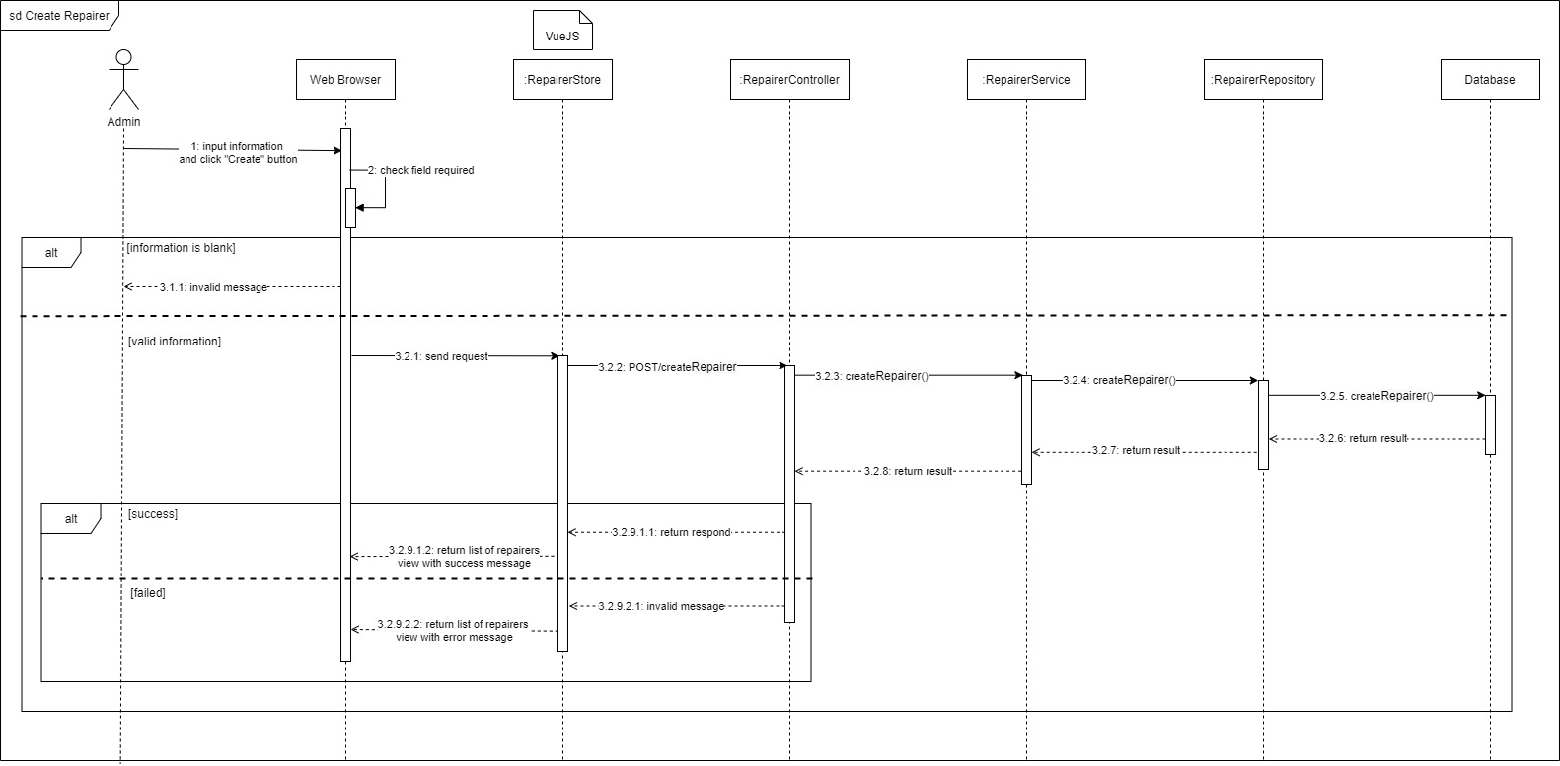

[Figure 178. <Sequence Diagram> Create repairer](https://drive.google.com/file/d/1ixO7_oj99LAtpxYpVLTIiTgrYPMtJBmW/view?usp=sharing)

#### l. Update repairer

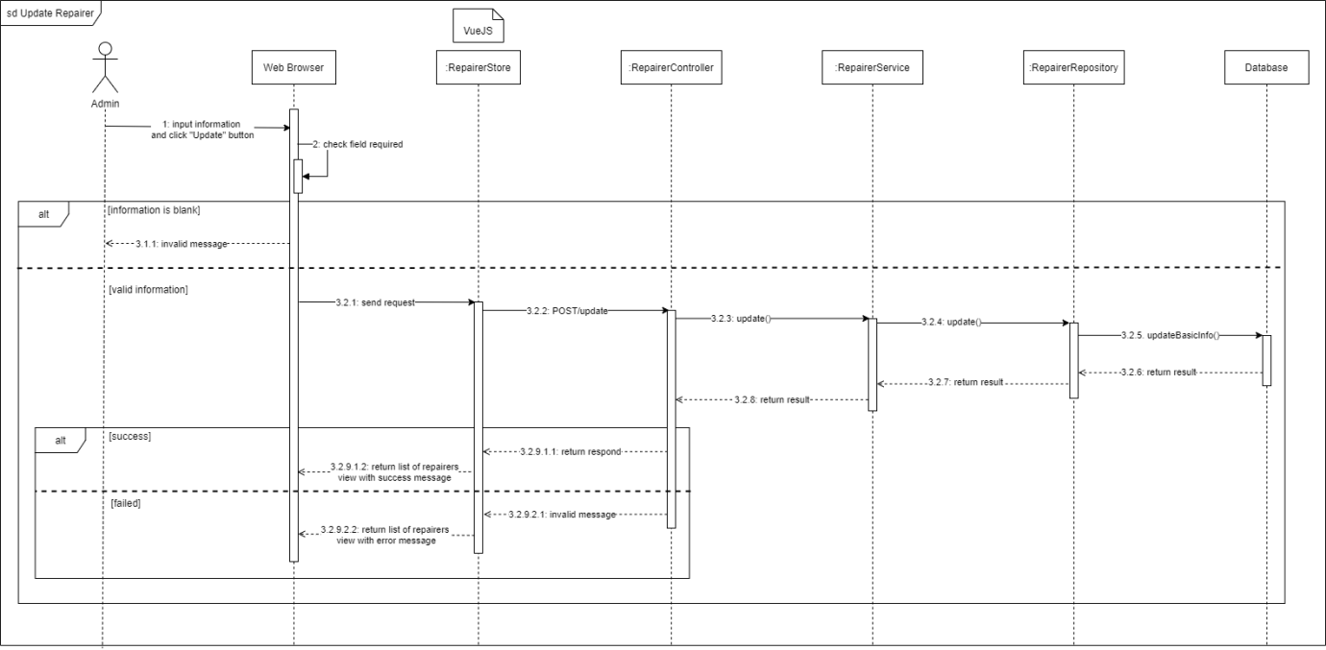

[Figure 179. <Sequence Diagram> Update repairer](https://drive.google.com/file/d/1RKosxHstY56EI3-xBGjvtTrf37MlNZjj/view?usp=sharing)

#### m. Delete repairer

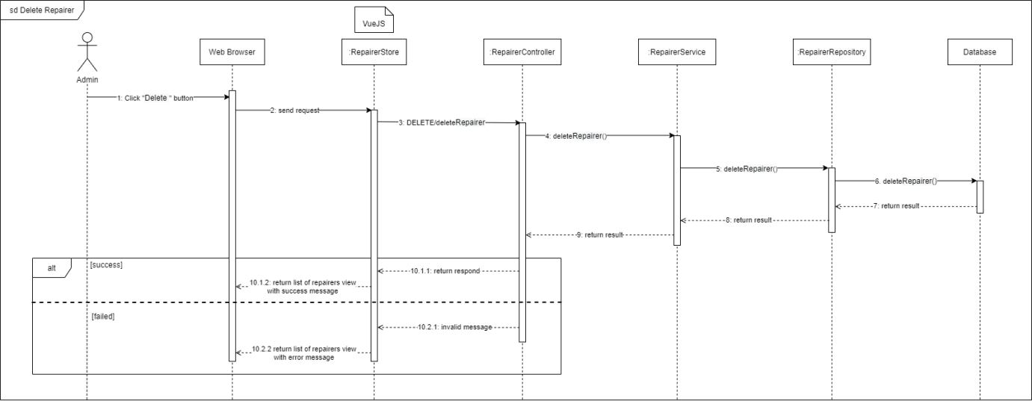

[Figure 180. <Sequence Diagram> Delete repairer](https://drive.google.com/file/d/1TaqUlHzyef-PpEce2NR4HRLXg6tGo1bB/view?usp=sharing)

#### n. Get list of repairers

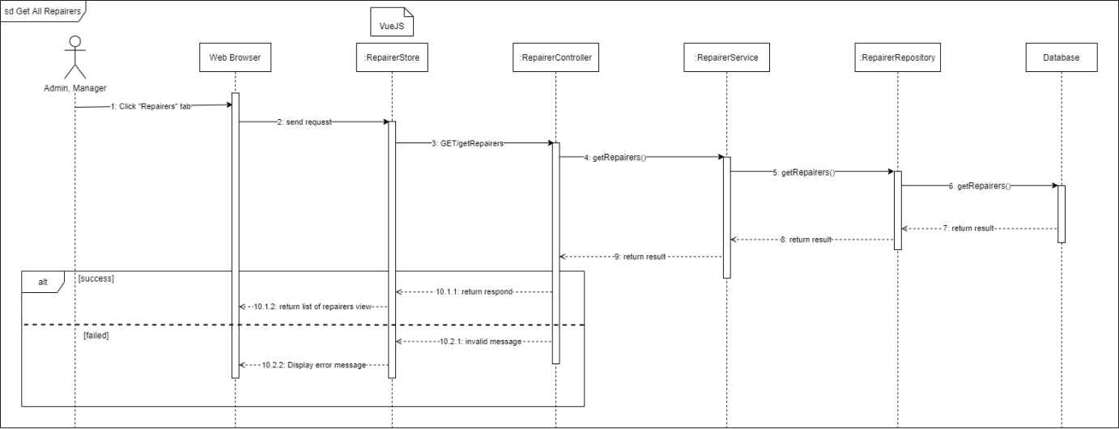

[Figure 181. <Sequence Diagram> Get list of repairers](https://drive.google.com/file/d/1ATlbrdRAn2GY3v8H8GwqgvoCFDNQGKBz/view?usp=sharing)

#### o. Assign staff to area

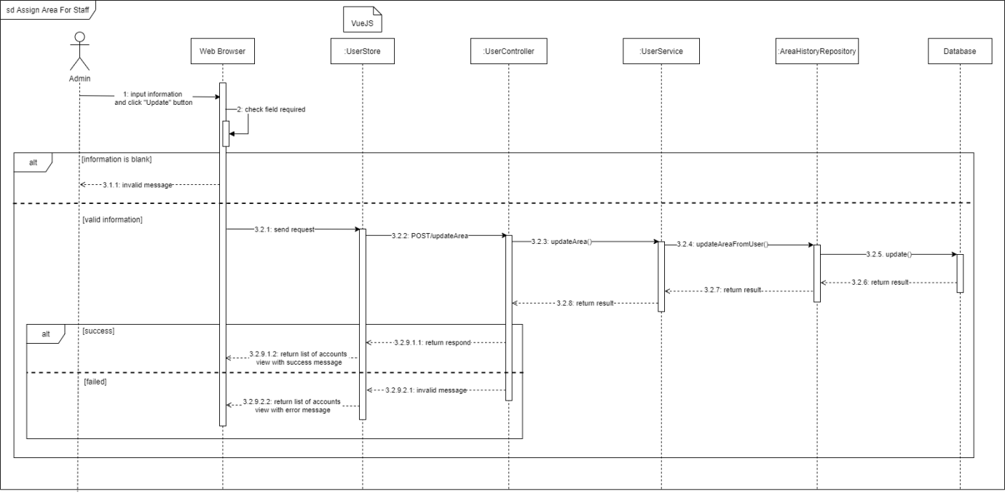

[Figure 182. <Sequence Diagram> Assign staff to area](https://drive.google.com/file/d/1uNAjZzVbAiWXN8FHIVvt-AGBRIYpa6yE/view?usp=sharing)

#### p. Delete video

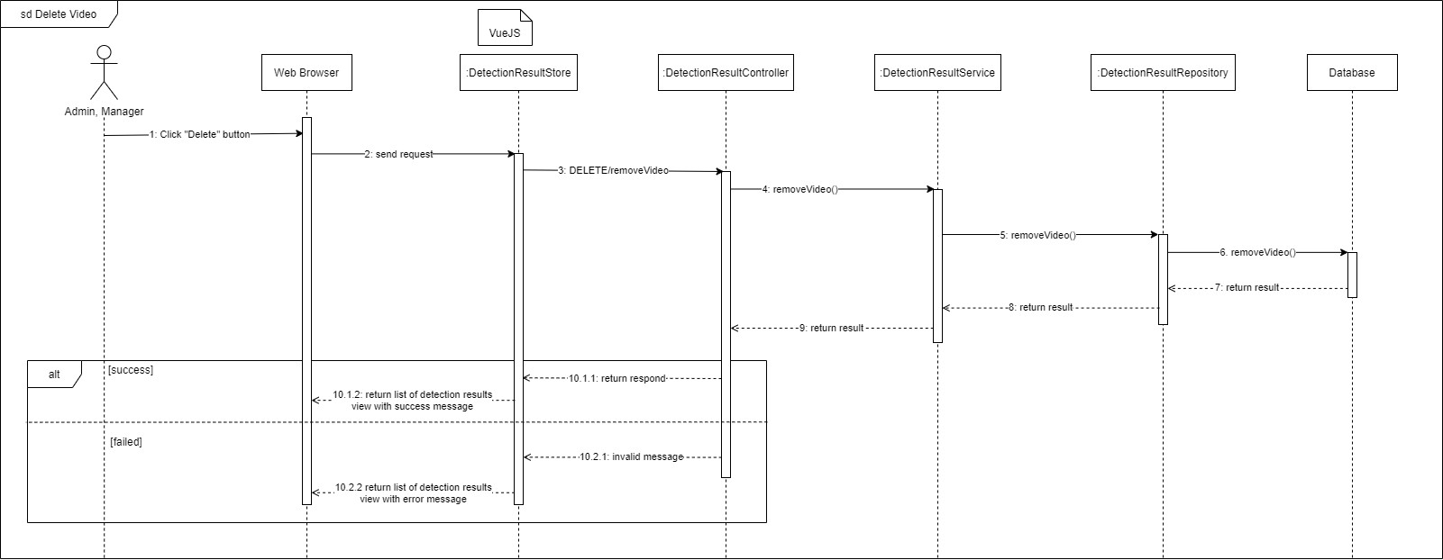

[Figure 183. <Sequence Diagram> Delete video](https://drive.google.com/file/d/1eZNK1Hs0htoFTWIMOMLdzgNFKY5Dol5o/view?usp=sharing)

#### q. Confirm crack

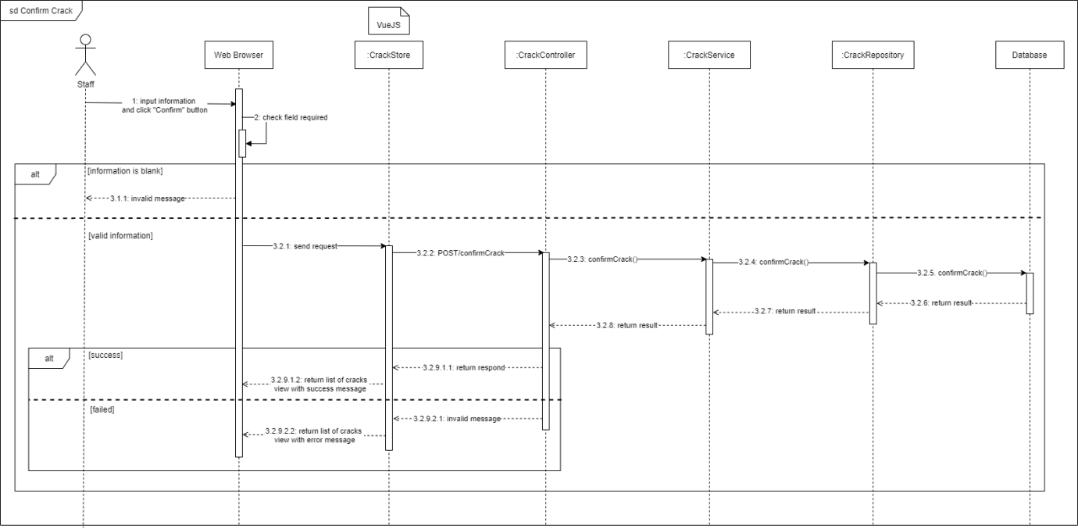

[Figure 184. <Sequence Diagram> Confirm crack](https://drive.google.com/file/d/1eZNK1Hs0htoFTWIMOMLdzgNFKY5Dol5o/view?usp=sharing)

#### r. Reject crack

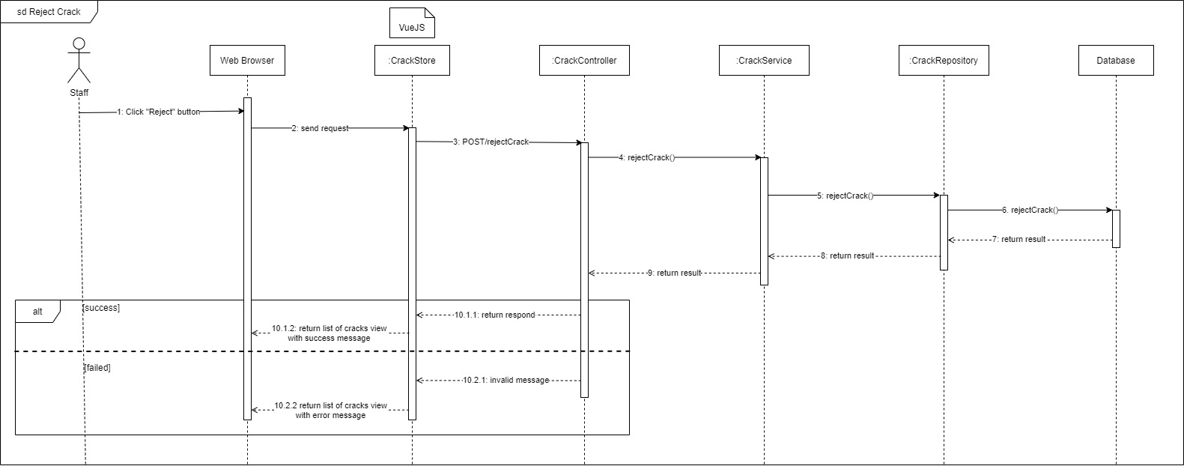

[Figure 185. <Sequence Diagram> Reject crack](https://drive.google.com/file/d/1V_8VKDP2mXgk9D1h5ouBMXk3Gq3K4Z79/view?usp=sharing)

#### s. Update crack

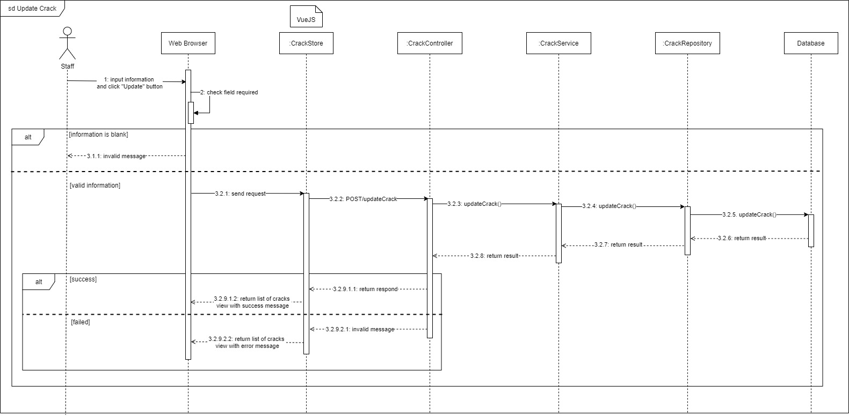

[Figure . <Sequence Diagram> Update crack](https://drive.google.com/file/d/1RCoHHLgHN_5vO6BdTe8Bd3-VVXDWVYgW/view?usp=sharing)

## 4. Data & Database Design

## 4.1 Database Design

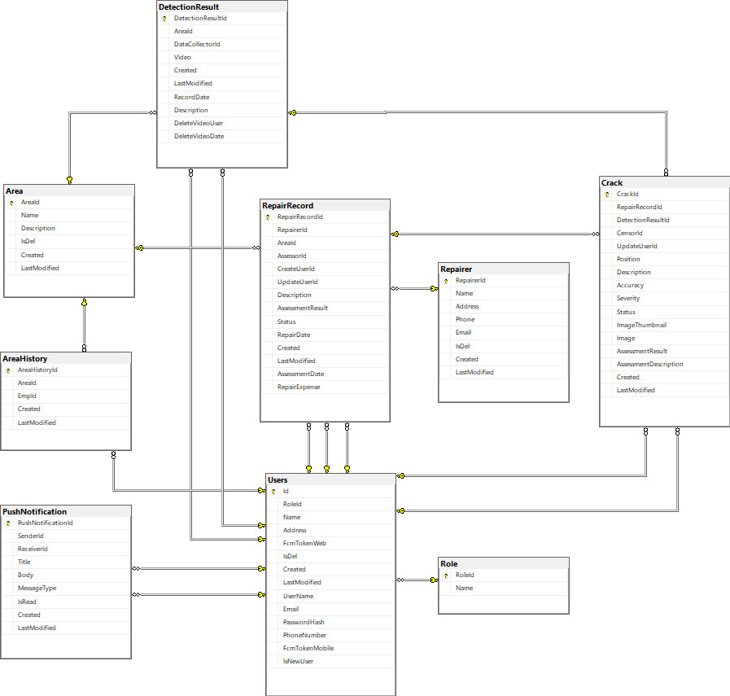

[Figure 187. Database design](../Diagram/Database%20Design.jpg)

### a. Area

Table . <Database Design> Area

|  |  |  |  |  |  |  |
| --- | --- | --- | --- | --- | --- | --- |
| **Field name** | **Type** | **Size** | **Unique** | **Not Null** | **PK/FK** | **Notes** |
| AreaId | int |  | Yes | Yes | PK | Unique identifier of area |
| Name | nvarchar | 100 | No | Yes |  | Name of location |
| Description | nvarchar | 200 | No | No |  | Description of area |
| IsDel | boolean |  | No | Yes |  | Delete status of area |
| Created | datetime2 | 7 | No | Yes |  | Created date of area |
| LastModified | datetime2 | 7 | No | Yes |  | Last modified date of area |

### b. Crack

Table . <Database Design> Crack

|  |  |  |  |  |  |  |
| --- | --- | --- | --- | --- | --- | --- |
| **Field name** | **Type** | **Size** | **Unique** | **Not Null** | **PK/FK** | **Notes** |
| CrackId | int |  | Yes | Yes | PK | Unique identifier of crack |
| RepairRecordId | int |  | No | No |  | Unique identifier of repair record |
| DetectionResultId | int |  | No | Yes |  | Unique identifier of detection result |
| CensorId | nvarchar | 450 | No | No |  | Unique identifier of censor |
| UpdateUserId | nvarchar | 450 | No | No |  | Unique identifier of updater |
| Position | nvarchar | 200 | No | Yes |  | Position of crack |
| Description | nvarchar | 200 | No | No |  | Description of crack |
| Accuracy | real |  | No | Yes |  | Accuracy of crack |
| Severity | nvarchar | 10 | No | No |  | Severity of crack |
| Status | nvarchar | 30 | No | Yes |  | Status of crack |
| ImageThumbnails | nvarchar | MAX | No | Yes |  | Image Thumbnails of crack |
| Image | nvarchar | MAX | No | Yes |  | Image of crack |
| AssessmentResult | int |  | No | Yes |  | Assessment result of crack |
| AssessmentDescription | nvarchar | MAX | No | No |  | Assessment description of crack |
| Created | datetime2 | 7 | No | Yes |  | Created date of crack |
| LastModified | datetime2 | 7 | No | Yes |  | Last modified date of crack |

### c. Repair Record

Table . <Database Design> Repair record

|  |  |  |  |  |  |  |
| --- | --- | --- | --- | --- | --- | --- |
| **Field name** | **Type** | **Size** | **Unique** | **Not Null** | **PK/FK** | **Notes** |
| RepairRecordId | int |  | Yes | Yes | PK | Unique identifier of repair record |
| RepairerId | int |  | No | No |  | Unique identifier of repairer |
| AreaId | int |  | No | Yes |  | Unique identifier of area |
| AssessorId | nvarchar | 450 | No | No |  | Unique identifier of assessor |
| CreateUserId | nvarchar | 450 | No | No |  | Unique identifier of creator |
| UpdateUserId | nvarchar | 450 | No | No |  | Unique identifier of updater |
| Description | nvarchar | 200 | No | No |  | Description of repair record |
| AssessmentResult | int |  | No | Yes |  | Assessment result of repair record |
| Status | nvarchar | 30 | No | Yes |  | Status of repair record |
| RepairDate | datetime2 | 7 | No | Yes |  | Repair date of repair record |
| Created | datetime2 | 7 | No | Yes |  | Created date of repair record |
| LastModified | datetime2 | 7 | No | Yes |  | Last modified date of repair record |
| AssessmentDate | datetime2 | 7 | No | Yes |  | Assessment date of repair record |
| RepairExpense | real |  | No | Yes |  | Expense of repair record |

### d. Users

Table . <Database Design> Users

|  |  |  |  |  |  |  |
| --- | --- | --- | --- | --- | --- | --- |
| **Field name** | **Type** | **Size** | **Unique** | **Not Null** | **PK/FK** | **Notes** |
| Id | nvarchar | 450 | Yes | Yes | PK | Unique identifier of user |
| RoleId | nvarchar | 450 | No | Yes |  | Role of user |
| Name | nvarchar | 50 | No | Yes |  | Name of user |
| Address | nvarchar | 150 | No | Yes |  | Address of user |
| FcmTokenWeb | nvarchar | MAX | No | Yes |  | Firebase Token for web app of user |
| IsDel | boolean |  | No | Yes |  | Delete status of user |
| IsNewUser | boolean |  | No | Yes |  | New user status of user |
| Created | datetime2 | 7 | No | Yes |  | Created date of user |
| LastModified | datetime2 | 7 | No | Yes |  | Last modified date of user |
| UserName | nvarchar | 256 | No | Yes |  | Username of user |
| Email | nvarchar | 256 | No | Yes |  | Email of user |
| PasswordHash | nvarchar | MAX | No | Yes |  | Password of user |
| PhoneNumber | nvarchar | MAX | No | Yes |  | Phone of user |
| FcmTokenMobile | nvarchar | MAX | No | Yes |  | FcmTokenMobile of user |

### e. Repairer

Table . <Database Design> Repairer

|  |  |  |  |  |  |  |
| --- | --- | --- | --- | --- | --- | --- |
| **Field name** | **Type** | **Size** | **Unique** | **Not Null** | **PK/FK** | **Notes** |
| RepairerId | int |  | Yes | Yes | PK | Unique identifier of repairer |
| Name | nvarchar | 50 | No | Yes |  | Name of repairer |
| Address | nvarchar | 150 | No | Yes |  | Address of repairer |
| Phone | nvarchar | 15 | No | Yes |  | Phone of repairer |
| Email | nvarchar | 50 | No | Yes |  | Email of repairer |
| IsDel | boolean |  | No | Yes |  | Delete status of repairer |
| Created | datetime2 | 7 | No | Yes |  | Created date of repairer |
| LastModified | datetime2 | 7 | No | Yes |  | Last modified date of repairer |

### f. Push Notification

Table . <Database Design> Push notification

|  |  |  |  |  |  |  |
| --- | --- | --- | --- | --- | --- | --- |
| **Field name** | **Type** | **Size** | **Unique** | **Not Null** | **PK/FK** | **Notes** |
| PushNotificationId | int |  | Yes | Yes | PK | Unique identifier of notification |
| SenderId | nvarchar | 450 | No | No |  | Unique identifier of sender |
| ReceiverId | nvarchar | 450 | No | No |  | Unique identifier of receiver |
| Title | nvarchar | 100 | No | Yes |  | Title of notification |
| Body | nvarchar | 200 | No | Yes |  | Body of notification |
| MessageType | nvarchar | MAX | No | Yes |  | Type of notification |
| IsRead | boolean |  | No | Yes |  | Read status of notification |
| Created | datetime2 | 7 | No | Yes |  | Created date of notification |
| LastModified | datetime2 | 7 | No | Yes |  | Last modified date of notification |

### g. Role

Table . <Database Design> Role

|  |  |  |  |  |  |  |
| --- | --- | --- | --- | --- | --- | --- |
| **Field name** | **Type** | **Size** | **Unique** | **Not Null** | **PK/FK** | **Notes** |
| RoleId | nvarchar | 450 | Yes | Yes | PK | Unique identifier of role |
| Name | nvarchar | 256 | No | Yes |  | Name of role |

### h. Detection Result

Table . <Database Design> Detection result

|  |  |  |  |  |  |  |
| --- | --- | --- | --- | --- | --- | --- |
| **Field name** | **Type** | **Size** | **Unique** | **Not Null** | **PK/FK** | **Notes** |
| DetectionResultId | int |  | Yes | Yes | PK | Unique identifier of detection result |
| AreaId | int |  | No | Yes |  | Unique identifier of area |
| DataCollectorId | nvarchar | 450 | No | Yes |  | Unique identifier of data collector |
| Video | nvarchar | MAX | No | Yes |  | Video of detection result |
| Created | datetime2 | 7 | No | Yes |  | Created date of detection result |
| LastModified | datetime2 | 7 | No | Yes |  | Last modified date of detection result |
| RecordDate | datetime2 | 7 | No | Yes |  | Record date of video |
| Description | nvarchar | MAX | No | No |  | Description of detection result |
| DeleteVideoUser | nvarchar | 450 | No | No |  | User who delete detection video |
| DeleteVideoDate | datetime2 | 7 | No | No |  | Date and time user delete detection video |

## 5. Algorithms & Research

### 5.1 Detect Crack

#### a. Problem definition

Import a video and find all cracks which appear in the video.

#### b. Requirement

* Detecting time is not too long.
* Almost all cracks have been successfully identified.

#### c. Solution

* We use machine learning to detect cracks. We choose YOLO (You Only Look Once), version 4 for training model object detection.
* Advantages of YOLO: detecting time is quite fast and accuracy is not too reduced compared to other models.

##### Base Concept

1. **YOLO Architecture**

* YOLO architecture include: Base Network and Extra Layers
* Base Network:
* Has the role of extracting feature maps.
* Includes CNN (Convolutional Neural Network), Flatten, Fully Connected.
* Output are feature maps. And it is used as the input of extra layer.

[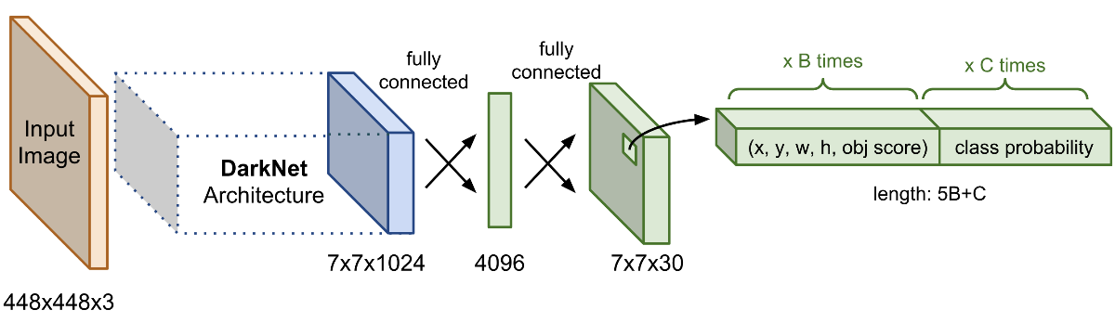](https://phamdinhkhanh.github.io/assets/images/20200309_YOLOAlgorithm/h1.png)

Figure . Base Network

***Source:*** *https://phamdinhkhanh.github.io/2020/03/09/DarknetAlgorithm.html*

* Extra Layers: Apply on feature maps to get detection results (bounding box coordinates, object score, class probability) of object.

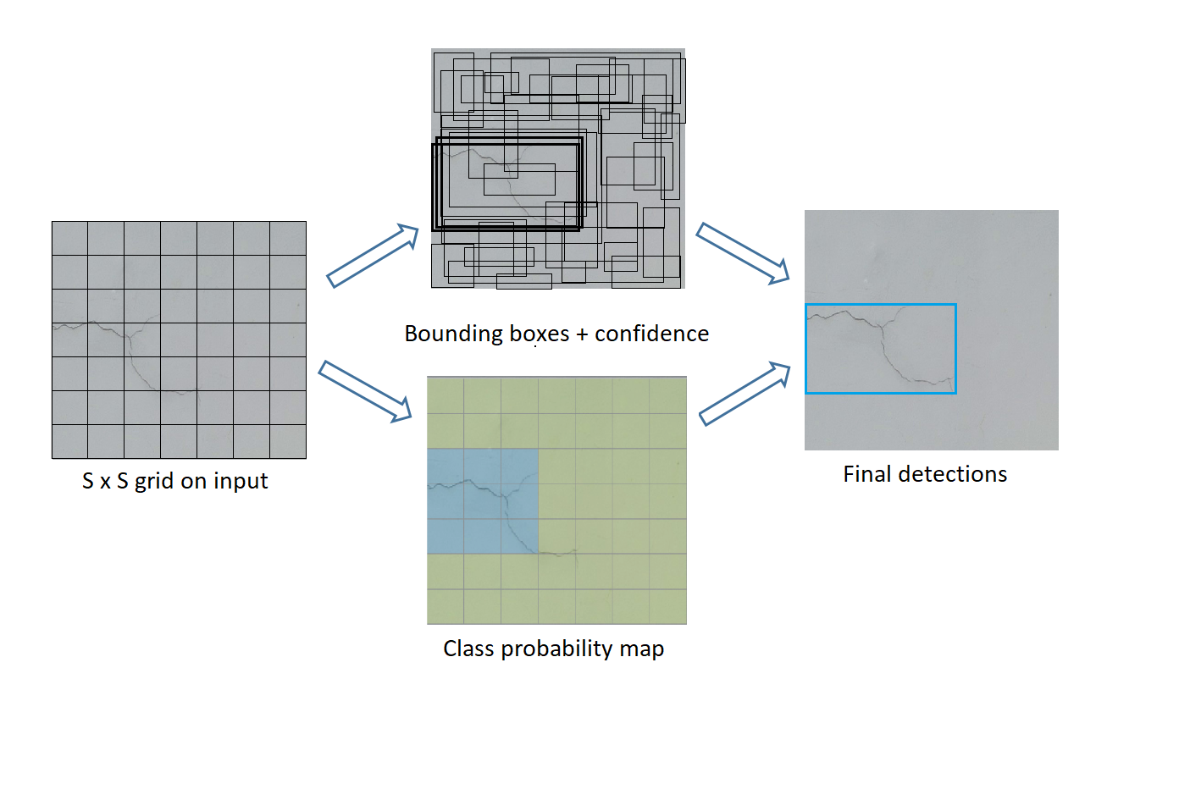

Figure . Extra layer

* CNN (Convolutional Neural Network): is a class of deep neural networks and used to analyze visual imagery. CNN contains 3 main layers: Convolutional Layer, Pooling Layer, Relu Layer.
* Convolutional Layer: extracts critical features from input images by filter matrix.

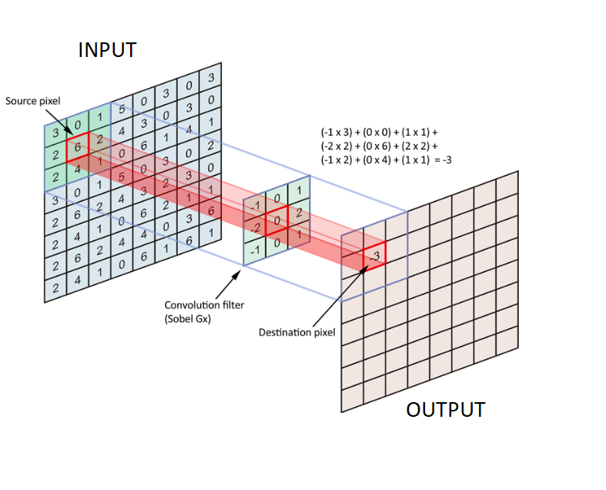

Figure . Convolution

***Source:*** [*https://medium.com/@pallawi.ds/ai-starter-build-your-first-convolution-neural-network-in-keras-from-scratch-to-perform-a059eaa6d4ff*](https://medium.com/@pallawi.ds/ai-starter-build-your-first-convolution-neural-network-in-keras-from-scratch-to-perform-a059eaa6d4ff)

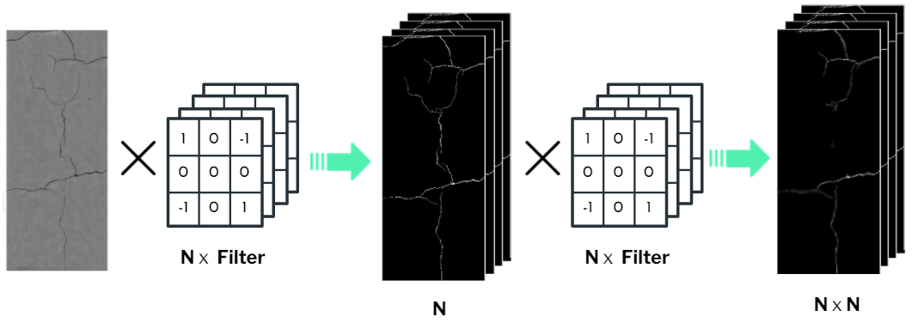

Figure . Convolution example in process

* Pooling layer:provides an approach to down sampling features, reduces the number of parameters to learn and the amount of computation performed in the network.

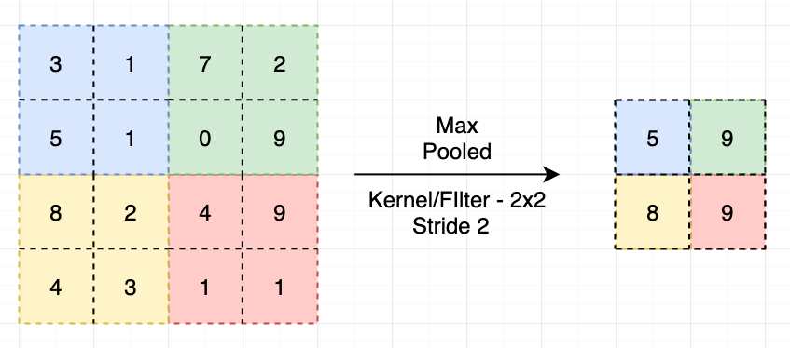

Figure . Pooling

**Source:** <https://ai.plainenglish.io/pooling-layer-beginner-to-intermediate-fa0dbdce80eb>

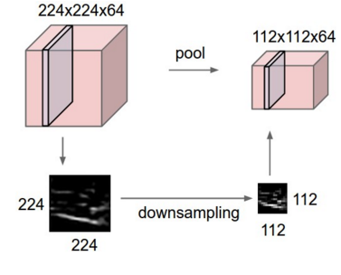

Figure . Pool example in process

**Source:** <https://nttuan8.com/bai-6-convolutional-neural-network/>

* ReLu Layer: is a non-linear activation function and used for converting negative numbers to zero.

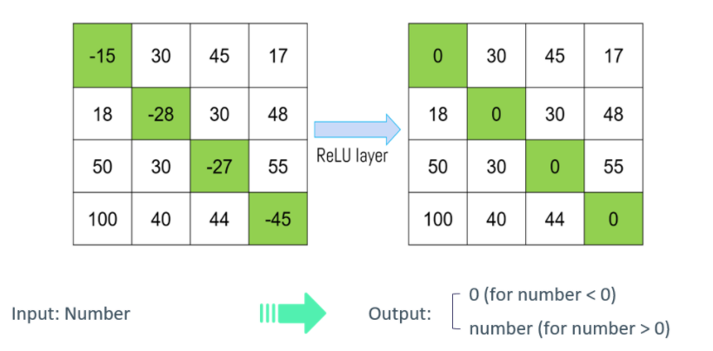

Figure . ReLU layer

* Flatten is used for transforming matrices into vectors that can apply into Fully Connected.
* Fully Connected: is used for detection and classification by applying weights.

1. **Output Process Of YOLO**

* Each image is presented as many types of grid like 32x32, 16x16, 8x8.

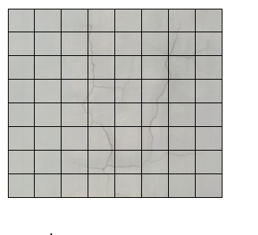  
Figure . YOLO grid 3x3

* On next step, inputting each grid to Base Network and get a feature map which is output.
* Feature map information contains bounding box coordinates (centroid coordinates (x, y), width, height), object score and class scores.

[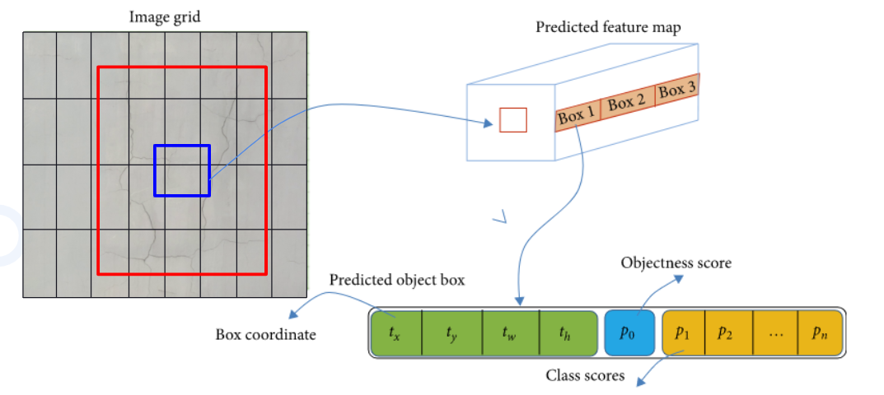](http://www.gauravpande.in/Object-Detection/)

Figure . Feature map

***Source:***[*http://www.gauravpande.in/Object-Detection/*](http://www.gauravpande.in/Object-Detection/)

* Then Extra Layer navigates anchor boxes and predicts objects

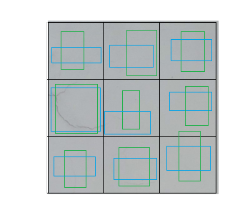

Figure . YOLO prediction on each grid

* In final step, non-max suppression algorithm is applied to filter the predictions of object detectors, reduced redundant bounding boxes:
* First, remove anchor boxes that have low confidence and have objects inside.
* Second, each class will calculate IOU to define that boxes contain the same object and just hold the box that has the highest percentage contain object.

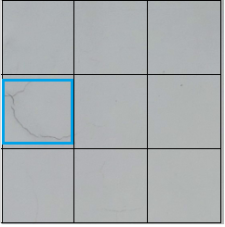

Figure . YOLO final result

##### Prepare data and train process

* Quantity: 2000 images for train, 400 images for test, 400 images for validation.
* Train 48 epochs in 5 hours.
* Data features:
* Single image: Image contains single crack.

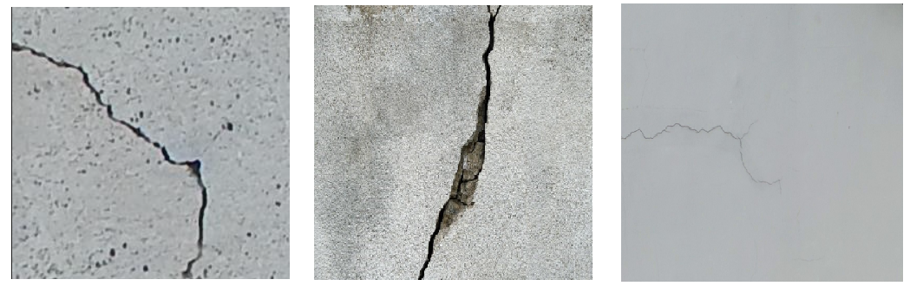

Figure . Cluster image

* Cluster image: Image contains multiple cracks.

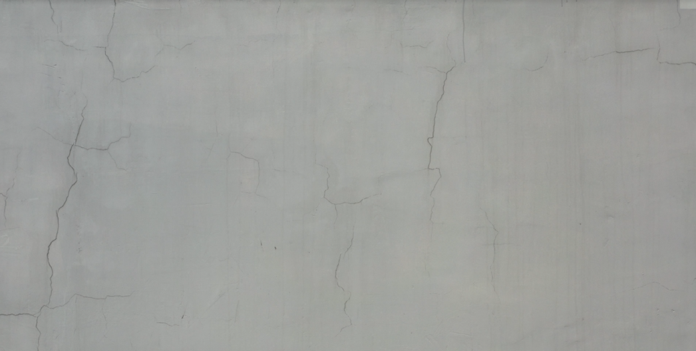

Figure . Cluster image

* Data contains many different types of wall surfaces. Lack of light or bright enough data.

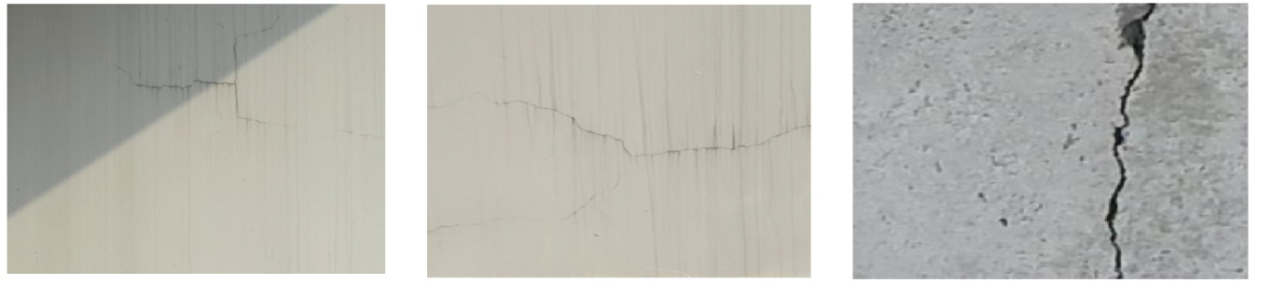

Figure . Simulate the camera of drone

##### Evaluate Model

* We evaluate model base on mAP, loss.
* mAP (mean Average Precision): it is used for evaluating the ability to predict the correct object
* mAP_0.5 is mAP base on IOU = 0.5
* Precision: number of correct predictions out of the total number of predictions
* Loss: Error functions in YOLO are calculated in prediction and label the model for calculation.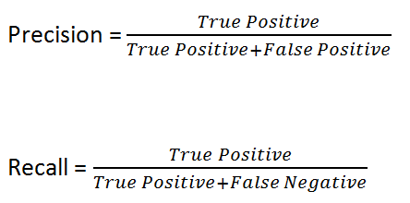

Figure . Simulate the camera of drone

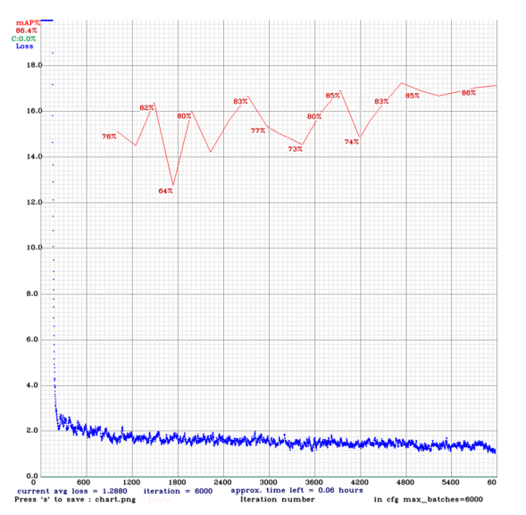

Figure . Simulate the camera of drone

* After train:
* interaction: 6000
* mAP = 0.86
* avg loss  = 1.288
* Conclude: Our model has acceptable detection ability. The average loss is 1.288, not to high, so error appearance rate is low.

### 5.2 Check Duplicate Cracks

#### a. Problem definition

When the drone flies from left to right, consecutive frames will have duplicated cracks, for example in the image below, the same crack but appear in 2 frames and identified as 2 cracks.

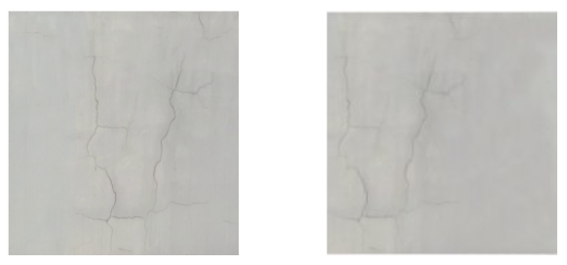

Figure . Two frames

#### b. Solution

##### Purpose

Calculate frame transition distance to predict the position of the crack in the next frame, then calculate the IOU ratio (intersection over union) to determine whether this crack is duplicate or not.

##### Description

* **Calculate frame transition distance**

Table . Annotation

|  |  |
| --- | --- |
| **Annotation** | |
| **a:** | half of opposite edge length |
| **2a:** | opposite edge length |
| **t:** | time transition between two frames |
| **v:** | velocity of drone |
| **s:** | transition distance between two frame |

When flying the drone, some configuration parameters are set up such as velocity is 0.5m/s, angle of rotation in HQ mode is 55 degrees, distance from drone to wall is 2.5m and perpendicular to the midpoint of the opposite side, dividing the 55° degrees angle into 2 angles of 27.5° degrees. We call the opposite edge of 27.5° degrees is **a** and calculate **a** by the formula **a** = tan 55° * 2.5 ≈ 1.3(m), from that the opposite edge of 55° degrees is 2**a** ≈ 2.6(m).

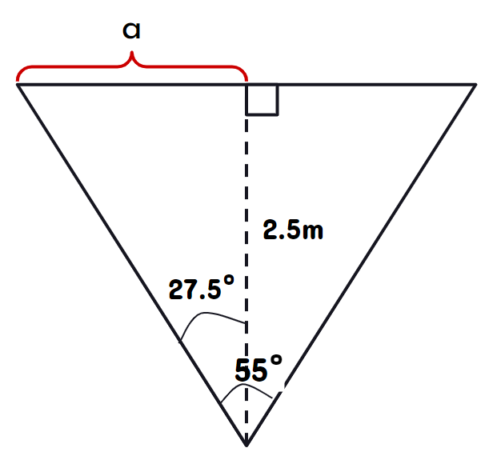

Figure . Calculate the opposite edge of 55 degrees

We have fps is 30 so time **t** is 1/30 (s), velocity of drone **v** is 0.5 (m/s), it leads to the transition distance between two frame is **s** = **v** * **t** = 0.5 * 1/30 = 1/60 (m).

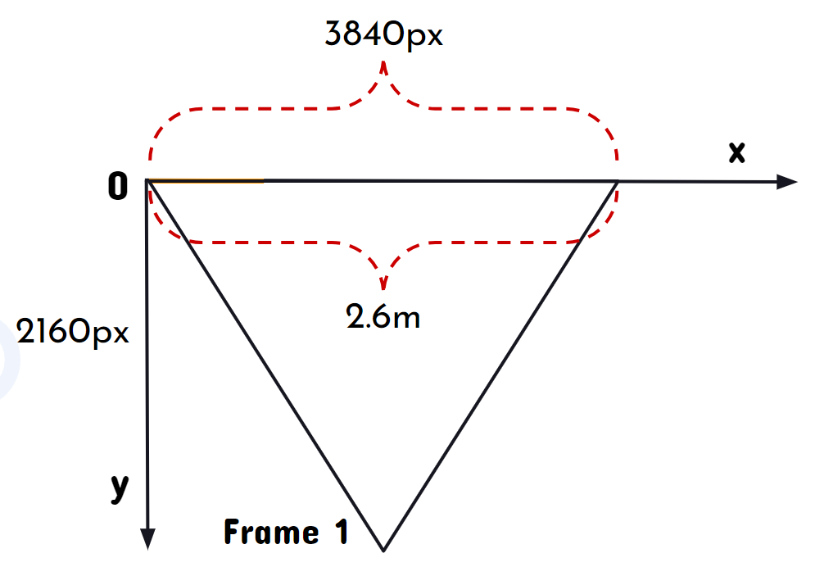

Figure . Map frame 1 to oxygen coordinate axis

After that, when having frame length in reality, frame length in coordinate system, actual frame transition distance in reality, we can set a ratio:

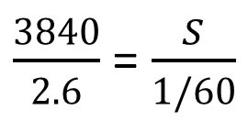

Figure . Ratio to calculate frame transition distance

This ratio leads to the frame transition distance **s** = 24.6px.

* **Crack tracking process**

Crack tracking process includes 2 steps:

1. Getting an initial set of crack detection results (set of bounding box coordinates) and adding to a list called “Crack tracker”.
2. Maintaining the assignment of bounding box coordinates in “Crack tracker” when each of the cracks moves around frames in a video (by calculating frame transition distance).

* **Duplication recognition**

By calculating IOU of new crack detection results and old crack detection results in “Crack tracker”, we measure overlap between them. It helps us to determine whether these cracks are duplicate or not.

New crack detection results that heavily overlap with old crack detection results have a high possibility of duplication than those with less overlap. Formula of IOU:

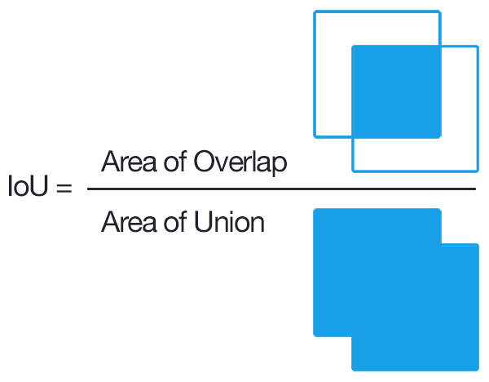

Figure . IOU ratio

***Source:***[*https://www.pyimagesearch.com/2016/11/07/intersection-over-union-iou-for-object-detectio*](https://www.pyimagesearch.com/2016/11/07/intersection-over-union-iou-for-object-detection/)*n*

IOU > 0.5: new crack detection result is added to “Crack tracker”.

IOU <= 0.5: new crack detection result is recognized to be a duplication.

After the completion of the object detection process in video, crack detection results stored in “Crack tracker” have been processed with removing duplicates.

##### Complexity

O(n²)

# V. Software Testing Documentation

## 1. Overall Description

### 1.1 Test Model

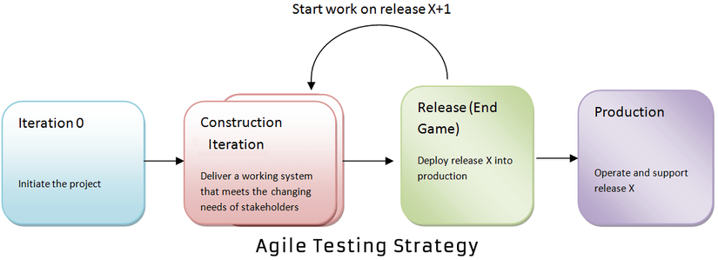

Figure . Agile model

***Source:***[*What is Agile Testing? Methodology, Process & Life Cycle (guru99.com)*](https://www.guru99.com/agile-testing-a-beginner-s-guide.html)

We apply Agile Testing because of the following reasons:

* It makes the interaction between developers and customers more fast and simple.
* It can quickly adapt to the rate of change required.
* It helps developers pay more attention to quality, performance and usability.

### 1.2 Testing Levels

* Unit testing
* Integration testing
* System testing

### 1.3 Testing Types

* Function testing
* UI testing

## 2. Test Plan

### 2.1 Test Stages

Table . Test stages

|  |  |  |  |  |
| --- | --- | --- | --- | --- |
| **Type of Tests** | **Stage of Test** | | | |
| **Unit** | **Integration** | **System** | **Acceptance** |
| Function Test | X | X | X | X |
| User Interface Test | X |  | X |  |

### 2.2 Resources

#### a. Human Resources

Table . Human resources

|  |  |  |
| --- | --- | --- |
| **Worker/Doer** | **Role** | **Specific Responsibilities/Comments** |
| Tran Hoang Dung | Test Leader | Write test plans, test cases, do test, and report |
| Hoang Tuan Anh | Tester | Do test and report |
| Le Nguyen Viet Hung | Tester | Do test and report |
| Nguyen Quang Huy | Tester | Do test and report |

### 2.3 Test Milestones

Table . Test milestones

|  |  |  |  |
| --- | --- | --- | --- |
| **Milestone Task** | **Effort (md)** | **Start Date** | **End Date** |
| Create Test Plan | 3 | 27/03/2021 | 27/03/2021 |
| Create unit tests for module Web App | 2 | 28/03/2021 | 30/03/2021 |
| Create integration test cases for Web App | 2 | 01/04/2021 | 03/04/2021 |
| Create system test cases for Web App | 2 | 05/04/2021 | 07/04/2021 |
| Create unit tests for module Mobile App | 2 | 09/04/2021 | 11/04/2021 |
| Create integration test cases for Mobile App | 2 | 12/04/2021 | 14/04/2021 |
| Create system test cases for Mobile App | 2 | 14/04/2021 | 16/04/2021 |
| Create reports for testing | 2 | 16/04/2021 | 18/04/2021 |

### 2.4 Deliverables

Table . Deliverables

|  |  |  |
| --- | --- | --- |
| **No** | **Deliverables** | **Due Date** |
| 1 | Test Plan | 27/03/2021 |
| 2 | Test Case Suite for Web App | 07/03/2021 |
| 3 | Test Case Suite for Mobile App | 16/04/2021 |
| 4 | Report on Testing | 18/04/2021 |

## 3. Test Cases

* Unit Test Cases: Report5_Unit Test Case.xls
* Other Test Cases: Report5_ Test Case.xls

## 4. Test Reports

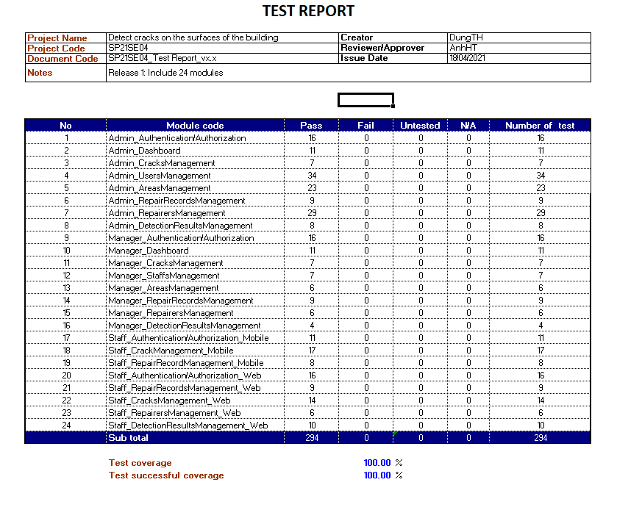

Figure . Test case report

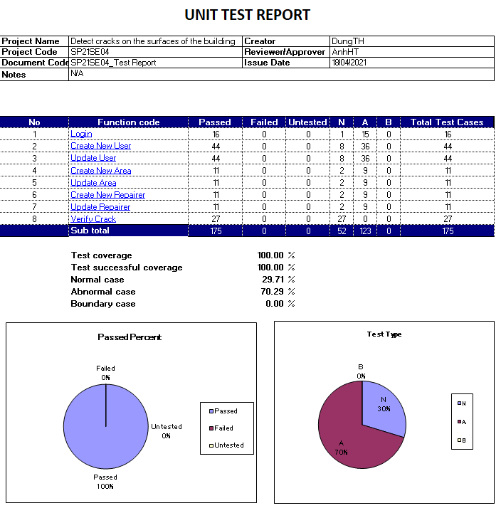

Figure . Unit test case report

# VI. Release Package & User Guides

## 1. Deliverable Package

### 1.1 Source codes & documents

Table . Source codes & documents

|  |  |  |
| --- | --- | --- |
| **No** | **Items** | **Sub-Items** |
| **Code packages** | | |
| 1 | BCDS.CapstoneBE.zip |  |
| 2 | BCDS.CapstoneFE.zip |  |
| 3 | BCDS.Mobile.apk |  |
| 4 | BCDS.CapstoneDetect.zip |  |
| **Databases** | | |
| 1 | Script | capstone.sql |

### 1.2 Known Issues, Limitations & Restrictions

* Because our budget is tight and unable to afford a drone, we have to rent it leading to be passive in time as well as number of flights.
* Our capstone project topic is quite new, so the amount of data on the Internet is not much, we must collect from outside.
* We have to find old buildings to collect cracks and there are protected areas that do not allow to record video or take photo, so we have to delete all collected data.
* Weather changes also affect the video quality of the drone.

## 2. Installation Guides

### 2.1 System Requirements

#### a. Back End Server requirements:

* Tested OS: Windows 7/10/Server 2016 or above.
  + Network: LAN, Internet access capability.
  + Hardware configurations:

Table . Back End Server - Recommended hardware configuration

|  |  |  |  |
| --- | --- | --- | --- |
| **Type** | **Part/Component** | **Minimum** | **Recommended** |
| Computer | OS supported | Windows | _ |
| Computer | Network | Internet | _ |
| Computer | RAM | 4GB | >= 8GB |
| Computer | HDD | 100GB | >= 200GB |
| Computer | Ports | USB, Network | _ |

* + Software requirements:
* .NET Core Runtime 5.0 Hosting bundles.
* SQL Server 2019.

#### 2. Web Server requirements:

* + Tested OS: Windows 7/10/Server 2016 or above.
  + Network: Internet access capability.
  + Hosting and web server capabilities.
  + Hardware configurations:

Table . Web Server - Recommended hardware configuration

|  |  |  |  |
| --- | --- | --- | --- |
| **Type** | **Part/Component** | **Minimum** | **Recommended** |
| Computer | OS supported | Windows | _ |
| Computer | Network | Internet | _ |
| Computer | RAM | 4GB | >= 8GB |
| Computer | HDD | 100GB | >= 200GB |

* + Software requirements:
* Nodejs.
* Vue3.

#### 3. Detect Server requirements:

* + Tested OS: Windows 7/10/Server 2016 or above.
  + Network: Internet access capability.
  + Hosting and web server capabilities.
  + Hardware configurations:

Table . Detect Server - Recommended hardware configuration

|  |  |  |  |
| --- | --- | --- | --- |
| **Type** | **Part/Component** | **Minimum** | **Recommended** |
| Computer | OS supported | Windows, Linux | _ |
| Computer | Network | Internet | _ |
| Computer | RAM | 4GB | >= 8GB |
| Computer | HDD | 100GB | >= 200GB |

* + Software requirements:
* Python.

### 2.2 Environment setup requirements

* Operating system: Windows 10.
* Runtimes/SDKs: .NET Core Runtime 5.0 Hosting Bundle, Java SE Runtime 8.
* Softwares: SQL Server 2019, SQL Server Management Studio.

### 2.3 Setup Files

* *BCDS.CapstoneBE.zip* : Api for applications.
* *BCDS.CapstoneWeb.zip* : Web for Module Web.
* *BCDS.CapstoneDetect.zip* : Detect for Module Detect.
* *BCDS.Mobile.apk : apk mobile for android.*

### 2.4 Installation Instruction

#### a. Setup environment

##### 1. Setup and start a Windows OS (Windows 10 or Windows Server 2016).

* 1. For further information: [Download Windows 10 | Microsoft](https://www.microsoft.com/vi-vn/windows/get-windows-10)
  2. Setup a Windows Server 2016

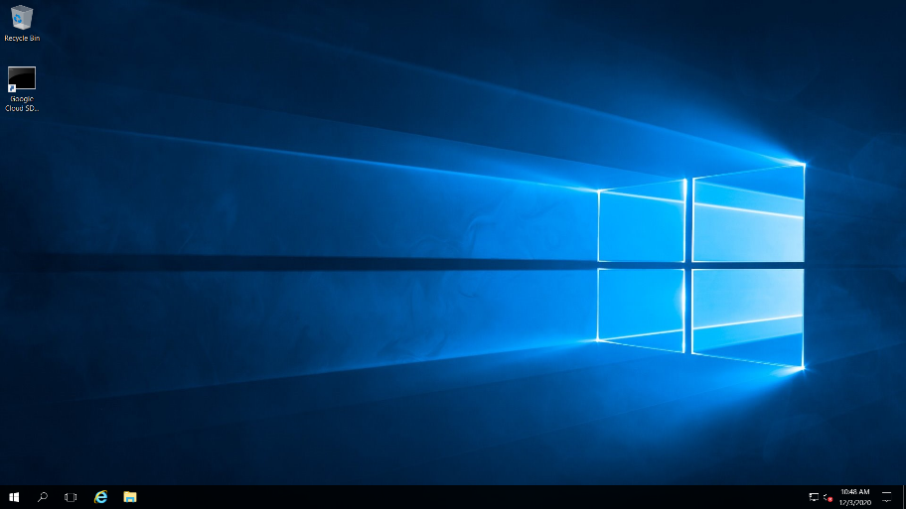

Figure

##### 2. Install .NET Core Runtime 5. Hosting Bundles

1. Open a browser.

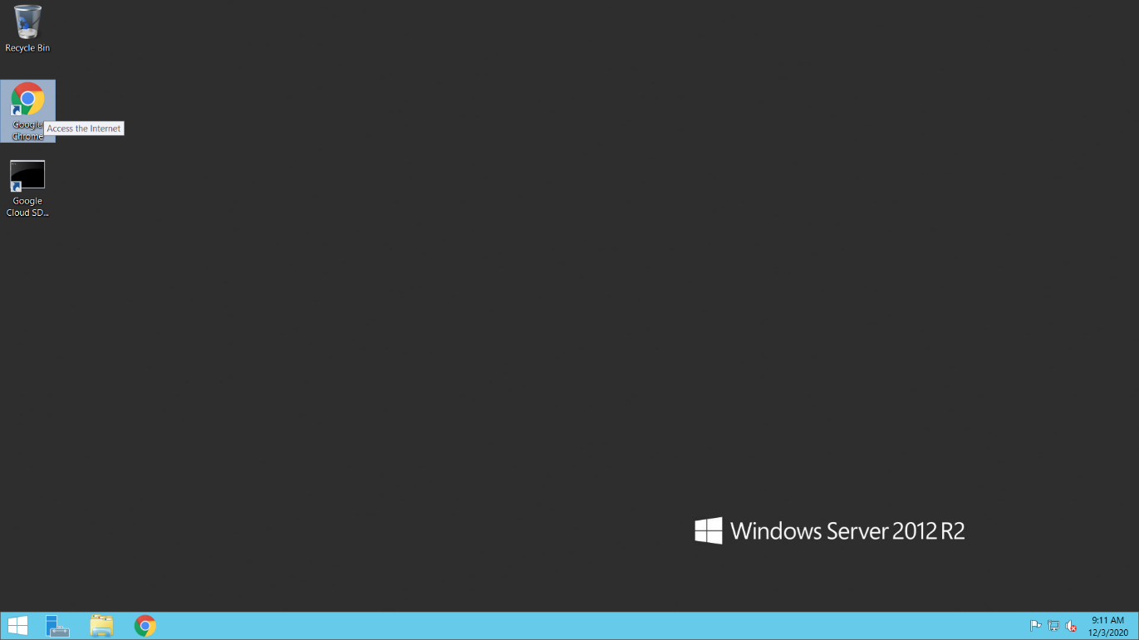

Figure

1. Go to this URL: [Download .NET 5.0 (Linux, macOS, and Windows) (microsoft.com)](https://dotnet.microsoft.com/download/dotnet/5.0)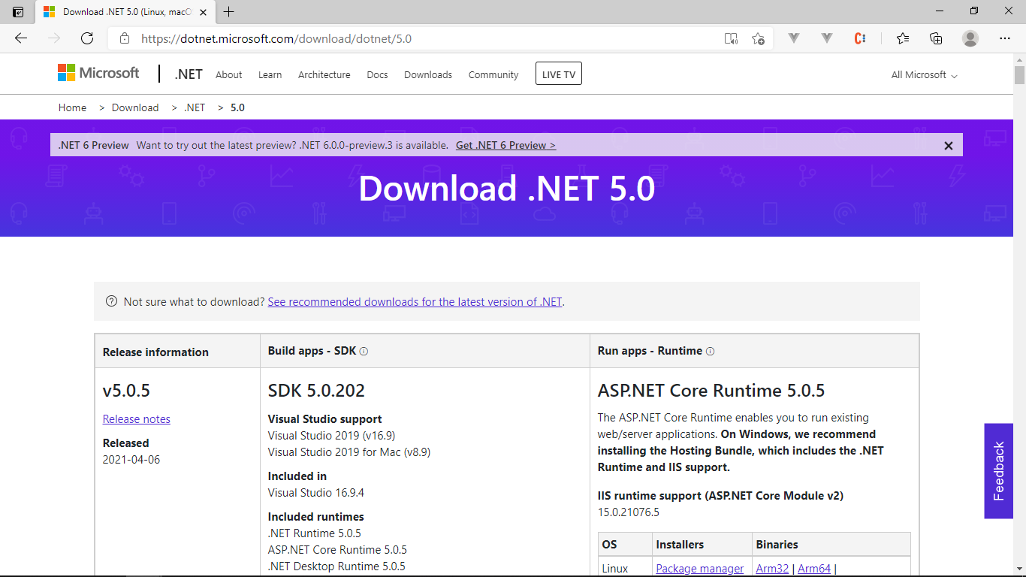

Figure

1. Choose **Windows → Hosting bundle** in the section **ASP.NET Core Runtime 5.0.5**.

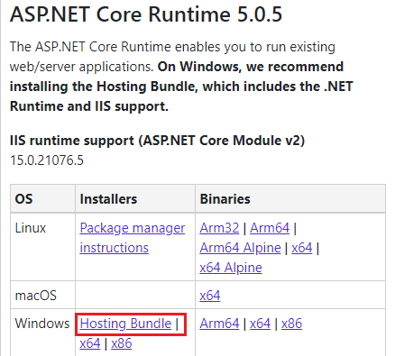

Figure

1. Wait for browser to download the installer.

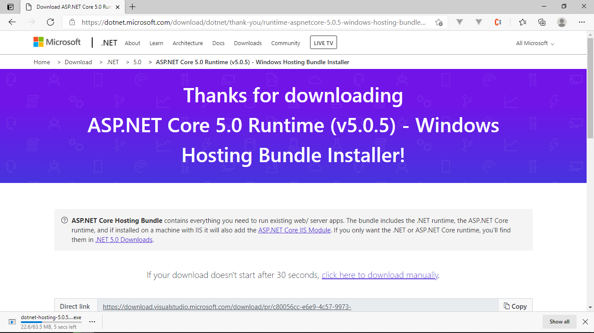

Figure

1. Run the downloaded file → Agree terms and conditions → click **Install**.

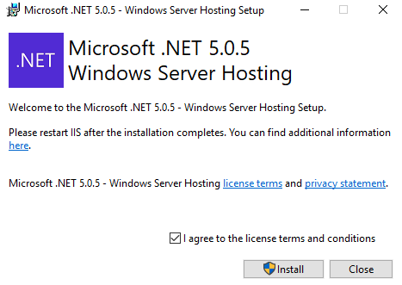

Figure

1. Wait for installing to finish and click **Close**.

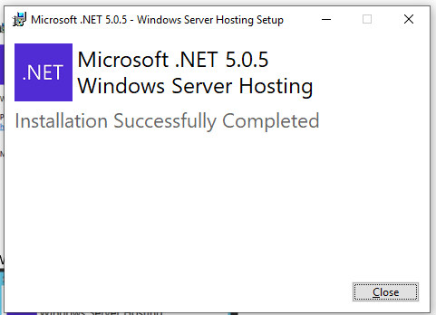

Figure

##### 3. Setup SQL Server 2019

1. For further information: [SQL Server 2019 | Microsoft](https://www.microsoft.com/en-us/sql-server/sql-server-2019)
2. Go to this URL: <https://www.microsoft.com/en-US/sql-server/sql-server-downloads>
3. In the section **Or, download a free specialized edition**, choose download **Express** version and wait for downloading to finish.

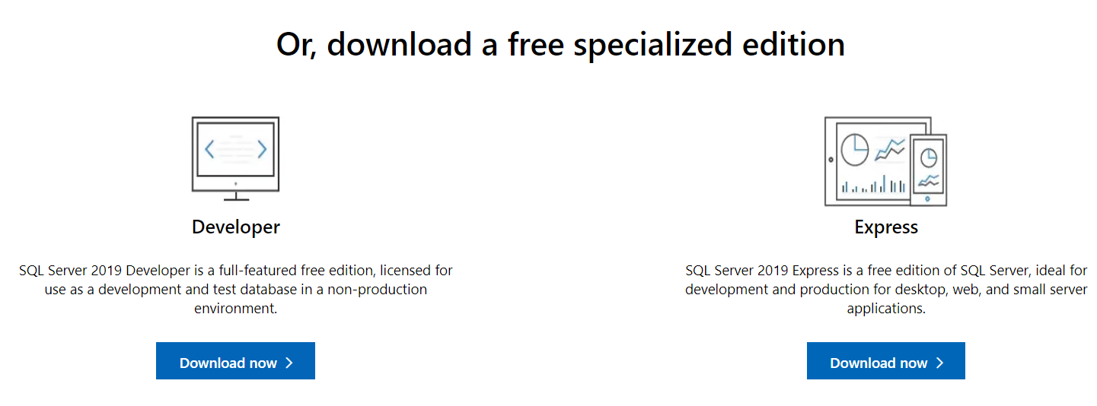

Figure

1. Open the downloaded file.

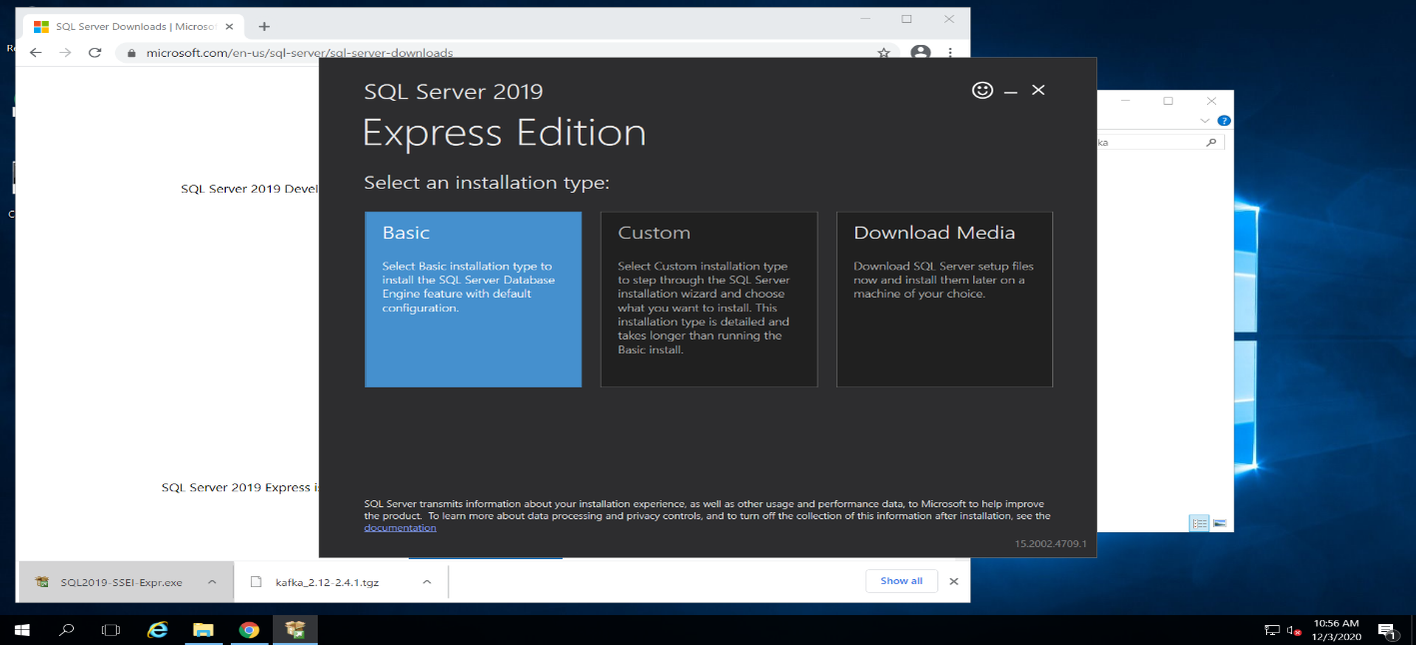

Figure

1. Choose **Basic** → Accept Terms and conditions → Choose an installation directory → click **Install** then wait for installation to finish → click **Close**.

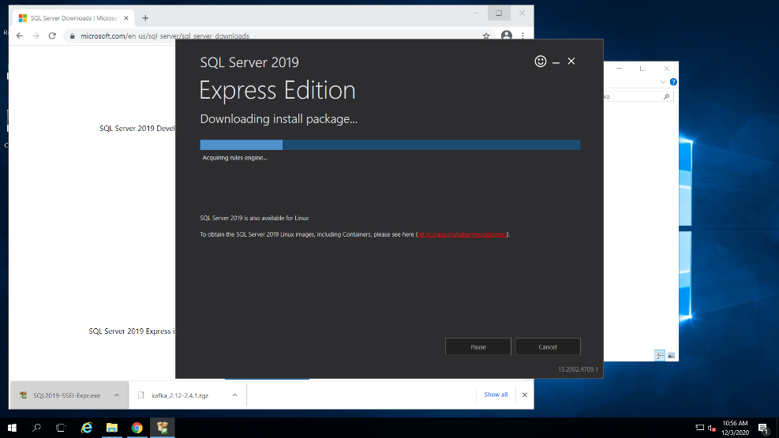

Figure

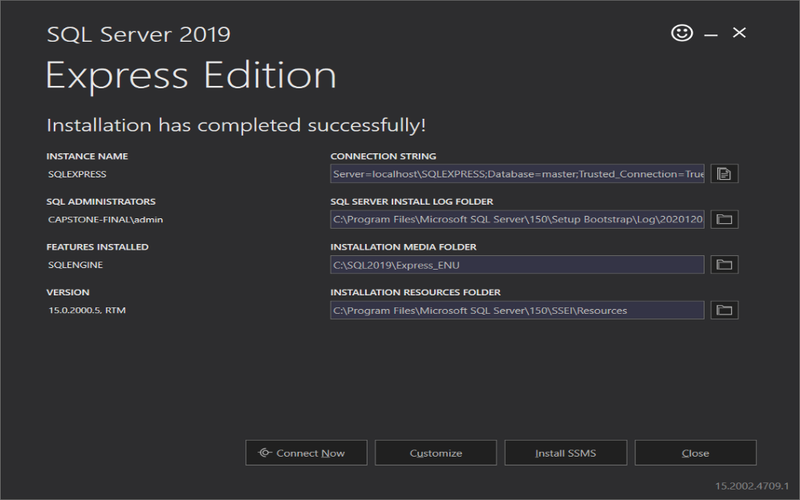

Figure

1. Press button **Start** , search *SQL SERVER 2019 CONFIGURATION MANAGER* → open this program .

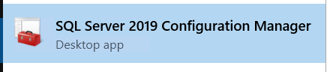

Figure

1. Select **SQL Server Network Configuration** → **Protocols for {instance_name}** → **TCP/IP**.

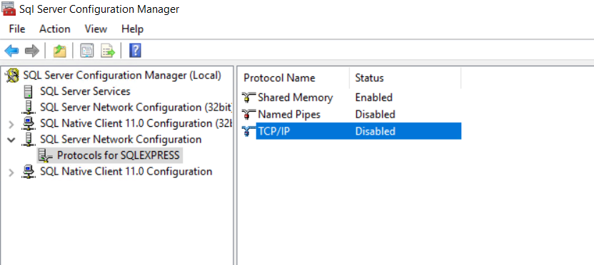

Figure

1. Right-click on **TCP/IP** → **Properties** → Set **Enabled** to Yes

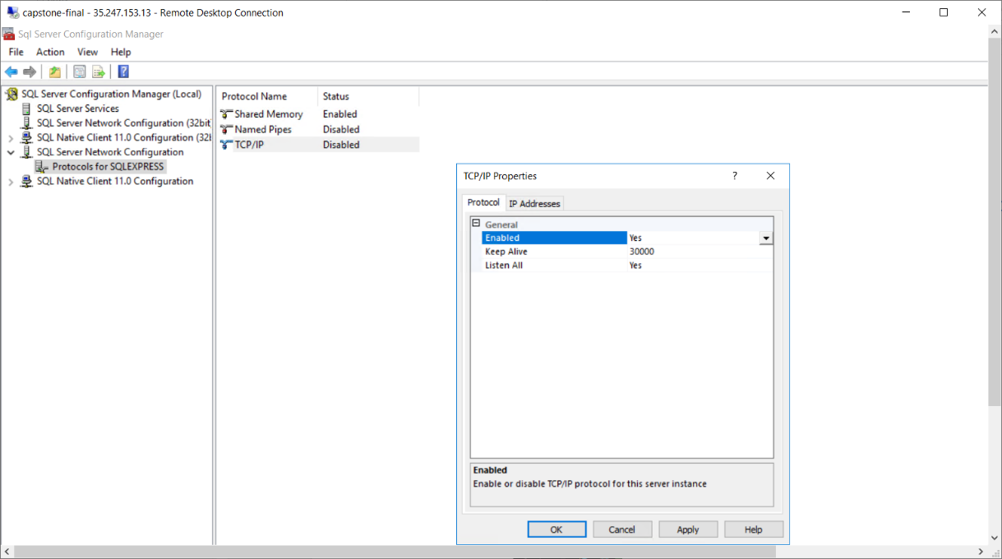

Figure

1. Go to tab **IP Addresses** → section **IPAll**, change the **TCP Port** to 1433 to make SQL Server listen to port 1433 → click **OK**.

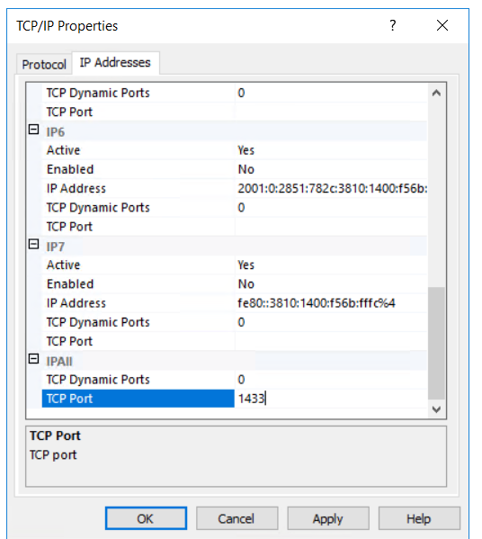

Figure

1. Select **SQL Server Services** → right-click on **SQL Server ({instance_name})** → **Restart** then wait for the service to restart.

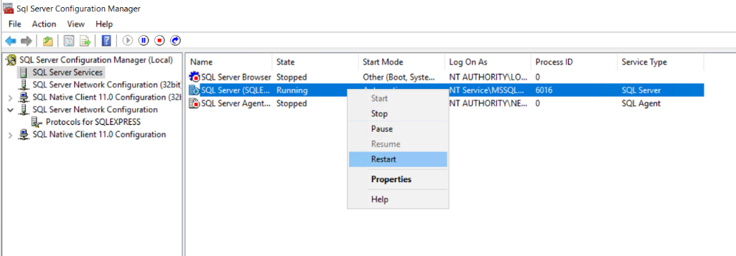

Figure

##### 4. Setup Api for application

1. Extract the file **BCDS.CapstoneBE.zip then run CapstoneBE.exe** 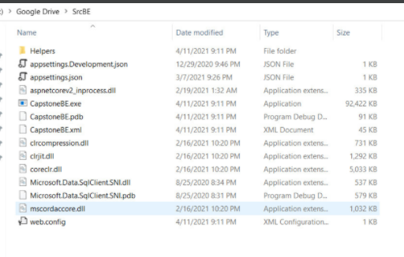

Figure

1. Test the app in browser by go to the url: <http://localhost:5000> 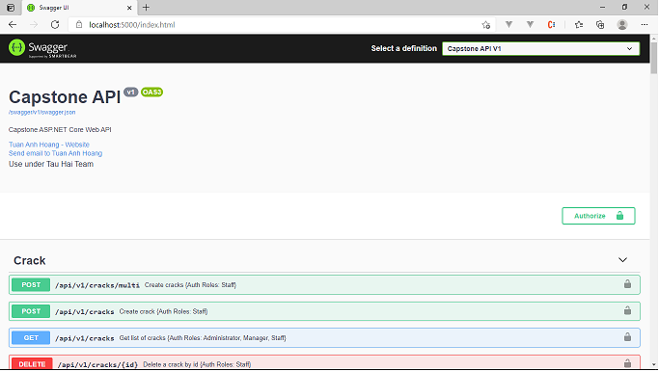

Figure

##### 5. NodeJS

1. Open a browser.



Figure

1. Go to this URL: [Download | Node.js](https://nodejs.org/en/download/)

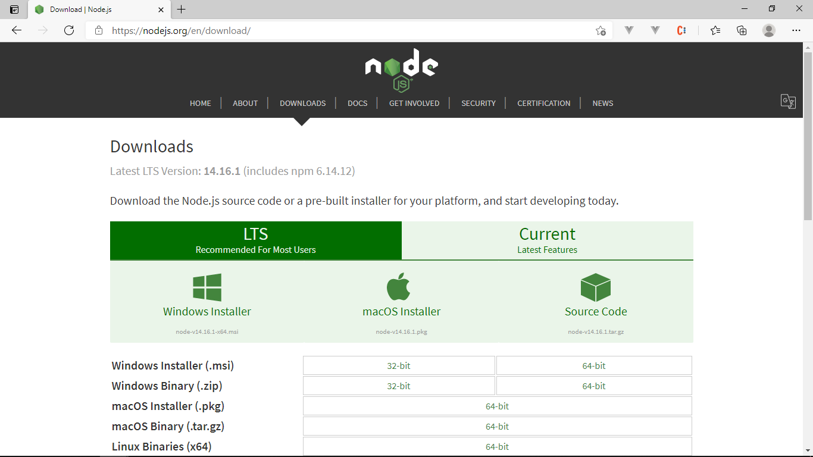

Figure

1. Click on Windows Installer

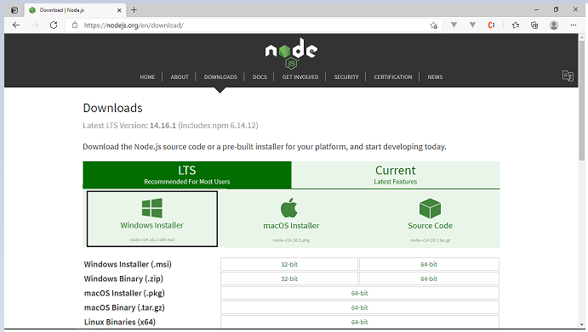

Figure

1. Run the downloaded file → click **Next**

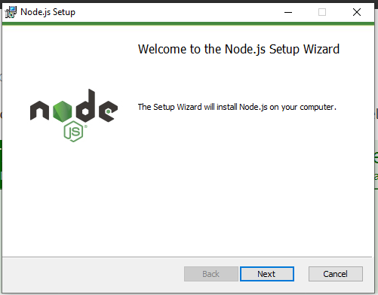

Figure

1. Agree terms and conditions → click **Next**.

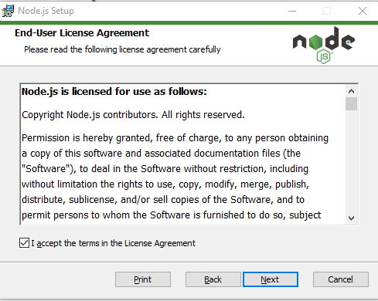

Figure

1. Choose a custom location → click **Next**

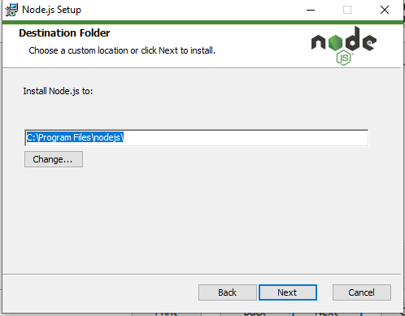

Figure

1. Click **Next**

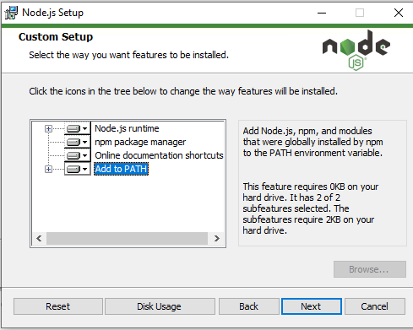

Figure

1. Click **Next**

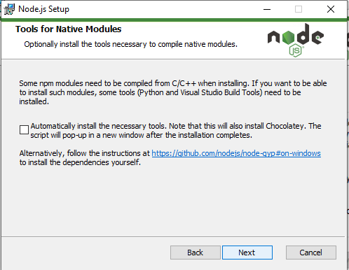

Figure

1. Click **Install**

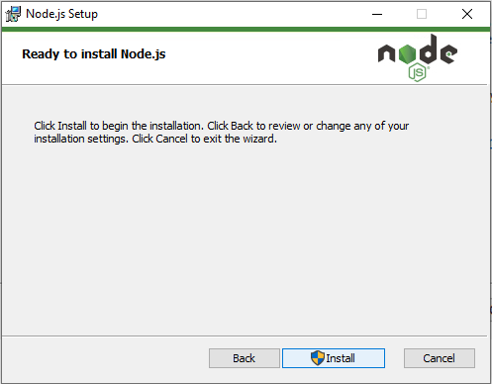

Figure

1. Wait for installing to finish and click **Finish**

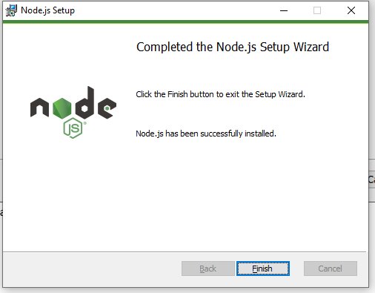

Figure

##### 6. Vue3

1. Search **cmd** and open **Command Prompt**

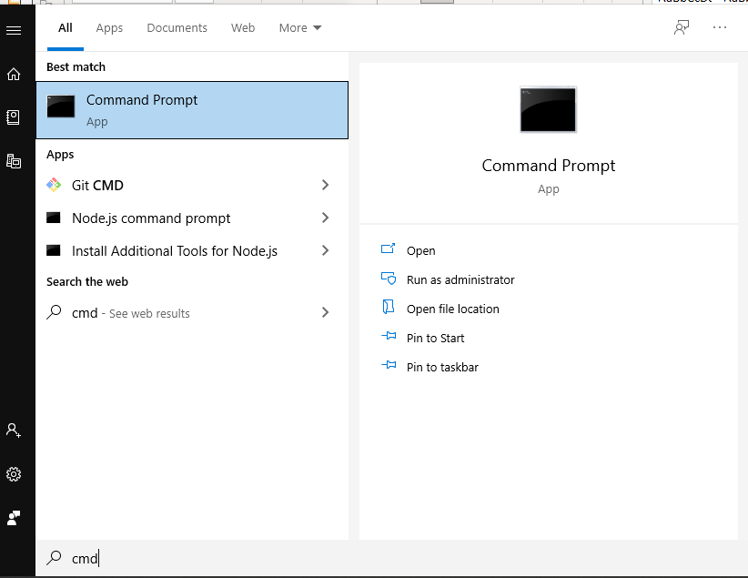

Figure

1. Input **npm install vue@next** and enter

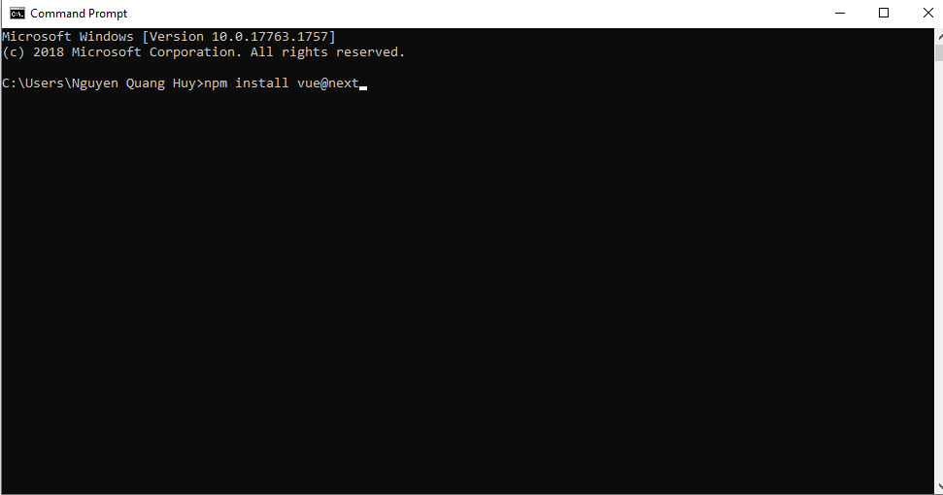

Figure

1. Wait for installing to finish

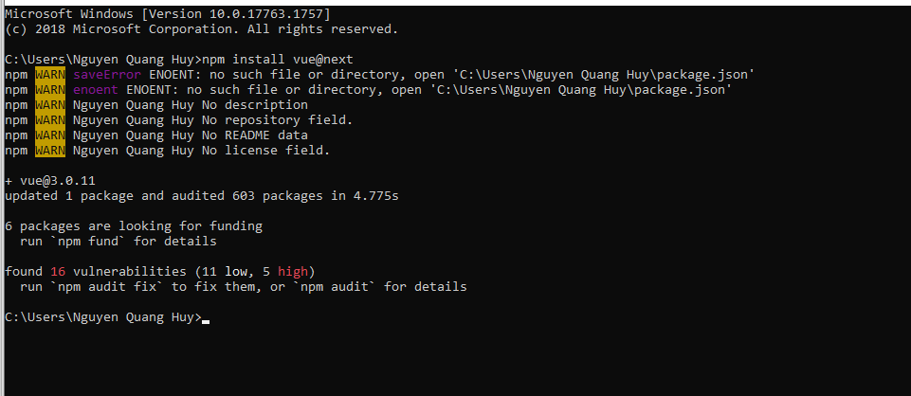

Figure

##### 7. Fire Base

1. Open a browser.



Figure

1. Go to this URL: [Firebase (google.com)](https://firebase.google.com/?hl=vi) then click **Get started** 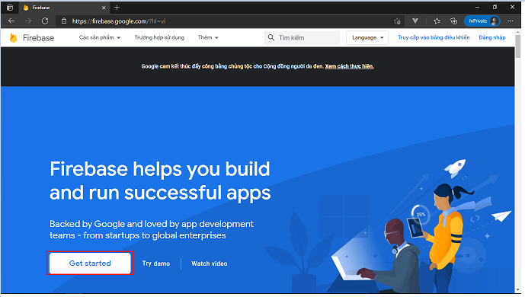

Figure

1. Log in with **Google account** 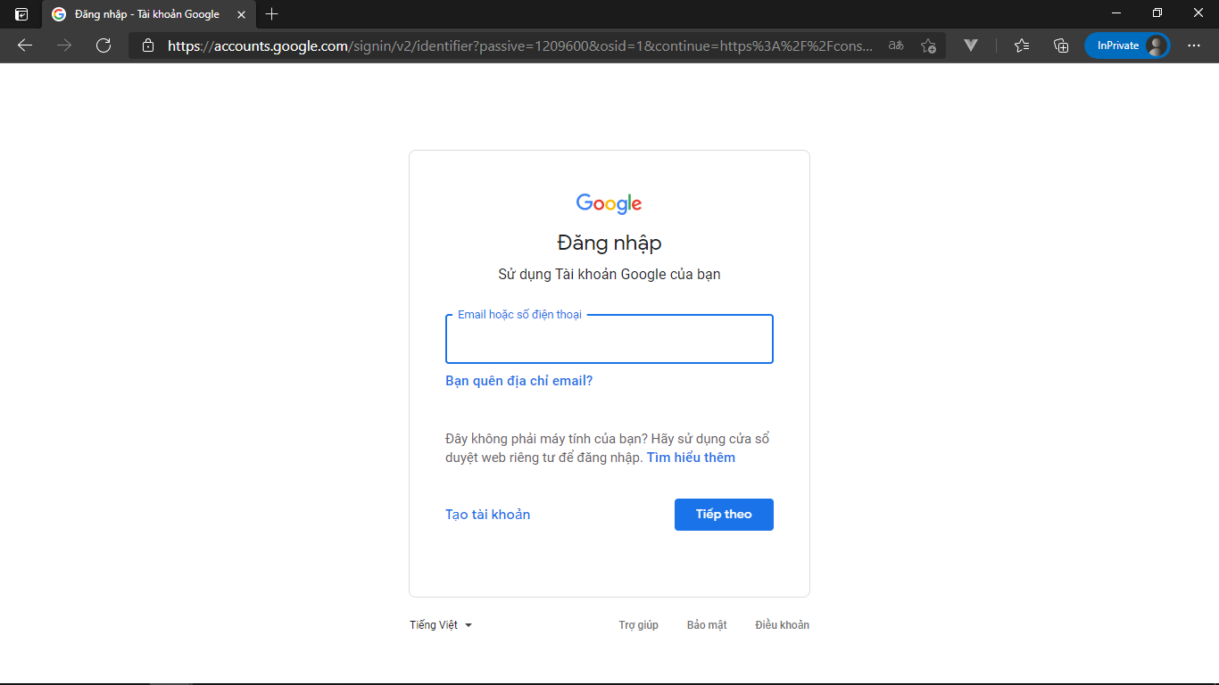

Figure

1. Click **Add project** 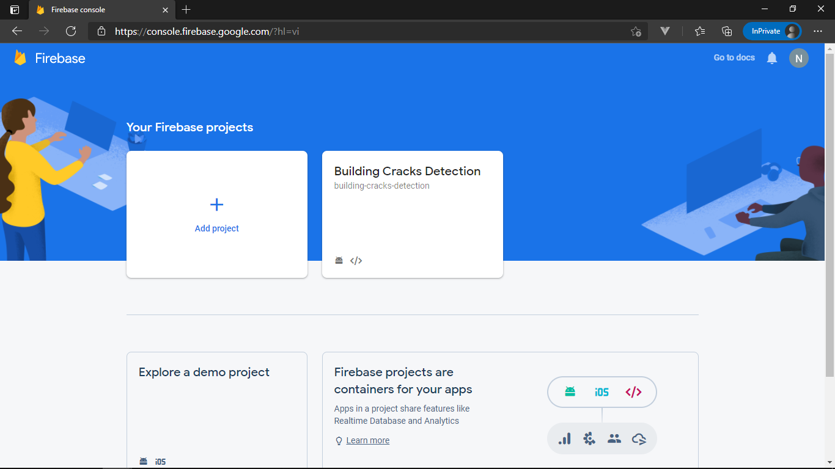

Figure

1. Input your **Project Name** ( ex:Capstone Project ) and click **Continue** 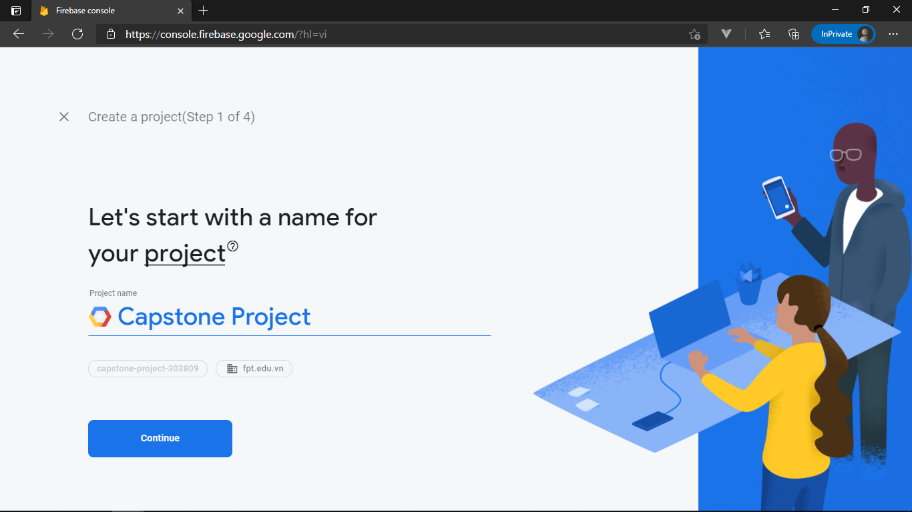

Figure

1. Click **Continue** 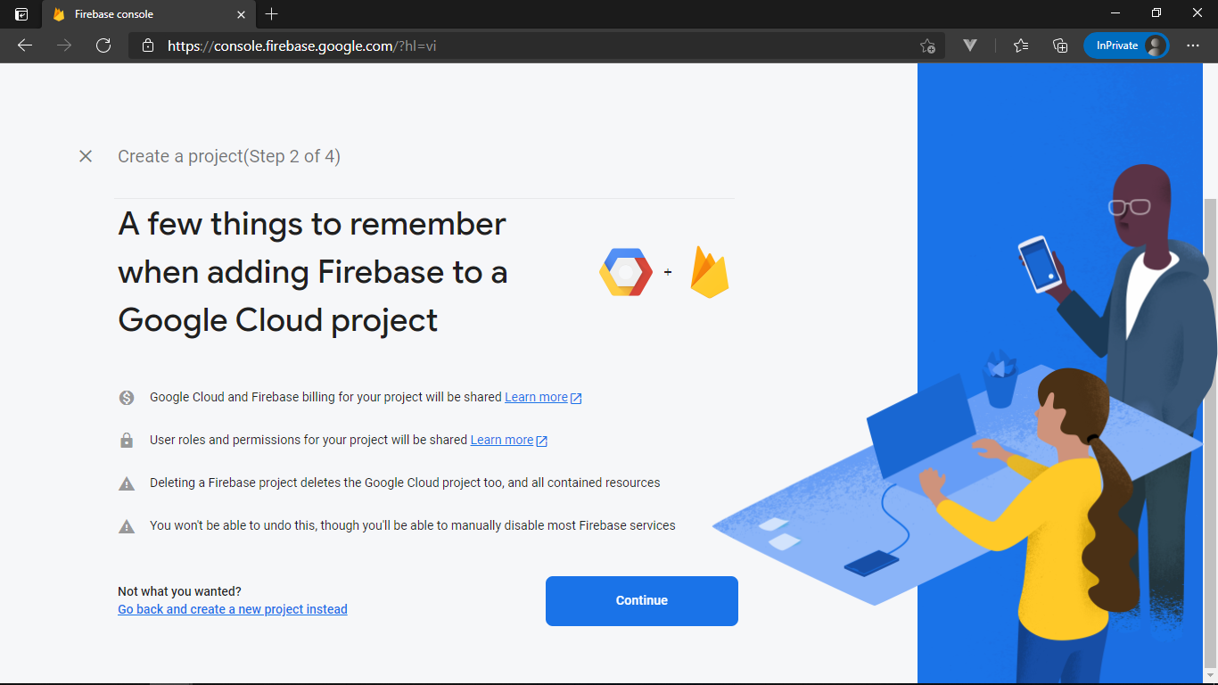

Figure

1. Turn off **Enable Google Analytics** and click **Add Firebase** 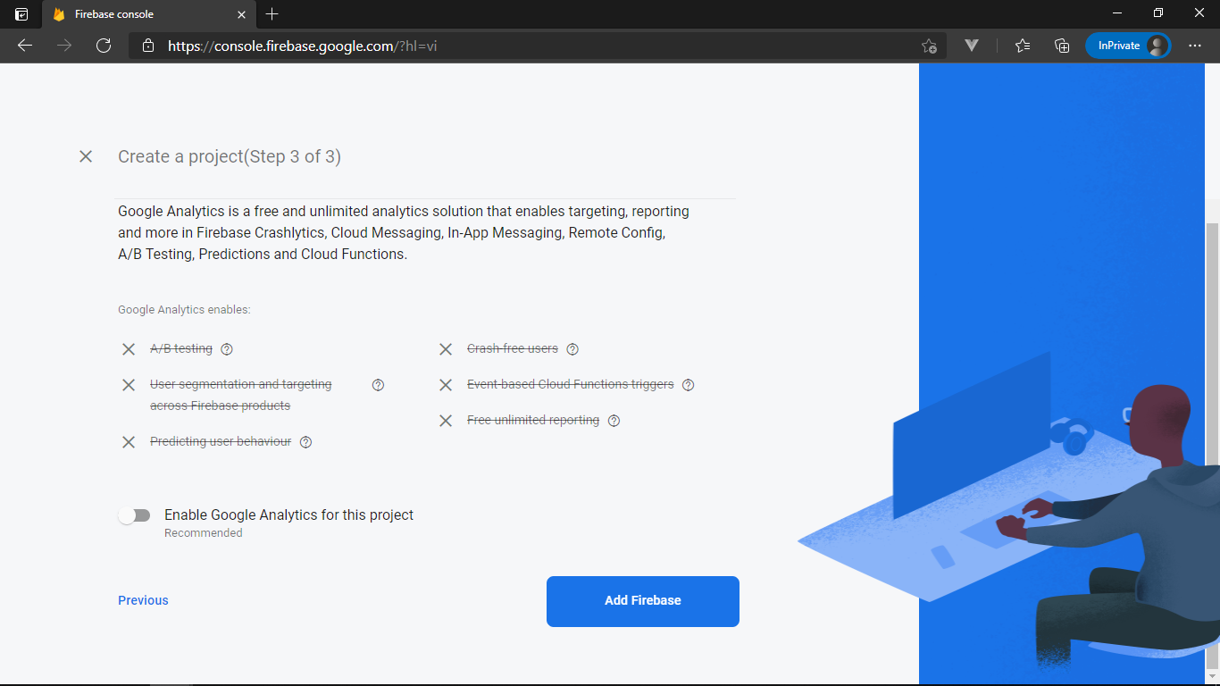

Figure

1. Wait to create project then click **Continue**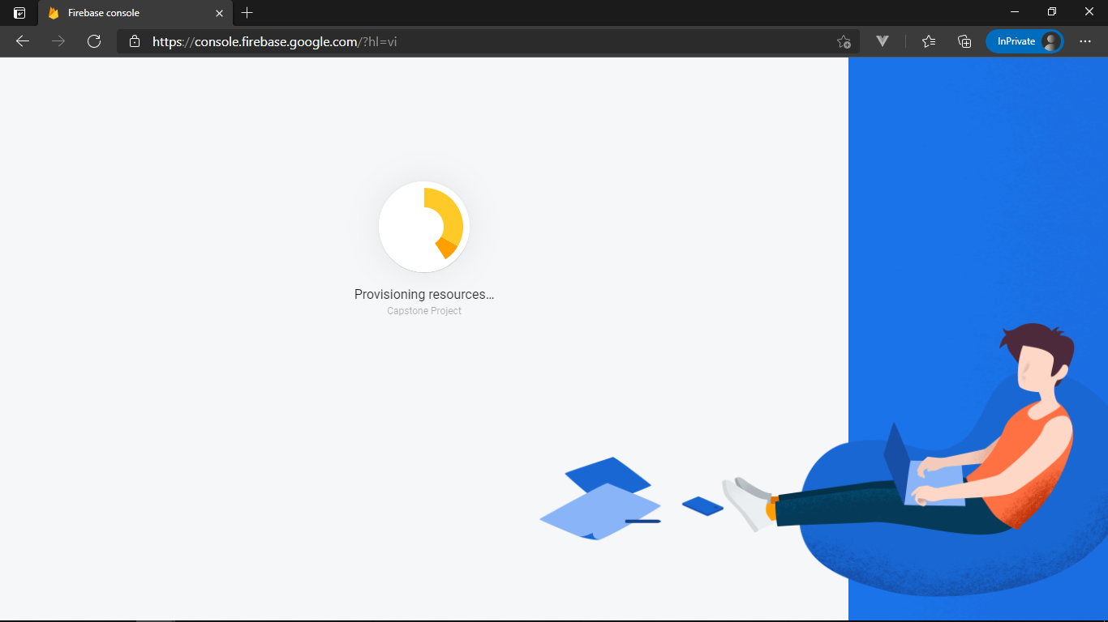

Figure

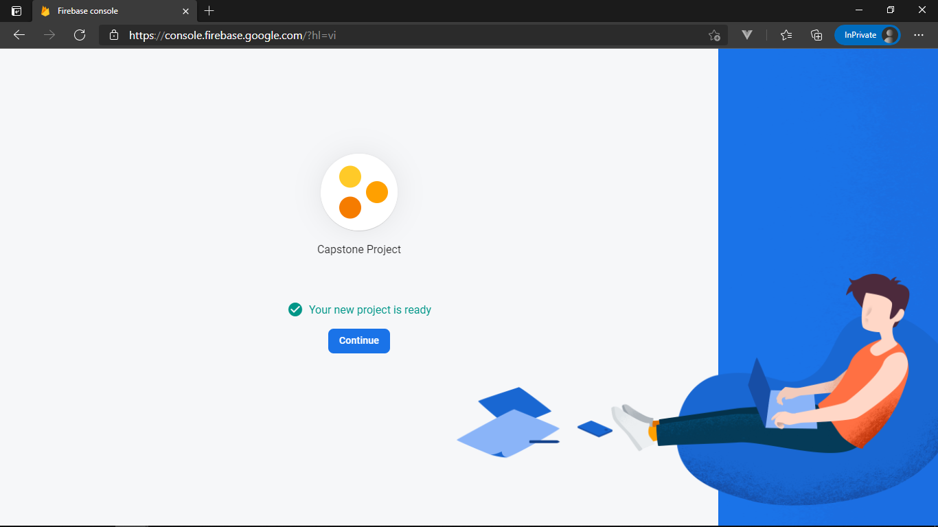

Figure

1. Set up notification in web by clicking icon **Web** 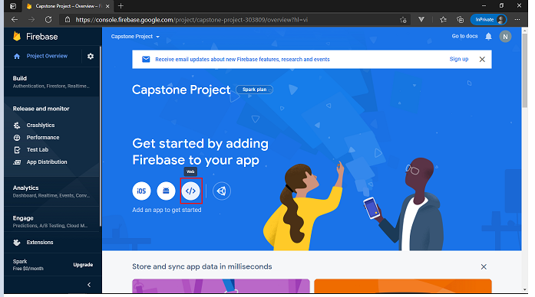

Figure

1. Input Web name (ex BCDSystemWeb) then click **Register app** 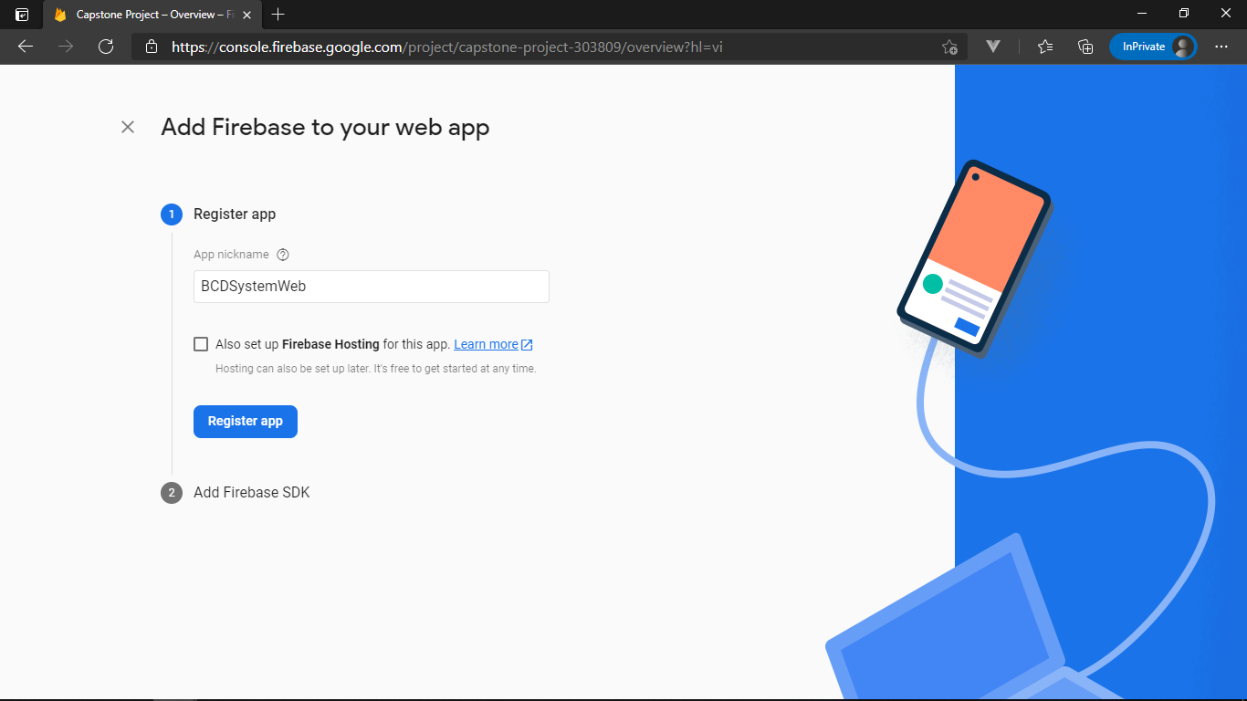

Figure

1. Copy firebaseConfig to config with web then click **Continue to the console** 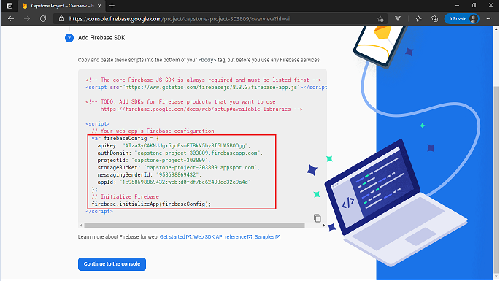

Figure

1. Click **Add app** then choose icon **Android** 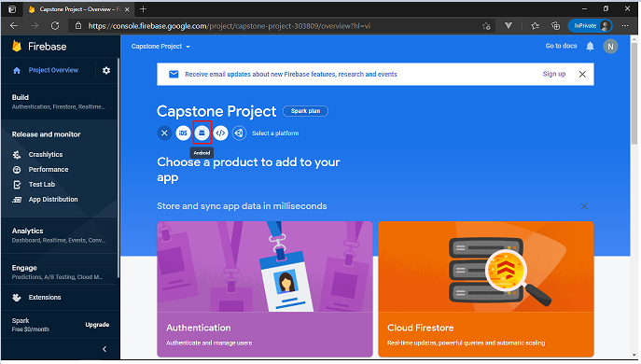

Figure

1. Input **applicationID (package in Android.Mainfest)** into **Android Package Name** then click **Register app**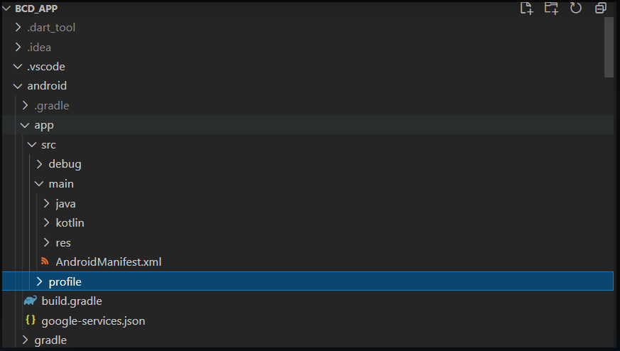

Figure



Figure

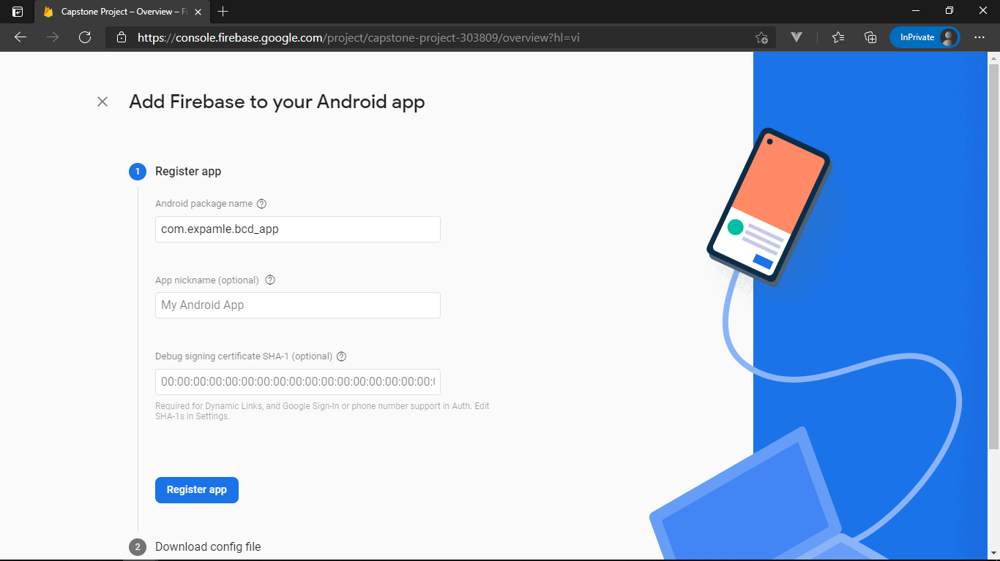

Figure

1. **Download** google-services.json file then add to source **Mobile** then click **Next**

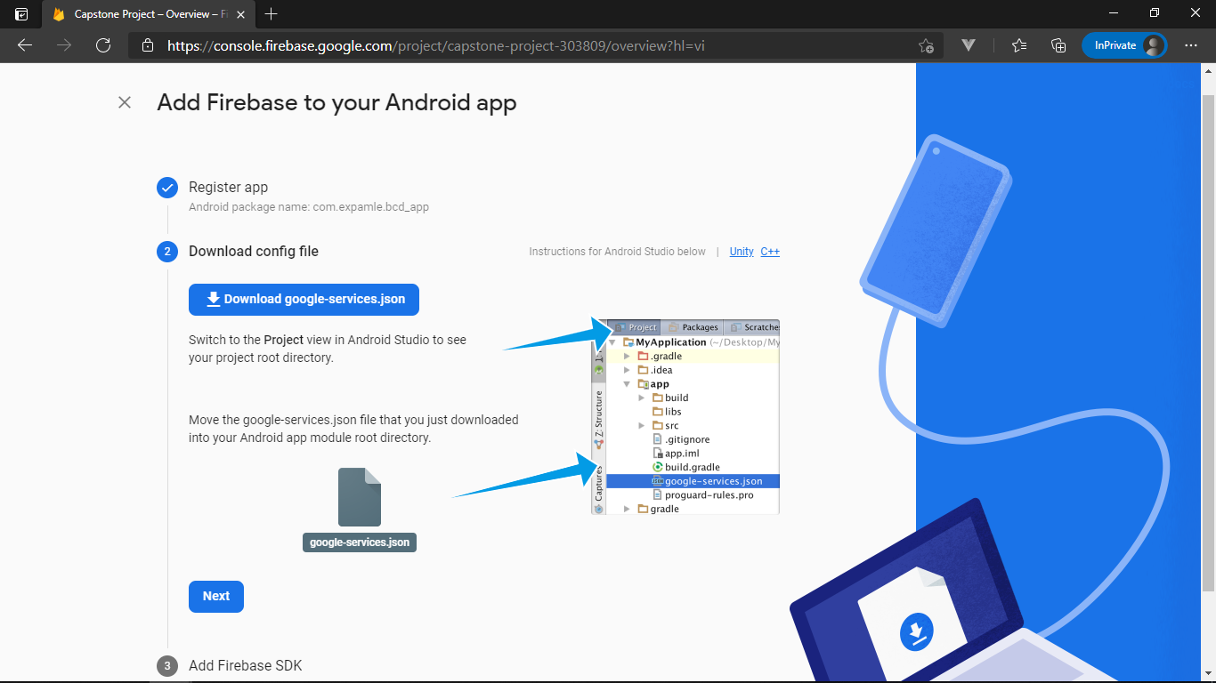

Figure

1. Modify your build.gradle files then click **Next** 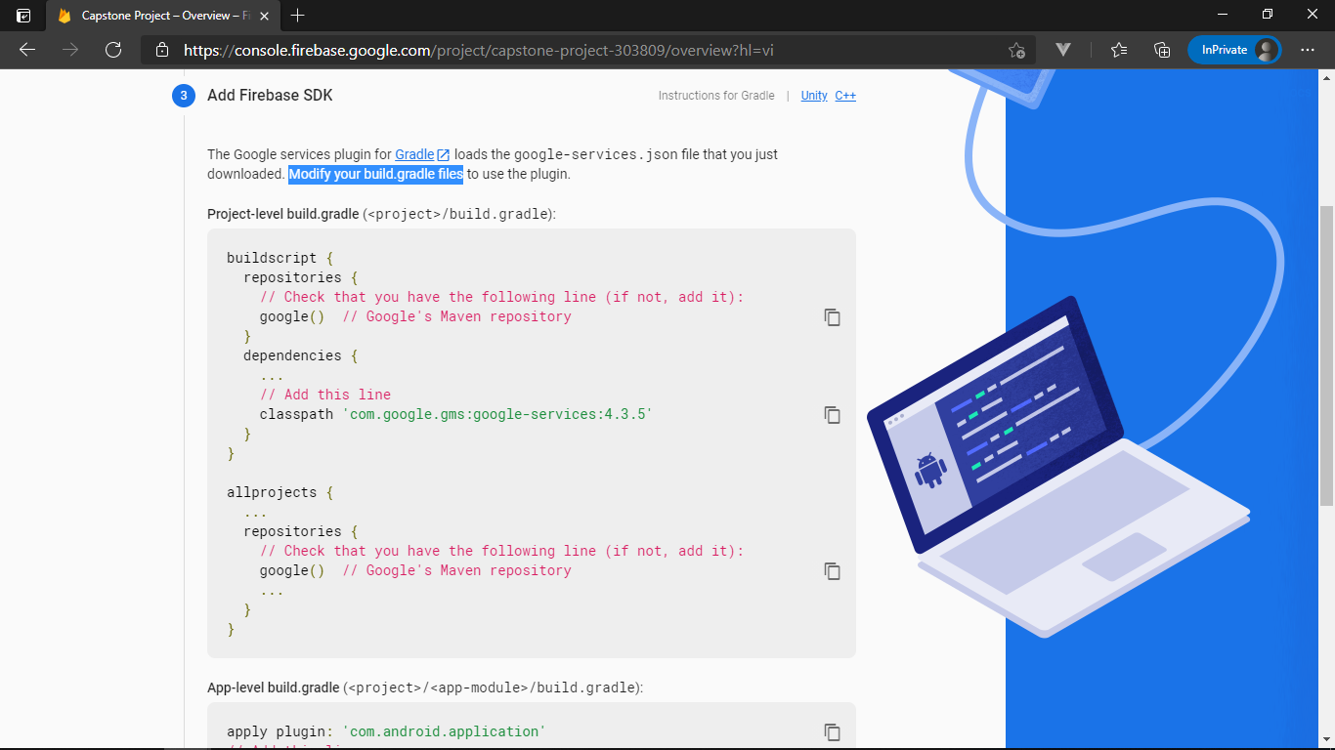

Figure

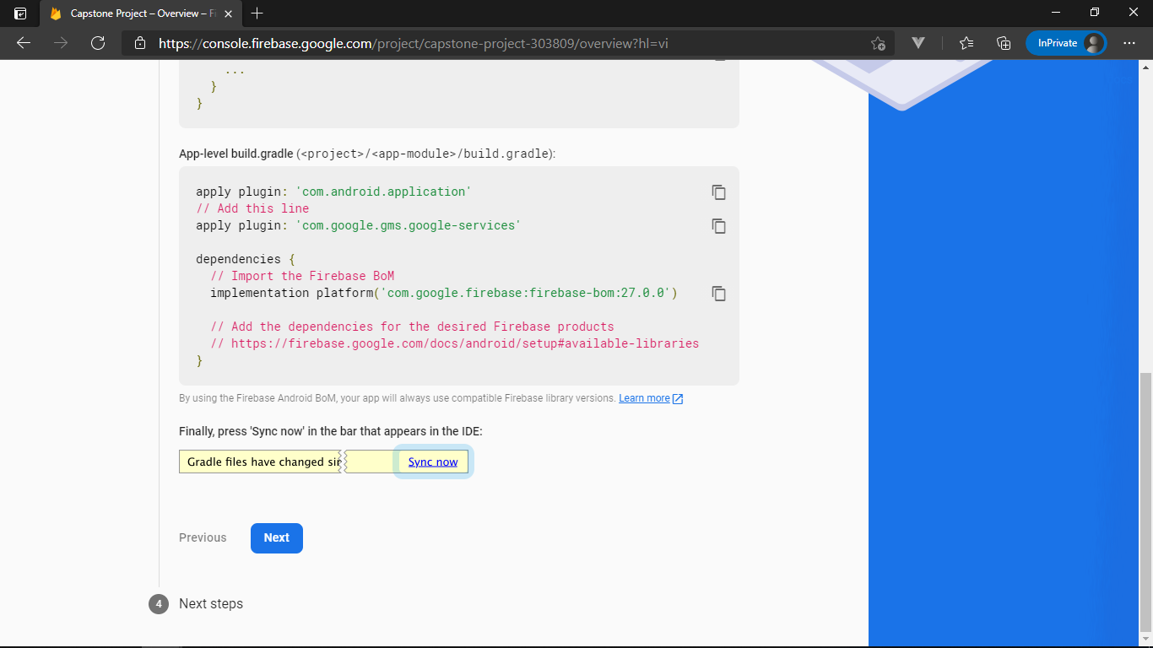

Figure

1. Click **Continue to the console** to finish config firebase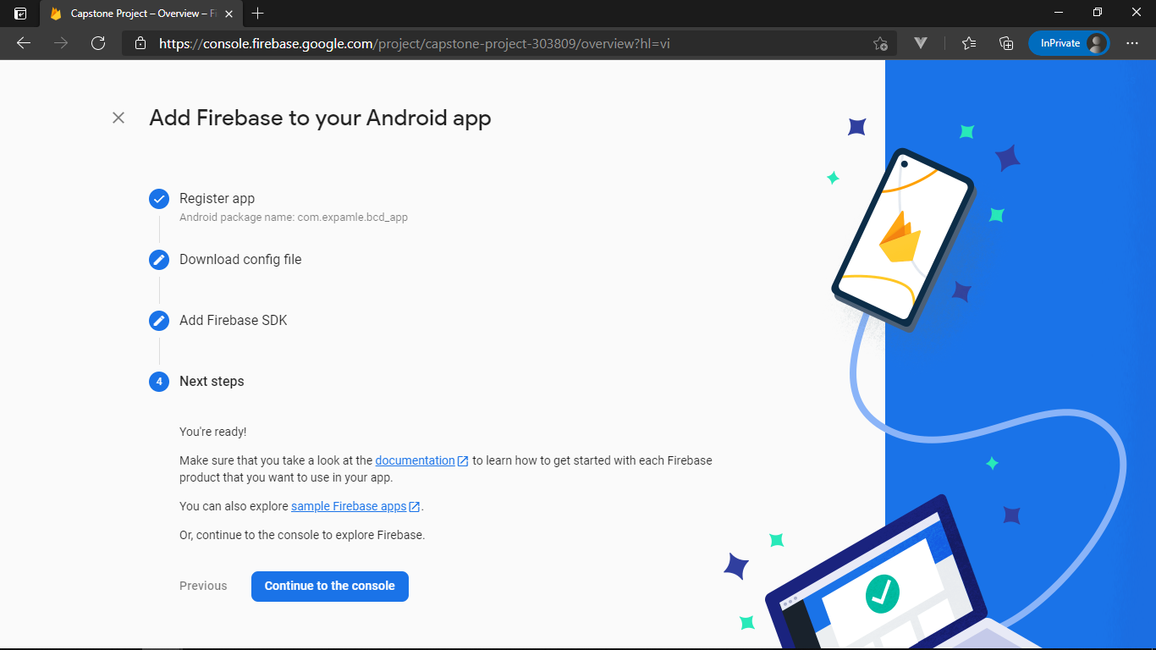

Figure

##### 8. Run Web application.

1. Extract the file **BCDS.CapstoneWeb.zip** then Search **cmd** and open **Command Prompt**



Figure

1. Use command cd to file path 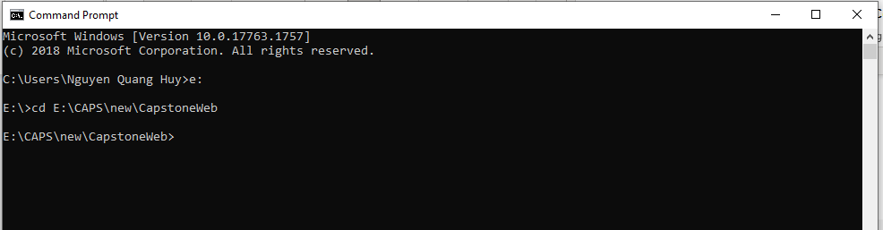

Figure

1. Use command **npm install** to saves any specified packages into dependencies by default 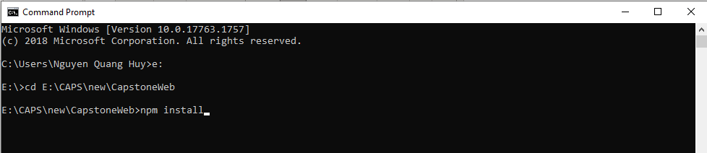

Figure

1. Wait to finish install package then use command **npm run serve** to start web application. 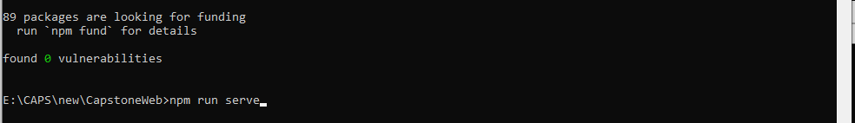

Figure

1. Wait to build app then open <http://localhost:8080/> in browser to run web application 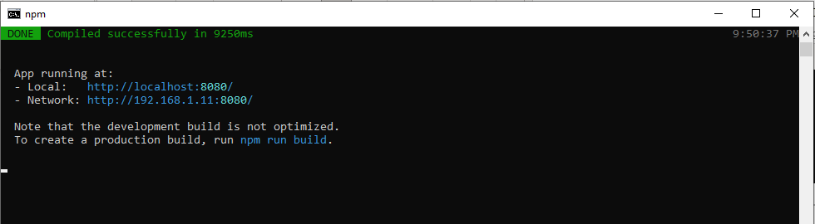

Figure

1. Show Log in Screen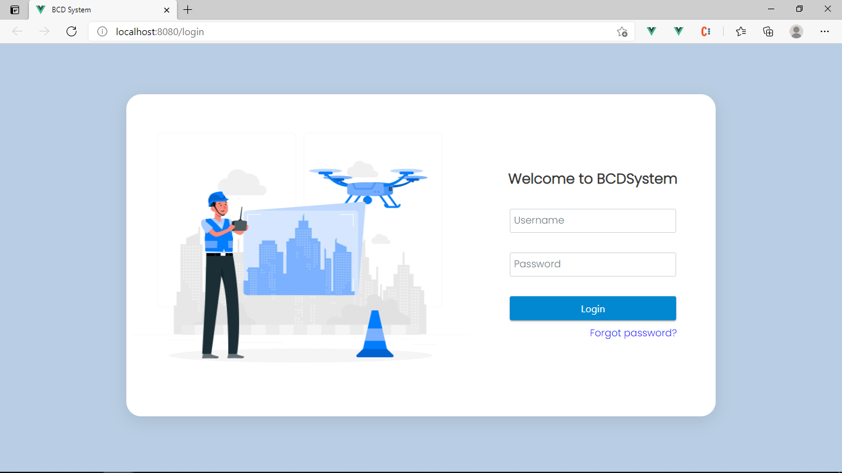

Figure

##### 9. Python

1. Open a browser.



Figure

1. Go to this URL: [Download Python | Python.org](https://www.python.org/downloads/) 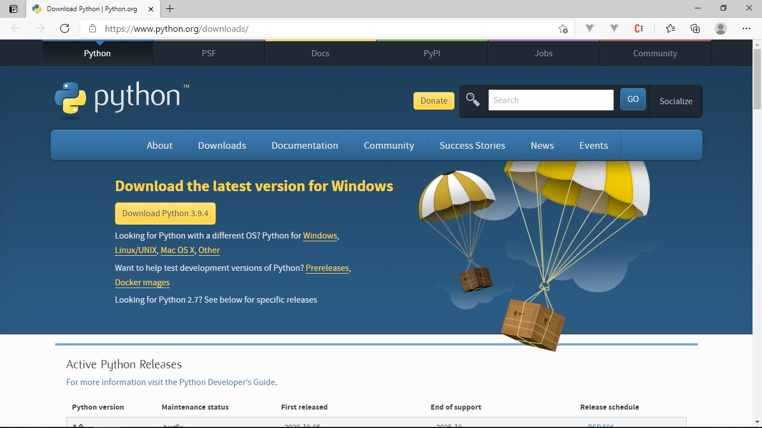

Figure

1. Click **Download Python** (lastest version for Windows) 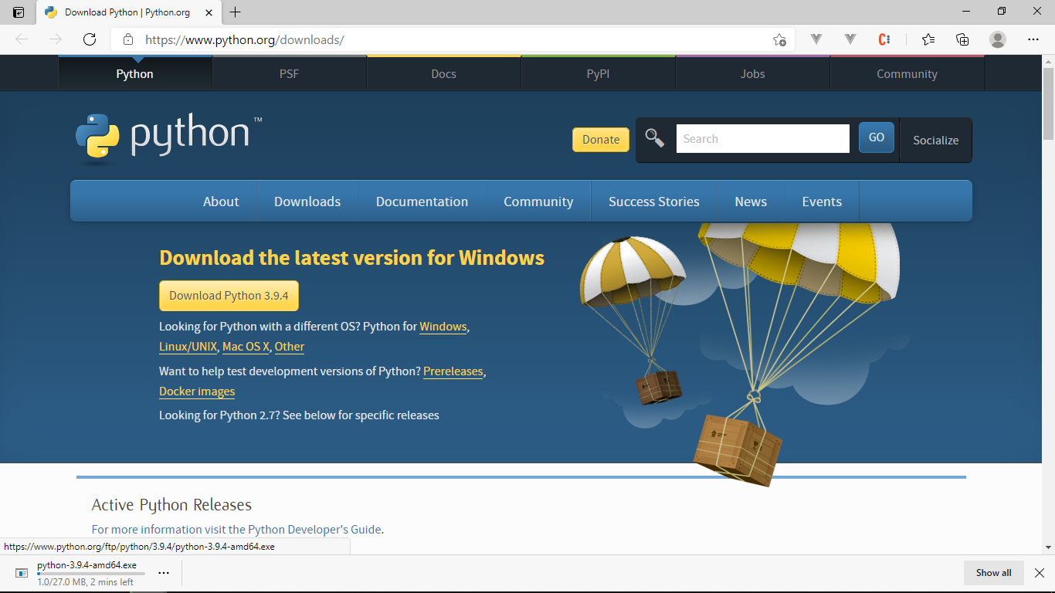

Figure

1. Run file choose **Customize installation**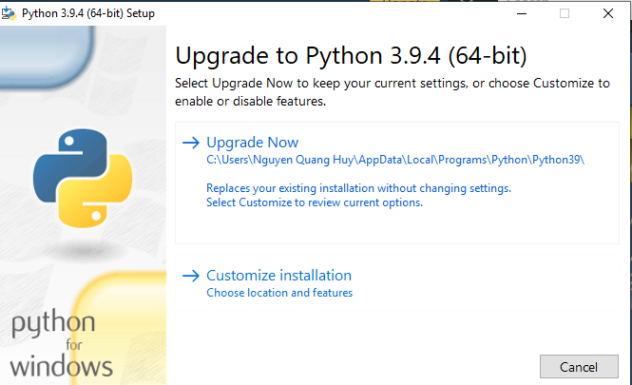

Figure

1. Tick in Check Box then click **Next** 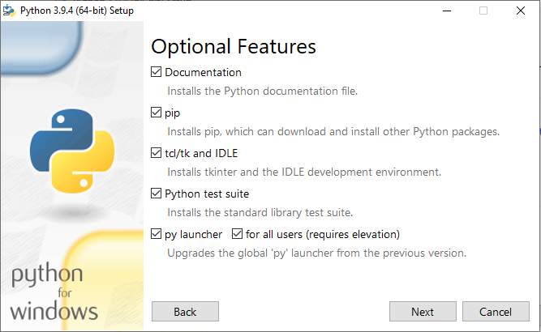

Figure

1. Customize install location then click **Install** 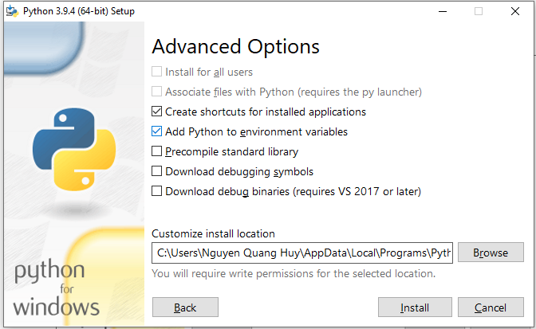

Figure

1. Wait to finish install then click **Close** 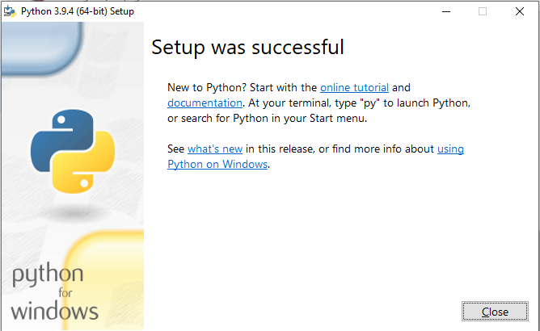

Figure

##### 10. Run Detect Sever

1. Extract the file **BCDS.CapstoneDetect.zip** then Search **cmd** and open **Command Prompt**

Figure

1. Use command **cd** to CapstoneDetectfolder****

Figure

1. Run command **pip install -r requirements.txt** 

Figure

1. Wait to finish download then show success message 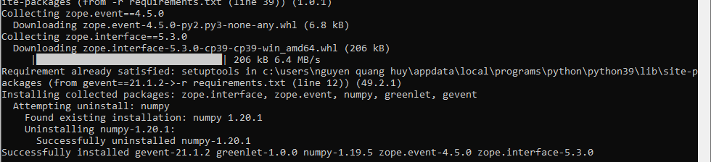

Figure

1. Run command python **detectapi.py** to run server detect. 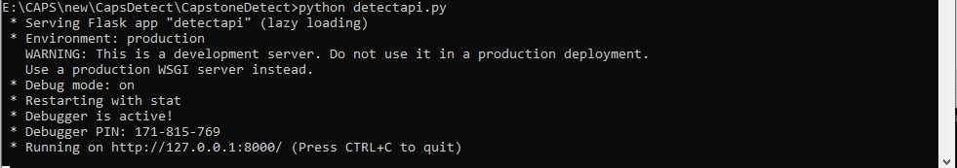

Figure

##### 11. Run Mobile Application

1. Click in Mobile.apkfile

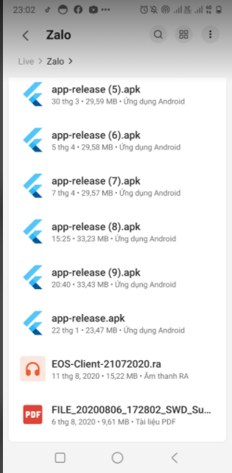

Figure

1. Show popup then click **Cài Đặt**

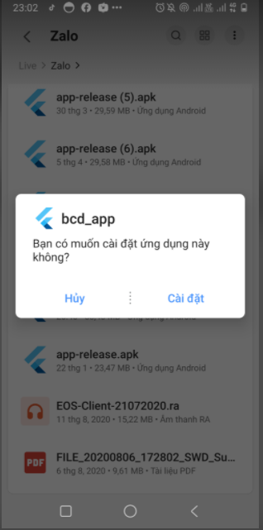

Figure

1. Wait for install Mobile app

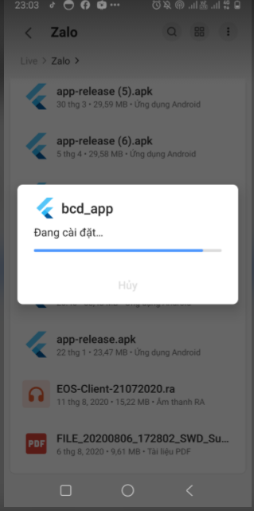

Figure

1. Finish install then click **Mở**

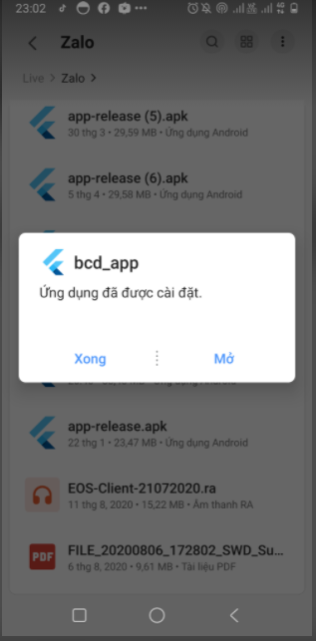

Figure

1. Show login page in Mobile app

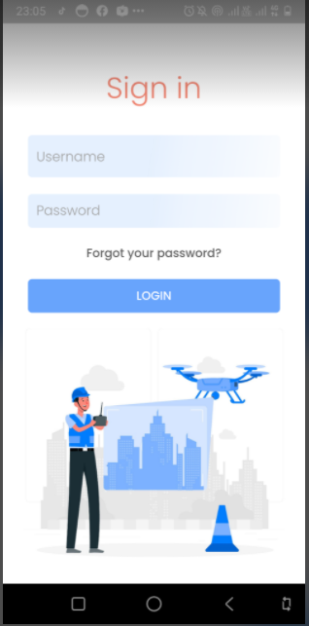

Figure

## 3. User Manual

### 3.1 Terms and definitions

N/A

### 3.2 System requirements

*See to* *section 2.1**.*

### 3.3 Application Usage

#### a. Overview

*Login Page:*

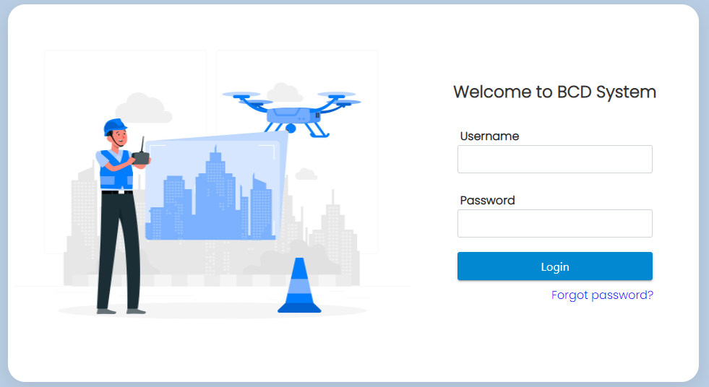

Figure . Login page

*Dashboard page:*

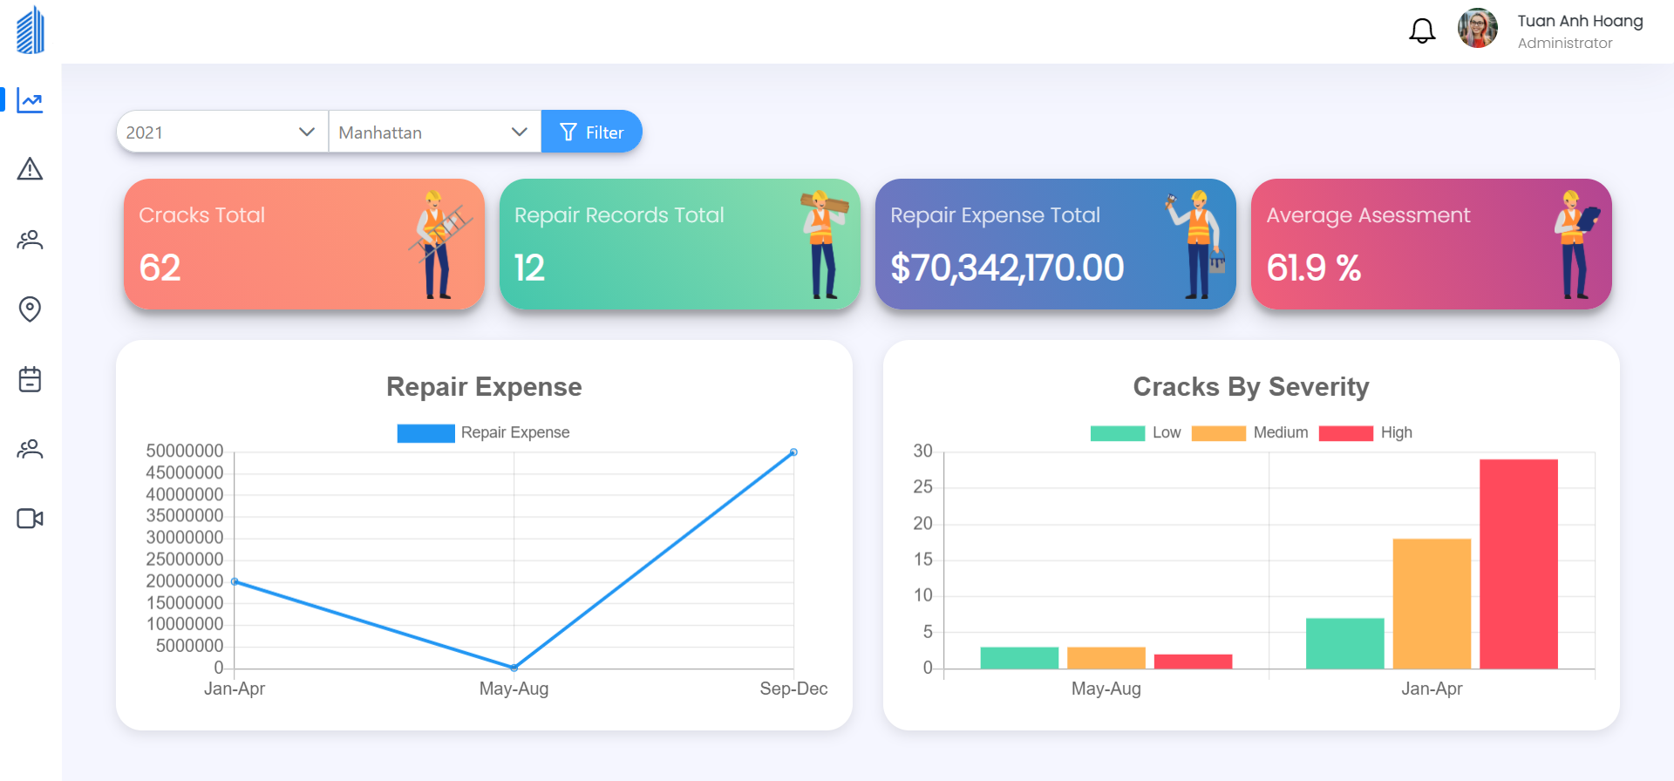

Figure . Dashboard

#### b. Login

*Step 1. User visits this site*

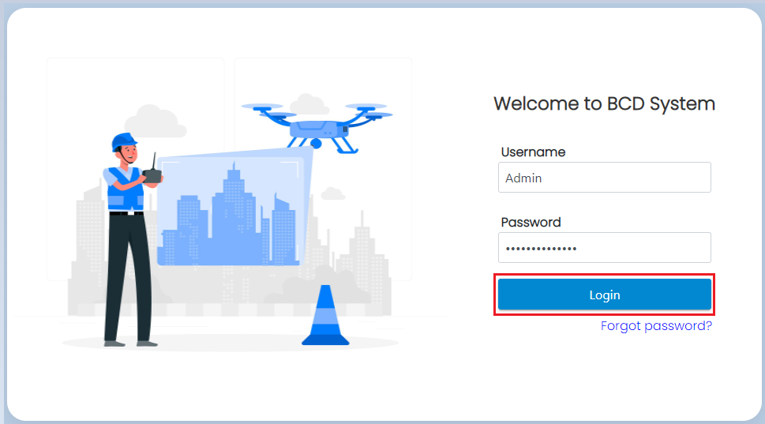

Figure . Login screen

*Step 2. Fill in account’s username and password*

*Step 3. Click “Login” button*



Figure . Login button

#### c. Forgot Password

*Step 1. User visits this site*

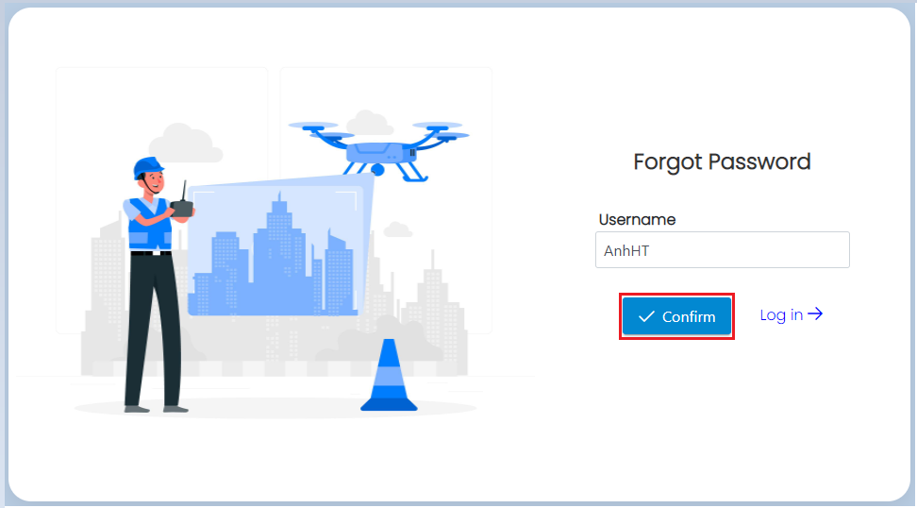

Figure . Forgot password screen

*Step 2. Fill in username*

*Step 3. Click “Confirm” button*

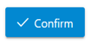

Figure . Confirm button

*Step 4. User opens his/her email*

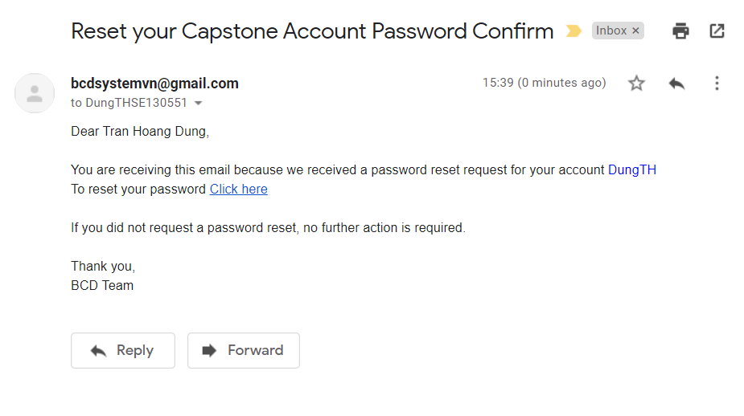

Figure . Reset password mail

*Step 5. Click “Click here” link*

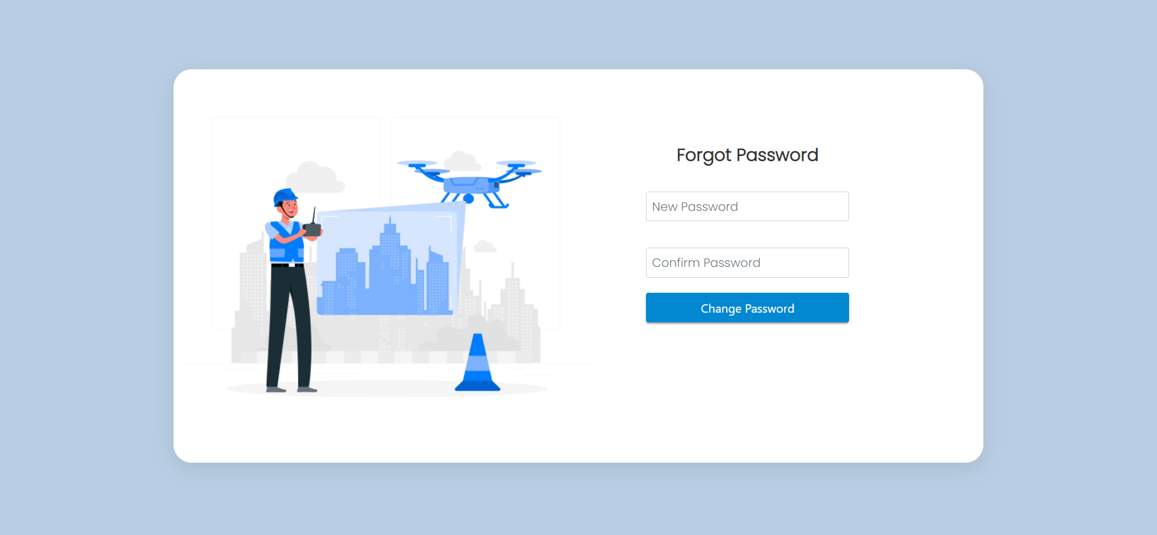

Figure . Forgot password screen

*Step 6. Fill in new password and confirm password*

*Step 7. Click “Change Password” button*



Figure . Change password button

#### e. Create User

*Step 1. On Dashboard page when logged in*

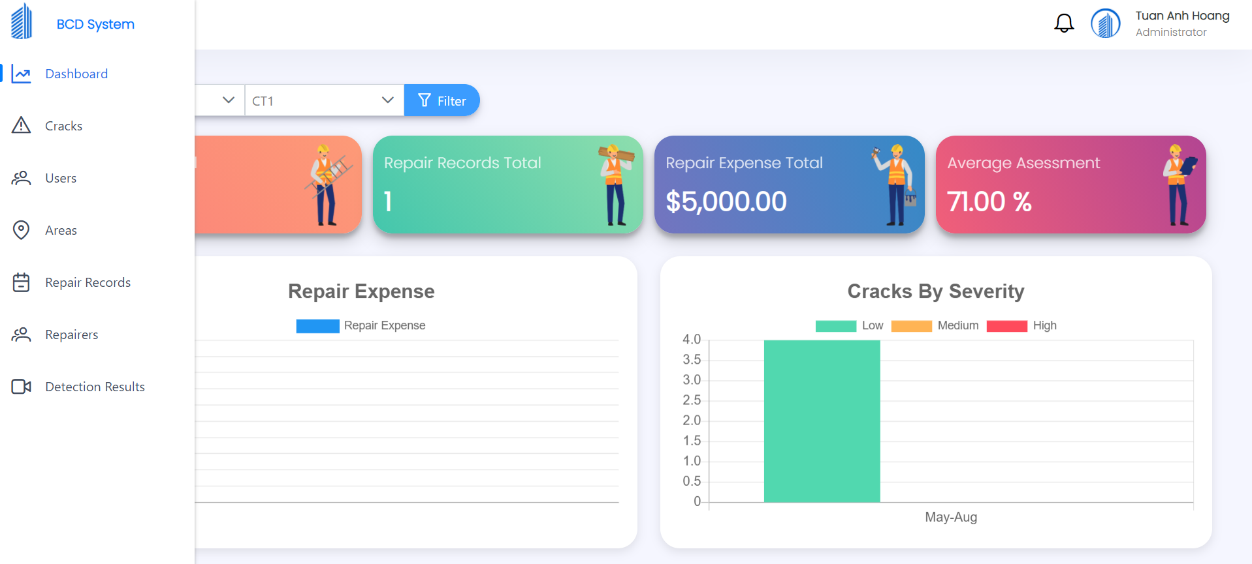

Figure

*Step 2. Select “Users” tab on left side bar*

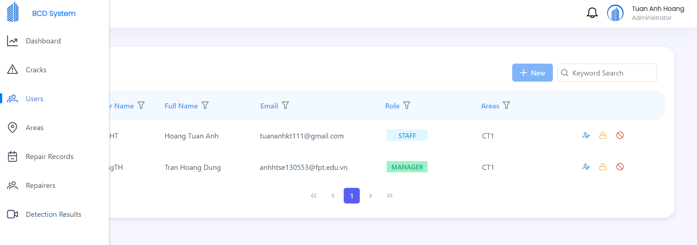

Figure

*Step 3. Click “New” button*

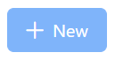

Figure

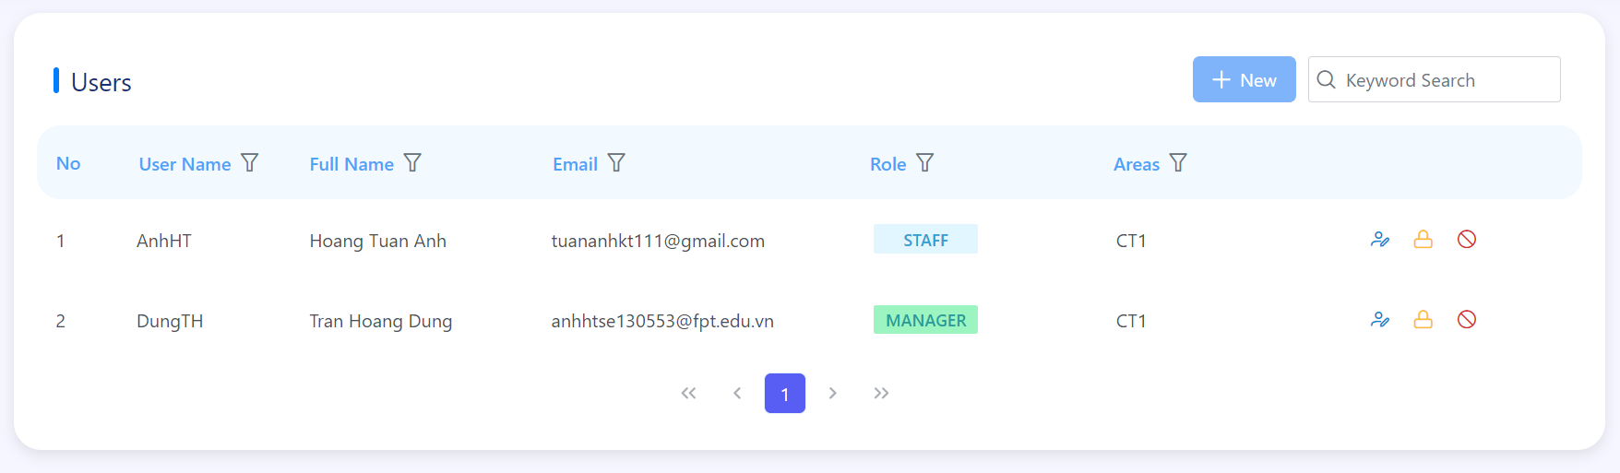

Figure

*Step 4. Enter required fields then click “Create” button to create new user*

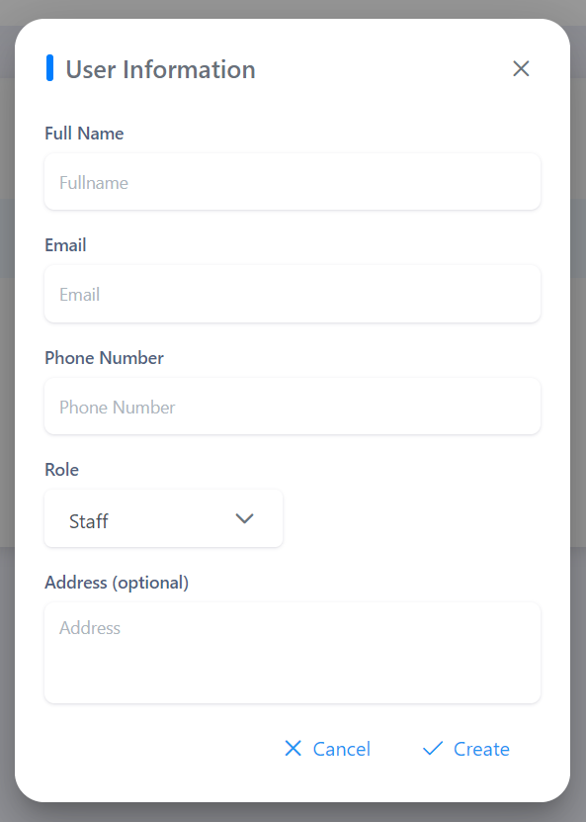

Figure

#### f. Update User

*Step 1. On Dashboard page when logged in*



Figure

*Step 2. Select “Users” tab on left side bar*

**

Figure

*Step 3. Click the below icon on user that want to update information*



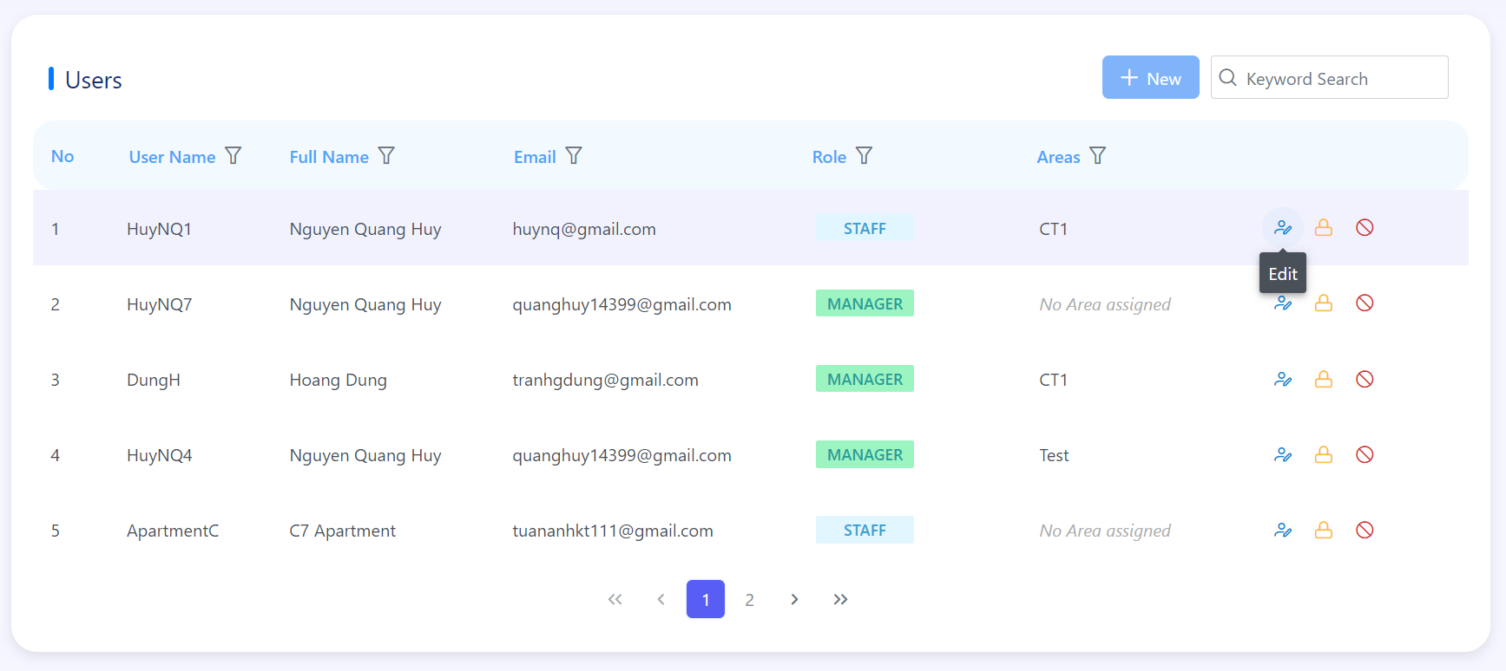

Figure

*Step 4. Edit information that you want then click “Update” button*



Figure

#### g. Reset Password

*Step 1. On Dashboard page when logged in*



Figure

*Step 2. Select “Users” tab on left side bar*

**

Figure

*Step 3. Click the below icon on user that want to reset password*

**

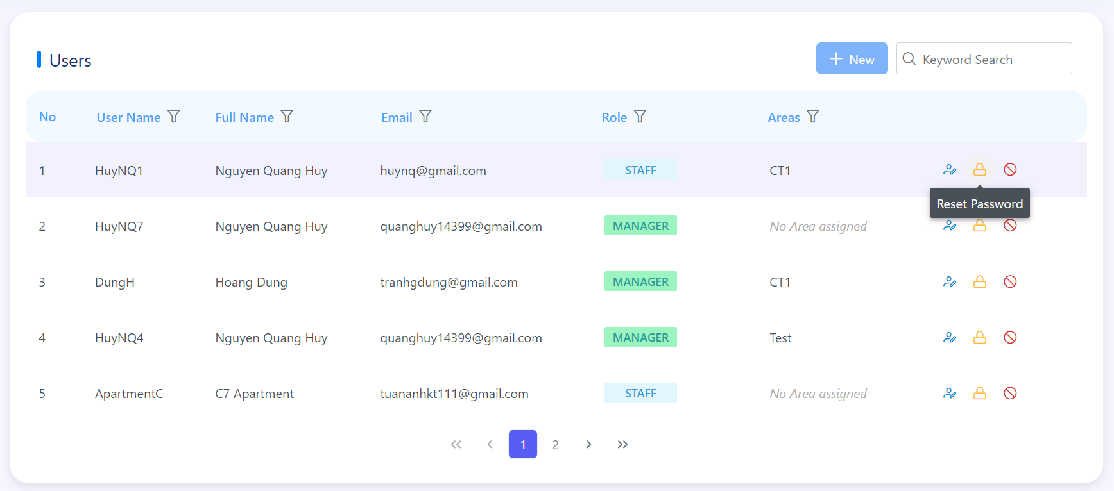

Figure

*Step 4. Click “Yes” button if you want to reset password for this user*



Figure

#### h. Delete Account

*Step 1. On Dashboard page when logged in*



Figure

*Step 2. Select “Users” tab on left side bar*

**

Figure

*Step 3. Click the below icon on user that want to delete*

**

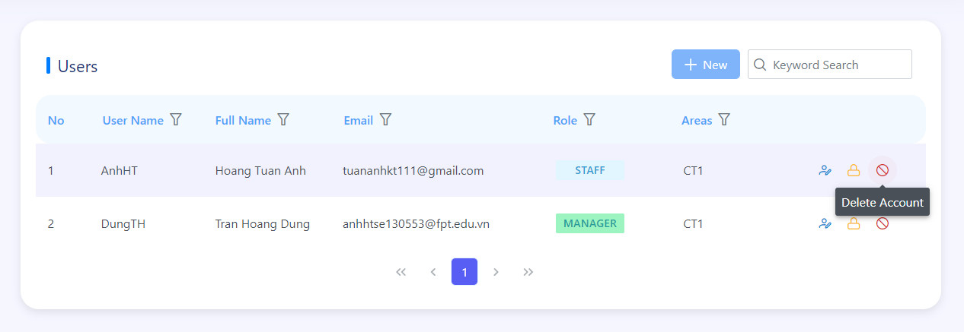

Figure

*Step 4. Click “Yes” button if you want to delete this user*



Figure

#### i. Create Area

*Step 1. On Dashboard page when logged in*



Figure

*Step 2. Select “Areas” tab on left side bar*

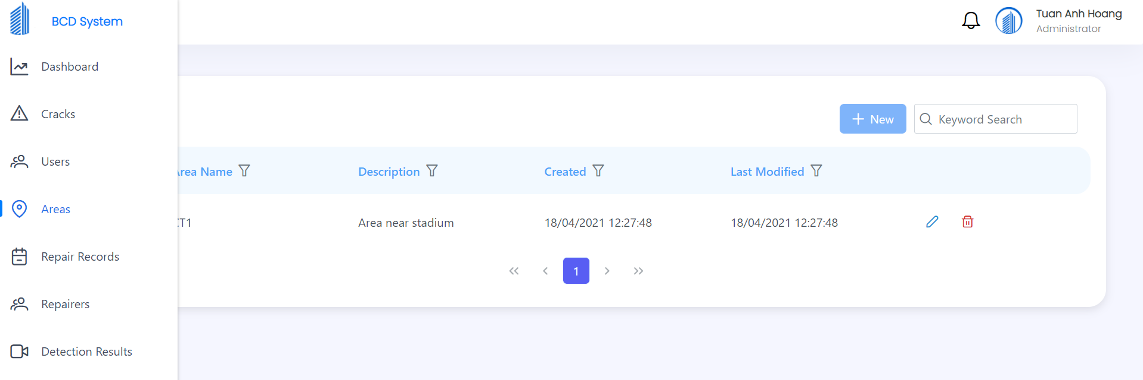

Figure

*Step 3. Click “New” button*

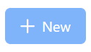

Figure

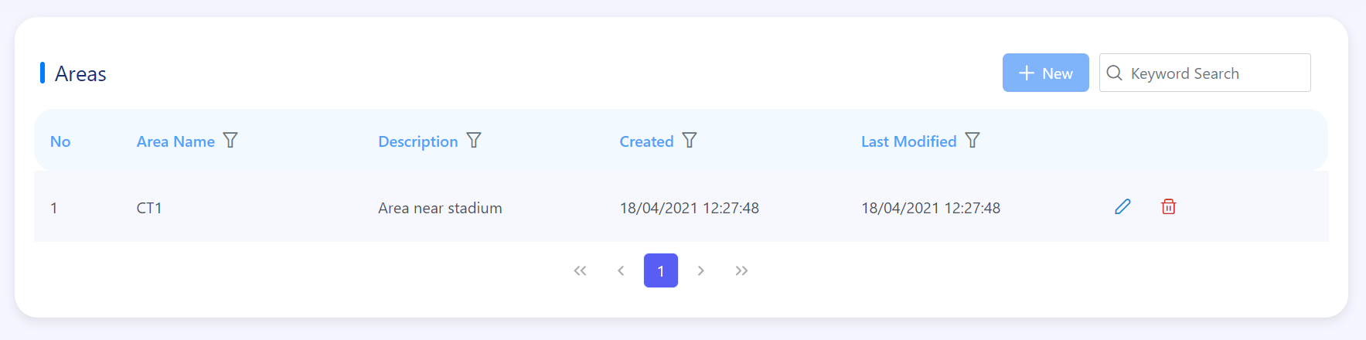

Figure

*Step 4. Enter required fields then click “Create” button to create new area*

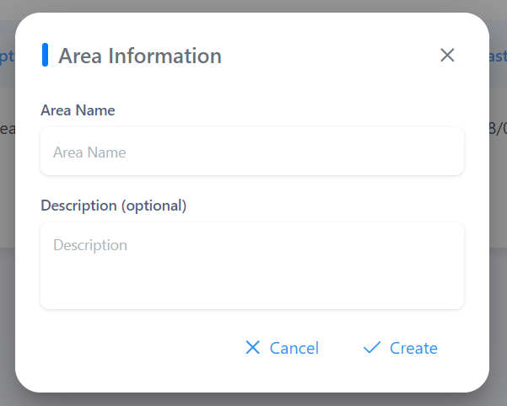

Figure

#### j. Update Area

*Step 1. On Dashboard page when logged in*



Figure

*Step 2. Select “Areas” tab on left side bar*

**

Figure

*Step 3. Click the below icon on area that want to update information*



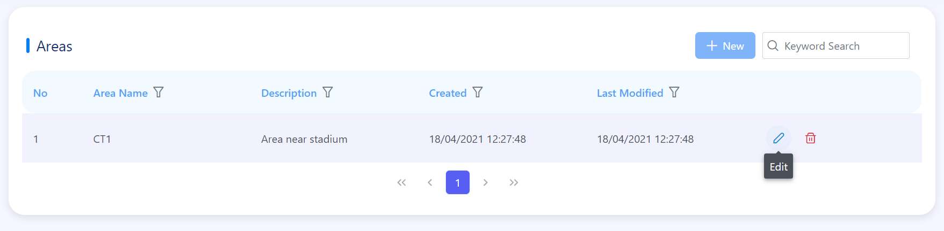

Figure

*Step 4. Edit information that you want then click “Update” button*

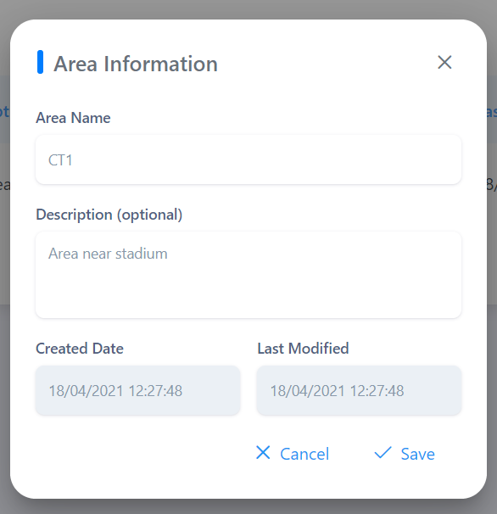

Figure

#### k. Delete Area

*Step 1. On Dashboard page when logged in*



Figure

*Step 2. Select “Areas” tab on left side bar*

**

Figure

*Step 3. Click the below icon on user that want to delete*



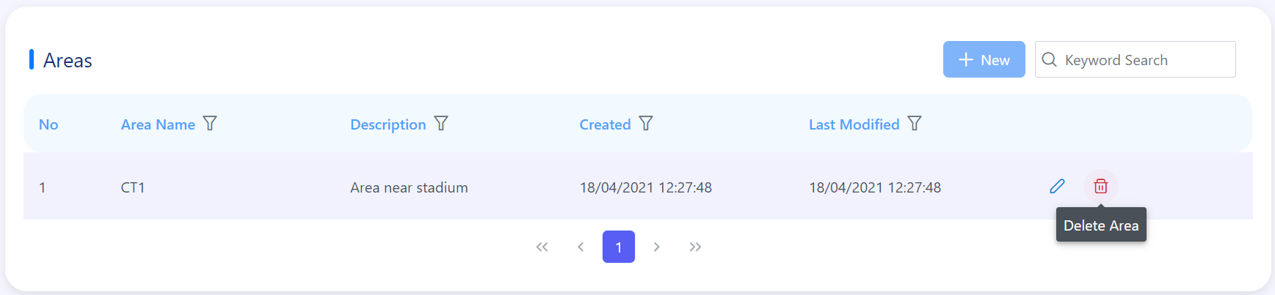

Figure

*Step 4. Click “Yes” button if you want to delete this area*

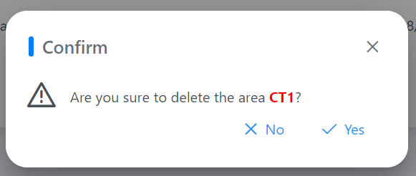

Figure

#### l. Create Repairer

*Step 1. On Dashboard page when logged in*



Figure

*Step 2. Select “Repairers” tab on left side bar*

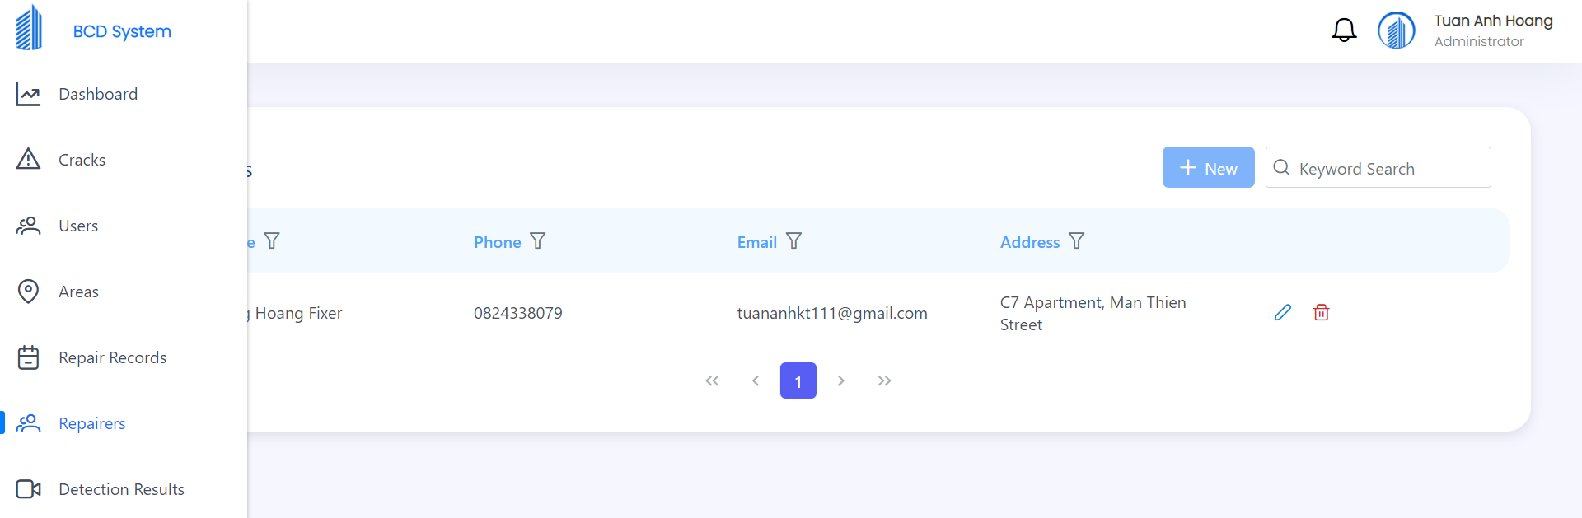

Figure

*Step 3. Click “New” button*



Figure

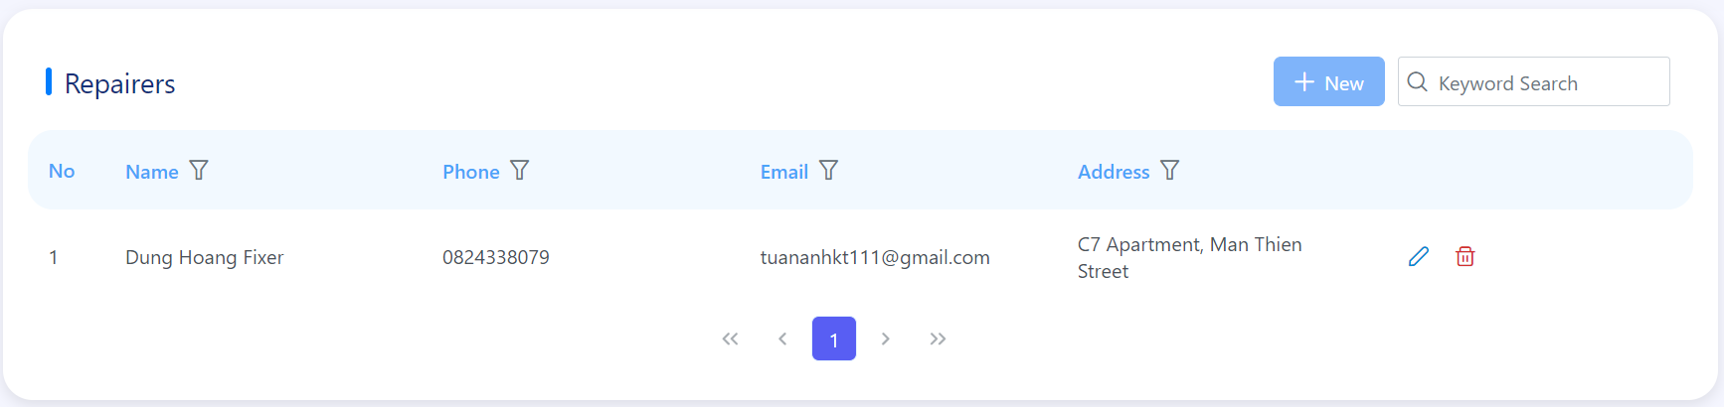

Figure

*Step 4. Enter required fields then click “Create” button to create new repairer*

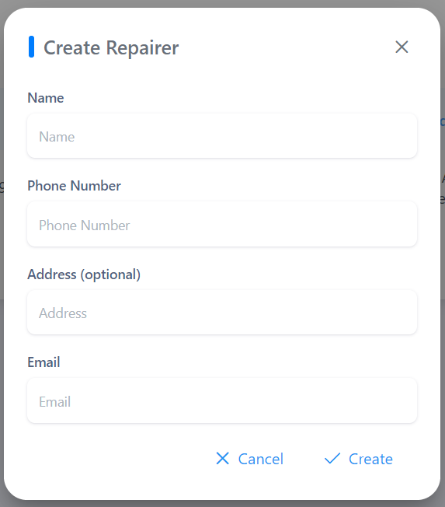

Figure

#### m. Update Repairer

*Step 1. On Dashboard page when logged in*



Figure

*Step 2. Select “Repairers” tab on left side bar*

**

Figure

*Step 3. Click the below icon on repairer that want to update information*



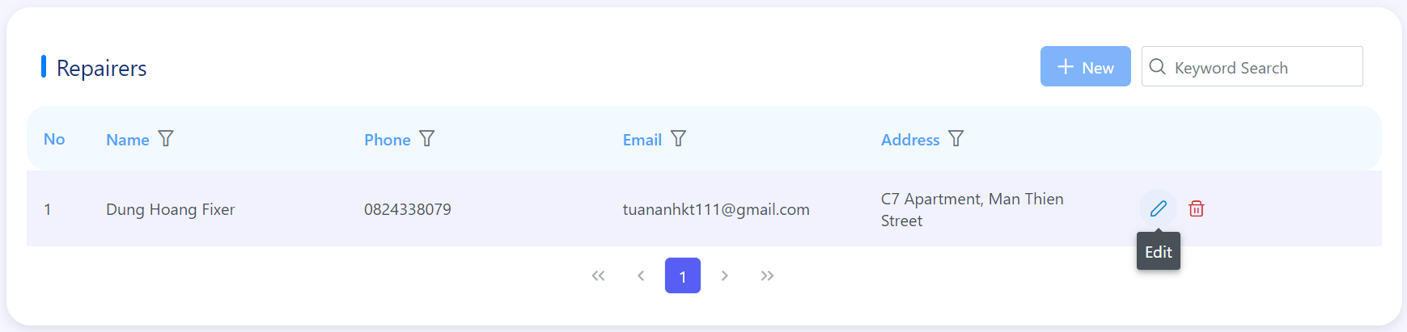

Figure

*Step 4. Edit information that you want then click “Update” button*

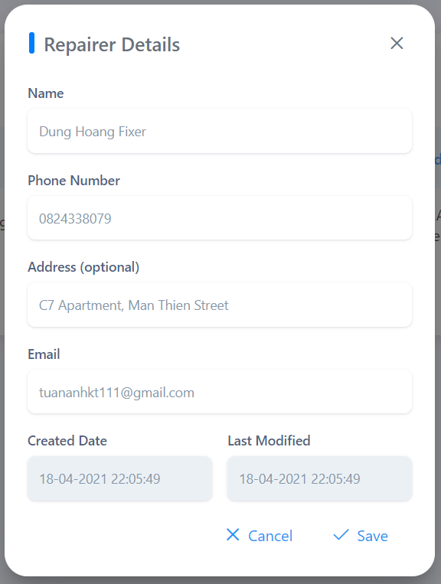

Figure

#### n. Delete Repairer

*Step 1. On Dashboard page when logged in*



Figure

*Step 2. Select “Repairers” tab on left side bar*

**

Figure

*Step 3. Click the below icon on user that want to delete*



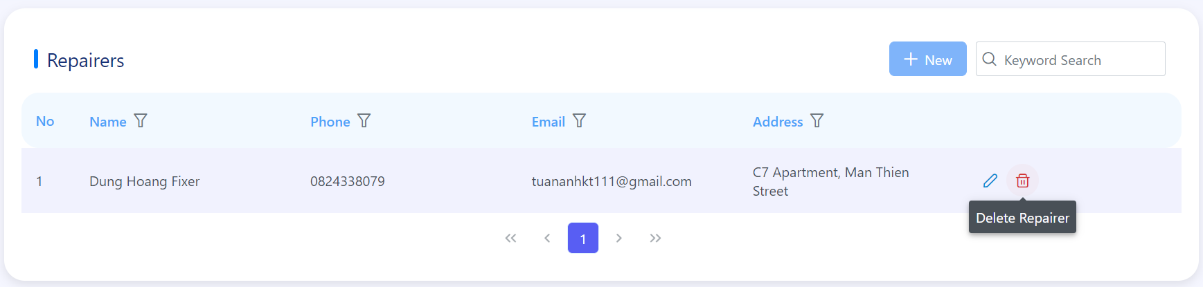

Figure

*Step 4. Click “Yes” button if you want to delete this area*

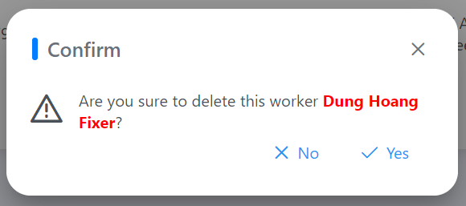

Figure

#### o. Detect crack(s)

*Step 1. On Crack page when logged in*

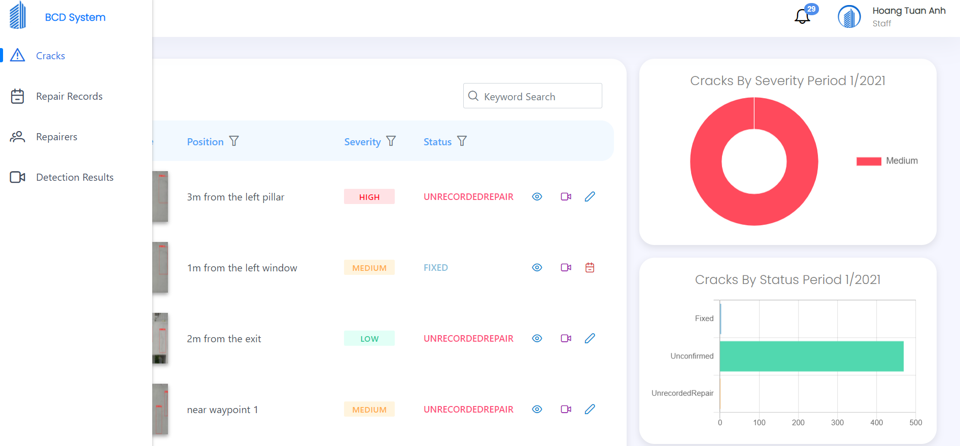

Figure

*Step 2. Select “Detection Results” tab on left side bar*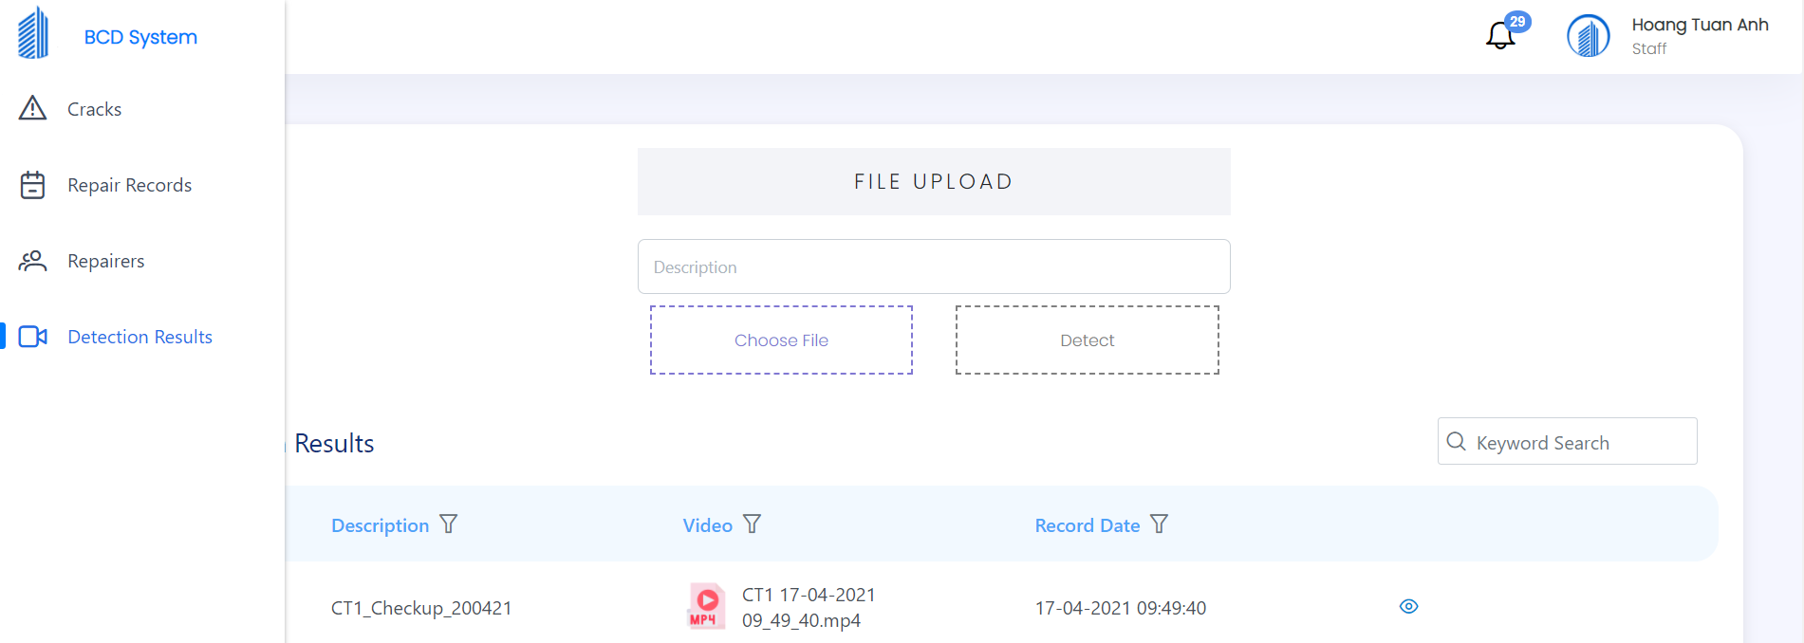

Figure

*Step 3. Input Description field and click “Choose file” button then choose a video file*



Figure

*Step 4. Choose “Detect” button*

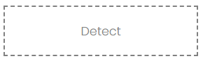

Figure

# VII. Appendix

## 1. Glossary

See section Definition and Acronyms.

## 2. References

1. [Khoa học dữ liệu (phamdinhkhanh.github.io)](https://phamdinhkhanh.github.io/2020/03/09/DarknetAlgorithm.html?fbclid=IwAR3KCv5tQySa8V9BOVpW-FHveQRIyUVZrf_87KLYAYCi9KU1Z4eS27_K5eQ)
2. [Convolutional neural network - Wikipedia](https://en.wikipedia.org/wiki/Convolutional_neural_network?fbclid=IwAR0iB0qSWoAW5Sx1YvsgJU__fg7DcWufDyNKs3eOUmi_8AFR06adeIgY-zI)
3. <http://www.gauravpande.in/Object-Detection/>
4. <https://nttuan8.com/bai-6-convolutional-neural-network/>
5. <https://ai.plainenglish.io/pooling-layer-beginner-to-intermediate-fa0dbdce80eb>
6. <https://medium.com/@pallawi.ds/ai-starter-build-your-first-convolution-neural-network-in-keras-from-scratch-to-perform-a059eaa6d4ff>
7. <https://phamdinhkhanh.github.io/2020/03/09/DarknetAlgorithm.html>
8. [Unified Modeling Language (UML) description, UML diagram examples, tutorials and reference for all types of UML diagrams - use case diagrams, class, package, component, composite structure diagrams, deployments, activities, interactions, profiles, etc. (uml-diagrams.org)](https://www.uml-diagrams.org/)
9. [Tải Windows 10 | Microsoft](https://www.microsoft.com/vi-vn/windows/get-windows-10)
10. [Download .NET 5.0 (Linux, macOS, and Windows) (microsoft.com)](https://dotnet.microsoft.com/download/dotnet/5.0)
11. [SQL Server 2019 | Microsoft](https://www.microsoft.com/en-us/sql-server/sql-server-2019)
12. [SQL Server Downloads | Microsoft](https://www.microsoft.com/en-US/sql-server/sql-server-downloads)
13. [Download | Node.js (nodejs.org)](https://nodejs.org/en/download/)
14. [Firebase (google.com)](https://firebase.google.com/?hl=vi)
15. [Download Python | Python.org](https://www.python.org/downloads/)
16. [DevOps Tutorial for Beginners: Learn Now (Training Course) (guru99.com)](https://www.guru99.com/devops-tutorial.html)
17. [What is Agile Testing? Methodology, Process & Life Cycle (guru99.com)](https://www.guru99.com/agile-testing-a-beginner-s-guide.html)
18. [Use Case Diagram và 5 sai lầm thường gặp | Thinhnotes.com](https://thinhnotes.com/chuyen-nghe-ba/use-case-diagram-va-5-sai-lam-thuong-gap/)
19. [Thiết Kế Chức Năng Với Sequence Diagram Có Phức Tạp Không? (codelearn.io)](https://codelearn.io/sharing/sequence-diagram-trong-uml)
20. [Bản vẽ hoạt động - Activity Diagram - iViettech](https://iviettech.vn/blog/1066-activity-diagram-ban-ve-hoat-dong.html)
21. [What is Package Diagram? (visual-paradigm.com)](https://www.visual-paradigm.com/guide/uml-unified-modeling-language/what-is-package-diagram/)
22. [Tìm hiểu về cách thiết kế Class Diagram (viblo.asia)](https://viblo.asia/p/tim-hieu-ve-cach-thiet-ke-class-diagram-L4x5xLyY5BM)
23. [Bản vẽ sơ đồ lớp - Class Diagram - iViettech - iViettech](https://iviettech.vn/blog/813-classs-diagarm-ban-ve-ve-classlop.html)
24. [ERD là gì? | Thinhnotes.com](https://thinhnotes.com/chuyen-nghe-ba/erd-la-gi/)

## 3. Appendix

Table . Appendix

|  |  |  |  |  |
| --- | --- | --- | --- | --- |
| **STT** | **Message Code** | **Message Type** | **Context** | ***Content*** |
| 1 | MSG01 | Toast message | Login Failed | *Login failed* |
| 2 | MSG02 | Toast message | Username or Password is incorrect | *Your Username or Password is incorrect* |
| 3 | MSG03 | Toast message | Create account success | *Create account successfully* |
| 4 | MSG04 | Toast message | Create account failed | *Create account failed* |
| 5 | MSG05 | Toast message | Edit account success | *Edit account successfully* |
| 6 | MSG06 | Toast message | Edit account failed | *Edit account failed* |
| 7 | MSG07 | Toast message | Reset password success | *Reset password successfully* |
| 8 | MSG08 | Toast message | Reset password failed | *Reset password failed* |
| 9 | MSG09 | Toast message | Delete account success | *Delete account successfully* |
| 10 | MSG10 | Toast message | Delete account failed | *Delete account failed* |
| 11 | MSG11 | Toast message | Create area success | *Create area successfully* |
| 12 | MSG12 | Toast message | Create area failed | *Create area failed* |
| 13 | MSG13 | Toast message | Edit area success | *Edit area successfully* |
| 14 | MSG14 | Toast message | Edit area failed | *Edit area failed* |
| 15 | MSG15 | Toast message | Delete area success | *Delete area successfully* |
| 16 | MSG16 | Toast message | Delete area failed | *Delete area failed* |
| 17 | MSG17 | Toast message | Create repairer success | *Create repairer successfully* |
| 18 | MSG18 | Toast message | Create repairer failed | *Create repairer failed* |
| 19 | MSG19 | Toast message | Edit repairer success | *Edit repairer successfully* |
| 20 | MSG20 | Toast message | Edit repairer failed | *Edit repairer failed* |
| 21 | MSG21 | Toast message | Delete repairer success | *Delete repairer successfully* |
| 22 | MSG22 | Toast message | Delete repairer failed | *Delete repairer failed* |
| 23 | MSG23 | Toast message | Confirm crack success | *Confirm crack successfully* |
| 24 | MSG24 | Toast message | Confirm crack failed | *Confirm crack failed* |
| 25 | MSG25 | Toast message | Update crack success | *Update crack successfully* |
| 26 | MSG26 | Toast message | Update crack failed | *Update crack failed* |
| 27 | MSG27 | Toast message | Reject crack success | *Reject crack successfully* |
| 28 | MSG28 | Toast message | Reject crack failed | *Reject crack failed* |
| 29 | MSG29 | Toast message | Add crack to repair record queue success | *Add crack to queue successfully* |
| 30 | MSG30 | Toast message | Crack has existed in queue | *Crack has existed in queue* |
| 31 | MSG31 | Toast message | Remove crack from queue success | *Remove crack from queue successfully* |
| 32 | MSG32 | Toast message | Remove crack from queue failed | *Remove crack from queue failed* |
| 33 | MSG33 | Toast message | Record repair success | *Record repair successfully* |
| 34 | MSG34 | Toast message | Record repair failed | *Record repair failed* |
| 35 | MSG35 | Toast message | Update repair record success | *Update repair record successfully* |
| 36 | MSG36 | Toast message | Update repair record failed | *Update repair record failed* |
| 37 | MSG37 | Toast message | Evaluate crack success | *Evaluate crack successfully* |
| 38 | MSG38 | Toast message | Not fully evaluate crack | *You need evaluate all cracks* |
| 39 | MSG39 | Toast message | Evaluate repair success | *Evaluate repair successfully* |
| 40 | MSG40 | Toast message | Evaluate repair failed | *Evaluate repair failed* |
| 41 | MSG41 | Toast message | Delete video success | *Delete video successfully* |
| 42 | MSG42 | Toast message | Delete video failed | *Delete video failed* |
| 43 | MSG43 | Toast message | Sent new password to account ** | *Reset password successfully* |
| 44 | MSG44 | Toast message | Failed to send password to account ** | *Reset password failed* |
| 45 | MSG45 | Toast message | Change password success | *Change password successfully* |
| 46 | MSG46 | Toast message | Change password failed | *Change password failed* |
| 47 | MSG47 | Toast message | Forgot password failed | *Your account doesn't exist* |
| 48 | MSG48 | Toast message | Forgot password success | *Reset password URL has been sent to the email successfully!* |
| 49 | MSG49 | Toast message | Mark all notifications as read success | *Mark all as read* |
| 50 | MSG50 | Toast message | Mark all notifications as read failed | *Mark all as read failed* |
| 51 | MSG51 | Toast message | Video exists | *Video exists* |
| 52 | MSG52 | In red, under the text box | Input-required fields are empty | *\* is a required field* |
| 53 | MSG53 | In red, under the text box | * must be a valid * | *\* must be a valid \** |
| 54 | MSG54 | In red, under the text box | * must be at most * characters | *\* must be at most * characters* |
| 55 | MSG55 | In red, under the text box | Phone is not validated | *Phone must be a valid phone number for region VN* |
| 56 | MSG56 | In red, under the text box | Password is not validated | *Password must contain at least 8 characters, 1 uppercase, 1 number* |
| 57 | MSG57 | In red, under the text box | Password is not matched | *Password is not matched* |
| 58 | MSG58 | In red, under the text box | Old password is incorrect | *Old password is incorrect* |
| 59 | MSG59 | In red, under the text box | Manager only manage at most three areas | *Manager only manage at most three areas* |
| 60 | MSG60 | In red, over the text box | File's format is not mp4 | *Wrong format file* |
| 61 | MSG61 | In line | List of * searched is empty | *No * found* |
| 62 | MSG62 | Toast message | Update area successfully | *Update area successfully* |
| 63 | MSG63 | Toast message | Update area failed | *Update area failed* |

## 